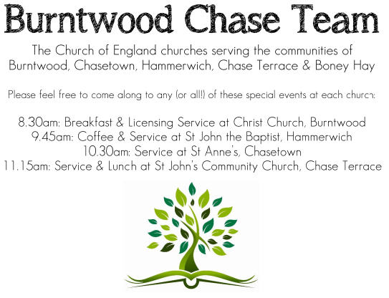 CHRIST CHURCH
SUNDAY 26th October 2025 at 10am

SERVICES:
Sunday 26th October 2025
Morning Worship
Last Sunday after Trinity

Readings:
Joel 2: 23-32
²³ O children of Zion, be glad
and rejoice in the Lord your God;
for he has given the early rain for your vindication,
he has poured down for you abundant rain,
the early and the later rain, as before.
²⁴ The threshing-floors shall be full of grain,
the vats shall overflow with wine and oil.
²⁵ I will repay you for the years
that the swarming locust has eaten,
the hopper, the destroyer, and the cutter,
my great army, which I sent against you.
²⁶ You shall eat in plenty and be satisfied,
and praise the name of the Lord your God,
who has dealt wondrously with you. And my people shall never again be put to shame.
²⁷ You shall know that I am in the midst of Israel,
and that I, the Lord, am your God and there is no other.
And my people shall never again
be put to shame.

²⁸ Then afterwards
I will pour out my spirit on all flesh;
your sons and your daughters shall prophesy,
your old men shall dream dreams,
and your young men shall see visions.
²⁹ Even on the male and female slaves,
in those days, I will pour out my spirit.
³⁰ I will show portents in the heavens and on the earth, blood and fire and columns of smoke. ³¹ The sun shall be turned to darkness, and the moon to blood, before the great and terrible day of the Lord comes. ³² Then everyone who calls on the name of the Lord shall be saved; for in Mount Zion and in Jerusalem there shall be those who escape, as the Lord has said, and among the survivors shall be those whom the Lord calls.
Luke 18: 9-14
⁹ He also told this parable to some who trusted in themselves that they were righteous and regarded others with contempt: ¹⁰ ‘Two men went up to the temple to pray, one a Pharisee and the other a tax-collector. ¹¹ The Pharisee, standing by himself, was praying thus, “God, I thank you that I am not like other people: thieves, rogues, adulterers, or even like this tax-collector. ¹² I fast twice a week; I give a tenth of all my income.” ¹³ But the tax-collector, standing far off, would not even look up to heaven, but was beating his breast and saying, “God, be merciful to me, a sinner!” ¹⁴ I tell you, this man went down to his home justified rather than the other; for all who exalt themselves will be humbled, but all who humble themselves will be exalted.’

COLLECT FOR TODAY
Blessed Lord,
who caused all holy Scriptures
to be written for our learning:
help us so to hear them,
to read, mark, learn and inwardly digest them
that, through patience, and the comfort of your
holy word,
we may embrace and for ever hold fast
the hope of everlasting life,
which you have given us in our Saviour Jesus Christ,
who is alive and reigns with you,
in the unity of the Holy Spirit,
one God, now and for ever.

WHAT’S GOING ON
Upcoming Services

Wednesday 29th October Morning Prayer 9.30am
Saturday 1st November Art Cafe 3-5pm
Sunday 2nd November Holy Communion 10am
Monday 3rd November Cameo Cafe 10-12noon

Art Cafe

Art Cafe will be on Saturday 1st November, 3-5pm.
All welcome to join.

Cameo Cafe

Cameo Cafe will be open on Monday 3rd October, 10 till 12 noon.
All welcome for a cuppa and a biscuit or two.

Christmas Fayre

Our Christmas Fayre will be on Saturday 15th November, 2-4pm.
Any help to set up would be very much appreciated.

FLOODLIGHTING
If you think about commemorating a special occasion by floodlighting our Church. Please contact Chris Brown on 01543 683862 for details.

PRAYER CHAIN
Christ Church is blessed with a very active prayer chain. If you, or anyone you know, feel that they would like others to pray for them, please speak to Chris Brown on 01543 683862.

HOME COMMUNION
For anyone who is unable to attend church and would like Home Communion,
Steve Morgan is able to carry this out.

VICAR CONTACT DETAILS
Stephen Morgan Tele: 07305 852152
CHURCH WARDENS CONTACT DETAILS
Judith Rogers Tele: 01543 324718
Mike Holmes Tele: 01543 672970
Church Office Tele: 01543 642187 [leave a message and we will respond]
Church Web Site:www.christchurchburntwood.org.uk
Church Email: christchurchburntwood15@gmail.com
Facebook: www.facebook.com/group/christchurchburntwood/

Other Contacts
Matt Wallace St. John’s, Chase Terrace— Tele: 01543 670078
Richard Westwood St. Anne’s, Chasetown—Tele: 01543 686111

NEXT SUNDAY SERVICE
Sunday 2nd November at 10am
Holy Communion
Isaiah 1: 10-18
Luke 19: 1-10
4th Sunday after Trinity

