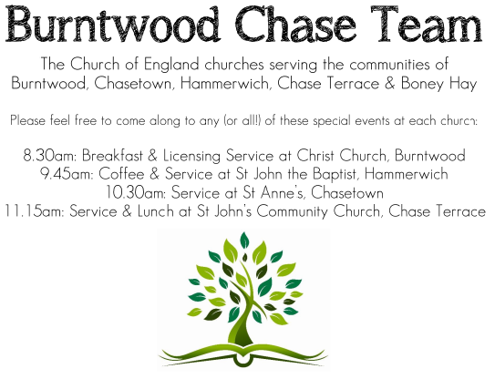 **CHRIST CHURCH**

SUNDAY 12th October 2025 at 10am

**SERVICES:**

**Sunday 12th October 2025**

**Morning Worship**

**17th Sunday after Trinity**

**Readings:**

**Jeremiah 29: 1, 4-7**

These are the words of the letter that the prophet Jeremiah sent from Jerusalem to the remaining elders among the exiles, and to the priests, the prophets, and all the people, whom Nebuchadnezzar had taken into exile from Jerusalem to Babylon.

**4**Thus says the Lord of hosts, the God of Israel, to all the exiles whom I have sent into exile from Jerusalem to Babylon: **5**Build houses and live in them; plant gardens and eat what they produce. **6**Take wives and have sons and daughters; take wives for your sons, and give your daughters in marriage, that they may bear sons and daughters; multiply there, and do not decrease. **7**But seek the welfare of the city where I have sent you into exile, and pray to the Lord on its behalf, for in its welfare you will find your welfare.

**Luke 17: 11-19**

**11**On the way to Jerusalem Jesuswas going through the region between Samaria and Galilee. **12**As he entered a village, ten lepersapproached him. Keeping their distance, **13**they called out, saying, ‘Jesus, Master, have mercy on us!’ **14**When he saw them, he said to them, ‘Go and show yourselves to the priests.’ And as they went, they were made clean. **15**Then one of them, when he saw that he was healed, turned back, praising God with a loud voice. **16**He prostrated himself at Jesus’ feet and thanked him. And he was a Samaritan. **17**Then Jesus asked, ‘Were not ten made clean? But the other nine, where are they? **18**Was none of them found to return and give praise to God except this foreigner?’ **19**Then he said to him, ‘Get up and go on your way; your faith has made you well.’

**COLLECT FOR TODAY**

Almighty God,

you have made us for yourself,

and our hearts are restless till they find their rest

in you:

pour your love into our hearts and draw us

to yourself,

and so bring us at last to your heavenly city

where we shall see you face to face;

through Jesus Christ your Son our Lord,

who is alive and reigns with you,

in the unity of the Holy Spirit,

one God, now and for ever.

***WHAT’S GOING ON***

**Upcoming Services**

**Wednesday 15th October Morning Prayer 9.30am**

**Sunday 19th October Holy Communion 10am**

**Wednesday 22nd October Morning Prayer 9.30am**

**Sunday 26th October Morning Worship 10am**

**Wednesday 29th October Morning Prayer 9.30am**

**FLOODLIGHTING**If you think about commemorating a special occasion by floodlighting our Church.  Please contact Chris Brown on 01543 683862 for details.

PRAYER CHAIN

Christ Church is blessed with a very active prayer chain. If you, or anyone you know, feel that they would like others to pray for them, please speak to Chris Brown on 01543 683862.

HOME COMMUNION

For anyone who is unable to attend church and would like Home Communion,

Steve Morgan is able to carry this out.

VICAR CONTACT DETAILS

Stephen Morgan Tele: 07305 852152

**CHURCH WARDENS CONTACT DETAILS**

**Judith Rogers Tele: 01543 324718**

**Mike Holmes Tele: 01543 672970**

**Church Office Tele: 01543 642187** *[leave a message and we will respond]*

Church Web Site:www.christchurchburntwood.org.uk

Church Email: [christchurchburntwood15@gmail.com](mailto:christchurchburntwood15@gmail.com)

Facebook: [www.facebook.com/group/christchurchburntwood/](http://www.facebook.com/group/christchurchburntwood/)

**Other Contacts**

**Matt Wallace St. John’s, Chase Terrace— Tele: 01543 670078**

**Richard Westwood St. Anne’s, Chasetown—Tele: 01543 686111**

**NEXT SUNDAY SERVICE**

**Sunday 19th October at 10am**

**Holy Communion**

**Jeremiah 31: 27-34**

**Luke 18: 1-8**

**18th Sunday after Trinity**

**DEANERY CONFIRMATION SERVICE**

**Sunday 26th October 2025 at 5pm**

**At Christ Church, Gentleshaw**

**With the Bishop of Wolverhampton, the Right Rev’d Dr Timothy Wambunya**