Psalm 149
Just a reminder you can find out more that is happening and get in touch via our website
https://allsaintschurchkirkhallam.enablecomcloud.co.uk/
or A Church Near You website
www.achurchnearyou.com/church/13402/
These are our two official, authorised websites, other sites may have our name but actually are nothing to do with the church.
Please stand, if able, and join in the verses in bold

Praise the Lord! Sing to the Lord a new song,
his praise in the assembly of the faithful.
Let Israel be glad in its Maker;
let the children of Zion rejoice in their King.
Let them praise his name with dancing,
making melody to him with tambourine and lyre.
Distribution of Communion –currently the Priest will dip the communion wafer in the wine while we discern a safe way to bring the common cup back into worship, as we want everyone to feel included and safe. We also have gluten free wafers available.
For the Lord takes pleasure in his people;
he adorns the humble with victory.
Let the faithful exult in glory;
let them sing for joy on their couches.
Confirmation Service
Everyone is invited to Derby Cathedral at 11am on Saturday 8th November when Tiwa and Arnold will be getting confirmed by Bishop Libby, please hold them in your prayers.
Let the high praises of God be in their throats
and two-edged swords in their hands,
to execute vengeance on the nations
and punishment on the peoples,
to bind their kings with fetters
and their nobles with chains of iron,
to execute on them the judgement decreed.
This is glory for all his faithful ones. Praise the Lord!
As from Sunday 16th November the 4pm service will be in Friendship House (except on 21st December for the Carol Service) until Sunday 15th February.

Glory be to the Father and to the Son and to the Holy Spirit,
as it was in the beginning, is now and ever shall be,
world without end. Amen

A big ‘thank you’ to the students at Kirk Hallam Community Academy for making this Remembrance display
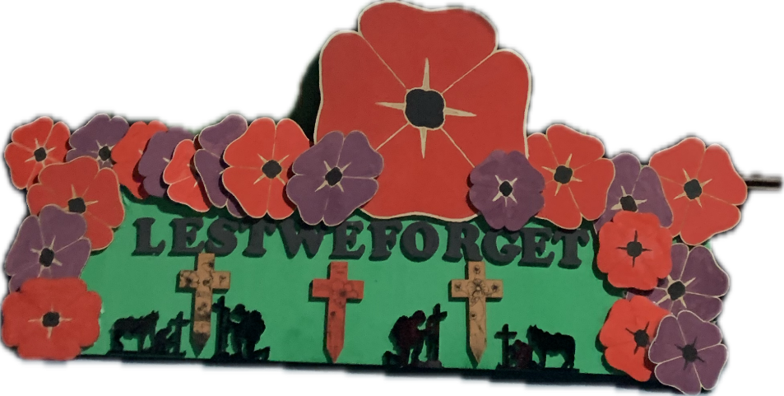
In our weekly prayers for our parish
This week we pray for God’s blessing on Sharp Close, Spinney Road and St Norbert Drive.

New Testament Readings from the Lectionary

Monday 3rd All Souls Day Matthew 1: 18 to end
Tuesday 4th Matthew 2: 1 to 15
Wednesday 5th Matthew 2: 16 to end
Thursday 6th Matthew 3
Friday 7th Matthew 4: 1 to 11
Saturday 1st Saints & Martyrs of England Matthew 4: 12 to 22

We are using the readings from the
Church of England’s Morning Prayer service.
All Saints Church
Refreshments After the Morning Service
Please stay seated after the service and a hot drink will be brought to you in the pews.
Church contact information
Contact: Rev’d Christine - revchristine@outlook.com
The Rectory, The Village, West Hallam, DE7 6GR
Landline 0115 646 1497
Rev’d Ailsa -revailsahunt@gmail.com
Tel - 07356064856

Churchwardens – Mrs Janet Wheeldon, -Tel: 0115 8771593
Mrs Linda Gregory – linda.gregory3@icloud.com
https://www.achurchnearyou.com/church/13402/
https://www.facebook.com/allsaintskirkhallam
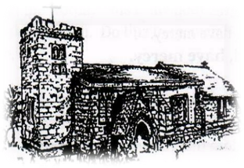
Kirk Hallam
Disabled Toilet in Friendship House.
Disabled Toilet in Friendship House.

Working with God to transform lives & communities.
Please can you ensure your mobile is on silence, or off during the service, it is affecting people with hearing aids and the loop system.

2nd November – All Saints Day
10.00am Communion Service with Rev’d Christine
4.00pm BCP Evening Prayer with Alan and Eileen

Forthcoming Events
Mon 3rd 11.00am Funeral of Dulcie Reece in church
Mon 3rd 6.00pm Young People’s Confirmation Class
Tues 4th 11.30am Mid Week Remembrance Service
with local schools
Tues 4th 6.00pm Home Group in Friendship House
Weds 5th 9.30am Morning Prayer at UCAS, Stanley Common
Weds 5th 12.30pm Funeral of Eric Holmes at Trent
Valley Crematorium
Weds 5th 2.00pm Mothers’ Union meeting in church
Fri 7th 6.00pm Choir Practice in Friendship House
Sat 8th 10.00am Prayer Meeting in Friendship House
Sat 8th 11.00am Confirmation Service at Derby Cathedral

9th November – Remembrance Sunday
10.00am Iona Communion Service with Rev’d Ailsa
4.00pm Iona Evening Prayer with Rev’d Alan
It’s Good to Talk! If you spot that someone is missing, please pop a news sheet through their door, & if you’ve time, call for a chat - just to check they’re OK & to let them know that they are not forgotten!
‘The heavens declare the glory of God; the skies proclaim the work of his hands’ Psalm 19:1

