NEWSLETTER NUMBER 290
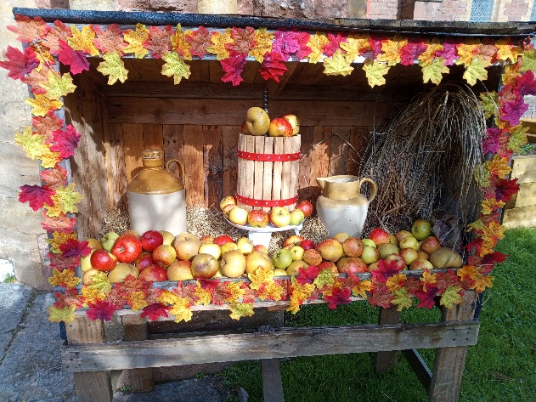
Last Sunday the church looked amazing from the moment you arrived at the South door to the display inside. If you were not there, then you missed a treat so I have put in a small picture to show what you have missed. Well done to Melodie, Alison and Charlotte for their magnificent work. Following the service we all had a superb lunch in the Lang Room and managed t raise £70-00. Well done to Jacquie and her team of helpers for preparing all that food for us to demolish!

OUR SERVICE ON SUNDAY 5TH OCTOBER 2025 – 14TH SUNDAY AFTER TRINITY
This Sunday’s service will be a Sung Eucharist starting at 11.15 a.m. The celebrant will be
Rev Stephen Bowen. There will be coffee and chat after the service so please stay.

LOOKING FORWARDS – REV ANDY
As the harvest season unfolds so does our gratitude. Across our churches we are gathering in the gifts provided for us from the land and offering our thanks to the one who has given them. Children from the primary schools in Sampford Arundel and Rockwell Green gathered in their parish churches this week to celebrate harvest, too. Both schools have collected donations of food which will go to support those in our local community who find it hard to put meals on the table. Which reminds us that alongside gratitude at harvest time, we are also invited to be generous. We have a choice when we receive, to either hoard or to share. A mindset of scarcity leads to an instinct of hoarding whereas a mindset of gratitude for what we have received, turns our instincts naturally towards giving and sharing.
It is fitting therefore that our Vision Day falls within this harvest season. It will be a chance for us to look back with gratitude for all the life, growth and good times we have enjoyed this past year. Upon this foundation of gratitude, we can then turn our conversations to how can we bless, be generous and give back.
You are all invited to the Vision Day, and your voice matters in this conversation. What are you grateful for in your church life? What do you hunger to see more of? What would you miss if it died away? What seeds do you think we should sow? The event is taking place on 18th October at Appley Pavilion, Appley Cross, TA21 0HH. There are two ways you can get involved: Come from 9.30am for tea and coffee (and cake) and join us for the start of our discussions at 10.00am. The day runs through until 3.00pm.
Just come for lunch at 11.45am, along with wider members of our community, who may not come to church but very much value the local area. The lunch session finishes at 1.30pm. I am very keen that everyone’s voice gets heard, so if you are unable to come along on the day itself, then please share your thoughts with me in advance. That way I can bring them to the day and your opinion will be valued. Please prioritise this opportunity to give thanks this harvest time, and to take a step into our shared future together. Thank you.
Office: 2 White Oaks, Langford Budville, TA21 0RB Phone: 01823 924007 or
Email: revdbarton@gmail.com
ROTA FOR SUNDAY 5TH OCTOBER 2025
Sidesmen:- Angela Setter and Rachel Yates
Reader:- Stephanie Emery
Coffee:- Angela Setter and Rachel Yates
Flowers:- Philippa Deem
READINGS FOR SUNDAY 5TH OCTOBER 2025
Collect:- Almighty God, whose only Son has opened for us a new and living way into your presence: give us pure hearts and steadfast wills to worship you in spirit and in truth; through Jesus Christ your Son our Lord, who is alive and reigns with you, in the unity of the Holy Spirit, one God, now and for ever. Amen
Readings:-
Habakkuk, Chapter 1, vv 1 – 4 and Chapter 2, vv 1 – 4
2nd Timothy Chapter 1, vv 1 – 14
Luke Chapter 17, vv 5 – 10
PRAYER LIST FOR OCTOBER
The Rev Caroline Luff (Rachel Yates’ godmother)
Chris Monckton
Elizabeth Miles
Eunice Durrance
Ian Sansom
Mike Toogood
Pam Wilkie
Paul
Stephen Daley
Susan Dobson
The people of Palestine
The people of Ukraine, Poland and Estonia
Vision day for the West Tone Benefice
YEARS MIND FOR OCTOBER
8TH Herbert George Goff
9th James Martin Westaway

BIRTHDAY LIST
There are no known birthdays this week. Please let me know if we are missing this date in our list.

OUTREACH GROUPS
Soup ‘n’ a Bite
The next meeting of this group will be on Saturday, 11th October 2025 at 12.00 noon. The group usually offers a choice of soups, a variety of bread and/or rolls, various cheeses, fresh fruit. tea or coffee. There is also a free raffle.

Recycled Teenagers
The next meeting, which will take place at 2.30 p.m. on Tuesday, 28th October 2025. There will be the normal chat as well as a superb tea of sandwiches and cakes to demolish.

Knit, Sew and Natter
The next meeting will be on Thursday, 2nd October 2025 starting at 2.00 p.m. It will be the usual meeting with lots of chat and refreshments.
OUR NEXT SERVICE
The next service at All Saints’ will be on Sunday 12th October 2025 starting at 11.15 a.m. It will be a Sung Eucharist and our parish priest, Rev Andy Barton will be the celebrant. Coffee and chat will follow the service.

FORTHCOMING EVENTS
Sunday, 5th October 2025
History Talk at 3.00 p.m.
There will be an illustrated talk on the why, who etc of the building of All Saints’ Church at Rockwell Green. The cost will be £5-00 per person. This will be followed by tea and cakes.

October
Cocktails and Mocktails with the same format as last time.

November
Quiz night with jacket potato and filling supper.
Same format as before with teams of up to 6 people, bring your own drinks. The cost will be £7-50 per person. Start eating fish now to get the brain in tiptop condition!!! Supply your own drinks.

December 13th – 14th
Christmas tree festival
This will be a two-day event with the trees staying up until the school has had its two mid-week Christmas services in the church.
CHURCH VISION DAY – SATURDAY 18TH OCTOBER 10.00 A.M. -3.00 P.M. at APPLEY PAVILION, TA21 0HH – see the two notices attached
All the churches in the West Tone Benefice are coming together in October to hold a Vision Day. The goal is to listen to God and one another as we look for how to be a relevant and fruitful church for the present time in our communities. Everyone is welcome to come, and everyone will be able to share their views. The venue has been chosen carefully to make the most of the day, and if you would like a lift to get there, please just ask. Over the lunch time slot, from 11.45 to 1.30pm, any member of our local community is welcome to join us for a free Community Lunch. Here they will have the chance to share what matters to them in life, and what they value about the community. The material gained from these discussions will help us, the churches, to shape our own priorities in the years ahead as we seek to play our part in the local area. Please make coming to this day a priority. Your opinion matters and will help us hear a wide range of views. Please confirm your place, or share your thoughts beforehand if you cannot come on the day, either by:
- emailing me at revdbarton@gmail.com
- ringing me on 01823 924007
- sending me a letter to 2 White Oaks, Langford Budville, TA21 0RB
- or going online at westtone.org.uk/conversation

OTHER INFORMATION
From Rev Anrew Norris
On the “Home Service” this week:
Revd Suzy Kirkham from the Vale Churches benefice leads a Harvest Service focusing on the theme of “Gratitude”. We also hear the next in the series illustrating Aspects of God’s Love in poetry by Hilary Allen, this week following the theme of “Prayer.”

FUN CORNER


