Psalm 119:97 to 104
Just a reminder you can find out more that is happening and get in touch via our website
https://allsaintschurchkirkhallam.enablecomcloud.co.uk/
or A Church Near You website
www.achurchnearyou.com/church/13402/
These are our two official, authorised websites, other sites may have our name but actually are nothing to do with the church.

Please stand, if able, and join in the verses in bold

Oh, how I love your law!
It is my meditation all day long.
Your commandment makes me wiser than my enemies,
for it is always with me.
I have more understanding than all my teachers,
for your decrees are my meditation.
I understand more than the aged,
for I keep your precepts.
I hold back my feet from every evil way,
in order to keep your word.
I do not turn away from your ordinances,
for you have taught me.
How sweet are your words to my taste,
sweeter than honey to my mouth!
Through your precepts I get understanding;
therefore I hate every false way.

Glory be to the Father and to the Son and to the Holy Spirit,
as it was in the beginning, is now and ever shall be,
world without end. Amen

Harvest Flowers

Thank you to everyone who contributed to the harvest displays
– they looked fabulous.

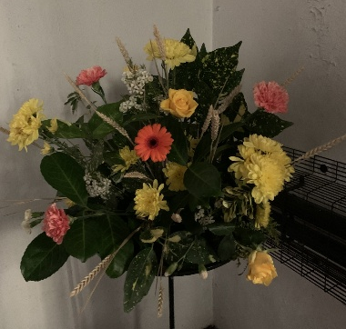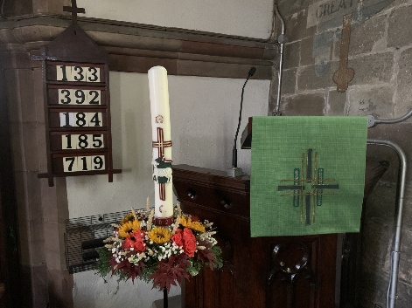

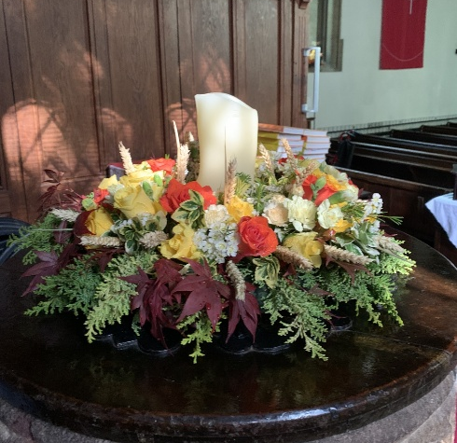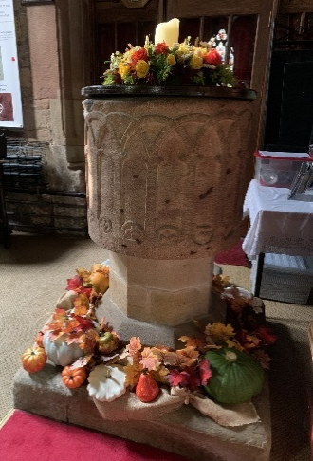
In our weekly prayers for our parish
This week we pray for God’s blessing on Quarry Hill Road, Queen Elizabeth Way and Ribblesdale.

New Testament Readings from the Lectionary

Monday 20th Mark 15: 1 to 15
Tuesday 21st Mark 15:16 to 32
Wednesday 22nd Mark 15: 33 to 41
Thursday 23rd Mark 15: 42 to end
Friday 24th Mark 16: 1 to 8
Saturday 26th Mark 16: 9 to end

We are using the readings from the
Church of England’s Morning Prayer service.
All Saints Church
Refreshments After the Morning Service
Please stay seated after the service and a hot drink will be brought to you in the pews.
Church contact information
Contact: Rev’d Christine - revchristine@outlook.com
The Rectory, The Village, West Hallam, DE7 6GR
Landline 0115 646 1497
Rev’d Ailsa -revailsahunt@gmail.com
Tel - 07356064856

Churchwardens – Mrs Janet Wheeldon, -Tel: 0115 8771593
Mrs Linda Gregory – linda.gregory3@icloud.com
https://www.achurchnearyou.com/church/13402/
https://www.facebook.com/allsaintskirkhallam
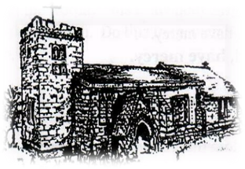
Kirk Hallam
Disabled Toilet in Friendship House.
Disabled Toilet in Friendship House.

Working with God to transform lives & communities.
Please can you ensure your mobile is on silence, or off during the service, it is affecting people with hearing aids and the loop system.
19th October – Eighteenth Sunday After Trinity
10.00am Communion Service with Rev’d Christine & Rev’d Jan
3.00pm Building Faith (Lego Church) at Community Hall
4.00pm BCP Communion with Rev’d Christine

Forthcoming Events
Mon 20th 6.00pm Young People’s Confirmation Class
Tues 21st 6.00pm Home Group in Friendship House
Weds 22nd 9.30am Morning Prayer at UCAS, Stanley Common
Fri 24th 6.00pm Choir Practice in Friendship House
Sat 25th 10.00am Prayer Meeting in Friendship House
Don’t forget the clocks go back an hour on Sunday 26th

26th October – Last Sunday After Trinity
10.00am Communion Service with Rev’d Ailsa & Eileen
4.00pm BCP Evening Prayer with Rev’d Christine
It’s Good to Talk! If you spot that someone is missing, please pop a news sheet through their door, & if you’ve time, call for a chat - just to check they’re OK & to let them know that they are not forgotten!
‘Every word of God proves true; he is a shield to those who take their refuge in him’ Proverbs 30: 5
Distribution of Communion –currently the Priest will dip the communion wafer in the wine while we discern a safe way to bring the common cup back into worship, as we want everyone to feel included and safe. We also have gluten free wafers available.

