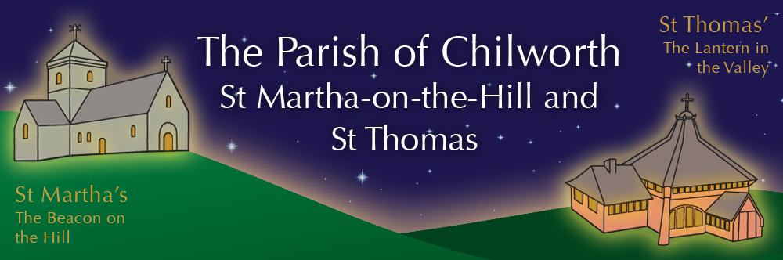

NOTICES: - 12th OCTOBER 2025
Priest David Oakden – Revdavid@parishofchilworth.org.uk - 01483 534293 (day off Friday)
Do let me know of anybody or anything that you would like to be prayed for.
www.parishofchilworth.org.uk and find us on https://www.achurchnearyou.com

***********Matthew 10:12(TPT)***********
Once you enter a house, speak to the family there and say, "God's blessing of peace be upon this house!'.
***********************************

Opportunities to pray together: -
Ecumenical Prayer Breakfast 1st Saturday of the month at the Vicarage, from 9am, prayer, coffee and croissant. Next is the 1st November – Thursday evening at St Thomas at 7:30 pm for an hour every other week. ** 16th October & 6th November.

This Sunday Services: – 17th after Trinty
09:30 St. Peter’s & St. Pauls – Morning Prayer.
11:15 St. Martha’s – Harvest Communion.

Next Sunday Services: - 19th October
09:30 St. Thomas – Communion with Rev’d Tim.
11:15 St. Martha’s – BCP Mattins with Rev’d Tim.

Looking further ahead: -
Chilworth Tinies and Toddler Group: St T’s Monday 9:15 – 10:30am
Harvest Communion: 12th Oct St M’s 11:15
Benefice Autumn Course: 13th Oct 7:30 Albury Village Hall

Food & Hygiene Bank: -
The Foodbank Larder box is now located in the porch of St Thomas Church. Suggested items are: - Long life milk /tins tuna/ tins meat/ sachets microwaveable rice /pasta sauces/curry sauces/cereal/spreads/ tea/ coffee/ hot chocolate/ tins soup/ baked beans.
The need is great and growing, the Foodbank is struggling to keep up with demand – both through gifts and funds. Please consider if you are able to assist, especially as the autumn is now upon us.
Donations at St Martha’s during services can now be made electronically via our Card Reader.

Chilworth Tinies and Toddler Group: -
Mondays from 9:15 -10:30 meet in St Thomas, play chat, pray and support.

Harvest Communion 12th Oct St M’s: -
Celebrate, and bring gifts suitable for the food bank.

Christian Resources Exhibition: -
Sandown Park 15-16 October, oodles of exhibitors showcasing their wares. Worth a visit if you have never been before, plenty of parking, and everything for church, services, youth, etc. etc.

Alexandra Birthday: -11:15 St Martha’s
Help Alexandra celebrate her 100th birthday on the 12th October at our Harvest Communion service.

Autumn Sale, Gingerbread & Hot Chocolate: -
Saturday 15th November at St T’s - our Autumn Sale with Gingerbread & Hot Chocolate from 11.00 – 3.00pm. Usual stalls plus various craft stalls and a ‘recycle your last year’s Christmas Gifts’ tombola to get you in the mood for Christmas gift buying. Donations of cakes and gifts welcome. Contact Carole on shattocks@hotmail.com or call 07711 864 488 with offers of help or to have your own stall.

Shoe Box Appeal
We are joining with Albury parish church in filling shoeboxes during October with items to provide Christmas gifts for young / adult / elderly males and females. For more information on contents and shoe box filler ideas please contact Linda on Linda.Holden1@btinternet.com who will liaise with the Albury church co-ordinators. Thank you

Benefice Autumn Study Course: -
7:30pm Monday evenings at Albury Village Hall
Can simply being with God, being with each other and being with our community really form the heart of our mission and ministry as a church? Join us to explore together how the concept of “being with” rather than “doing for” or “working for” can guide us as individuals as well as churches. Find out how by focusing on presence, attention, mystery, delight, participation, partnership, enjoyment and glory we can more actively engage with the world and its people, attending to their needs, and participating in their lives, just as Jesus did. Each session will look at a different aspect, so just come to as many as you can

