**12th October 2025**

28th Sunday In Ordinary Time 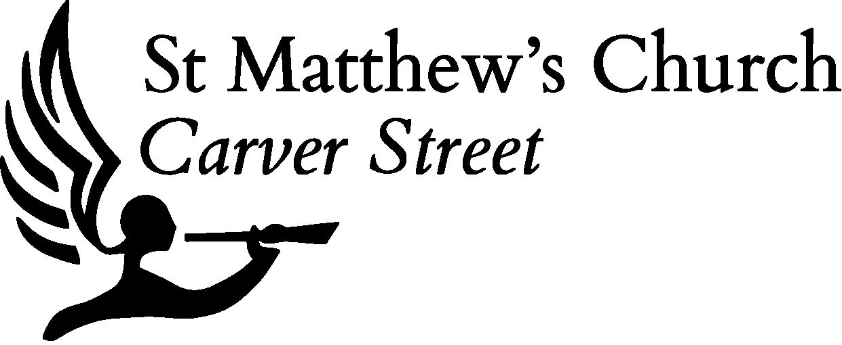

Welcome to St Matthew’s. Coffee is served after the 11:00am Mass.  
If you are new please do introduce yourself to the welcomers or clergy

|  |  |  |
| --- | --- | --- |
| **Monday**   13 October | Saint Edward the Confessor, King | 12:30pm: Said Mass |
| **Tuesday**   14 October | Saint Callistus, Pope, Martyr | 12:30pm: Said Mass |
| **Wednesday**   15 October | Saint Teresa of Ávila, Virgin, Doctor | 12:30pm: Said Mass  6:00pm: Said Mass |
| **Thursday**   16 October | Saint Margaret Mary Alacoque, Virgin    Sheffield Scriptorium | 9:00am: Morning Prayer  11:30am: Holy Hour  12:30pm: Said Mass  5:00pm: Evening Prayer |
| **Friday**  17 October | *Saint Ignatius of Antioch, Bishop, Martyr* | 12:00pm: Rosary  12:30pm: Said Mass |
| **Saturday**   18 October | Saint Luke, Evangelist | 9:30am: Said Mass |
| **Sunday 19 October 11:00am: Sung Mass, 6pm: Said Mass** | | |

**Notices**

Scriptorium

**Thursdays during Term Time**

A weekly quiet study day for all students and home-workers. Prayer, food, and focus. Contact

scriptorium@carverstreet.co.uk for more info.

Parish Nursing Sunday

**Sunday 19th October**

Celebrating and praying for our ministry of healthcare and healing in the city centre. 11am

Mass followed by a presentation and meal.

Bishop’s Visit & Confirmations

**Sunday 26 October 11am**

The Sacrament of Confirmation bestows a special blessing of the Holy Spirit upon those who have undergone a time of Catechesis and Formation and is the final step in the full initiation into the life of the Church. If have not yet been Confirmed and would like to know more or if you wish to enquire on behalf of your child, please email father.naylor@carverstreet.co.uk

Fr Micheal Dixon Induction

**Sunday 26 October 6pm**

Fr Micheal Dixon (sometime student and ordinand of this parish) is being instituted and inducted as the Vicar of Edlington and Hexthorpe. All invited to the induction at St John’s DN12 1AX.

Meet a Monk

**Saturday 1 November 4pm**

Br Steven Haws is a originally from Philadelphia USA and is now a Monk at the Community of the Resurrection Mirfield. Tea and cake at the Vicarage, 77 Wilkinson Street.

All Saints

**Sunday 2nd November**

**Masses 11am and 6pm**

*Preacher: Br Steven Haws CR*

All Souls

**Monday 3rd November**

**Masses 12:30pm and 7pm**

Preacher: Br Steven Haws CR

Remembrance

**Sunday 9th November 10:00am** Requiem for the War Dead followed by the City Act of Remembrance on Barker’s Pool

Fr Naylor’s Installation at the Cathedral

**Sunday 9th November 4pm**

Fr Naylor will be installed as a Canon. A small celebration will take place back at Church shortly after the ceremony. All welcome.

Barkers Pool Remembrance

**Tuesday 11th November 11am**

Act of remembrance at Barker’s Pool

Walk in the Peak District

**Saturday 15November**

Meet at St Matthew’s for the 0930 Mass and depart straight after.

***Recently Departed***

***Years’ Mind***  
Mabel Green

*Lamp dedications*

**Shrine Our Lady**

Shrine of Our Lady of Walsingham

**Shrine of the Sacred Heart**

Society St Wilfrid & St Hilda



Giving and Links to Events **linktr.ee/carverstreet**