Psalm 100
Just a reminder you can find out more that is happening and get in touch via our website
https://allsaintschurchkirkhallam.enablecomcloud.co.uk/
or A Church Near You website
www.achurchnearyou.com/church/13402/
These are our two official, authorised websites, other sites may have our name but actually are nothing to do with the church.

Please stand, if able, and join in the verses in bold

Make a joyful noise to the Lord,
all the earth.
Worship the Lord with gladness;
come into his presence with singing.

Know that the Lord is God.
It is he that made us, and we are his;
we are his people, and the sheep of his pasture.

Enter his gates with thanksgiving,
and his courts with praise.
Give thanks to him, bless his name.

For the Lord is good;
his steadfast love endures for ever,
and his faithfulness to all generations.

Glory be to the Father and to the Son and to the Holy Spirit,
as it was in the beginning, is now and ever shall be,
world without end. Amen
Diocese of Derby Clergy Conference.
Please note both Ailsa and Christine will be at the Clergy Conference from Monday 13th to Wednesday 15th October, but will try to return messages, as soon as possible when back in parish.
Congratulations!
Congratulations to both Jane Mortimer and Joyce Lewis who have been awarded the ‘Bishop’s Badge’ from Bishop Libby for their dedication to the church and diocese for many years. Picture below is Joyce and her family at Derby Cathedral.
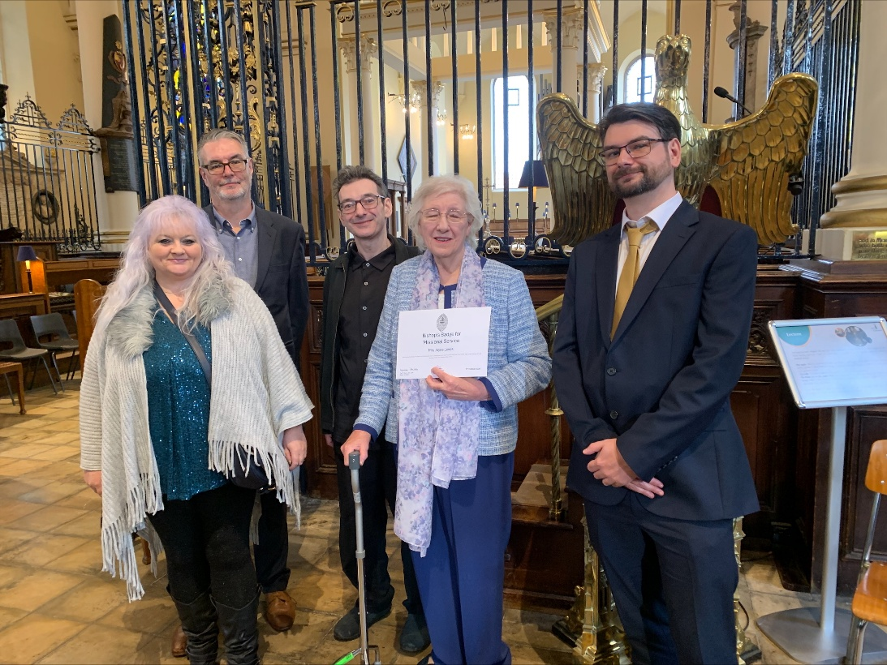

In our weekly prayers for our parish
This week we pray for God’s blessing on Poplar Way, Priory Close & Pudding Plate Lane.

New Testament Readings from the Lectionary

Monday 13th Mark 14: 1 to 11
Tuesday 14th Mark 14: 12 to 25
Wednesday 15th St Teresa of Avila Mark 14: 26 to 42
Thursday 16th Mark 14: 43 to 52
Friday 17th Ignatius of Antioch Mark 14: 53 to 65
Saturday 18th St Luke, the Evangelist Luke 1: 1 to 4

We are using the readings from the
Church of England’s Morning Prayer service.
All Saints Church
Refreshments After the Morning Service
Please stay seated after the service and a hot drink will be brought to you in the pews.
Church contact information
Contact: Rev’d Christine - revchristine@outlook.com
The Rectory, The Village, West Hallam, DE7 6GR
Landline 0115 646 1497
Rev’d Ailsa -revailsahunt@gmail.com
Tel - 07356064856

Churchwardens – Mrs Janet Wheeldon, -Tel: 0115 8771593
Mrs Linda Gregory – linda.gregory3@icloud.com
https://www.achurchnearyou.com/church/13402/
https://www.facebook.com/allsaintskirkhallam
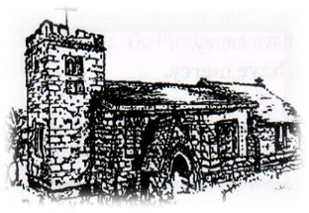
Kirk Hallam
Disabled Toilet in Friendship House.
Disabled Toilet in Friendship House.

Working with God to transform lives & communities.

12th October – Harvest Festival & 17th Sunday After Trinity
10.00am Iona Communion Service with Rev’d Alan
4.00pm Iona Evening Prayer with Julie & Rev’d Christine

Forthcoming Events
Tues 14th 6.00pm Home Group in Friendship House
Weds 15th 9.30am Morning Prayer at UCAS, Stanley Common
Thurs 16th 7.00pm PCC Meeting in Church
Fri 17th 6.00pm Choir Practice in Friendship House
Sat 18th 10.00am Prayer Meeting in Friendship House

19th October – Eighteenth Sunday After Trinity
10.00am Communion Service with Rev’d Christine & Rev’d Jan
3.00pm Building Faith (Lego Church) at Community Hall
4.00pm BCP Communion with Rev’d Christine
‘Do not be anxious about anything, but in every situation, by prayer and petition, with thanksgiving, present your requests to God’ Philippians 4: 6
Distribution of Communion –currently the Priest will dip the communion wafer in the wine while we discern a safe way to bring the common cup back into worship, as we want everyone to feel included and safe. We also have gluten free wafers available.
It’s Good to Talk! If you spot that someone is missing, please pop a news sheet through their door, & if you’ve time, call for a chat - just to check they’re OK & to let them know that they are not forgotten!

