NOTICES FOR 12th OCTOBER

REQUESTS

REFRESHMENTS for SUNDAY@7

Are you able to provide any refreshments for Sunday @7. If so please let Linda know or bring to Church on Sunday morning.

FACEBOOK
I am asking for items for the church Facebook please. ie photos of events or posters of events to be sent to me at my email address Ruth.townsend68@gmail.com or via the message option on the church Facebook page.
Please could posters not be in word. They fall apart into their separate bits when I try and post them. A photo of the poster is great.
Any photos of recent events gratefully received please, but please check you have sought permission for posting.
Many thankyous,
Ruth

THANK YOU’S

Thank you to all those who contributed towards the beautiful flowers for the Harvest thanksgiving and also to those who brought in all sorts of wonderful things for the children’s clay pictures. Anything left has either gone in for well dressing or to ladies in the Cabin in Belper who make amazing things using nature’s bounty - which is God’s bounty.
I’m sure we all appreciated such a wonderful weekend of joy in praising and thanking God for His generosity.
Sylvia

CHURCHYARD WORK MORNING

Churchyard work morning
Saturday 18th Oct
9.30-11.30am

We will be mowing, composting and managing our wildlife meadow near the bierhouse. Please join me with gloves and secateurs at the ready!

Sophy



Thanks for all your heartfelt responses to our Climate Sunday service. At the beginning of the service we each placed our pebble of responsibility for the climate crisis together to form a St Mary’s cairn. For me this was a great illustration of how by each playing a small part we can collectively make a big impact.
Our service then led us to agree on this commitment for St Mary’s:
Our church recognises and teaches that creation care and action to address the climate and nature crises are integral to Christian faith, life and worship. We are committed to respond to this by joining the A Rocha UK Eco Church award scheme.
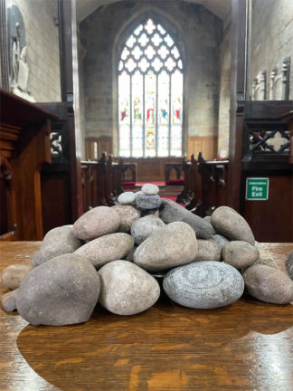

If you would like to know more about Eco Church visit: Eco Church - An A Rocha UK Project
And if you feel moved to join in with our participation of Eco Church or have any Eco ideas then please get in touch!
Sophy Barnes 07710409053/sophy.key@hotmail.com

Octobers tip for the month from the ECO Church website
Provide food and shelter for wildlife, now and in preparation for next year. Clean all your bird feeders to avoid the spread of disease to winter migrants and put up a nest box well in advance of breeding season. A nest box could also prove a cosy spot for small birds to spend the night on particularly cold winter evenings ahead

REQUEST
Do you have a Eco tip to share for next weeks notice sheet? If so please send to me at office@crichstmarys.org

