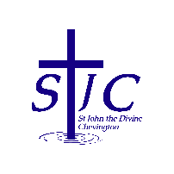
St John the Divine Welcome to our service today
Chevington 19th October 2025
Eighteenth Sunday after Trinity

Children’s morning – October 29th 10am-12:30pm  Cynthia and Sheila are planning another activity morning for children on the Wednesday of half term week.  The theme will be Saints and Light.  = . = . = . = . = . = . = . = . = . = . = . = . = . = . = . = . = . = . = . = . = . = . = . = . = . =  All Souls – Sunday November 2nd at 4pm  Our annual service to remember those who have died will be at 4pm on 2nd November. There are lists of names at the back of church – please check them so we can make sure your loved ones are included.  = . = . = . = . = . = . = . = . = . = . = . = . = . = . = . = . = . = . = . = . = . = . = . = . = . =  What’s on this week  Sunday 19th October  10am Eucharist with Ian  4pm Take Time – reflection and mediation at St Cuthbert’s  Thursday 23rd October  9:30am Coquet Churches together AGM, Holy Trinity Methodist church, Amble  Saturday 25th October  10am Coffee morning  Sunday 26th October  10am Service of the Word with Cynthia  = . = . = . = . = . = . = . = . = . = . = . = . = . = . = . = . = . = . = . = . = . = . = . = . = . =  Christmas Fair  Our Christmas Fair will be on Saturday November 22nd from 10am in the Community Centre.  Please spread the word to friends and neighbours.  Donations for raffle, tombola, bottles and white elephant can be brough to church at any time and left in the kitchen.  Thank you  = . = . = . = . = . = . = . = . = . = . = . = . = . = . = . = . = . = . = . = . = . = . = . = . = . =  Don’t be late next week!  Clocks go back one hour next Saturday night so don’t forget.   |  | This week, please pray for  We pray this week for all those who live in Acklington Road, Chibburn Avenue and Hadston Road and for the staff and customers of the Brick Club.  From the memorial book  = . = . = . = . = . = . = . = . = . = . = . = . = . = . = . = . = . = . = . = . = . = . = . = . = . =  Happy birthday!  To Lily Armstrong for today!  = . = . = . = . = . = . = . = . = . = . = . = . = . = . = . = . = . = . = . = . = . = . = . = . = . =  Church contacts  Priest in charge Revd Rachael Dines  revd.rachael.dines@gmail.com  01665 497631 / 07763 211901  Please note - Rachael’s rest day is Tuesday  Churchwardens  Anthony Reay – 07429 929537  Sheila Orgill (also Parish Safeguarding Officer) – 07484 825203  Reader Cynthia Bishop – 07498 182350  Website https://www.achurchnearyou.com/church/16282/  Facebook St John the Divine Chevington  Churchwardens St Cuthbert’s Amble  Richard Colson – 07724 687107  Linda Williams – 07720 716794  = . = . = . = . = . = . = . = . = . = . = . = . = . = . = . = . = . = . = . = . = . = . = . = . = . =  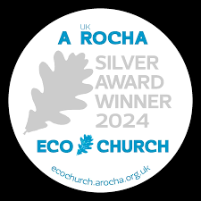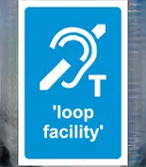
  Robert | Finnigan | 2017
  Connie | Luke | 2009
  George | Ross | 1951
  Alexander | Simpson | 1983
  Robert | Stewart | 2010

