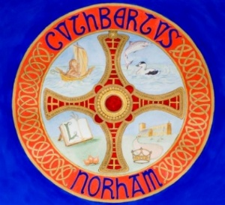 | The St Cuthbert’s Project  Bulletin No. 7  October 2025

The St Cuthbert’s Project aims to improve the heating, lighting, seating and heritage interpretation at Norham Church, in order to make the church building more user-friendly and more useful to the wider community. The project will also:

- Restore the pillars at the Bride’s Gate.
- Upgrade the path from the Bride’s Gate to the church.
- Develop visitor information and interpretation.
- Provide a range of events for both local people and visitors.

Our goal is to allow more people to access and enjoy St Cuthbert’s Church in all seasons. As an historic stone building, the church is never going to reach ‘toasty warm’ temperatures in the winter, but a new heating system should make it more comfortable.

Attracting visitors to Norham brings money into the local economy, which helps to maintain local facilities. We are also mindful of the need to manage visitor numbers, and by no means expect a huge increase. We envisage a handful of additional people (in perhaps two or three cars) arriving on an average day. Concerts and other events already attract additional visitors to Norham, and the St Cuthbert’s Project should allow concerts at the church to be spread more evenly throughout the year.

The story of Norham Church – together with Norham Castle, and the village as a whole – is inextricably linked to significant periods in our history, including the Golden Age of Northumbria and the Scottish Borders. Our rich heritage can sometimes be overwhelming, and so we plan to appoint an interpretation specialist to help us improve our visitor offer.

All are welcome to First Sunday Worship at 10am on Sunday 2nd November, which we hope will include the ceremonial ‘closing of the curtains’ by the St Cuthbert’s Junior Singers. (See Bulletin No. 6).

If you have any comments or questions, please contact:
- Churchwarden, Lucy Carroll, 07974 416692
- Churchwarden, Nick Ellis, (01289) 382754
- The Vicar, the Revd Rob Kelsey, (01289) 382325

