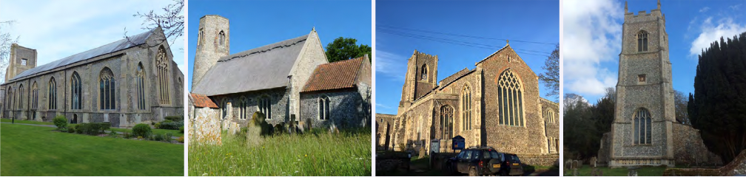

N.E.W.
North Walsham
Edingthorpe
Worstead and Westwick
NEWS
The Magazine for the North Walsham Benefice November 2025 40p
Transformed by Christ: Prayerful, Pastoral, Prophetic

Editor’s Bit

Contents in this issue:
- Vicar’s Page
- From the assistant curate
- Dates from the Diary
- November service Dates
- Upcoming Events
- Christmas services for 2025
We hope to see you at our services; you are all welcome.

Please note the date for items to go in the December/January edition of NEWS needs to be at the Parish office by November 20th latest.

It was announced in September that the Revd Canon Susanna Gunner has been appointed to a part time role in the Brooke and Hempnall Benefices with a probable start there in the New Year. We pray for Susanna and Ben, thank them for all they have given this community, and pray for the parishes that will be receiving Susanna as their new priest.

Anna, our Treasurer at St Nicholas is stepping down after many years of service. We thank her for all she has done to support PCC and our wider life. We begin the search for a successor - could it be you or someone you know? Contact David for information!

Financial Information

Please may we remind you, that if you are giving us a cheque for any of the Churches, they need to be made payable to the following:
St Nicholas’ Church – North Walsham PCC
All Saints’ – Edingthorpe PCC
St Mary’s – Worstead PCC
St Botolph’s – Diocesan Churches Trust
Please may we ask if you are sending any payments to us via an online service that you put a meaningful reference on the payment to ensure we know where the payment should go to.

Live-streamed services are available on YouTube - please search St Nicholas North Walsham. Do you participate in our live-streamed services - we would love to hear your feedback: contact David on 07506 723946 or davidnorthwalsham@gmail.com

If you are considering a change to your Committed Giving for St. Nicholas, please inform Chris Sherman (Committed Giving Officer)
Please support St. Nicholas Church, North Walsham on #easyfundraising, you can raise FREE donations when you shop online with over 5,000 retailers. It is simple and only takes 2 minutes to sign up! Plus, once you have raised your first £15, easy fundraising will match it!
Sign up now: https://www.easyfundraising.org.uk/causes/stnicholaschurchnw/

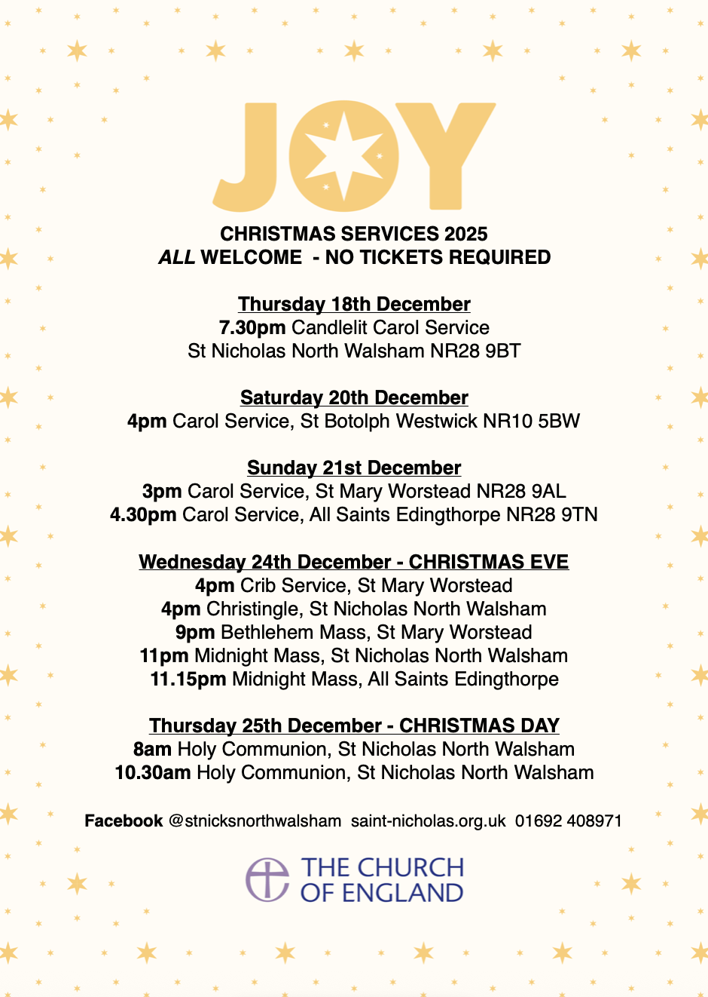
The Vicar’s page:
From David:
It’s probably an understatement to say that quite a lot has happened lately. Thank you to all those who sent good wishes on the birth of James. We are so grateful for the support and prayer we have received and look forward to these years of getting to know him and him getting to know you.

November is the month of remembrance both of our own departed and the departed of the nations. We come together to remember and to give thanks and to make real again the memory and it is good in this part of the world that our local council work with veterans’ organisations, youth organisations and others to make all of this possible. We are proud to play our part in this, offering worship and remembrance.

As we look back this month, we also look forward we give thanks for the ministry of Sue Ruffett at Edingthorpe and of Anna Bright at North Walsham, and we give thanks for all who continue to support our life. Please pray for those who will offer themselves as leaders in this community as we seek together to move forward, honouring the past and making what we can of God’s future.

Some of you will have heard following the announcement of the new Archbishop of Canterbury and more sombrely, that the House of Bishop’s recently met and has decided not to authorise same-sex blessings as standalone services. This will bring huge disappointment and pain to those who were awaiting this development. We here remain committed to a welcome for ALL people, and I encourage all affected by this change and development to contact me or Dan directly for pastoral and prayerful support.

November will be the final month in which Canon Susanna Gunner will minister actively in our Benefice. We pray for Susanna and for Ben as they prepare for new responsibilities. My continued thanks go to all our ministry team for all that they do to support our life here.

Please join me in praying for Bishop Sarah Mullally as she prepares for her new responsibilities as Primate of All England: she remains ‘first among equals’ on this tightrope of a job and we give thanks for her, and pray for her ministry and her witness and give hearty thanks for the fact that she is the first woman to take on this role, something many of us did not think we would see in our lifetime: praise God.

With my prayers and good wishes,

David

The Curate’s Page
Autumn is my favourite time of the year, and it’s stunning in Norfolk!
All these beautiful leaves, mysterious dark skies, lovely evenings under the blanket, with fire going, cup of tea in one hand and a good book in another.
No one warned me about the wind though!

There is one more reason why I love autumn so much: Remembrancetide.
It is this special time of the year to remember; first all the Saints, then our dearly departed loved ones and then those who died so that we may live, in many conflicts around the world, especially those who lost their lives during the World Wars.
It is important to remember, because when the memory is lost, the crack opens for all these terrible things to happen again.
It is importantly to remember, because there are still some people around us who lived through these dark times.
It is important to remember, because God remembers.

This is the time to come together, united in our memory, a kind of first step of coming together at Christmas. It is also important to come together at this time, when so many people in our country would rather separate themselves from the ‘other’, who would use the symbols of Christianity and our nation for their own distorted agenda.

So, I invite you all to enjoy the many colours of leaves, to enjoy countless cups of tea and to stand together, in silence, remembrance and neighbourly love for one another.

Dan



Edingthorpe Village news for November
For personal reasons, Sue Ruffett has stepped down as churchwarden at Edingthorpe with immediate effect. We give grateful thanks for all that Sue has given to the life of our church over many years and wish her every blessing.

Dates for your diary
Services
2nd November Patronal Choral Evensong 4 p.m.
9th November Holy Communion 10.55am.
23rd November Morning Prayer 9.15 a.m.

Our thanks go to Sue and her helpers who run a Coffee Morning on the 2nd Thursday of each month in St. Benet’s Hall. Do go along for a cup of coffee to support her.
On Thursday 11th December we will have our Christmas Coffee morning at St Benet’s Hall, North Walsham from 9am to 12 noon. There will be various stalls including cakes, bric-a-brac, tombola, crafts together with a Hamper Raffle. Further details will be in the next issue of the Village News but if anybody would like to help in any way please contact the number below.
All events about the Church are on https://www.achurchnearyou.com/church/10076/ or the village website www.edingthorpe.village.org.uk
June Hannant 01692 402337

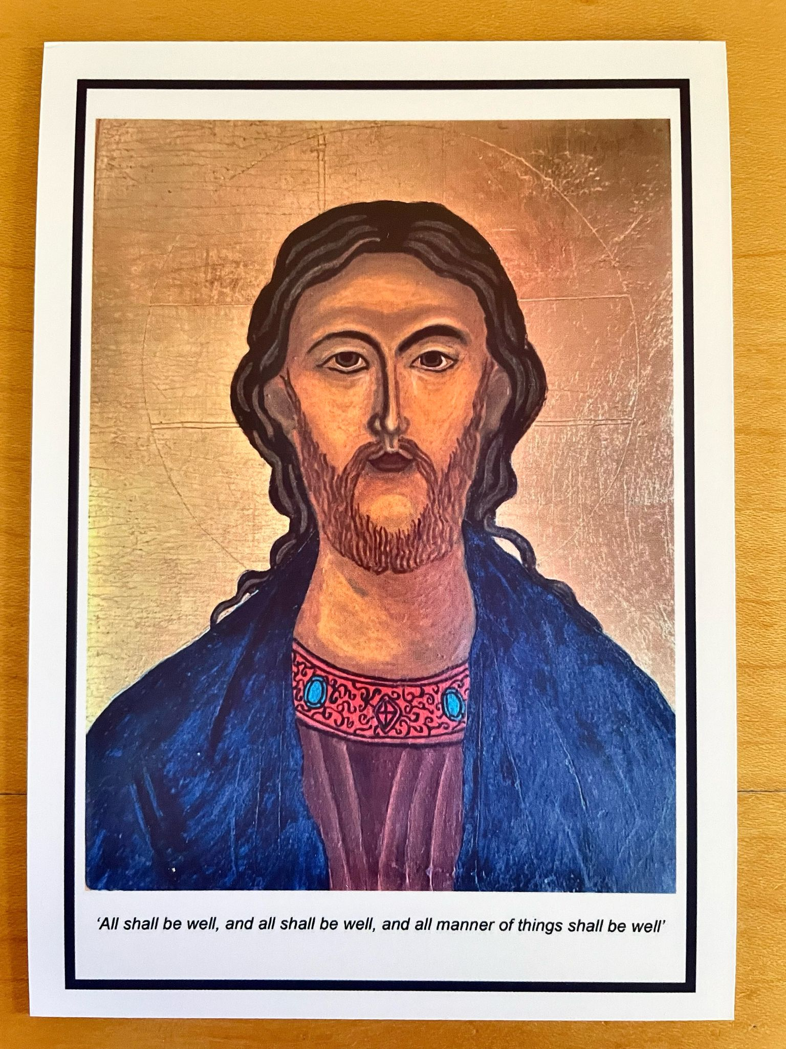
ST MARY’S WORSTEAD

Some important dates for your diary:

9th November - Remembrance Sunday service - 10.45 am
22nd November - “Made in Worstead” Craft Fair - 10am – 2pm
18th December - School Christingle Service - 2.15 pm
21st December - Carol Service - 3.00 pm
24th December - Crib Service - 4.00 pm
24th December - Midnight Mass (midnight in Bethlehem) - 9.00 pm

The clocks have gone back, the leaves are falling, and Winter approaches as ever.
Thanks to the generosity of the Festival, your Church is now well-lit, and reasonably warm as the temperature outside drops. Their further generosity has also enabled us to plan, at long last, for a much-needed new kitchen. It is scheduled to be fitted in mid January.
Our new, electronic, door entry system, on the Priest’s (small) Door is working well. Visitors are directed there by a superbly carved wooden notice and can enter the Church as usual. It is open every day between 9.00 am and 3.00 pm.
We’ve also turned our attention to the two Notice Boards which you see when entering from the Square. One has received a much-needed wash & clean. The other needs sanding down and re-painting/varnishing. Any volunteers?
November also directs our thoughts to remembering the ‘Fallen’ in two World Wars. To that end we will be having our usual Service of Remembrance on Sunday, 9th November at 10.45 am. Do join us if you can.
The annual “Made in Worstead” Craft Fair takes place, here at St Mary’s, on Saturday, 22nd November between 10.00 am and 2.00 pm. Lots to see and do and, of course, refreshments to keep you going. Not to be missed.
We look forward to welcoming you to your Church.

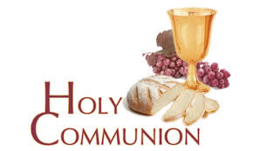
You may have read items in the press relating to the use of 'gluten free' wafers at Holy Communion - for those who require them, we use wafers which are approved and recommended for use by Coeliac UK - more information here. If you need a gluten free wafer, please advise the churchwardens/welcomers when you arrive for the service, and please indicate to the clergy distributing Holy Communion.
The Church teaches that receiving Holy Communion in both kinds (wafer and wine), or in one kind (the wafer or the wine) are acceptable and contain the fulness of the Sacrament. There are many reasons why this will be the case at different times in our lives, and there will be times when we cannot physically receive but join in an Act of Spiritual Communion (as those who watch online do - see below).

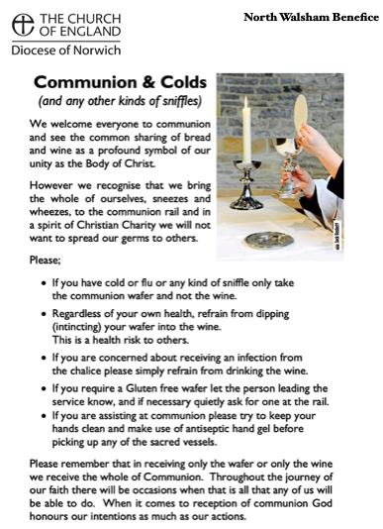
​Intinction (that is, dipping your wafer into the wine) is not permitted, both for hygiene reasons and because it might introduce gluten to the wine, which could be consumed by someone who is allergic to it.
If you wish to discuss any of this, please speak to David.

An Act of Spiritual Communion
In union, O Lord, with the faithful at every altar of your Church, where the Holy Eucharist is celebrated, I desire to offer you praise and thanksgiving. I present to you my soul and body with the earnest wish that I may always be united to you. And since I cannot now receive you sacramentally, I ask you to come spiritually into my heart.
I unite myself to you and embrace you with all the affections of my soul. Let nothing ever separate you from me. May I live and die in your love. Amen.



Why not come along to Sunday Kids and find out how to learn about what we do? We meet on the 1st and 3rd Sunday of the month at St Nicholas Church during the 10.30am service. You are most welcome.

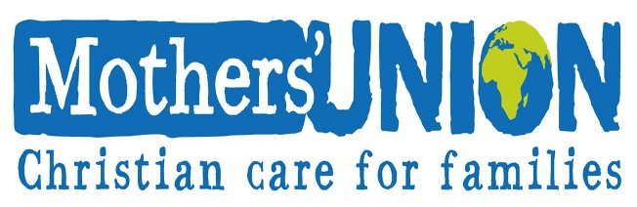

North Walsham Mothers’ Union. We meet in St Nicholas Room on the second Tuesday of the month at 2.00 p.m. Following a short act of worship and a few notices our speaker then takes the floor, after which, over tea and biscuits, there is an opportunity to ask questions and socialise. We usually finish about 3.30 pm.

Services for November

Sunday 2nd November - All Saints
8am Holy Communion (1662) at North Walsham
9.15am Morning Prayer at Worstead
10.30am Holy Communion at North Walsham welcoming as our preacher Fr Ben Eadon CMP, Priest Administrator of the Shrine of Our Lady of Walsingham
4pm Patronal Choral Evensong at Edingthorpe followed by refreshments
Monday 3rd November
9am Morning Prayer at North Walsham
Tuesday 4th November
9am Morning Prayer at North Walsham
Wednesday 5th November
9am Morning Prayer at North Walsham
10am Worstead Wednesday coffee morning at the Village Hall
3.15pm Worstead PCC
7pm Edingthorpe PCC
Thursday 6th November
9am Morning Prayer at North Walsham
9.30am Market Day coffee morning in the St Nicholas Room
10.30am Holy Communion at North Walsham
Friday 7th November
9am Morning Prayer at North Walsham
9.30am Quiet Prayer at North Walsham
Sunday 9th November - Remembrance Sunday
8am Holy Communion (1662) at North Walsham
10.45am Remembrance Morning Prayer at Worstead
10.55am Remembrance Holy Communion at Edingthorpe
10.55am Remembrance Holy Communion at North Walsham
2.15pm Civic Remembrance Parade in the Memorial Park, North Walsham
3pm Civic Remembrance Service at North Walsham
Monday 10th November
9am Morning Prayer at North Walsham
10am Knitting group at North Walsham
Tuesday 11th November - Armistice Day
9am Morning Prayer at North Walsham
10.55am Act of Remembrance in the Market Place, North Walsham
10.55am Act of Remembrance at North Walsham Hospital
2pm Mothers' Union meet in St Nicholas Room
Wednesday 12th November
9am Morning Prayer at North Walsham
10am Worstead Wednesday coffee morning at the Village Hall
7.30pm North Walsham PCC
Thursday 13th November
9am Morning Prayer at North Walsham
9.30am Market Day coffee morning in the St Nicholas Room
10.30am Holy Communion at North Walsham
Friday 14th November
9am Morning Prayer at North Walsham
9.30am Quiet Prayer at North Walsham
Sunday 16th November - 2nd before Advent
8am Holy Communion (1662) at North Walsham
9.15am Holy Communion at Worstead
10.30am Holy Communion at North Walsham
5pm Evening Prayer at North Walsham
Monday 17th November
9am Morning Prayer at North Walsham
Tuesday 18th November
9am Morning Prayer at North Walsham
Wednesday 19th November
9am Morning Prayer at North Walsham
10am Worstead Wednesday coffee morning at the Village Hall
Thursday 20th November
9am Morning Prayer at North Walsham
9.30am Market Day coffee morning in the St Nicholas Room
10.30am Holy Communion at North Walsham
Friday 21st November
9am Morning Prayer at North Walsham
9.30am Quiet Prayer at North Walsham
Saturday 22nd November
7 p.m. Camerata Christmas concert: Messiah Pt 1 at North Walsham
Sunday 23rd November - Christ the King
8am Holy Communion (1662) at North Walsham
9.15am Morning Prayer at Edingthorpe
10.30am Holy Communion at North Walsham
5pm Choral Evensong at North Walsham
Monday 24th November
9am Morning Prayer at North Walsham
10am Knitting group at North Walsham
Tuesday 25th November
9am Morning Prayer at North Walsham
Wednesday 26th November
9am Morning Prayer at North Walsham
10am Worstead Wednesday coffee morning at the Village Hall
Thursday 27th November
9am Morning Prayer at North Walsham
9.30am Market Day coffee morning in the St Nicholas Room
10.30am Holy Communion at North Walsham
Friday 28th November
9am Morning Prayer at North Walsham
9.30am Quiet Prayer at North Walsham
Saturday 29th November
Christmas Lights Switch on in North Walsham
Sunday 30th November - Advent Sunday
8am Holy Communion (1662) at North Walsham
10.30am Holy Communion at North Walsham
5pm Advent Carol Service at North Walsham
Monday 1st December
9am Morning Prayer at North Walsham
Tuesday 2nd December
9am Morning Prayer at North Walsham
Wednesday 3rd December
9am Morning Prayer at North Walsham
10am Worstead Wednesday coffee morning at the Village Hall
7pm Murrell Cork Christmas Memorial Service at North Walsham
Thursday 4th December
9am Morning Prayer at North Walsham
9.30am Market Day coffee morning in the St Nicholas Room
10.30am Holy Communion at North Walsham
Friday 5th December
9am Morning Prayer at North Walsham
9.30am Quiet Prayer at North Walsham
Sunday 7th December - St Nicholas
8am Holy Communion (1662) at North Walsham
10.30am Patronal Holy Communion at North Walsham
5pm Choral Evensong at North Walsham
Monday 8th December
9am Morning Prayer at North Walsham
10am Knittng group at North Walsham
Tuesday 9th December
9am Morning Prayer at North Walsham
Wednesday 10th December
9am Morning Prayer at North Walsham
10am Worstead Wednesday coffee morning at the Village Hall

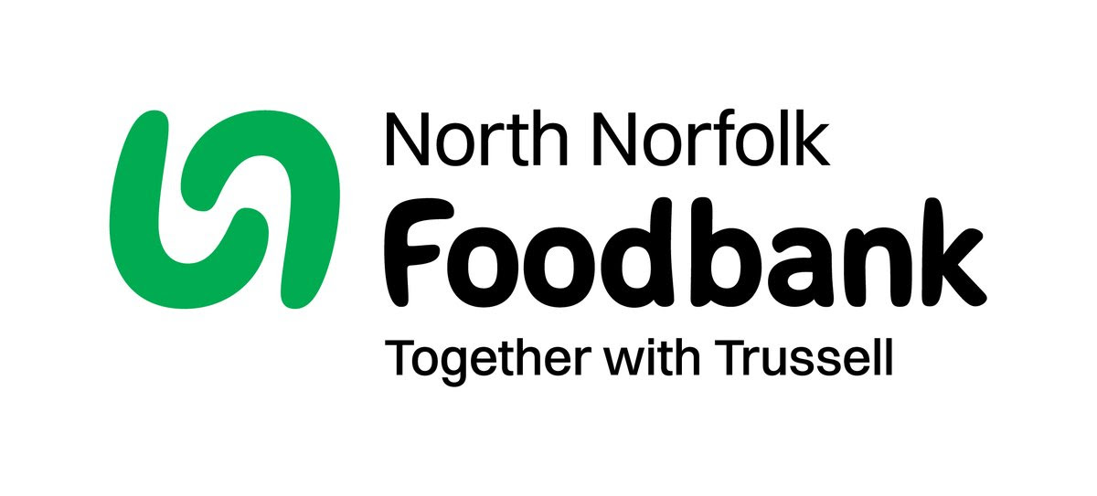Dear Foodbank supporter,
Thank you for your donation from North Walsham C of E St Nicholas last month of 23.45 kg.
As a small charity we rely on food and financial donations to operate, and we are extremely grateful when people choose to support us.
During the 24/25 year we gave out 2012 food parcels, providing food for 4,520 people; 2,843 adults and 1,677 children.
Whilst Trussell campaigns to end the need for foodbanks, we will be here helping those who need us right now. But that can only be done with kind donations from our supporters.
To see what we need most right now, our wish list is published on our website and social media, and the list gets updated throughout the month on our donation page https://northnorfolk.foodbank.org.uk/give-help/donate-food/
Thank you for thinking of us and enabling us to serve the people facing hardship across our district.
Kind regards
Julie and the Foodbank team
North Norfolk Foodbank
Cromer Methodist Church Hall, West Street, Cromer, NR27 9DT
07826 376343

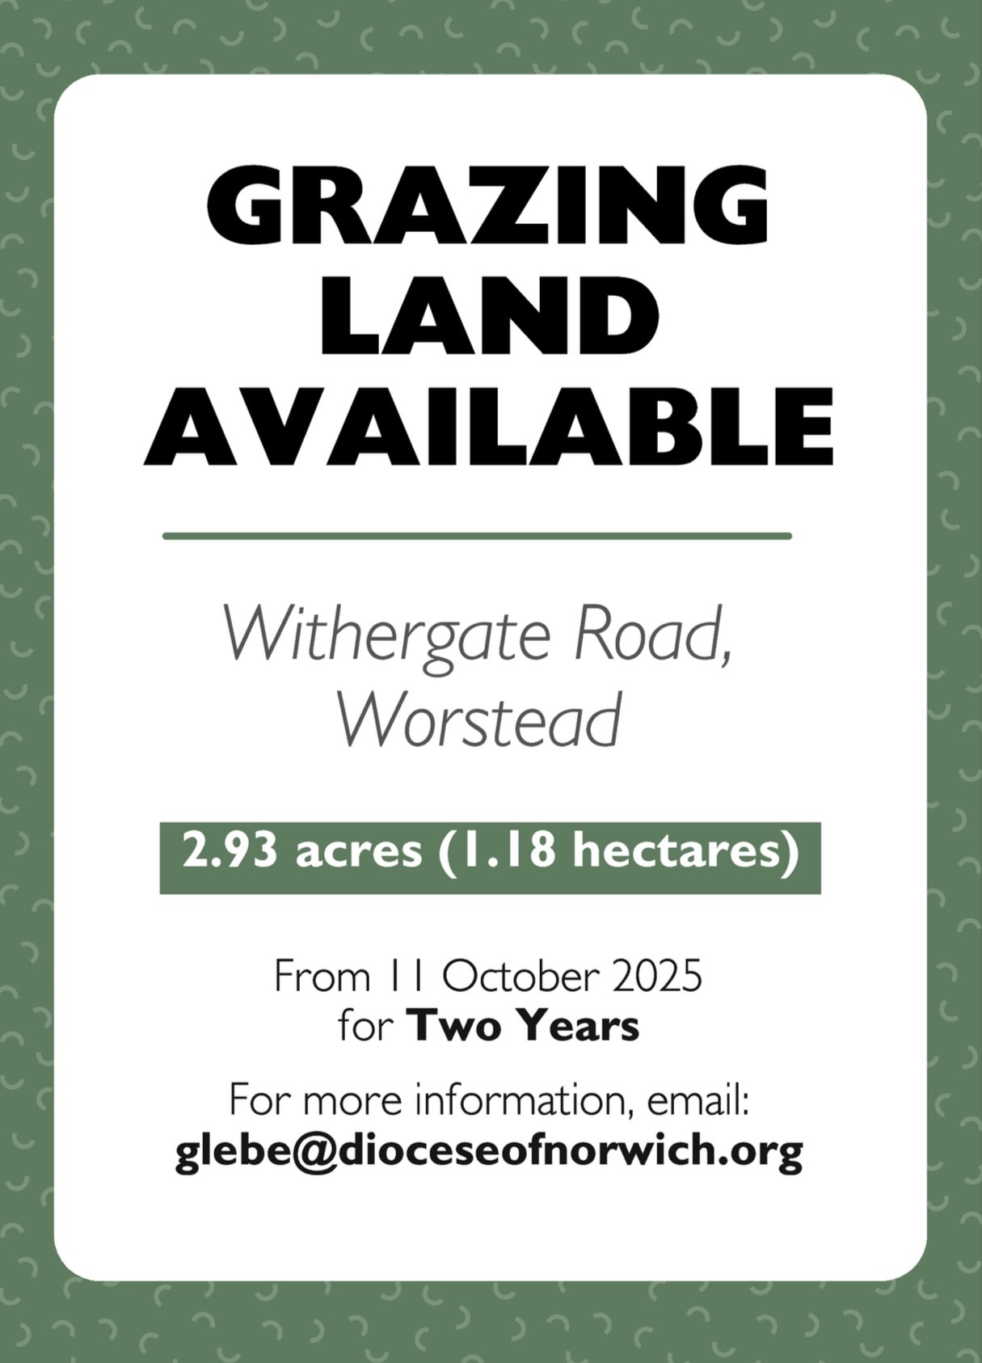

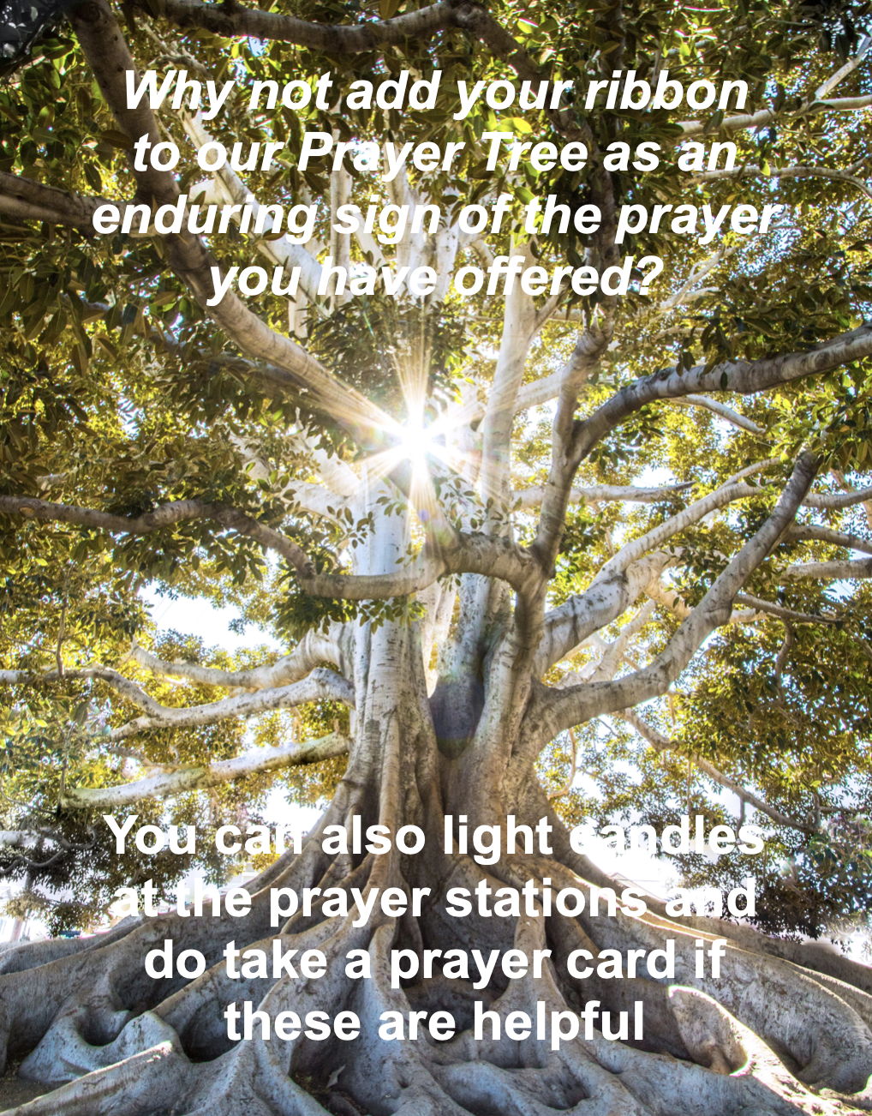

We are privileged to hold special
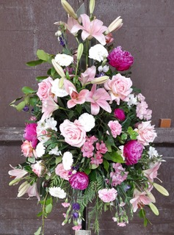
services at any of our churches
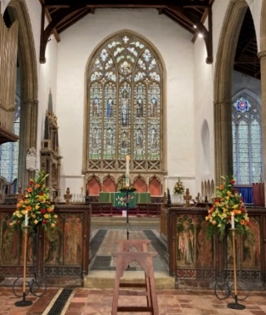
All who live in the benefice are entitled to a baptism, wedding or funeral service in church, and our clergy can officiate at the crematorium and cemeteries too. The church is here for you, through every moment of life.

************************************************************************************


Dates from the Diary

Baptisms

19th Ronnie Cardy - St Nicholas

Funeral

28th Ena Howard - St Nicholas

Weddings

18th Samantha Jane Elderton and Clint George Scott - St Nicholas

Please hold those above and their families in your prayers.

*************************************************************************************
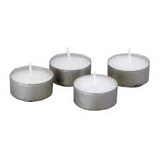
Thanks to all who’ve provided tealights for prayer stations at St Nicholas!
All donations of white, unscented tealights gratefully received!





We're pleased that our weekly coffee mornings at North Walsham and Worstead are now registered with Warm Welcome Spaces
North Walsham Market Day Coffee Morning
Thursdays 9.30 – 12.00noon
The space is open to all (and their well-behaved dogs on leads), every Thursday! A warm welcome and refreshments available

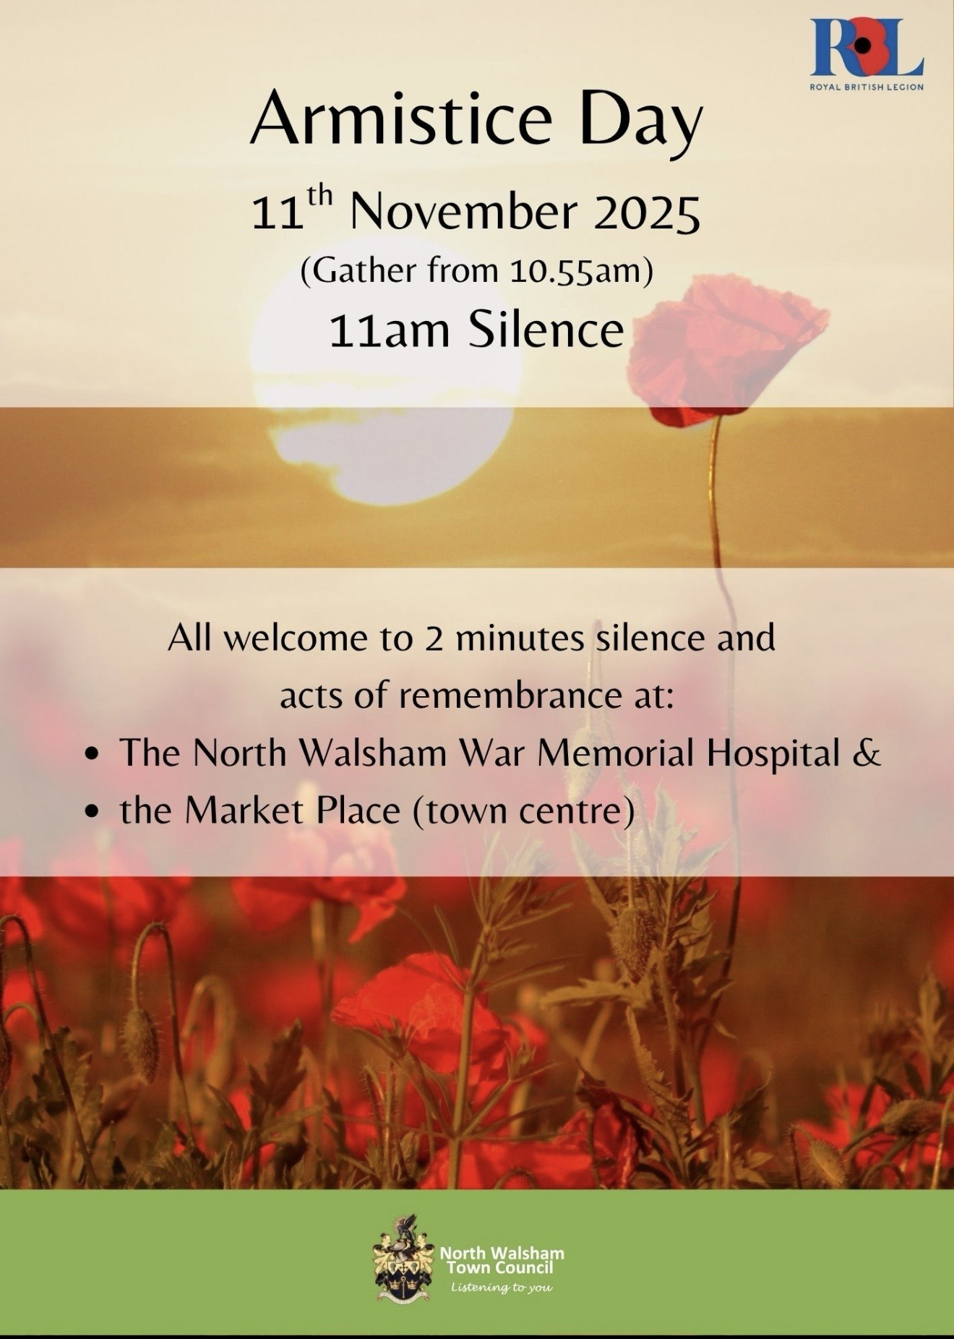

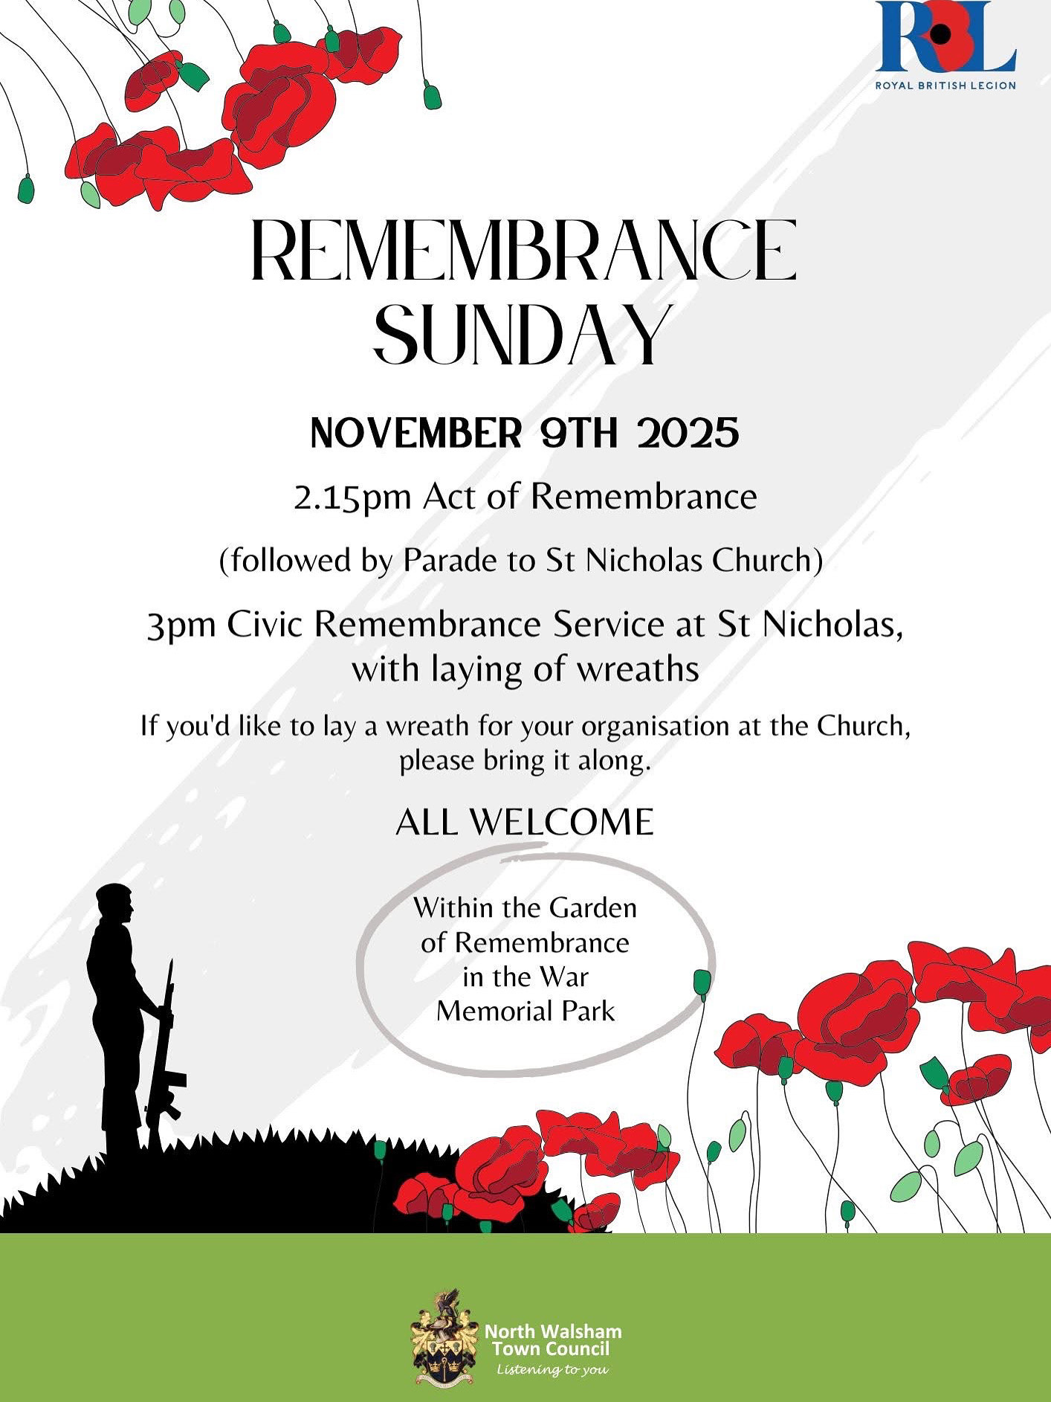

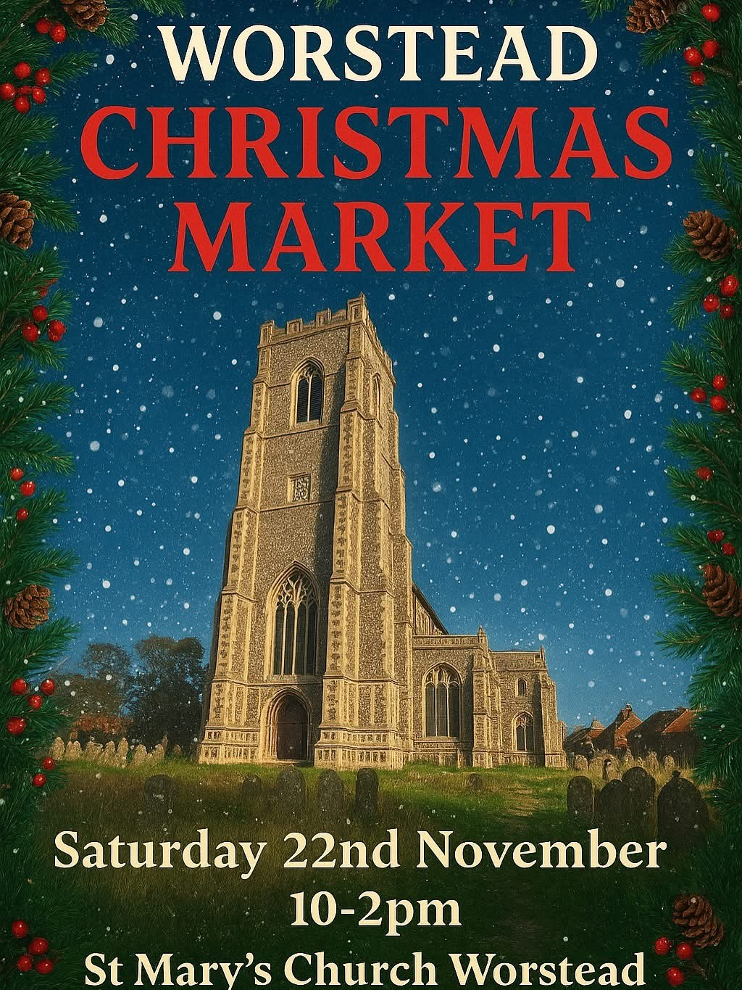

Thank you to everyone for raising donations for St. Nicholas Church, North Walsham with #easyfundraising! If you have not signed up yet, it is easy and completely FREE. 8,100 brands will donate to us when you use easy fundraising to do your everyday online shopping - at no extra cost to you! Every donation you raise makes a difference to us so please sign up & share today. https://join.easyfundraising.org.uk/stnicholaschurchnw/XT7MPH/at/TSX8RX7z/RTND2/facebook/
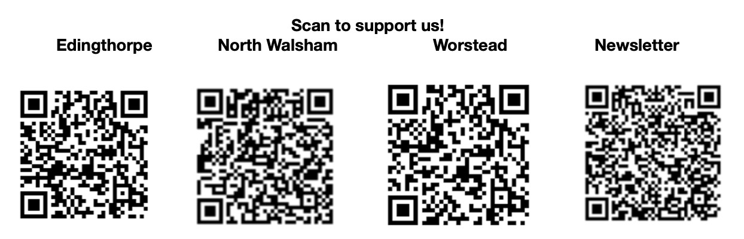


Please support the work of our Churches, by using the contactless giving point at St Nicholas or St Mary’s, leaving your gift on the offering plates or in the wall safes, or through these QR codes. Thank you.

Do you have a Business you would like to advertise in this magazine?
Whole, half or quarter page space is available.
Full Page £ 150.00
Half Page £ 75.00
Quarter Page £ 50.00
Please contact the Benefice office on 01692 408971
or email saintnicholasnw@gmail.com
for details and prices

Church Postcodes
Edingthorpe NR28 9TN, North Walsham NR28 9BT, Worstead NR28 9AL, Westwick NR10 5BW

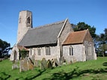
Benefice dates

All Saints’ Edingthorpe
2nd November 4 p.m. Choral Evensong for the Patronal Festival
9th November 10.55 Holy Communion
23rd November 9:15 Morning Prayer

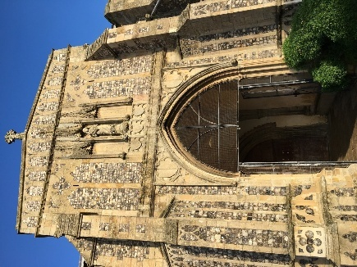
St. Mary’s, Worstead
2nd November 9:15 Morning Prayer

9th November 10.45 Remembrance Service

16th November 9:15 Holy Communion

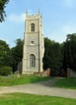
St Botolph’s Westwick

No service in November

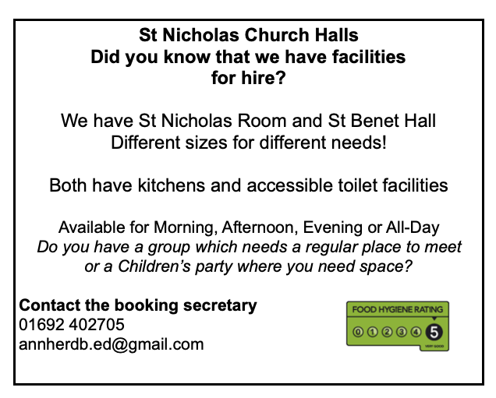

Ready to tick off your list – Will Made?
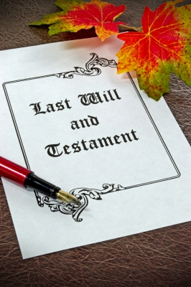
"The Church of England have teamed up with Farewills to provide a free will writing service: Online Will Writing Service | Legal Will In 15 Minutes . Anyone can use this service and it is not compulsory to leave something to your church, but it would be nice if you did. It is important for each one of us to leave our earthly matters in good order so why not take advantage of this opportunity now? It is good to remember a gift in your will to a charity is tax free. If you already have a will, you could consider leaving a legacy to the church by adding a codicil. https://farewill.com/norwich-diocese

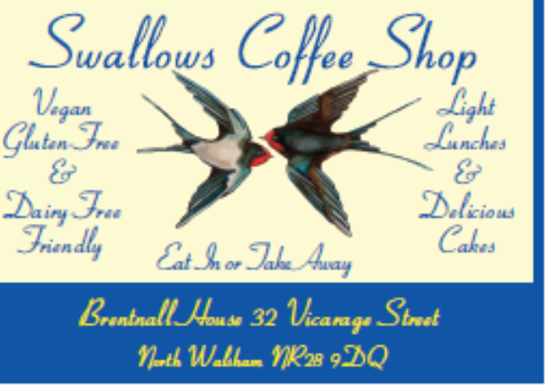

Edingthorpe Village news for November
All Saints Church, Edingthorpe
Services
2nd November. 4pm. All Saints Patronal Choral Evensong.
9^{h} November. 10.55am. Remembrance Service (Note time) Holy Communion
23rd November. 9.30 am. Morning Prayer
The Church looked lovely for the Harvest Floral, Photographic and Produce Display. There were several old tractors on display. Many from the Vintage Tractor Club. It was lovely to see so many people in the church for the Harvest Thanksgiving service. A representative from the Charity YANA (You are not alone) gave an interesting talk explaining about the Charity which was founded to help people in the agricultural industry. Thanks must go to Margaret and all her team for the wonderful display of floral arrangements. Thanks also to all who brought their tractors for display and those who helped with the refreshments and cakes. It was a long day but was great to see so many people coming to make it such an enjoyable day.
On 2nd November there is All Saints Patronal Choral Evensong at 4pm. We will be joined by the Choir from St. Nicholas Church for this service. Do join us!
Our Christmas Coffee Morning is being held on Thursday 11th December in St Benet’s Hall, North Walsham from 9.00am to 12 noon. There will be many stalls including cakes and preserves, bric a brac, tombola, Christmas raffle and many more. Tea, coffee and mince pies will be served. Please come along and join us. All proceeds to the Church.
Looking further ahead our Carol Service will be on 21st December at 4pm. We are having a Midnight Mass Service at 11.15pm on Christmas Eve. All welcome. This was very popular last year.
All events about the Church are on https://www.achurchnearyou.com/church/10076/ or the village website www.edingthorpe.village.org.uk

June Hannant 01692 402337

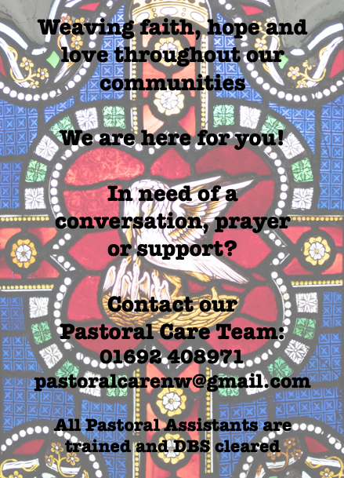

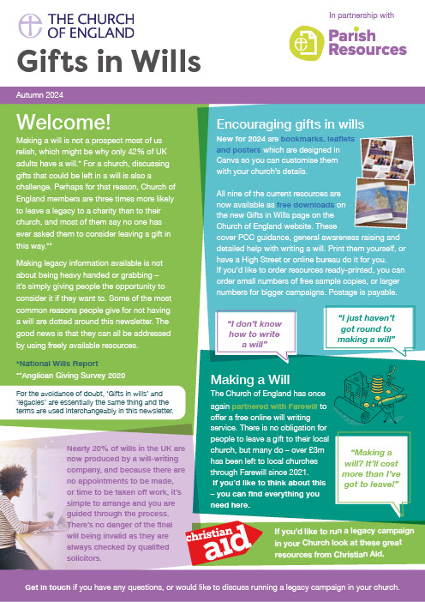
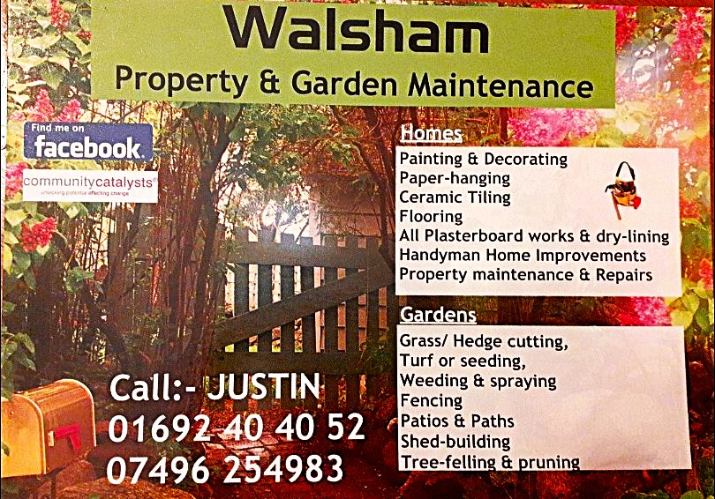

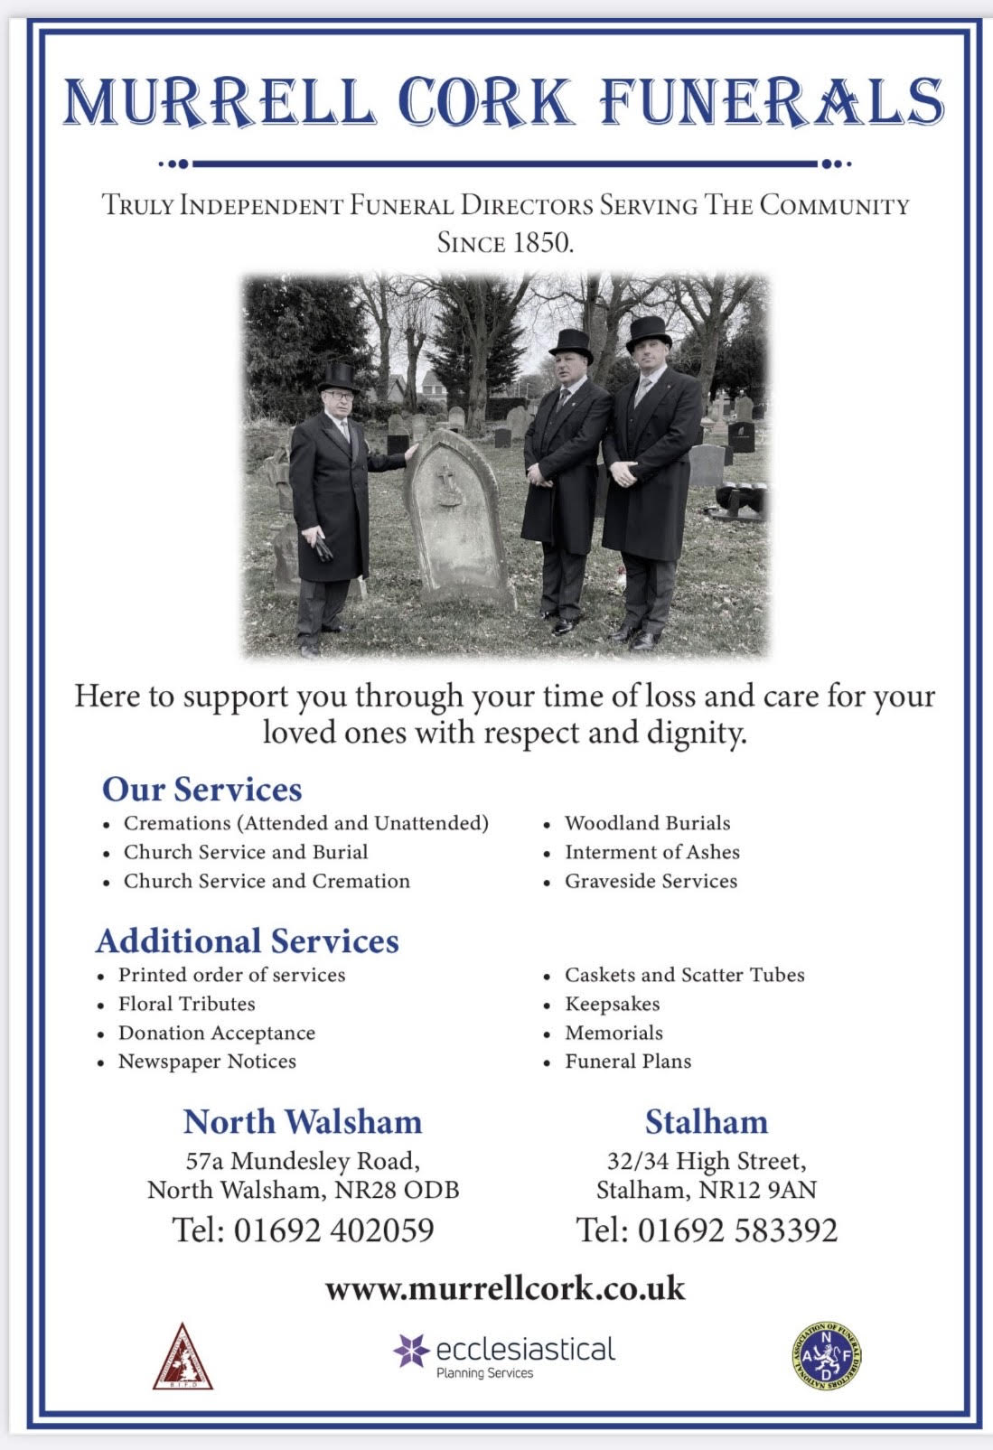
r Sale and Wants Page




Money Matters …
A regular report for our readers written by James Reginald Drake at ClearView Financial Consultants
Burgh Road, Aylsham - 01263 734859, Station Road, Hoveton - 01603 273590 and North Walsham 07773 626662

Lasting Powers of Attorney – Why are they so Important?
Lasting Powers of Attorney (LPA’s) are documents that give an individual you trust (your attorney) the legal authority to make decisions on your behalf should you either lose the mental capacity to make them, or you no longer wish to make these decisions yourself. Lasting Powers of Attorney come in 2 forms, these coming under the heading of ‘Property & Financial Affairs’ and ‘Health & Welfare’
So, how can they help?
The Property & Financial Affairs LPA covers things such as running your bank and savings accounts, making or selling investments, paying bills, buying or selling property and applying for benefits.
The Health & Welfare LPA covers things such as the type of health care and medical treatment you receive (including decisions on life sustaining treatment), where you live, as well as the type of care that you receive in areas such as diet and daily routine.
Given the wide range of areas that these documents cover, it becomes quite obvious as to why they are so important. However, according to ‘The Office of the Public Guardian’ via an article produced in 2022, less than 1% of the UK population have a Lasting Powers of Attorney in place.
So, why do so few people have them in place? One of the most commonly mentioned reasons is that people assume that their spouse will automatically have the right to make decisions for them should they ever reach the stage where they are unable to. This however is a common misconception and it is very often discovered far too late that they actually have no legal authority at all. Cost is another reason people put it off, I can assure you are costs for this type of work are minimal, in the hope this is not a reason to delay.
What should you do?
Well, the answer to this one is quite simple……. get on and set up both types of LPA as soon as you can. It is never too soon to set one up, but it certainly can be too late. By law, once your mental capacity has gone, so has your opportunity to appoint attorneys to act on your behalf. At this point your loved ones will be required to go down a different route and apply to the Court of Protection for a Deputyship order. This requires more forms, more cost and more time, which can all be easily avoided with a bit of forward planning.
So, if setting up Lasting Powers of Attorney(s) is something that you think would benefit you and your loved ones, please feel free to contact me and we can discuss how they can be put in place in a way that is best suited to your own personal requirements.
This short article in no way should be taken by readers as advice.
James can be contacted on either of the above landline numbers or via email at support@smithifa.co.uk
ClearView Financial Consultants is a trading name of Martin Smith Independent Financial Adviser Ltd, a company registered in England
under number 11439150 and authorised and regulated by the Financial Conduct Authority under number 944677.


