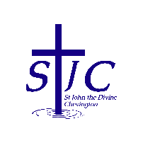
St John the Divine Welcome to our service today
Chevington 14th September 2025
Thirteenth Sunday after Trinity

September 14th – Holy Cross Day  On Holy Cross Day the Church celebrates the Cross as a symbol of triumph, as the sign of Christ’s victory over death. Holy Cross Day goes right back to 14 September 335, and we have the mother of a Roman Emperor to thank for it.  Helena was a devout Christian, and after her son, Constantine, was converted, they agreed that she should travel from Rome to Israel and seek out the places of special significance to Christians.  Of course, much of Jerusalem had been destroyed by the Romans around 135 AD. But even so, Helena finally located what she believed to be the sites of the Crucifixion and of the Burial (and modern archaeologists think she may well be correct). The sites were so close together that she built one large church over them – the Church of the Holy Sepulchre.  That church, built in honour of the Cross, was dedicated on 14 September 335.  = . = . = . = . = . = . = . = . = . = . = . = . = . = . = . = . = . = . = . = . = . = . = . = . = . =  Harvest Festival  Our Harvest Festival will be on Sunday 28th September and we will be having lunch together after the service. Please put your name on the list if you’d like to stay for lunch and remember that you are welcome to bring family members and friends along. Cost will be £6, please give money to Sheila.  For Harvest please bring gifts of non-perishable food items which will be donated to our local food bank.  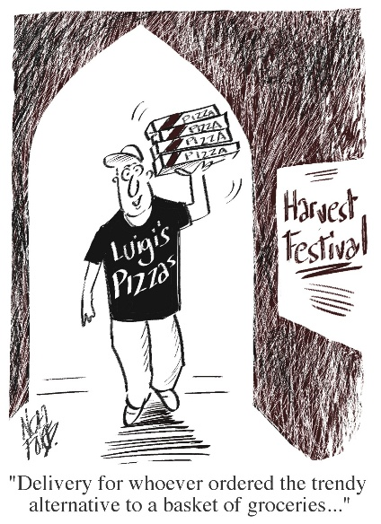 |  | This week, please pray for  We pray this week for all those who live in live in Coquet Square, Queen Street and Willow Close and for the staff, children and families of Red Row school.  From the memorial book  Margaret Black 2007  James Robert Elder 1918  John Ivor Grey 1916  Frank Hedley 1916  Denise Kathryn Howard 2012  Arthur Johnson 1916  Stanley Chapman Knox 2019  Ernest Logan 1916  Elsie Lowden Luntley 1997  William Lyall 1915  Robert Tait 1916  = . = . = . = . = . = . = . = . = . = . = . = . = . = . = . = . = . = . = . = . = . = . = . = . = . =  What’s on this week  Sunday September 14th  10am Service of the Word with Cynthia  Thursday September 18th  2pm Third Thursday  Sunday September 21st  10am Euchariust with Rachael  = . = . = . = . = . = . = . = . = . = . = . = . = . = . = . = . = . = . = . = . = . = . = . = . = . =  Church contacts  Priest in charge Revd Rachael Dines  revd.rachael.dines@gmail.com  01665 497631 / 07763 211901  Please note - Rachael’s rest day is Tuesday  Churchwardens  Anthony Reay – 07429 929537  Sheila Orgill (also Parish Safeguarding Officer) – 07484 825203  Reader Cynthia Bishop – 07498 182350  Website https://www.achurchnearyou.com/church/16282/  Facebook St John the Divine Chevington  Churchwardens St Cuthbert’s Amble  Richard Colson – 07724 687107  Linda Williams – 07720 716794

