**The Parish Church**

**of St Andrew, Stratton**

**Priest in Charge**

The Revd Teresa Folland

Tel: 01288 352599

e-mail: [teresa.folland@gmail.com](mailto:teresa.folland@gmail.com)

**Churchwarden**

Mrs Diana Ohlson

Tel: 01288 354441

e-mail: [dohlson24@gmail.com](mailto:dohlson24@gmail.com)

**SEPTEMBER and OCTOBER 2025**

Creationtide Prayer

Living Lord, you call us to be good stewards of this earthly home, strengthen us to care for your creation.

Forgive us when, through our greed and indifference, we abuse its beauty and damage its potential.

Empower us, through your Spirit to so nurture and love the world,

that all of creation sings your glory.

Amen

**Services at St Andrew’s September 2025**

**3rd Sept Christian Meditation** 9.30am

**Midweek Mass** Wed. 10.30am – Officiant: Rev Teresa **7th Sept**  **12th Sunday of Trinity**   
Readings:*Deuteronomy 30:15-end; Psalm 1; Philemon 1-21; Luke 14:25-33.*  **Morning Worship** 9.30am – LWLs Val H & Judy D

**Evensong** 6pm. Officiant: Rev Teresa Folland

Cantor: Dafydd Thomas

Psalm: 121:1-8

Readings: Isaiah 43:14 - 44:5 John 5:30-end Reader: Vee Ellis

**10th Sept Christian Meditation** 9.30am

**Midweek Mass** Wed.10.30am - Officiant: Rev Doug Adams

**14th Sept 13th Sunday of Trinity**Readings: *Number 21:4-9; Psalm 22:23-28; Philippians 2:6-11; John 3:13-17.* **Parish Mass** 9.30am – Officiant: Rev Doug Adams

**17th Sept Christian Meditation** 9.30am

**Midweek Mass** Wed.10.30am – Officiant: Rev Richard WS

**21st Sept 14th Sunday of Trinity**   
Readings: *Proverbs 3:13-18; Psalm 119:65-72; 2 Corinthians 4:1-6; Matthew 9:9-13.*

**Morning Worship** 9.30am LWLs Judy Dunne & Val H

**24th Sept Christian Meditation** 9.30am

**Midweek Mass** Wed.10.30am - Officiant: Rev Jane Bradbury

**28th Sept 15th Sunday of Trinity**

Readings: *Amos 6:1a, 4-7; Psalm 146; 1 Timothy 6:6-19; Luke 16:19-end*

**Parish Mass** 9.30am – Officiant: Rev Jane Bradbury

**Services at St Andrew’s October 2025**

**1st Oct Christian Meditation** 9.30am

**Midweek Mass** Wed. 10.30am – Officiant: Rev Teresa

**5th Oct 16th Sunday of Trinity**

Readings: *Habbakuk 1:1-4, 2:1-4; Ps 37:1-9; 2 Timothy 1:1-14; Luke 17:5-10*  
 **Morning Worship** 9.30am - LWLs Val H & Judy Dunne

**Evensong** 6pm – Officiant: LWL Sheila Waring

Cantor: David Goodwin

Psalm: 142:1-9

Readings: Nehemiah 5:1-13 John 9 Reader: Simon Waring

**8th Oct Christian Meditation** 9.30am

**Midweek Mass** Wed. 10.30am – Officiant: Rev Doug Adams

**12th Oct Sunday of Trinity HARVEST THANKSGIVING**Readings: *2 Kings 5:1-3, 7-15c; Ps 111; 2 Timothy 2:8-15; Luke 17:11-19.* **Parish Mass** 9.30am – Officiant: Rev Teresa Folland

**15th Oct Christian Meditation** 9.30am

**Midweek Mass** Wed.10.30am – Officiant: Rev Richard WS

**19th Oct 18th Sunday Trinity**   
Readings: *Genesis 32:22-31; Psalm 121; 2 Timothy 3:14-4:5; Luke 18:1-8.*

**Morning Worship** 9.30am - LWLs Val H & Judy Dunne

**22nd Oct Christian Meditation** 9.30am

**Midweek Mass** Wed. 10.30am – Officiant: Rev Jane

**26th Oct 19th Sunday after Trinity**Readings: *Ecclesiasticus 35:12-17;* ***OR*** *Jeremiah 14:7-10, 19-end; Psalm 84:1-7; 2 Timothy 4:6-8, 16-18; Luke 18:9-14*  **Parish Mass** 9.30am – Officiant: Rev Richard WS

**29th Oct Christian Meditation** 9.30am

**Midweek Mass** Wed. 10.30am - Officiant: Rev Teresa

**Please be aware that the names of the Readers and Intercessors will no longer be included in the Services lists. It has been agreed that we would omit these as there are so many changes occurring that the list becomes out of date almost before the printing process is completed.**

**If you feel strongly about this either way (for or against) please do let us know your thoughts.**

~~~~~~~~~~~~~~~~~~~~~~~~~~~~~~~~~~~~~~~~~~~~~~~~~~~~~~~~~~~~~~~~~~~

**Supper Parties**

Anne Day has very generously offered to undertake a series of themed dinner parties, in aid of FoStA. They will be hosted by her and her husband Geoff, at Crossways, New Road, Stratton. Tickets will be on sale at £25 a head and if alcohol is required you are asked to bring your own bottle of wine please. Time 6 for 6.30pm. Tickets will be available from Val Barker and there will be 14 in total for each party other than in December when there will be changes. Admission will be strictly by pre-paid ticket only.

**FROM THE PARISH REGISTERS 2025**

**Wedding**

5th July 2025 Kaylie Anne Wright to Dominic Jesse Owen

**Burial of Ashes**

12th July 2025 Wendy Lynn Seymour

**Funeral**

Thanksgiving Service for the Life of Grenville Ivor Martin

25th July 2025 followed by interment in the churchyard.

6th August 2025 Funeral Service for Russell John Hopgood

followed by interment in the churchyard.

~~~~~~~~~~~~~~~~~~~~~~~~~~~~~~~~~~~~~~~~~~~~~~~~~~~~~~~~~~~

**Dates for your Diary**

**Thurs 4th Sept –** PastoralCare meeting 10am at 6 Drovers Way

**Tues 9th Sept –** 2pm PCC Meeting

**Sat 20th Sept** – Supper Party at Crossways Greek Cuisine (by ticket only)

**Fri 26th Sept –** Hot Lunch in the Church. A celebration of pasties!

**Sat 11th Oct –** Harvest Supper in the Community Hall

**Thurs 16th Oct –** FoStA Committee Meeting at Stamford House

**Sat 25th Oct –** Supper Party at Crossways French Cuisine (by ticket only)

**Fri 31st Oct –** Hot lunch in the Church All Hallows Eve

**Fri 28th Nov –** Hot Lunch in the Church St Andrew’s Patronal Weekend

**Sat 20th Dec –** Supper Party at Crossways Carols and Canapés

**Thurs 1st Jan 2026** – New Year’s Day Lunch in church

**Sat 24th Jan –** Burns Night Supper at Crossways

**YOU’RE INVITED TO ALPHA. For the open-minded, still thinking, curious.**

Starts Tuesday 2nd September 2025 at St Andrew’s Church, Stratton**.**  Time: 6pm - A meal will be served before the start of each Alpha session.

Contact: Dan and Cherry Archer**.**  [danandcherryarcher@gmail.com](mailto:danandcherryarcher@gmail.com) or 07851943707

**Concert for a Summer Afternoon**

In June we were very pleased to welcome Hartland Chamber Orchestra to St Andrew’s once again to give us another wonderful afternoon of music. The audience enjoyed a varied programme, some well known as in The Hebrides Overture and some new to us, Summer Evening by a Cornish composer Paul Carr. To add to the excitement of the afternoon we were treated to a new work, Adagietto for Strings, by Bristol Uni music student, Rufus Nicolson whose grandparents are long time members of St Andrew’s. The orchestra are always very keen to encourage young players and composers and help them to further their interest in orchestral playing. Another successful occasion, with cream teas in the interval! We look forward to more music being played in this beautiful church with a wonderful acoustic.

______________________________________________________________

**St Andrew’s Harvest Supper Saturday 11th October 2025 7pm for 7.30 pm**



It is that time of year again and plans are well in hand for the Harvest Supper with entertainment!

To enable us to host a large number of diners in comfort, seated at tables, we will be in Stratton Community Hall. There will be a Pasty Supper, locally made pasties, with a variety of salads and a selection of delicious puddings to choose from followed by coffee and mints.

Tickets for the evening are £15 each, in advance only to aid our catering. Your ticket includes your 1st drink and entertainment!

There will be a licensed bar should you wish to buy more and there will

also be a raffle. Tickets available from Stratton Stores, Val Barker, or from Jennie on 01288 359601

**100 Club winners for May/June 2025** 1st prize is £20; 2nd prize is £15

|  |  |  |  |
| --- | --- | --- | --- |
| **Date** | **Prize** | **Name** | **Number** |
| 3rd May 2025 | 1st 2nd | Joy Heryet Sarah Harding | 90 79 |
| 10th May 2025 | 1st 2nd | Ian Barker Pru Jarman | 52 43 |
| 17th May 2025 | 1st 2nd | Iona Stevens Yvonne Burgess | 64 55 |
| 24th May 2025 | 1st 2nd | Wendy Thomas J Bowers | 26 102 |
| 31st May 2025 | 1st 2nd | Terry Cornish Ross Cook | 12 40 |
| 7th June 2025 | 1st 2nd | Diana Ohlson David Hobbs | 108 14 |
| 14th June 2025 | 1st 2nd | Margaret Stuttaford Vee Ellis | 16 6 |
| 21st June 2025 | 1st 2nd | Pippa Hasson Steve Congdon | 19 69 |
| 28th June 2025 | 1st 2nd | Jenny Balsdon David Shepherd | 76 12 |
| 5th July 2025 | 1st 2nd | Sarah Harding Pru Jarman | 79 43 |
| 12th July 2025 | 1st 2nd | Frances Hornblow Nita Courtney | 3 28 |
| 19th July2025 | 1st 2nd | Sheila Waring Brett Campbell | 31 109 |
| 26th July 2025 | 1st 2nd | Ivy Cobbledick Steve Parrott | 77 32 |
| 2nd August 2025 | 1st 2nd | Paul Knight Andrew Davey | 78 44 |
| 9th August 2025 | 1st 2nd | Kim Gouldson Gloria Braund | 9 54 |
| 16th August 2025 | 1st 2nd | Alison Thorne Jen Keat | 8 104 |
| 23rd August 2025 | 1st 2nd | Simon Waring Wendy Thomas | 50 25 |
| 30th August 2025 | 1st 2nd | Doreen Pearce Henry Stuttaford | 92 11 |

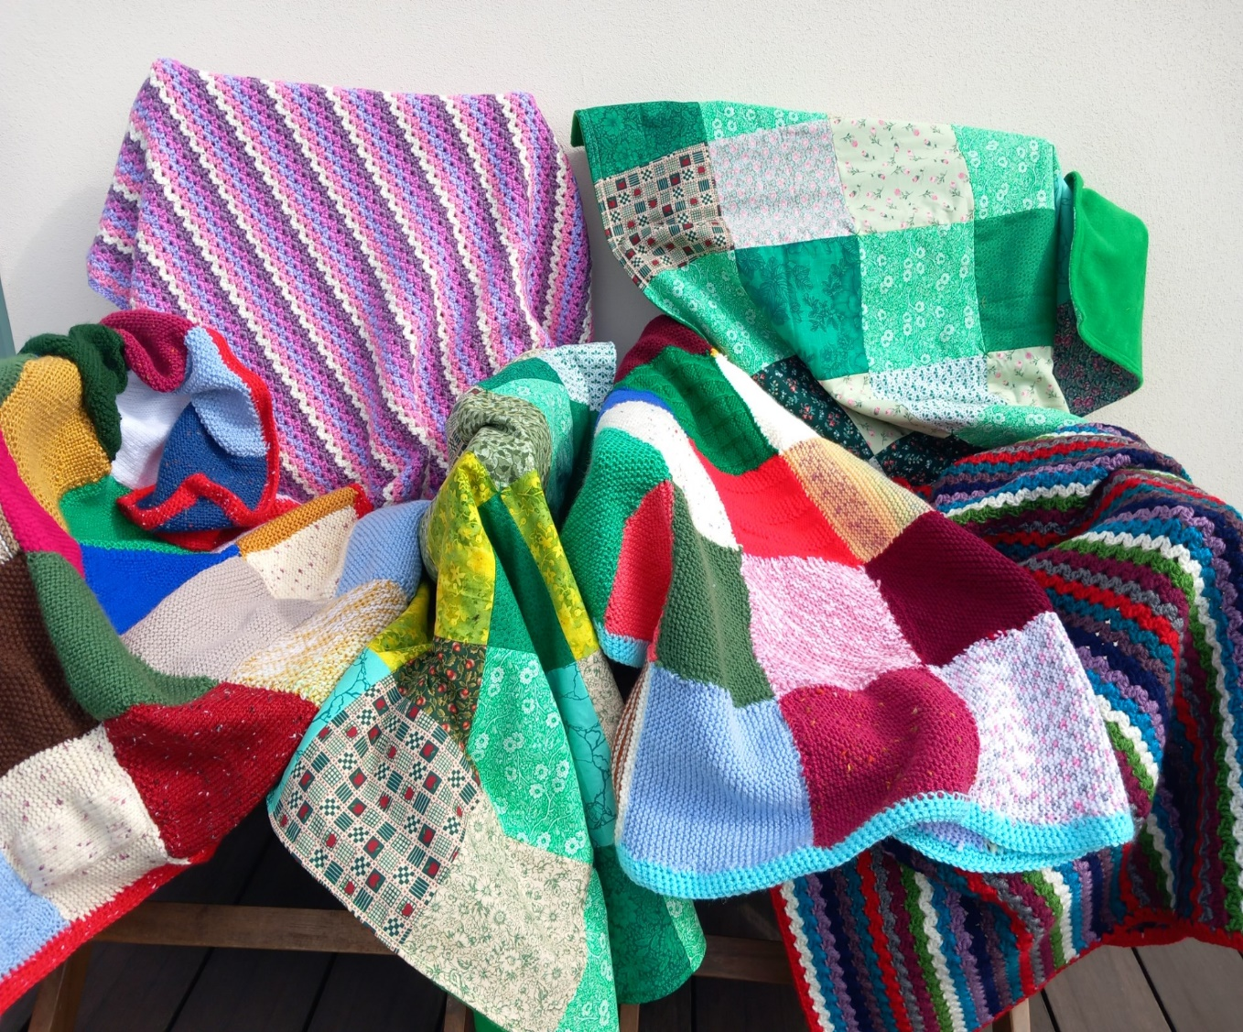

**2Cs**

Members of St Andrew’s church in Stratton, together with friends, have made 6 knee blankets for the in patients at Stratton hospital. They have knitted squares which have been sewn together and crocheted around the border, sewn patchwork fabric squares backed with fleece and crocheted blankets in lovely stripes to make up the collection. They will be presented to Stratton in the autumn when the holidays are over. We are having a break to gather our thoughts and will meet to discuss the future in due course.

**[](https://www.melton.leicester.anglican.org/Articles/518895/St_Marys_C/What_we_do/Mothers_Union/A_perfect_setting.aspx)The Mothers’ Union**

At our August branch meeting members celebrated the life of Mary Sumner, who founded the Mothers’ Union in 1876. Through music, prayer and fellowship we recalled the humble beginnings of a group of women meeting in Mary Sumner’s sitting room, nearly 150 years ago, becoming the huge worldwide organisation in 84 countries that the Mothers’ Union is today.

We reflected on our vision, which is a world where everyone prospers. Through our prayers and actions, we help build confident people and resilient communities, seek to bring about justice, challenge prejudice and advocate for change. Our mission is to show our Christian faith through actions, helping transform communities worldwide. We do this by nurturing strong relationships, and promoting peace and reconciliation locally, nationally and globally.

Continuing with our global connections, our September meeting will be our Wave of Prayer. Each diocese is linked to MU dioceses overseas and the global wave of prayer expresses our commitment to each other. Truro Diocese is linked with Makamba in Burundi, North Karamoja in Uganda, Lokoja and Sapele in Nigeria and Tirunelveli in India. As we remember our members in these faraway places, they will in turn be remembering and holding us in their prayers.

Next Meeting: Wave of Prayer – Monday 1st September 2pm at Stamford House, Stamford Hill EX23 9EY

October meeting Monday 6th 2pm - venue to be confirmed.

**The Darley Oak**

Thank you to the Blanchminster Trust for providing a plaque to commemorate the planting of our Darley Oak sapling, which continues to thrive.

Why not go and see the tree and then you can read the writing on the notice.

**Update on Fundraising for the East Window Restoration.**

Fundraising continues for the East Window restoration project and we are now very close to the revised target of £50,360 + VAT. Funds raised to date are:

Church Fundraising £1,553

FoStA Fundraising £5,902

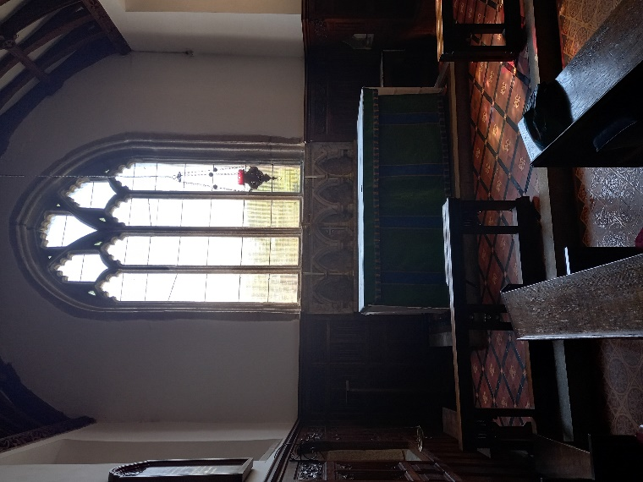Grants already received £6,250

Grants promised £33,500

The balance is available from the Fabric Fund if required, but fundraising continues and it is hoped this won’t be necessary. VAT will need to be paid but can then be claimed back.

With the funds raised or promised to date this has allowed us to instruct Holy Well Glass to proceed with the restoration work.

They attended site in August and within three days the window had been removed and a temporary polycarbonate sheet installed in its place. The window is now at Holy Well Glass’s workshop in Wells and the work to the window is expected to take approximately 5 months.

Spot What's Missing

Thank you to everyone who has contributed or helped in any way during our appeal.

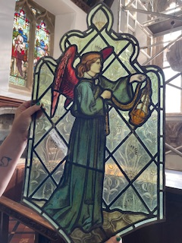

Two quick snaps taken of Sarah (Holy Well Glass Craftsperson) holding up two of the precious sections of glass from the apex of the window. Ed

**Friends of St Andrews Summer Brass Concert**

The Summer Brass Concert, given by the Tiverton Town Band in July, in aid of the East Window restoration appeal proved to be quite a success. We were extremely grateful for members of the band coming such a long way on a very warm afternoon and apart from members coming from Tiverton there were instrumentalists from Okehampton and Hatherleigh. The variety of music played was very pleasing and sensitive of the space and venue making it obvious that a great deal of thought and consideration had gone into the planning of the programme.

It was thoroughly enjoyed by all who came along to support us and financially, thanks to the many generous donors, a goodly sum was raised.

Many thanks to Philip Jackson of Stratside Gallery, for allowing the band to use his parking facility.

Thank you everyone

**In the month of September we remember in our prayers all those living in:**

**Sunday 7th** Stapleton Road, Traly Close, Catherine Close **Sunday 14th** Kernow Crescent, The Rowans and Manor Road

**Sunday 21st** St Annes, Grove, Thorn, Hele and the parts of King’s Hill & Bedehaven Close within the Parish

**Sunday 28th** Redwood Grove, Elm Drive, Elm Lea and the parts of Holnicote Road within the Parish

**In the month of October we remember in our prayers all those living in:**

**Sunday 5th** Those living outside the Parish for whom St Andrew’s is their spiritual home.

**Sunday 12th** Diddies Lane, Diddies Road, Old Drovers Way, Sanctuary Lane , Cott Hill

**Sunday** 19th Maiden Street, Market Street, Pollards, Townsend and the parts of Bush within the Parish

**Sunday 26th** Links View, Lea Way, Melliars Way, the parts of William Edwards Close, Flexbury Park Road, Meadow Drive and Fosters Way within the Parish

Those who have asked for our prayers:

Allan Gouldson, Bella, Molly Hooper, Pam Kemp,

Lyzette Bevan and Karen Hunting.

We bring before God, especially at this time, all who work in our local hospitals, the inpatients and all undergoing investigations and outpatient treatment. We remember too those of our church family who are ill at home or housebound.

The recently departed: Grenville Martin, Russell Hopgood, Oliver Gittens May they rest in peace and rise in glory.

**Those in our Year’s Mind in September the week beginning:**

**Sunday 7th** Samuel Grills, Gerald Evans, Marjorie Grills, Christine Worland, Peter Stephens, Kathleen Peardon, Olive Ridgeman, Terence Barnard, Eric Worth, Gwendoline Baldwin, Moira Cann, Frederick Sandercock, Nell Varley

**Sunday 14th** Ruth Saltern, Barbara Piper, Eleanor Burley, Doris Pooley, Joyce Fowler, Gladys Pearce, Francis Worth.

**Sunday 21st** Shirley Philp, Mark Peardon, Jean Gorman, John Going, Margery Trzaska Nartowski, Ivy Hough, Charles Bryant **Sunday 28th** Frederick Copeland, Kenneth Hopgood, Thelma Copeland, Susan Pearce, Ellen Davey, Maud Dodgson, Stanley Cook, Olga Panter, Edna Biggin

**Those in our Year’s Mind in October the week beginning**:

**Sunday 5th** Kenneth Glew, Muriel Broadbent, Anthony Mears, Arthur Robinson

**Sunday 12th** Violet Sweet, Emily Boon, Daphne Dale-Glossop, Christopher Yeo, Lydia Cole, John Spiby, Ralph Coker

**Sunday 19th** Christopher Jordan, John Dale-Glossop, Wesley Hatcher, Frank Price, Ron Hothersall, Anthony Ford, Margaret Evans, Norman Ward, Alice Grills

**Sunday 26th** Mavis Tinker, Peggy Jeffery, Patricia Dorrington, Joan Barker, Edith Martin, Elizabeth Cardale, Andrew Copeland, Sidney Walker, Barbara Worden

All those in our own special remembrance.

________________________________________________________________

***The photograph on the front page is of the rarely seen window in the west aspect of the Tower. It was manufactured by C. E. Kempe and inserted in 1906. Kempe windows are signed with a wheatsheaf emblem and so are easily identified. The window’s main three lights show the Saints, Gabriel, Michael and Raphael.***

***A quote taken from the archives states, “A very fine Archangel window” given by Miss Rowe, daughter of Mr William Rowe, late of Sanctuary.***

***William Rowe had been a Churchwarden at St Andrew’s for a number of years.***

**Photograph by kind permission of David Goodwin JP**

News Sheet Editors: Val Barker Tel: 353435 and Sheila Waring Tel: 714338

If you have anything for inclusion in the News Sheet for September and/or October please send it to the editors by Monday 18th August. It would be a kindness if you could send all documents in Calibri (Body) Font, Size11. Thank you.