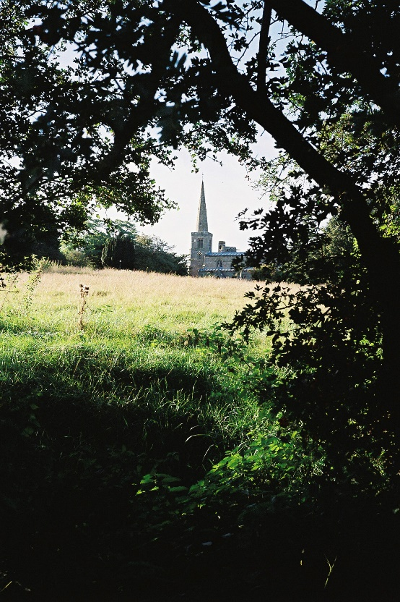
ST MICHAEL AND ALL ANGELS,
HAMSTALL RIDWARE

In the United Benefice of King’s Bromley, the Ridwares
and Yoxall

September 28th 2025
St Michael and All Angels

PARISH NOTICES

UNITED BENEFICE SERVICE ROTA
 | Hamstall Ridware  St Michael and All Angels | Yoxall  St Peter | King’s Bromley  All Saints | Mavesyn Ridware  St Nicholas
September 28th  St Michael and All Angels | 10.30 am  United Benefice service and Patronal Festival  St Michael and All Angels, Hamstall Ridware
October 5th  Trinity 16 | 9.00 am  Holy Communion | 10.30 am  Parish Communion | 10.30 am  Harvest Festival | 4.00 pm  Harvest Praise
October 12th  Trinity 17 | 4.00 pm  Holy Communion | 10.30 am  Harvest Festival | 10.30 am  Something different – come and see!
October 19th  Trinity 18 | 10.30 am  Holy Communion | 4.00 pm  Holy Communion | 9.00 am  Holy Communion | 10.30 am  Morning Prayer
October 26th  Trinity 19 | 10.30 am  Service of the Word | 9.00 am  Holy Communion | 10.30 am  Holy Communion
Please note that services of Holy Communion at 9 am follow the Book of Common Prayer and are said. Services at 10.30 will include hymns and other singing.
*******************
Rugeley Food Bank. Please do remember those who depend on Food Banks. They are needed now just as ever. If you wish to donate directly to Rugeley Foodbank at Rugeley Community Centre the Centre is open everyday to receive contributions. Alternatively, the Rugeley Food Bank welcomes financial contributions – see https://rugeley.foodbank.org.uk. Gifts can also be brought to St Michael’s and left in the box at the back of church near the font. If that is not convenient please contact Liz Carter on 07751 068181.
****************
Contact details: If you wish to contact the Rector, Jeremy Brading you can do so on revd@kbhmy.co.uk and Glenis Turner, the PCC Secretary and Benefice Administrator is on admin@kbhmy.co.uk. The churchwardens are Michael Elsom michael.elsom@btopenworld.com and John Ferguson clan.member1954@gmail.com Information about events at church can be found at our webpages at https://www.achurchnearyou.com/church/4451/ and https://kbhmy.co.uk/hamstall/
St Michael’s will continue to be open everyday (weather permitting) between 10.00 am until 6.00 pm. We will revert to shutting the church at 4.00 pm on October 26th
Safeguarding of children and vulnerable adults. If you have any concerns please speak in complete confidence to the Parish Safeguarding Officer, Dr Paul Carter 01889 504347 or the Diocesan Safeguarding Officer Mr Neil Spiring 01543 306 030.
PLEASE REMEMBER IN YOUR PRAYERS:
Those who are sick: Mary Mycock, Brenda, Angela Perkin, Doug, David and Barbara Rudge, May Windley, Pam Payne, Rev’d Frank Finch, Chris Poole, Les Woods, Pat Lomax, Alison Scott and any known personally to you.
Those who live and work in the Nursing, Care and Retirement homes in the villages both in and near the parishes of the United Benefice.
Using the Archbishops’ prayer for Ukraine at this time let us remember the people of that war-torn land:
God of peace and justice, we pray for the people of Ukraine today. We pray for peace and the laying down of weapons. We pray for all those who fear for tomorrow, that your Spirit of comfort would draw near to them. We pray for those with power over war or peace, for wisdom, discernment and compassion to guide their decisions. Above all, we pray for all your precious children, at risk and in fear, that you would hold and protect them. We pray in the name of Jesus, the Prince of Peace. Amen
Let us also pray that the right of the people of Ukraine and neighbouring countries to exist without threat of dominance from any other country and the greed of those with eyes on its resources may be honoured.
The situation in the Middle East where hopes for a peaceful resolution sometimes appear irretrievably bleak:
O God of all justice and peace, we cry out to you in the midst of the pain and trauma of violence and fear which prevails in the Holy Land. Be with those who need you in these days of suffering; we pray for people of all faiths - Jews, Muslims and Christians and for all people of the land. While we pray to you, O Lord, for an end to violence and the establishment of peace, we also call to you to bring justice and equity to the peoples. Guide us into your kingdom where all people are treated with dignity and honour as your children - for to all of us you are our Heavenly Father. In Jesus' name we pray. Amen.
From the Diocesan Prayer Diary:
Sunday 28th September:
Lord today, we pray for All Saints Church in Madeley as they celebrate 1050 years since a 975 royal charter granted land to be used in Madeley for a church and monastery. We thank you for all the work for your kingdom that has taken place there up to this point, and join with the launch of their 'Prayerfest' that the impact of their work may continue for at least another millennium and more. We especially pray for their Family Communion today with Archdeacon Megan, for a positive launch of their prayerful celebration.
Monday 29th: (Michael and All Angels)
Lord, today we lift before you those churches in the diocese dedicated to St Michael, and sometimes to other angels. For St Gabriel's Fulbrook; for (St Isidore and) St Raphael's Petton; and for Holy Angels Hoar Cross. So too we pray for all the St Michael's; Adbaston, Brereton, Chell, Chetwynd, Childs Ercall, Colwich, Cross Heath, Hamstall Ridware, High Ercall, Himley, Horton, Lichfield, Lilleshall, Llanyblodwel, Loppington, Pelsall, Penkridge, Rocester, Rushall, Stone, Stramshall, Tatenhill, Tettenhall Regis, Tividale, Waters Upton, Welshampton, and West Felton. We pray for your hand of blessing to rest on all of these churches and each of the communities they serve.
We also pray for today's Churchwarden Cafe in Tatenhill, exploring the possibilities in pilgrimage around so many of our beautiful churches, and the opportunities they could bring in people wanting to explore them. May their journeys around our churches prompt an even more fulfilling journey with you.
Saturday 4th: (Francis of Assisi, Friar, Deacon, Founder of the Friars Minor, 1226)
Lord, today we lift before you those churches in the diocese dedicated to St Francis; in Friar Park (between Wednesbury and West Bromwich), Leyfields (Tamworth), and Meir Heath (Stoke on Trent). We pray for your hand of blessing to rest on all of these churches and each of the communities they serve.
The Churchyard
is a very important part of the heritage of the village and St Michael’s in particular. Keeping it in good order and a fitting place for the repose of those buried there and a space of solace and prayer for visitors is hard work but much appreciated by all. The next working party is on Tuesday October 7th at 5.00 pm.
PLEASE NOTE!
There will be no Weekly Notices for Sunday October 5th or 12th as their producer is away on holiday.
The information you need should be on these!

