

**WELCOME**

**ST.STEPHEN’S CHURCH**

**is open 10am-3pm daily**

**for Private Prayer and Reflection**

**BULLETIN**

**21st September 2025**

**Matthew, Apostle & Evangelist**

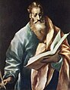

**Family Communion 10.30am**

Notices for inclusion in the bulletin please email to me by Tuesday of each week

***officeststephenfradley@gmail.com***

**Please take Bulletin away with you**



**Diary Dates**

**September 2025**

21st 10.30am Family Communion

22nd 7-8.30pm PCC Meeting

23rd 7-9pm Community Choir Rehearsal

24th 12-1pm Interment of Ashes of Graham Griffiths

2-4pm Wednesday Welcome

25th 7.30-9pm Heritage Talks

**Next event**

**Saturday 4th October 7pm**

**Harvest Supper and Auction**

in Fradley Youth & Community Hall Tickets £15 including a hot meal and dessert Licensed Bar

D. Giles 07767 434776

**Tickets on sale from 7th September**



Welcome to our Worship today

If you are visiting for the first time, please introduce yourself so that we may welcome you personally.

Refreshments are served after every service – do join us!

**21st September 2025**

**St Matthew the Apostle and Evangelist**

**Collect**

Merciful God,

your Son came to save us

and bore our sins on the cross:

may we trust in your mercy

and know your love,

rejoicing in the righteousness

that is ours through Jesus Christ our Lord.

**Readings**

Isaiah 33. 13-17 2 Corinthians 4. 1-6

Matthew 9 . 9-13

**Post Communion**

Lord God, the source of truth and love,

keep us faithful to the apostles’ teaching and fellowship,

united in prayer and the breaking of bread,

and one in joy and simplicity of heart,

in Jesus Christ our Lord.

**presents**

**The Story of Oberleutnant Joachim Schwartz**

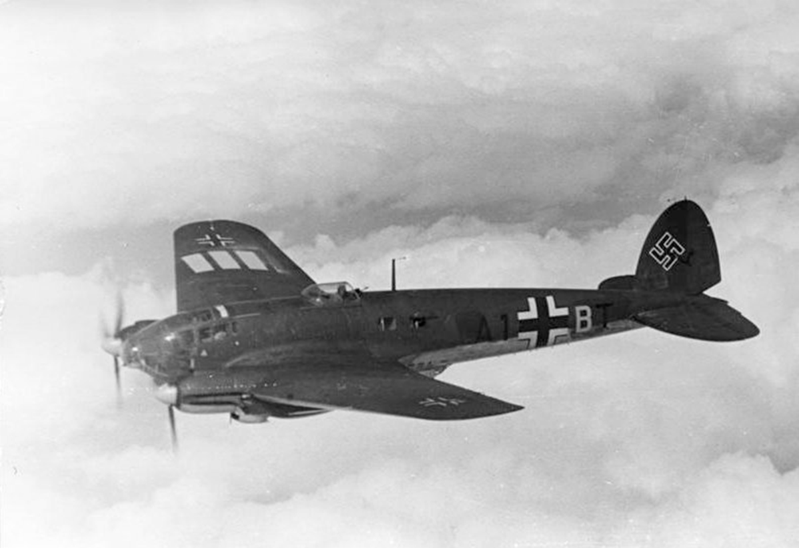 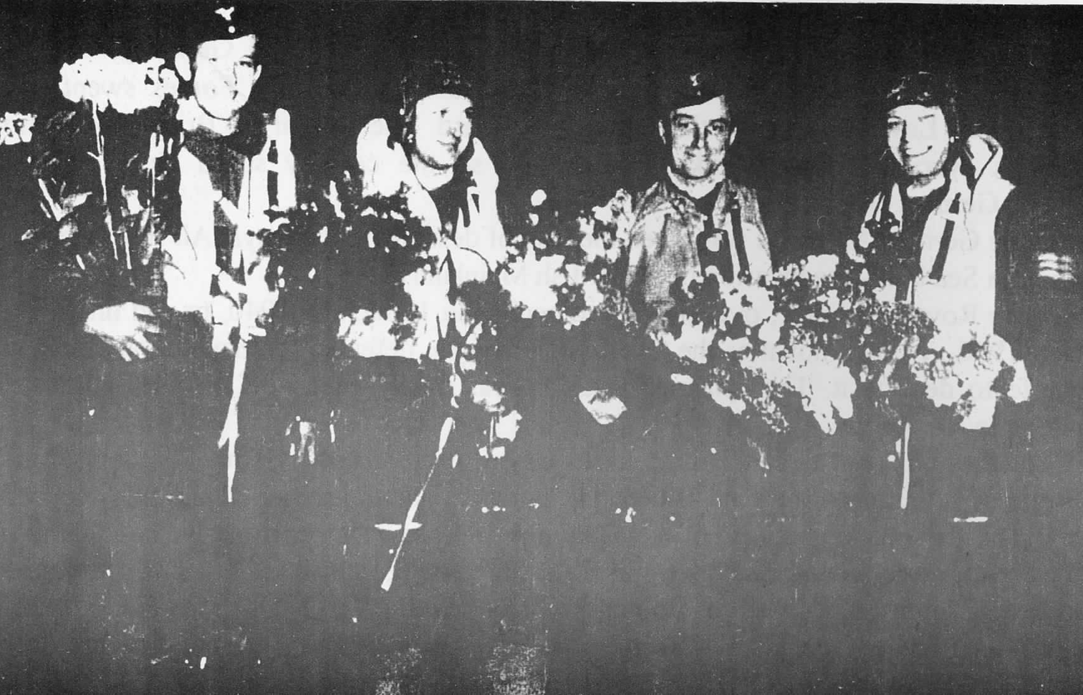

‘Somewhere in the corner of a Foreign Field’

Presented by Lyn Tyler Chair of FHG

Thursday 25th September 7.30pm

St Stephens Church Fradley WS13 8NL

Mulled Cider and Savouries served

Admission Free Donations accepted

*In our thoughts and prayers…..*

As we think about all who suffer

– we pray for those who struggle with pain

– for all who look for healing and find it not.

* for all who inspire us with their patience and courage and reveal to us a glimpse of the love of God. Be to them a light in their darkness and strength in times of fear.

You have called us to be a caring church, reflecting in our lives your infinite care for us.

We give thanks for those whose care and concern and compassion reveals to us a glimpse of the love of God.

God of all life and time, we remember how the hopes and fears of generations have been drawn together in Christ. Help us to let the past rest in your keeping; help us to leave the future to your wisdom and care, and enable us to invite you into all that is present so we may discover with you the glory of your resurrected life.

**YOU ARE INVITED**

**LICHFIELD FAIRTRADE**

We are now happy to announce that Lichfield City is now once more officially a Fairtrade Community.

To mark this, we are hosting a Fairtrade tea and

coffee event at the start of Fairtrade Fortnight.

**Date: Tuesday 23 September**

**Time: 2:30pm – 4pm**

**Place: Jungle Street Kitchen, Bore Street, Lichfield**

**Price: Free Fairtrade tea and coffee**

**(donations accepted)**

We would like a rough idea of how many people we can expect, so please let us know via the form on our website https://www.lichfieldfairtrade.org.uk/invitation/

We will have some information and literature to share with you, as well as a short video from the

Fairtrade Foundation.

Information should flow both ways -

we will be interested in

hearing from you about new ways in which we can implement and promote Fairtrade .and if you are interested in working with us to help promote the

Fairtrade principles, we would love to hear from you when you join us for your Fairtrade drinks.

**See you on the 23rd!**

**Auction of Talents, Gifts & Promises**

**We know that this is a very talented community with many gifts to offer. Could you offer even a small thing to raise some money for St Stephen’s and harvest your talents to help others**

**(and have some fun in the process!!)**

**We plan to have an Action of talents, gifts and promises at our Harvest Supper**

**Saturday 4th October.**

**Ideas from our past auction can be very simple –**

**Can you offer a bit of gardening?**

**A trip out to a coffee shop?**

**A Flower arrangement?**

**A lift for shopping at a supermarket?**

**Bake a cake? Host a meal or Afternoon Tea?**

**A half day or day out?**

**Unused or surplus Gifts?**

**See the offers which have already come in!**

**Perhaps you might like to bid for something at Harvest also? Do come along and enjoy the evening!**



**Can you help to support St Stephens Church?**

St Stephen’s Church is heavily dependent on voluntary donations and income from events in order to fulfil its ministry to the local and wider communities.

If you would like to support us at this time,

donations can be made via our Just Giving page.

We are grateful for any donation, large or small.

[**https://www.justgiving.com/fundraising/ststephensfradley**](https://www.justgiving.com/fundraising/ststephensfradley)



## Contact us

## Revd Elizabeth Wall

## 01543 254891

## Email: [ayton265@gmail.com](mailto:ayton265@gmail.com)

## Churchwarden

## Marian Derry 01283 791573

## 

## St Stephen’s Administrator: Di Cooper  07930162991

## Email: officeststephenfradley@gmail.com

## Find us on

## ACNY https://www.achurchnearyou.com/church/4123/

**Face book:** [**www.facebook.com/ststephensfradley**](http://www.facebook.com/ststephensfradley)

DC17/09/25