St Peter and the Holy Apostles, Plymouth- Sunday 21st September 2025

**The Twentieth-Fifth Week in Ordinary Time *(Year C)***

*Welcome to the Parish Mass*

Welcome to St Peters Church. This sheet provides all that you will need for today’s Mass. If you need any assistance before, during or after the service or need a large print copy of this order of service please speak to one of our welcome team. (identifiable by a lanyard)  
Please respond to the words in non-italic **Bold,** The **Hymns** are sung by all. Please inform the people on the door when you enter if you require a **Gluten Free** Host

…………………………………………………………………………………

*We Stand for* ***The Entrance Hymn***

**1.** Son of God, eternal Saviour,  
source of life and truth and grace,  
Son of Man, whose birth incarnate  
hallows all our human race,  
thou, our Head, who, throned in glory,  
for thine own dost ever plead,  
fill us with thy love and pity;  
heal our wrongs, and help our need.

**2.** As thou, Lord, hast lived for others,  
so may we for others live;  
freely have thy gifts been granted,  
freely may thy servants give:  
thine the gold and thine the silver,  
thine the wealth of land and sea,  
we but stewards of thy bounty,  
held in solemn trust for thee.

**3.** Come, O Christ, and reign among us,  
King of love, and Prince of peace;  
hush the storm of strife and passion,  
bid its cruel discords cease;  
by thy patient years of toiling,  
by thy silent hours of pain,  
quench our fevered thirst of pleasure,  
shame our selfish greed of gain.

**4.** Son of God, eternal Saviour,  
source of life and truth and grace,  
Son of Man, whose birth incarnate  
hallows all our human race,  
thou who prayedst, thou who willest,  
that thy people should be one,  
grant, O grant our hope's fruition:  
here on earth thy will be done.

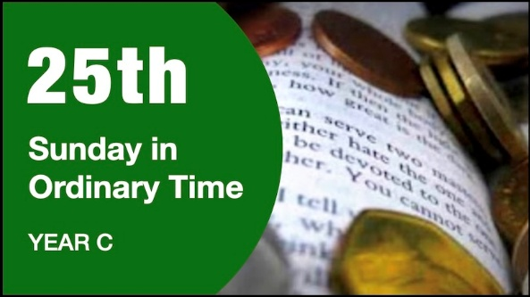

***The*** ***Introductory Rite***

In the name of the Father and of the Son and of the Holy Spirit. **Amen.**

*Following the greeting we respond*.

**And with your spirit.**

*The Priest introduces the Mass*

***The Penitential Rite***

Brothers and sisters, let us acknowledge our sins,

and so prepare ourselves to celebrate the sacred mysteries.

**I confess to almighty God and to you, my brothers and sisters, that I have greatly sinned, in my thoughts and in my words, in what I have done and in what I have failed to do, through my fault, through my fault, through my most grievous fault; therefore I ask blessed Mary ever-Virgin, all the Angels and Saints, and you, my brothers and sisters, to pray for me to the Lord our God.**

May almighty God have mercy on us, forgive us our sins, and bring us to everlasting life. **Amen.**

*Either:*

Lord, have mercy. **Lord, have mercy.**

Christ, have mercy. **Christ, have mercy.**

Lord, have mercy. **Lord, have mercy.**

*Or:*

Kyrie, eleison. **Kyrie, eleison.**

Christe, eleison. **Christe, eleison.**Kyrie, eleison. **Kyrie, eleison.**

***The Gloria***

**Glory to God in the highest,** **and on earth peace to people of good will.**   
**We praise you,** **we bless you,** **we adore you,** **we glorify you,** **we give you thanks for your great glory,** **Lord God, heavenly King,** **O God, almighty Father.**  
**Lord Jesus Christ, Only Begotten Son,** **Lord God, Lamb of God, Son of the Father,** **you take away the sins of the world,** **have mercy on us;** **you take away the sins of the world,** **receive our prayer;** **you are seated at the right hand of the Father,** **have mercy on us.**  
**For you alone are the Holy One,** **you alone are the Lord,** **you alone are the Most High,** **Jesus Christ,** **with the Holy Spirit,** **in the glory of God the Father.** **Amen.**

***The Collect***

Let us pray.

O God, who founded all the commands of your sacred Law upon love of you and of our neighbour, grant that, by keeping your precepts, we may merit to attain eternal life.

Through our Lord Jesus Christ, your Son, who lives and reigns with you in the unity of the Holy Spirit, God, for ever and ever. **Amen.**

*We sit for* ***The First Reading***- **Amos 8:4-7**

Hear this, you who trample on the needy and bring the poor of the land to an end, saying, ‘When will the new moon be over, that we may sell grain? And the Sabbath, that we may offer wheat for sale, that we may make the ephah small and the shekel great and deal deceitfully with false balances, that we may buy the poor for silver, and the needy for a pair of sandals, and sell the chaff of the wheat?’

The Lord has sworn by the pride of Jacob: ‘Surely I will never forget any of their deeds.’

The word of the Lord. **Thanks be to God.**

***The Responsorial Psalm****-* ***Ps 113(112):1-2. 4-6. 7-8. ℟ cf. 1a, 7b***

**Response-** *Praise the Lord, who raises the poor.*

Praise, O servants of the Lord, praise the name of the Lord!

May the name of the Lord be blest both now and for evermore! ***R***

High above all nations is the Lord, above the heavens his glory.

Who is like the Lord, our God, who dwells on high,

who lowers himself to look down upon heaven and earth? ***R***

From the dust he lifts up the lowly, from the ash heap he raises the poor,

to set them in the company of princes, yes, with the princes of his people. ***R***

***The Second reading- 1 Timothy 2:1-8***

Beloved: First of all, I urge that supplications, prayers, intercessions, and thanksgivings be made for all people, for kings and all who are in high positions, that we may lead a peaceful and quiet life, godly and dignified in every way. This is good, and it is pleasing in the sight of God our Saviour, who desires all people to be saved and to come to the knowledge of the truth. For there is one God, and there is one mediator between God and men, the man Christ Jesus, who gave himself as a ransom for all, which is the testimony given at the proper time.

For this I was appointed a preacher and an Apostle — I am telling the truth, I am not lying — a teacher of the Gentiles in faith and truth. I desire then that in every place the men should pray, lifting holy hands without anger or quarrelling.

The word of the Lord. **Thanks be to God**

*We stand for-* ***The Gospel Procession and Acclamation***- **2 Corinthians 8:9**

Alleluia, alleluia!  
*Jesus Christ, though he was rich, yet for your sake he became poor,*

*so that you by his poverty might become rich.*

Alleluia!

***The Gospel- Luke 16:1-13***

The Lord be with you. **And with your spirit.**

A reading from the holy Gospel according to *N*. **Glory to you, O Lord.**

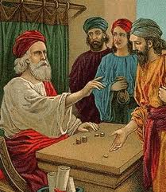At that time: Jesus said to the disciples, ‘There was a rich man who had a manager, and charges were brought to him that this man was wasting his possessions. And he called him and said to him, “What is this that I hear about you? Turn in the account of your management, for you can no longer be manager.” And the manager said to himself, “What shall I do, since my master is taking the management away from me? I am not strong enough to dig, and I am ashamed to beg. I have decided what to do, so that when I am removed from management, people may receive me into their houses.” So, summoning his master’s debtors one by one, he said to the first, “How much do you owe my master?” He said, “A hundred measures of oil.” He said to him, “Take your bill, and sit down quickly and write fifty.” Then he said to another, “And how much do you owe?” He said, “A hundred measures of wheat.” He said to him, “Take your bill and write eighty.” The master commended the dishonest manager for his shrewdness. For the sons of this world are more shrewd in dealing with their own generation than the sons of light.’ And I tell you, make friends for yourselves by means of unrighteous wealth, so that when it fails they may receive you into the eternal dwellings.

‘One who is faithful in a very little is also faithful in much, and one who is dishonest in a very little is also dishonest in much. If then you have not been faithful with the unrighteous wealth, who will entrust to you the true riches? And if you have not been faithful with that which is another’s, who will give you that which is your own? No servant can serve two masters: for either he will hate the one and love the other, or he will be devoted to the one and despise the other. You cannot serve God and money.’

The Gospel of the Lord. **Praise to you, Lord Jesus Christ.**

*We sit for* ***The Homily***

*We stand* ***The Creed***

**I believe in one God,** **the Father almighty,** **maker of heaven and earth,**

**of all things visible and invisible.**

**I believe in one Lord Jesus Christ,** **the Only Begotten Son of God,** **born of the Father before all ages.** **God from God,** **Light from Light,** **true God from true God,** **begotten, not made, consubstantial with the Father;** **through him all things were made.** **For us men and for our salvation he came down from heaven,**

*At the words that follow, up to and including ‘and became man’, all bow.*

**and by the Holy Spirit was incarnate of the Virgin Mary,** **and became man.**

**For our sake he was crucified under Pontius Pilate,** **he suffered death and was buried,** **and rose again on the third day** **in accordance with the Scriptures.**

**He ascended into heaven** **and is seated at the right hand of the Father.** **He will come again in glory** **to judge the living and the dead** **and his kingdom will have no end.**  
**I believe in the Holy Spirit, the Lord, the giver of life,** **who proceeds from the Father and the Son,** **who with the Father and the Son is adored and glorified,** **who has spoken through the prophets.  
I believe in one, holy, catholic and apostolic Church.** **I confess one Baptism for the forgiveness of sins** **and I look forward to the resurrection of the dead** **and the life of the world to come. Amen.**

*……………………………………………………………………………..*

*We remain standing for* ***The Prayers of the Faithful***

*Each biding concludes with the following said or sung-*

We pray to the Lord. **Lord in your Mercy hear our prayer.**

*The Priest Concludes the Prayers of the Faithful*

*……………………………………………………………………………..*

*No collection is taken during the Mass, but there is a collection box at the back of church for you to give your financial contribution. All money collected helps towards the mission and ministry of our churches. If you would prefer, a card reading machine is available at the back of the church for your contribution.*

***The Offertory Hymn***

**1.** Lord of creation, to you be all praise!  
Most mighty your working, most wondrous your ways!  
Your glory and might are beyond us to tell,  
and yet in the heart of the humble you dwell.

**2.** Lord of all power, I give you my will,  
in joyful obedience your tasks to fulfil.  
Your bondage is freedom, your service is song;  
and, held in your keeping, my weakness is strong.

**3.** Lord of all power, I give you my will,  
in joyful obedience your tasks to fulfil.  
Your bondage is freedom, your service is song;  
and, held in your keeping, my weakness is strong.

**4.** Lord of all bounty, I give you my heart;  
I praise and adore you for all you impart,  
your love to inspire me, your counsel to guide,  
your presence to shield me, whatever betide.

**5.** Lord of all being, I give you my all;  
if ever I leave you, I stumble and fall;  
but lead in your service your word to obey,  
I’ll walk in your freedom to the end of the way.

***The Liturgy of the Eucharist***

Pray, brethren **(**brothers and sisters**)**, that my sacrifice and yours may be acceptable to God, the almighty Father.  
**May the Lord accept the sacrifice at your hands** **for the praise and glory of his  
name,** **for our good** **and the good of all his holy Church.**

The Lord be with you. **And with your spirit.**

Lift up your hearts. **We lift them up to the Lord.**  
Let us give thanks to the Lord our God. **It is right and just.**

*The Priest continues with the Preface. The Sanctus is the said or sung:*

**Holy, Holy, Holy Lord God of hosts.**

**Heaven and earth are full of your glory.** **Hosanna in the highest.**

**Blessed is he who comes in the name of the Lord.** **Hosanna in the highest.**

*The Priest continues the Eucharistic prayer. The following is said or sung*

The mystery of faith….  
**We proclaim your Death, O Lord,** **and profess your Resurrection** **until you come again.**

*The Priest concludes the Eucharistic prayer.*

Through him, and with him, and in him, O God, almighty Father, in the unity of the Holy Spirit, all glory and honour is yours, for ever and ever. **Amen.**

***The Lord’s Prayer***

At the Saviour’s command and formed by divine teaching, we dare to say:

**Our Father, who art in heaven,** **hallowed be thy name;** **thy kingdom come,** **thy will be done** **on earth as it is in heaven.** **Give us this day our daily bread,** **and forgive us our trespasses,** **as we forgive those who trespass against us;** **and lead us not into temptation,** **but deliver us from evil.**

Deliver us, Lord, we pray… and the coming of our Saviour, Jesus Christ.  
**For the kingdom,** **the power and the glory are yours** **now and for ever.**

***The Peace***

Lord Jesus Christ, who said to your Apostles: Peace I leave you, my peace I give you,

look not on our sins, but on the faith of your Church, and graciously grant her peace and unity in accordance with your will. Who live and reign for ever and ever. **Amen.**

The peace of the Lord be with you always: **And with your spirit.**

Let us offer each other the sign of peace.

*All are invited to make an acknowledgement to each other to mark the sign of the peace.*

***The Agnus Dei***

*All say or sing:***Lamb of God, you take away the sins of the world,** **have mercy on us.**

**Lamb of God, you take away the sins of the world,** **have mercy on us.**

**Lamb of God, you take away the sins of the world,** **grant us peace.**

***The Invitation to Communion***

Behold the Lamb of God, behold him who takes away the sins of the world. Blessed are those called to the supper of the Lamb. **Lord, I am not worthy** **that you should enter under my roof,** **but only say the word and my soul shall be healed.**

*All who are regular communicants in their own tradition are welcome to receive the*  *sacrament if you are not a communicant you are welcome to come forward at this point in the service to receive a blessing To indicate that it is just a blessing you require, please take this service sheet up with you. We have returned to offering the chalice at the time of communion but please do not feel any pressure to receive from the common cup as the church teaches that the sacrament is received fully in one kind. We request that you do not* ***intinct (dip) your host in the Chalice*** *but either take a sip from the cup or return directly to your seat. This is for reasons of good hygiene.*

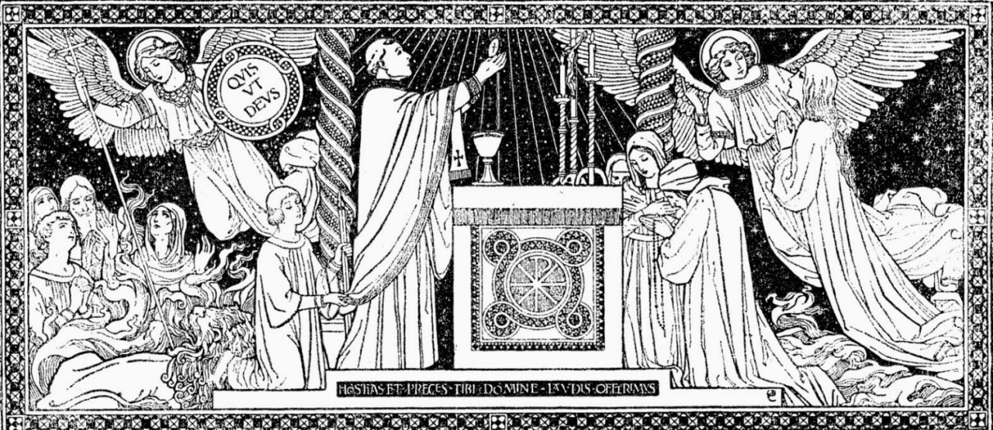

***The Communion Hymn***

**1.** Lord Jesus Christ,  
You have come to us  
You are one with us,  Mary's Son.   
Cleansing our souls from all their sin.   
Pouring Your love and goodness in.   
Jesus our love for you we sing,   
Living Lord.

**2.** Lord Jesus Christ,  
Now and every day   
Teach us how to pray, Son of God.   
You have commanded us to do   
This in remembrance Lord of you   
Into our lives your power breaks through,   
Living Lord.

**3.** Lord Jesus Christ,  
You have come to us   
Born as one with us, Mary's Son.   
Led out to die on Calvary,   
Risen from death to set us free,   
Living Lord Jesus help us see  
You are Lord.

**4.** Lord Jesus Christ,  
I would come to you   
Live my life for you, Son of God.   
All your commands I know are true,   
Your many gifts will make me new,   
Into my life your power breaks through,   
Living Lord.

*We stand for* ***The Prayer After Communion***

Graciously raise up, O Lord, those you renew with this Sacrament, that we may come to possess your redemption both in mystery and in the manner of our life. Through Christ our Lord. **Amen**

*We remain standing for* **Our Mission Prayer for 2025**Lord Jesus, you call us to be your missionary disciples.

Guide and strengthen us to share your love with all we meet.

Give us courage to reach out to help others.

Give us wisdom to know how best to care,

And give us hope to believe we can make a difference.

Bless us all who bring your compassion and mercy to the poor and marginalised.

Together, may we make known your love on earth.

We make our prayer through Christ Our Lord. **Amen.**

*The priest may give some brief notices*

***The Concluding Rites***

The Lord be with you. **And with your spirit.**

May almighty God bless you, the Father, and the Son, ✠ and the Holy Spirit. **Amen.**

***The Dismissal***

Go forth, the Mass is ended. **Thanks be to God**

***The Final Hymn***

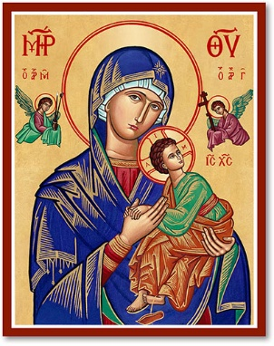**1.** Now thank we all our God  
with hearts and hands and voices,  
who wondrous things hath done,  
in whom his world rejoices;  
who from our mother's arms  
hath blessed us on our way  
with countless gifts of love,  
and still is ours to-day.  
  
**2.** O may this bounteous God  
through all our life be near us,  
with ever joyful hearts  
and blessèd peace to cheer us;  
and keep us in his grace,  
and guide us when perplexed,  
and free us from all ills  
in this world and the next.

**3.** All praise and thanks to God  
the Father now be given,  
the Son, and him who reigns  
with them in highest heaven,  
the one eternal God,  
whom earth and heaven adore;  
for thus it was, is now,  
and shall be evermore.

***The Angelus***

The Angel of the Lord declared unto Mary. **And she conceived of the Holy Spirit.**

Hail Mary, full of grace, The Lord is with Thee; Blessed art thou among women,  
And blessed is the fruit of thy womb, Jesus.   
**Holy Mary, Mother of God, Pray for us sinners, Now and at the hour of our death.**

Behold the handmaid of the Lord.  
**Be it done to me according to thy word.** *Hail Mary. . .*

And the Word was made flesh.  
**And dwelt among us.** *Hail Mary…*

Pray for us, O holy Mother of God.  
**That we may be made worthy of the promises of Christ.**

Let us pray:

Pour forth, we beseech Thee, O Lord, Thy grace into our hearts, that we to whom the Incarnation of Christ Thy Son was made known by the message of an angel, may by His Passion and Cross be brought to the glory of His Resurrection. Through the same Christ Our Lord. **Amen.**

***For Prayer***

**Those who have asked for our prayers….** Denise, Janice Allin, Leslie Porch, Sheila Tucker, Tina Smart, Kathy Haydon, Bobby Lilicrap, June Brock, Emma Addison, Georgie Maher, Ian Craggs, Brenda Alderson, Lois Tobin, Michael O’Leary, Brenda Steed, Anne Lewis, Jenny Harvey, Jackie Morrison, Fr Roger Beck, Anna, Gwen Lamb, Anna Lynch, Jackie Fisher, Helen Lewis, Val Bradden, Cynthia Way, Pauleen Stewart, Amelia Coughlan, Roger Lewis, Sarah Cavey, Shaun Carrie

**Recently Departed**- Audrey Dewey, David Steer, Diana Stephens, Pam Otley,, Gordon Walters, Charles Curvengen-Pitt

**Anniversaries of Death**

***The Notices***

**Coffee, Cleaning and Cake**, or as we like to call it “Shiney Church” returns on Saturdays between 11.00 and Noon

**Walsingham Cell- Sunday 21st September 6pm-** Our Walsingham Cell will take place at St Peters beginning with the Rosary- we will then move into cloisters for a time of fellowship enjoying memories of our recent pilgrimage.

**The Bishop Of Oswestry’s Pastoral Visitation** to Plymouth is taking place on September 25th and 26th . **Please note the change of Mass times Thursday & Friday** There will be an opportunity for lay people to meet with the Bishop Friday 26th at 11.00am at St Francis, Honicknowle and there will be a festival Mass at St Peter’s to bring the visitation to a close at 7.00pm on the Friday. Ask Sue or Fr David if you need transport.

***To avoid confusion!*** There is no PCC meeting this week but it is hoped that as many as possible of the PCC will be at the meeting in St Francis on Friday Morning.

**St Gabriels- Peverell Feast of Title**- There will be evening prayer followed by refreshments at St Gabriels on **Sunday 28th September 5pm**- All welcome.

Advance notice- St Peters will be holding a Quiz on Saturday 18th October and an **Autumn Fair on Saturday 25th October-** Please keep this date available, help will be needed at the event and for preparation.

**Training Event for our Winter Night Shelter- PROJECT 58:7 Help The Homeless**- A day of training for volunteers to support churches overnight provision. We're partnering with the local charity PATH to offer winter provision for rough sleepers because it combines practical support, community responsibility, and compassion into a meaningful initiative. **Saturday 4th October 9.30am- 3pm at St Marks Church, Ford- if you are interested in this event please speak to Ben**

The Mission Community of St Peter and the Holy Apostles

*St Peter, Wyndham Square + St Thomas, Royal Navy Avenue + St James-the-Less, Ham Drive*

**A Church of England Parish in the care of the Bishop of Oswestry**

**Parish Priest Fr. David Way SSC: 01752 240119** fr.davidway@gmail.com

.com

**Mission Development Minister/ LLM/ Parish Ordinand: Ben Otley 07939800544** benotley.mission.plym@gmail.com

**Parish Website**: **plymouthstpeter.co.uk ~ *FOR MUCH MORE INFORMATION ON EVENTS, ETC.***

***This week’s services***

|  |  |  |
| --- | --- | --- |
| **Sunday 21st**  **The Twenty-Fifth Sunday in Ordinary Time** | **8.30am St Thomas Fr DCW**  **10.00am St Peter Fr DCW**  **6.00pm St Peter** | **Mass with Hymns**  **Sung Mass**  **Rosary and Walsingham Cell** |
| Monday 22nd- Weekday in OT | St Peter 10.00am Fr PL | Mass |
| Tuesday 23rd- St Pius of Pietrelcina (Padre Pio) | St Peter 10.00am Fr DCW | Mass |
| Wednesday 24th-  **Our Lady of Walsingham** | St Peter 10.00am Fr DCW | Mass |
| Thursday 25th- Weekday in OT | St Peter 6.30pm Bp Paul | Mass |
| Friday 26th- Weekday in OT/ *St Cosmas and Damian* | St Peter 7.00pm Bp Paul | Sung Mass |
| Saturday 27th- St Vincent de Paul | St Peter 10.00am Fr DCW | Mass |
| **Sunday** | **8.30am St Thomas Fr DCW**  **10.00am St Peter Fr DCW** | **Mass with Hymns**  **Sung Mass** |

**St Peters is open daily 8.30am- 12noon- Place of Welcome, Place of Prayer, food larder etc.**

**Safeguarding:** If you have any concerns regarding the safety of children and others who are vulnerable, regardless of age, you must tell the Duty Priest or our parish Lay Safeguarding Representative- Jackie Morrison- email randj49@gmail.com Tel 07848859124.

***For online donations please scan the QR code***