ST. ANN’S, BELFIELD NEWS LETTER

**WORSHIP**

**Church open**

**St Ann’s** is open for public worship **on Sundays and Wednesdays at 10.30am**

**Streamed service**

On-line via twitch.tv/revdgill and for 1 week after. Downloads are available on request**.**

**Prayers for the sick**

Rachel Kisley, Abigail Frechou, Ruth Graham, Kevin, Grace, Ghislaine Glover, Cath Boon, Kim McFarlane, Rev. Graham Marshall Rev. Nick Andrewes and Roger.

**Prayers for home members**

Bob (in Mona Cliffe Care Home),Dorothy (in Braeside)

**The anniversary of the dearly departed** William Pilling, Basil Wystawnoha, John Minter and Frank Buckley.

Scan this with your phone to contribute to St Ann’s mission and ministry

**HARVEST 2025**

We will be supporting the Farming Community Network at our harvest festivals this year.

**175th Anniversary of the Dedication of Christ Church Healey, 16th October 2025**

A week of celebration and church and community events is planned – do you have memories to share?

**Schools**

Pray for our school and colleges as we work to offer the Christian message to staff and pupils together.

**14th September 2025.**

**Thirteenth Sunday after Trinity**

**Eucharist**

**Rev. Gill / Rev. Debs**

**Hymns :-**  All NEH

436 Praise my soul the King of heaven

486 We have a gospel to proclaim

457 The King of love

64 Be thou my guardian

339 Be thou my vision

**NOTICES**

**Jumble Sale**

Christ Church, Healey, Sat 13th Sept, 11am

**Leading Small Groups**

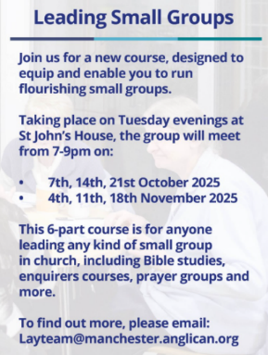Training for lay people – pilot course of 6 weeks at St John’s House. Limited numbers. See separate email. Looks very interesting. Is this your calling?

**ALM Authorisation Service**

Manchester Cathedral, 2.30pm, Saturday 20th Sept. All welcome to see Julie Doherty licensed to the benefice.

**MacMillan Afternoon Tea**

Christ Church, Healey, 27th September.

**FUTURE DATES Neil Diamond Tribute.**  Sat, 4th October, 7pm, St Clements Church, Spotland. Tickets £10. Contact Estelle on 07459 849274

**Art Exhibition and Craft Fayre**

St Ann’s Hall, Saturday 15th November.