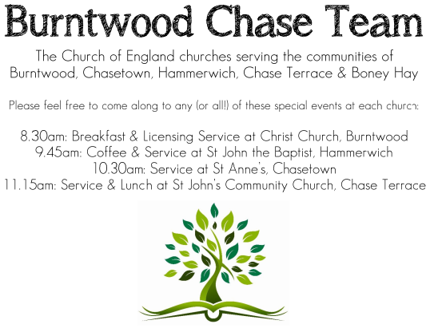 **CHRIST CHURCH**

SUNDAY 7th September 2025 at 10am

**SERVICES:**

**Sunday 7th September 2025**

**Holy Communion**

**12th Sunday after Trinity**

**Readings:**

**Philemon 1-21**

**1**Paul, a prisoner of Christ Jesus, and Timothy our brother, To Philemon our dear friend and co-worker, **2**to Apphia our sister to Archippus our fellow-soldier, and to the church in your house:

**3**Grace to you and peace from God our Father and the Lord Jesus Christ.

**4**When I remember youin my prayers, I always thank my God **5**because I hear of your love for all the saints and your faith towards the Lord Jesus. **6**I pray that the sharing of your faith may become effective when you perceive all the good that we may do for Christ. **7**I have indeed received much joy and encouragement from your love, because the hearts of the saints have been refreshed through you, my brother.

**8**For this reason, though I am bold enough in Christ to command you to do your duty, **9**yet I would rather appeal to you on the basis of love—and I, Paul, do this as an old man, and now also as a prisoner of Christ Jesus. **10**I am appealing to you for my child, Onesimus, whose father I have become during my imprisonment. **11**Formerly he was useless to you, but now he is indeed usefulboth to you and to me. **12**I am sending him, that is, my own heart, back to you. **13**I wanted to keep him with me, so that he might be of service to me in your place during my imprisonment for the gospel; **14**but I preferred to do nothing without your consent, in order that your good deed might be voluntary and not something forced. **15**Perhaps this is the reason he was separated from you for a while, so that you might have him back for ever, **16**no longer as a slave but as more than a slave, a beloved brother—especially to me but how much more to you, both in the flesh and in the Lord.

**17**So if you consider me your partner, welcome him as you would welcome me. **18**If he has wronged you in any way, or owes you anything, charge that to my account. **19**I, Paul, am writing this with my own hand: I will repay it. I say nothing about your owing me even your own self. **20**Yes, brother, let me have this benefit from you in the Lord! Refresh my heart in Christ. **21**Confident of your obedience, I am writing to you, knowing that you will do even more than I say.

**22**One thing more—prepare a guest room for me, for I am hoping through your prayers to be restored to you.

**23**Epaphras, my fellow-prisoner in Christ Jesus, sends greetings to you, **24**and so do Mark, Aristarchus, Demas, and Luke, my fellow-workers.

**25**The grace of the Lord Jesus Christ be with your spirit.

**Luke 14: 25-33**

**25**Now large crowds were travelling with him; and he turned and said to them, **26**‘Whoever comes to me and does not hate father and mother, wife and children, brothers and sisters, yes, and even life itself, cannot be my disciple. **27**Whoever does not carry the cross and follow me cannot be my disciple. **28**For which of you, intending to build a tower, does not first sit down and estimate the cost, to see whether he has enough to complete it? **29**Otherwise, when he has laid a foundation and is not able to finish, all who see it will begin to ridicule him, **30**saying, “This fellow began to build and was not able to finish.” **31**Or what king, going out to wage war against another king, will not sit down first and consider whether he is able with ten thousand to oppose the one who comes against him with twenty thousand? **32**If he cannot, then, while the other is still far away, he sends a delegation and asks for the terms of peace. **33**So therefore, none of you can become my disciple if you do not give up all your possessions.

**COLLECT FOR TODAY**

Almighty and everlasting God,

you are always more ready to hear than we to pray

and to give more than either we desire or deserve:

pour down upon us the abundance of your mercy,

forgiving us those things of which our conscience

is afraid

and giving us those good things

which we are not worthy to ask

but through the merits and mediation

of Jesus Christ your Son our Lord,

who is alive and reigns with you,

in the unity of the Holy Spirit,

one God, now and for ever.

***WHAT’S GOING ON***

**Upcoming Services**

**Sunday 7th September Holy Communion 10am**

**Wednesday 10th September Morning Prayer 9.30am**

**Sunday 14th September Morning Worship 10am**

**Wednesday 17th September Morning Prayer 9.30am**

**MOB next meeting 10th September 7.00 for 7,30 at St. Mathews**

**FLOODLIGHTING**If you think about commemorating a special occasion by floodlighting our Church.  Please contact Chris Brown on 01543 683862 for details.

PRAYER CHAIN

Christ Church is blessed with a very active prayer chain. If you, or anyone you know, feel that they would like others to pray for them, please speak to Chris Brown on 01543 683862.

HOME COMMUNION

For anyone who is unable to attend church and would like Home Communion,

Steve Morgan is able to carry this out.

VICAR CONTACT DETAILS

Stephen Morgan Tele: 07305 852152

**CHURCH WARDENS CONTACT DETAILS**

**Judith Rogers Tele: 01543 324718**

**Mike Holmes Tele: 01543 672970**

**Church Office Tele: 01543 642187** *[leave a message and we will respond]*

Church Web Site:www.christchurchburntwood.org.uk

Church Email: [christchurchburntwood15@gmail.com](mailto:christchurchburntwood15@gmail.com)

Facebook: [www.facebook.com/group/christchurchburntwood/](http://www.facebook.com/group/christchurchburntwood/)

**Other Contacts**

**Matt Wallace St. John’s, Chase Terrace— Tele: 01543 670078**

**Richard Westwood St. Anne’s, Chasetown—Tele: 01543 686111**

**NEXT SUNDAY SERVICE**

**Sunday 14th September at 10am**

**Morning Worship**

**1Timothy 1: 12-17**

**Luke 15: 1-10**

**13th Sunday after Trinity**