St Peter and the Holy Apostles, Plymouth- Sunday 28th September 2025

**The Twentieth-Sixth Week in Ordinary Time *(Year C)***

*Welcome to the Parish Mass*

Welcome to St Peters Church. This sheet provides all that you will need for today’s Mass. If you need any assistance before, during or after the service or need a large print copy of this order of service please speak to one of our welcome team. (identifiable by a lanyard)  
Please respond to the words in non-italic **Bold,** The **Hymns** are sung by all. Please inform the people on the door when you enter if you require a **Gluten Free** Host

…………………………………………………………………………………

*We Stand for* ***The Entrance Hymn***

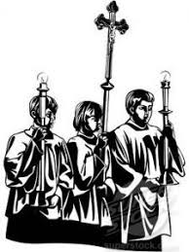**1.** Immortal, invisible, God only wise,  
in light inaccessible hid from our eyes,  
most blessèd, most glorious, the Ancient of Days,  
almighty, victorious, thy great name we praise.  
  
**2.** Unresting, unhasting, and silent as light,  
nor wanting, nor wasting, thou rulest in might;  
thy justice like mountains high soaring above  
thy clouds which are fountains of goodness and love.   
  
**3.** To all life thou givest, to both great and small;  
in all life thou livest, the true life of all;  
we blossom and flourish as leaves on the tree,  
and wither and perish; but naught changeth thee.  
  
**4.** Great Father of glory, pure Father of light,  
thine angels adore thee, all veiling their sight;  
all laud we would render: O help us to see  
'tis only the splendour of light hideth thee.

***The*** ***Introductory Rite***

In the name of the Father and of the Son and of the Holy Spirit. **Amen.**

*Following the greeting we respond*.

**And with your spirit.**

*The Priest introduces the Mass*

***The Penitential Rite***

Brothers and sisters, let us acknowledge our sins,

and so prepare ourselves to celebrate the sacred mysteries.

**I confess to almighty God and to you, my brothers and sisters, that I have greatly sinned, in my thoughts and in my words, in what I have done and in what I have failed to do, through my fault, through my fault, through my most grievous fault; therefore I ask blessed Mary ever-Virgin, all the Angels and Saints, and you, my brothers and sisters, to pray for me to the Lord our God.**

May almighty God have mercy on us, forgive us our sins, and bring us to everlasting life. **Amen.**

*Either:*

Lord, have mercy. **Lord, have mercy.**

Christ, have mercy. **Christ, have mercy.**

Lord, have mercy. **Lord, have mercy.**

*Or:*

Kyrie, eleison. **Kyrie, eleison.**

Christe, eleison. **Christe, eleison.**Kyrie, eleison. **Kyrie, eleison.**

***The Gloria***

**Glory to God in the highest,** **and on earth peace to people of good will.**   
**We praise you,** **we bless you,** **we adore you,** **we glorify you,** **we give you thanks for your great glory,** **Lord God, heavenly King,** **O God, almighty Father.**  
**Lord Jesus Christ, Only Begotten Son,** **Lord God, Lamb of God, Son of the Father,** **you take away the sins of the world,** **have mercy on us;** **you take away the sins of the world,** **receive our prayer;** **you are seated at the right hand of the Father,** **have mercy on us.**  
**For you alone are the Holy One,** **you alone are the Lord,** **you alone are the Most High,** **Jesus Christ,** **with the Holy Spirit,** **in the glory of God the Father.** **Amen.**

***The Collect***

Let us pray.

O God, who manifest your almighty power above all by pardoning and showing mercy, bestow, we pray, your grace abundantly upon us and make those hastening to attain your promises heirs to the treasures of heaven. Through our Lord Jesus Christ, your Son, who lives and reigns with you in the unity of the Holy Spirit, God, for ever and ever. **Amen.**

*We sit for* ***The First Reading***- **Amos 6:1a, 4-7**

Thus says the Lord, the God of hosts: ‘Woe to those who are at ease in Sion, and to those who feel secure on the mountain of Samaria.

‘Woe to those who lie on beds of ivory and stretch themselves out on their couches, and eat lambs from the flock and calves from the midst of the stall, who sing idle songs to the sound of the harp and like David invent for themselves instruments of music, who drink wine in bowls and anoint themselves with the finest oils, but are not grieved over the ruin of Joseph! Therefore they shall now be the first of those who go into exile, and the revelry of those who stretch themselves out shall pass away.’

The word of the Lord. **Thanks be to God.**

***The Responsorial Psalm****-* ***Ps 146(145): 7. 8-9a. 9b-10. ℟5a***

**Response-** My soul, give praise to the Lord. ***R***

It is the Lord who does justice to those who are oppressed.

It is he who gives bread to the hungry, the Lord who sets prisoners free. ***R***

It is the Lord who opens the eyes of the blind,

the Lord who raises up those who are bowed down.

It is the Lord who loves the just, the Lord who protects the stranger. ***R***

The Lord upholds the orphan and the widow, but thwarts the path of the wicked.

The Lord will reign for ever, your God, O Sion, from age to age. ***R***

***The Second reading- 1 Timothy 6:11-16***

O man of God, pursue righteousness, godliness, faith, love, steadfastness, gentleness. Fight the good fight of the faith. Take hold of the eternal life to which you were called and about which you made the good confession in the presence of many witnesses. I charge you in the presence of God, who gives life to all things, and of Christ Jesus, who in his testimony before Pontius Pilate made the good confession, to keep the commandment unstained and free from reproach until the appearing of our Lord Jesus Christ, which he will display at the proper time — he who is the blessed and only Sovereign, the King of kings and Lord of lords, who alone has immortality, who dwells in unapproachable light, whom no one has ever seen or can see. To him be honour and eternal dominion. Amen.

The word of the Lord. **Thanks be to God**

*We stand for-* ***The Gospel Procession and Acclamation***- **2 Corinthians 8:9**



Alleluia, alleluia.

Jesus Christ, though he was rich,

yet for your sake he became poor,

so that you by his poverty might become rich.

Alleluia.

***The Gospel- Luke 16:19-31***

The Lord be with you. **And with your spirit.**

A reading from the holy Gospel according to *N*. **Glory to you, O Lord.**

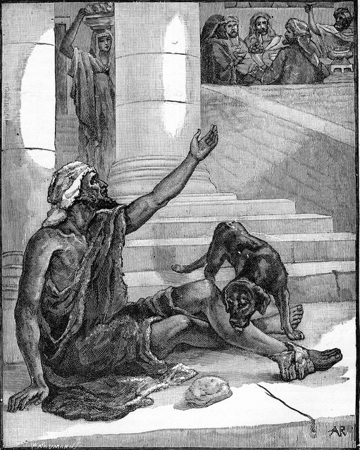At that time: Jesus said to the Pharisees, ‘There was a rich man who was clothed in purple and fine linen and who feasted sumptuously every day. And at his gate was laid a poor man named Lazarus, covered with sores, who desired to be fed with what fell from the rich man’s table. Moreover, even the dogs came and licked his sores. The poor man died and was carried by the angels to Abraham’s side. The rich man also died and was buried, and in Hades, being in torment, he lifted up his eyes and saw Abraham far off and Lazarus at his side. And he called out, “Father Abraham, have mercy on me, and send Lazarus to dip the end of his finger in water and cool my tongue, for I am in anguish in this flame.” But Abraham said, “Child, remember that you in your lifetime received your good things, and Lazarus in like manner bad things; but now he is comforted here, and you are in anguish. And besides all this, between us and you a great chasm has been fixed, in order that those who would pass from here to you may not do so, and none may cross from there to us.” And he said, “Then I beg you, father, to send him to my father’s house — for I have five brothers — so that he may warn them, lest they also come into this place of torment.” But Abraham said, “They have Moses and the Prophets; let them hear them.” And he said, “No, father Abraham, but if someone goes to them from the dead, they will repent.” He said to him, “If they do not hear Moses and the Prophets, neither will they be convinced if someone should rise from the dead.” ’

The Gospel of the Lord. **Praise to you, Lord Jesus Christ.**

*We sit for* ***The Homily***

*We stand* ***The Creed***

**I believe in one God,** **the Father almighty,** **maker of heaven and earth,**

**of all things visible and invisible.**

**I believe in one Lord Jesus Christ,** **the Only Begotten Son of God,** **born of the Father before all ages.** **God from God,** **Light from Light,** **true God from true God,** **begotten, not made, consubstantial with the Father;** **through him all things were made.** **For us men and for our salvation he came down from heaven,**

*At the words that follow, up to and including ‘and became man’, all bow.*

**and by the Holy Spirit was incarnate of the Virgin Mary,** **and became man.**

**For our sake he was crucified under Pontius Pilate,** **he suffered death and was buried,** **and rose again on the third day** **in accordance with the Scriptures.**

**He ascended into heaven** **and is seated at the right hand of the Father.** **He will come again in glory** **to judge the living and the dead** **and his kingdom will have no end.**  
**I believe in the Holy Spirit, the Lord, the giver of life,** **who proceeds from the Father and the Son,** **who with the Father and the Son is adored and glorified,** **who has spoken through the prophets.  
I believe in one, holy, catholic and apostolic Church.** **I confess one Baptism for the forgiveness of sins** **and I look forward to the resurrection of the dead** **and the life of the world to come. Amen.**

*……………………………………………………………………………..*

*We remain standing for* ***The Prayers of the Faithful***

*Each biding concludes with the following said or sung-*

We pray to the Lord. **Lord in your Mercy hear our prayer.**

*The Priest Concludes the Prayers of the Faithful*

*……………………………………………………………………………..*

*No collection is taken during the Mass, but there is a collection box at the back of church for you to give your financial contribution. All money collected helps towards the mission and ministry of our churches. If you would prefer, a card reading machine is available at the back of the church for your contribution.*

***The Offertory Hymn***

**1.** Longing for light, we wait in darkness.   
Longing for truth, we turn to you.   
Make us your own, your holy people,   
light for the world to see.  
*Christ, be our light!   
Shine in our hearts.   
Shine through the darkness.   
Christ, be our light!   
Shine in your church gathered today.*

**2.** Longing for peace, our world is troubled. Longing for hope, many despair. Your word alone has power to save us. Make us your living voice. *Christ, be our light…*

**3.** Longing for food, many are hungry.   
Longing for water, many still thirst.   
Make us your bread, broken for others,   
shared until all are fed. *Christ, be our light…*

**4.** Longing for shelter, many are homeless.   
Longing for warmth, many are cold.   
Make us your building, sheltering others,   
walls made of living stone.  
*Christ, be our light…*

**5.** Many the gifts, many the people,   
many the hearts that yearn to belong.   
Let us be servants to one another,   
making your kingdom come.  
*Christ, be our light…*

***The Liturgy of the Eucharist***

Pray, brethren **(**brothers and sisters**)**, that my sacrifice and yours may be acceptable to God, the almighty Father.  
**May the Lord accept the sacrifice at your hands** **for the praise and glory of his  
name,** **for our good** **and the good of all his holy Church.**

The Lord be with you. **And with your spirit.**

Lift up your hearts. **We lift them up to the Lord.**  
Let us give thanks to the Lord our God. **It is right and just.**

*The Priest continues with the Preface. The Sanctus is the said or sung:*

**Holy, Holy, Holy Lord God of hosts.**

**Heaven and earth are full of your glory.** **Hosanna in the highest.**

**Blessed is he who comes in the name of the Lord.** **Hosanna in the highest.**

*The Priest continues the Eucharistic prayer. The following is said or sung*

The mystery of faith….  
**We proclaim your Death, O Lord,** **and profess your Resurrection** **until you come again.**

*The Priest concludes the Eucharistic prayer.*

Through him, and with him, and in him, O God, almighty Father, in the unity of the Holy Spirit, all glory and honour is yours, for ever and ever. **Amen.**

***The Lord’s Prayer***

At the Saviour’s command and formed by divine teaching, we dare to say:

**Our Father, who art in heaven,** **hallowed be thy name;** **thy kingdom come,** **thy will be done** **on earth as it is in heaven.** **Give us this day our daily bread,** **and forgive us our trespasses,** **as we forgive those who trespass against us;** **and lead us not into temptation,** **but deliver us from evil.**

Deliver us, Lord, we pray… and the coming of our Saviour, Jesus Christ.  
**For the kingdom,** **the power and the glory are yours** **now and for ever.**

***The Peace***

Lord Jesus Christ, who said to your Apostles: Peace I leave you, my peace I give you,

look not on our sins, but on the faith of your Church, and graciously grant her peace and unity in accordance with your will. Who live and reign for ever and ever. **Amen.**

The peace of the Lord be with you always: **And with your spirit.**

Let us offer each other the sign of peace.

*All are invited to make an acknowledgement to each other to mark the sign of the peace.*

***The Agnus Dei***

*All say or sing:***Lamb of God, you take away the sins of the world,** **have mercy on us.**

**Lamb of God, you take away the sins of the world,** **have mercy on us.**

**Lamb of God, you take away the sins of the world,** **grant us peace.**

***The Invitation to Communion***

Behold the Lamb of God, behold him who takes away the sins of the world. Blessed are those called to the supper of the Lamb. **Lord, I am not worthy** **that you should enter under my roof,** **but only say the word and my soul shall be healed.**

*All who are regular communicants in their own tradition are welcome to receive the*  *sacrament if you are not a communicant you are welcome to come forward at this point in the service to receive a blessing To indicate that it is just a blessing you require, please take this service sheet up with you. We have returned to offering the chalice at the time of communion but please do not feel any pressure to receive from the common cup as the church teaches that the sacrament is received fully in one kind. We request that you do not* ***intinct (dip) your host in the Chalice*** *but either take a sip from the cup or return directly to your seat. This is for reasons of good hygiene.*

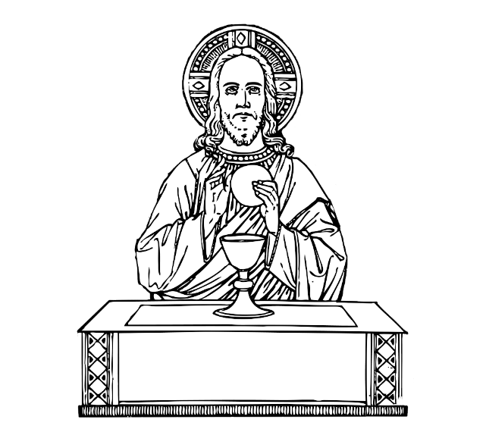***The Communion Hymn***

**1.** Soul of my Saviour, sanctify my breast,  
body of Christ, be thou my saving guest,  
blood of my Saviour, bathe me in thy tide,  
wash me with water flowing from thy side.

**2.** Strength and protection may thy Passion be,  
O blessèd Jesu, hear and answer me;  
deep in thy wounds, Lord, hide and shelter me,   
so shall I never, never part from thee.

**3.** Guard and defend me from the foe malign,  
in death's dread moments make me only thine;  
call me and bid me come to thee on high  
where I may praise thee with thy saints for ay.

*We stand for* ***The Prayer After Communion***

May this heavenly mystery, O Lord, restore us in mind and body, that we may be coheirs in glory with Christ, to whose suffering we are united whenever we proclaim his Death. Who lives and reigns for ever and ever. **Amen**

*We remain standing for* **Our Mission Prayer for 2025**Lord Jesus, you call us to be your missionary disciples.

Guide and strengthen us to share your love with all we meet.

Give us courage to reach out to help others.

Give us wisdom to know how best to care,

And give us hope to believe we can make a difference.

Bless us all who bring your compassion and mercy to the poor and marginalised.

Together, may we make known your love on earth.

We make our prayer through Christ Our Lord. **Amen.**

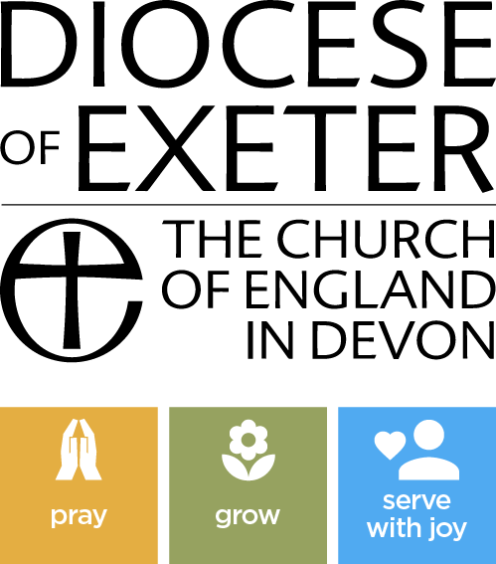

*The priest may give some brief notices*

***The Concluding Rites***

The Lord be with you. **And with your spirit.**

May almighty God bless you, the Father, and the Son, ✠ and the Holy Spirit. **Amen.**

***The Dismissal***

Go forth, the Mass is ended. **Thanks be to God**

***The Final Hymn***

**1.** For the healing of the nations,  
Lord, we pray with one accord;  
For a just and equal sharing  
Of the things that earth affords.  
To a life of love in action  
Help us rise and pledge our word.

**2.** Lead us, Father, into freedom,  
From despair the world release;  
That, redeemed from war and hatred,  
Men may come and go in peace.  
Show us how through care and goodness  
Fear will die and hope increase.

**3.** All that kills abundant living,  
Let it from the earth be banned;  
Pride of status, race or schooling,  
Dogmas keeping man from man.  
In our common quest for justice  
May we hallow life’s brief span.

**4.** You Creator-God have written  
Your great Name on all mankind;  
For our growing in Your likeness  
Bring the life of Christ to mind;  
That, by our response and service  
Earth its destiny may find.

***The Angelus***

The Angel of the Lord declared unto Mary.  
**And she conceived of the Holy Spirit.**

Hail Mary, full of grace, The Lord is with Thee;  
Blessed art thou among women,  
And blessed is the fruit of thy womb, Jesus.   
**Holy Mary, Mother of God, Pray for us sinners,  
Now and at the hour of our death.**

Behold the handmaid of the Lord.  
**Be it done to me according to thy word.**

*Hail Mary. . .*

And the Word was made flesh.  
**And dwelt among us.** *Hail Mary…*

Pray for us, O holy Mother of God.  
**That we may be made worthy of the promises of Christ.**

Let us pray:

Pour forth, we beseech Thee, O Lord, Thy grace into our hearts, that we to whom the Incarnation of Christ Thy Son was made known by the message of an angel, may by His Passion and Cross be brought to the glory of His Resurrection. Through the same Christ Our Lord. **Amen.**

***For Prayer***

**Those who have asked for our prayers….** Denise, Janice Allin, Leslie Porch, Sheila Tucker, Tina Smart, Kathy Haydon, Bobby Lilicrap, June Brock, Emma Addison, Georgie Maher, Ian Craggs, Brenda Alderson, Lois Tobin, Michael O’Leary, Brenda Steed, Anne Lewis, Jenny Harvey, Jackie Morrison, Fr Roger Beck, Anna, Gwen Lamb, Anna Lynch, Jackie Fisher, Helen Lewis, Val Bradden, Cynthia Way, Pauleen Stewart, Amelia Coughlan, Roger Lewis, Sarah Cavey, Shaun Carrie

**Recently Departed**- Audrey Dewey, Gordon Walters, Charles Curvengen-Pitt

**Anniversaries of Death**

***The Notices***

**Coffee, Cleaning and Cake**, or as we like to call it “Shiney Church” returns on Saturdays between 11.00 and Noon

**St Gabriels- Peverell Feast of Title**- There will be evening prayer followed by refreshments at St Gabriels on **TODAY at 5pm**- All welcome.

Advance notice- St Peters will be holding a Quiz on Saturday 18th October and an **Autumn Fair on Saturday 25th October-** Please keep this date available, help will be needed at the event and for preparation.

**Training Event for our Winter Night Shelter- PROJECT 58:7 Help The Homeless**- A day of training for volunteers to support churches overnight provision. We're partnering with the local charity PATH to offer winter provision for rough sleepers because it combines practical support, community responsibility, and compassion into a meaningful initiative. **Saturday 4th October 9.30am- 3pm at St Marks Church, Ford- if you are interested in this event please speak to Ben**

We thank Bishop Paul, The Bishop of Oswestry, our bishop for the time and work he has put into transforming his parishes in Plymouth! The batten has now been handed to us and there will be lots of change but also lot’s of new opportunities to develop our lives as disciples! If you have any thoughts about how **you** can contributr to this changing situation please tell Fr David

The Mission Community of St Peter and the Holy Apostles

*St Peter, Wyndham Square + St Thomas, Royal Navy Avenue + St James-the-Less, Ham Drive*

**A Church of England Parish in the care of the Bishop of Oswestry**

**Parish Priest Fr. David Way SSC: 01752 240119** fr.davidway@gmail.com

.com

**Mission Development Minister/ LLM/ Parish Ordinand: Ben Otley 07939800544** benotley.mission.plym@gmail.com

**Parish Website**: **plymouthstpeter.co.uk ~ *FOR MUCH MORE INFORMATION ON EVENTS, ETC.***

***This week’s services***

|  |  |  |
| --- | --- | --- |
| **Sunday 28th-**  **The Twenty-Sixth Sunday in Ordinary Time**  *(Psalter Week 2)* | **8.30am St Thomas Fr DCW**  **10.00am St Peter Fr DCW** | **Mass with Hymns**  **Sung Mass** |
| Monday 29th- **St Michael, St Gabriel and St Raphael, archangels** | St Peter 10.00am Fr PL | Mass |
| Tuesday 30th- St Jerome | St Peter 10.00am Fr DCW | Mass |
| Wednesday 1st October- St Therese of the Child Jesus *(of Lisieux)* | St Peter 10.00am Fr DCW | Mass |
| Thursday 2nd- The Holy Guardian Angels | St Peter 10.00am Fr DCW | Mass |
| Friday 3rd- Weekday in OT | St Peter 10.00am Fr DCW  St Peter 11.30 | Sung Mass  Funeral Rite |
| Saturday 4th- St Francis of Assisi | St Peter 10.00am Fr ?? | Mass |
| **Sunday 5th-**  **The Twenty-Seventh Sunday in Ordinary Time**  *(Psalter Week 3)* | **8.30am St Thomas Fr DCW**  **10.00am St Peter Fr DCW** | **Mass with Hymns**  **Sung Mass** |

**St Peters is open daily 8.30am- 12noon- Place of Welcome, Place of Prayer, food larder etc.**

**Safeguarding:** If you have any concerns regarding the safety of children and others who are vulnerable, regardless of age, you must tell the Duty Priest or our parish Lay Safeguarding Representative- Jackie Morrison- email randj49@gmail.com Tel 07848859124.

***For online donations please scan the QR code***