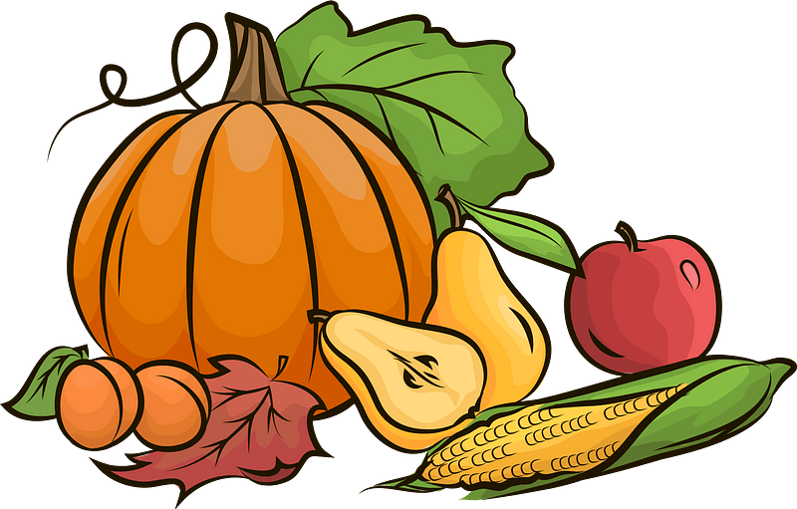

**SUNDAY**

11am Family Service

*Rev.Pete & Aletta*

**MICHAEL and ALL ANGELS**

**29th Sept.**

*St Michael is an archangel, whose name means ‘who is like unto God?’  He makes various appearances throughout the Bible, from the book of Daniel to the Book of Revelation.  In Daniel, he is ‘one of the princes’ of the heavenly host, and the special guardian of Israel.  In Revelation, he is the principal fighter of the heavenly battle against the devil.*

*From early times, St Michael’s cult was strong in the British Isles.  St Michael’s Mount in Cornwall was believed to commemorate a vision there in the 8th century.  By the end of the Middle Ages, St Michael had 686 English churches dedicated to him.*

*In art St Michael is often depicted as slaying the dragon, as in the 14th century East Anglican Psalters, or in Epstein’s famous sculpture at Coventry cathedral.  Or he is found (in medieval art) as weighing souls, as at Martham in Suffolk.  St Michael’s most famous shrine in western Europe is Mont-Saint-Michel, where a Benedictine abbey was founded in the 10th century.*

*The ‘All Angels’ bit of this feast-day was added in 1969 when Gabriel and Raphael were included in with St Michael.*

**WEDNESDAY** (1st Oct.)

***service is in St. Barnabas***

Services next week

**Sun 5th Oct** 8:00am St. J Holy Communion

9:30am St. B Morning worship

11:00am St. J Morning Worship

6:30pm St. J Evensong

**Weds 8th** **Oct**  10:30am St.J Holy Communion

**A prayer for those with empty cupboards**

Compassionate God, as we celebrate a full harvest table, we remember those whose cupboards are bare. We pray for every family worried about their next meal; for parents skipping meals so their children can eat; and for anyone facing isolation and hunger on their own, we ask and pray that You’ll provide for them and bring them hope.

**AMEN**

*Please also continue to pray for*, Guy Negus, Derek Cotgrove, Derek & Pam Johnson, Edward Hollis, ,Lisa Camelleri and all those who are finding life a struggle at the moment.

**Looking Ahead**

**Every Tues**.10:30am Kettle’s On at St. Barnabas

**Sat 11th** am Beat’n’Beans with Monday Folk

The

**Mon 13th** 10am Churchyard working party