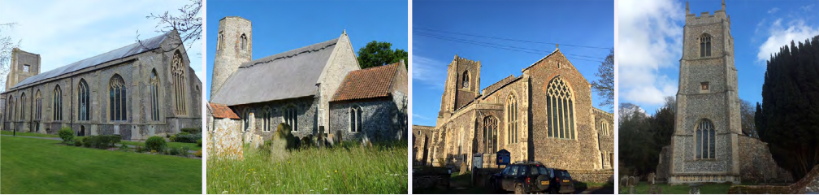
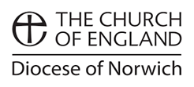
N.E.W.
North Walsham
Edingthorpe
Worstead and Westwick
NEWS
The Magazine for the North Walsham Benefice October 2025 40p
Transformed by Christ: Prayerful, Pastoral, Prophetic

Editor’s Bit

Contents in this issue:
- Vicar’s Page
- From the assistant curate
- Dates from the Diary
- October service Dates
- Upcoming Events
- Christmas services for 2025
We hope to see you at our services; you are all welcome.

Please note the date for items to go in the November edition of NEWS needs to be at the Parish office by October 20th latest.

It was announced in September that the Revd Canon Susanna Gunner has been appointed to a part time role in the Brooke and Hempnall Benefices with a probable start there in the New Year. We pray for Susanna and Ben, thank them for all they have given this community, and pray for the parishes that will be receiving Susanna as their new priest.

Financial Information

Please may we remind you, that if you are giving us a cheque for any of the Churches, they need to be made payable to the following:
St Nicholas’ Church – North Walsham PCC
All Saints’ – Edingthorpe PCC
St Mary’s – Worstead PCC
St Botolph’s – Diocesan Churches Trust

Please may we ask if you are sending any payments to us via an online service that you put a meaningful reference on the payment to ensure we know where the payment should go to.

Live-streamed services are available on YouTube - please search St Nicholas North Walsham. Do you participate in our live-streamed services - we would love to hear your feedback: contact David on 07506 723946 or davidnorthwalsham@gmail.com

If you are considering a change to your Committed Giving for St. Nicholas, please inform Chris Sherman (Committed Giving Officer)
Please support St. Nicholas Church, North Walsham on #easyfundraising, you can raise FREE donations when you shop online with over 5,000 retailers. It is simple and only takes 2 minutes to sign up! Plus, once you have raised your first £15, easy fundraising will match it!
Sign up now: https://www.easyfundraising.org.uk/causes/stnicholaschurchnw/

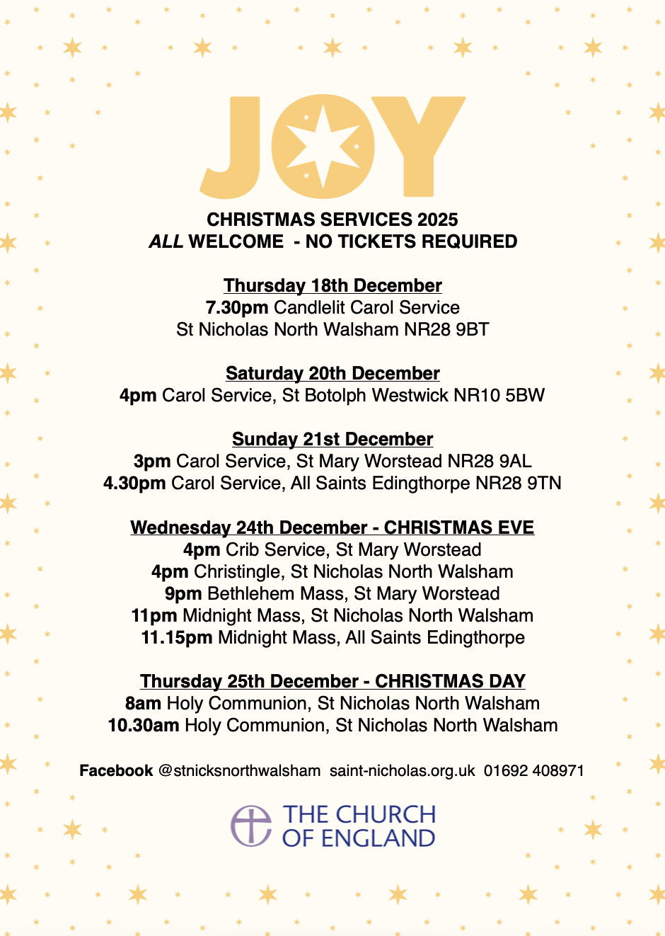
The Vicar’s page:
From David:
As October begins and leaves change colour there's lots going on - do join us for the events, services and opportunities that are detailed in this magazine.

One new event this October is a special service of commemoration on 15th October at 6.45pm, during Baby Loss Awareness Week (9th-15th October). A large proportion of people do at some time encounter this - ways of grieving and remembering have changed over the years, and this year we stand in solidarity with all those who have encountered this loss. During the week, the Market Cross will be lit in blue and pink as all who have been lost are remembered and in solidarity and prayer with their families.

You can find out more here www.babyloss-awareness.org

Thank you to all who offered their prayers and good wishes as Penny and I prepare for the birth of our child - we are well supported by friends and family, as well as the superb staff of the Norfolk and Norwich Hospital, many of them colleagues and friends too. We give thanks to God for all the blessings which we have been given.

Also in October, we open the second 'Field of Remembrance' in the Memorial Park - this will be a public place where members of the community can lay wreaths and poppies, to give thanks for those who gave themselves in the cause of freedom. The Field will be open from 23rd October until after Armistice Day.

With my prayers and good wishes,

David

The Curate’s Page
It is almost three months since I’ve started my ministry to the people of North Walsham Benefice and I loved every single day (so far so good)!
I remember those days before my ordination, especially my ordination retreat, when the imminent reality of the beginning of my ministry was slightly scary.
There I was, doing church since I was born, doing it even more from the age of 16 knowing what path I want to follow in the future.
And now, at the age of 30 it all comes to be the new reality.
The imposter syndrome kicked in, worries of lack of training, not enough knowledge and/or theological wisdom…
All these disappeared when I came to be amongst you all.
You welcomed me as I am and for who I am and stand for.
And so, three months in feels like much longer, because of how good it feels to be here, how privileged I am to be able to be your Curate and how quickly you made me feel part of your community.
One of the busiest times of Church Year is about to begin.
I hope that with David’s help, and support from all of you, this first really busy time in my ministry will be full of unexpected joys and blessings.

Dan



Edingthorpe Village news for October

Dates for your diary
Services
12th October Holy Communion 9.15 a.m.
26th October Morning Prayer 9.15 a.m.
2nd November Patronal Choral Evensong 4 p.m.

Our thoughts and prayers are with Caroline and Christopher, Noel’s son and daughter. Caroline has written the article below about Noel’s life:
Noel Smith died peacefully at North Walsham Cottage Hospital on the 3rd of September. He was 94 years old. He was born on the 6th of December 1930 at Wood Farm, Honingham and was the second youngest of nine children. He moved his family to Edingthorpe in 1970 to live at Laverocks which was the former home of his Father and Aunt. His father, Richard, had been Churchwarden at Edingthorpe church for many years. He took a job with Cawston Wineries when he moved but in latter years persuaded them to buy a farm in Cawston which he ran for them until retirement. His heart was always in farming and the countryside and he loved his horses and dogs.
On a lovely sunny Sunday afternoon Edingthorpe Church held a pet service. There was a lovely assortment of happy dogs and cats with their owners and all very well behaved. Each pet was blessed by our vicar David and Dan. Afterwards tea and cakes were served with treats for our best friends!
In August we had a stall at the Church entrance in North Walsham and raised just over £400. in aid of Edingthorpe Church. All cakes and preserves were sold by 11 a.m. Bric a Brac and books were in high demand. Many thanks to all who helped to make it such a successful morning.
Our thanks go to Sue and her helpers who run a Coffee Morning on the 2nd Thursday of each month in St. Benet’s Hall. Do go along for a cup of coffee to support her.
On Thursday 11th December we will have our Christmas Coffee morning at St Benets Hall, North Walsham from 9am to 12 noon. There will be various stalls including cakes, bric a brac, tombola, crafts together with a Hamper Raffle. Further details will be in the next issue of the Village News but if anybody would like to help in any way please contact the number below.
All events about the Church are on https://www.achurchnearyou.com/church/10076/ or the village website www.edingthorpe.village.org.uk
June Hannant 01692 402337

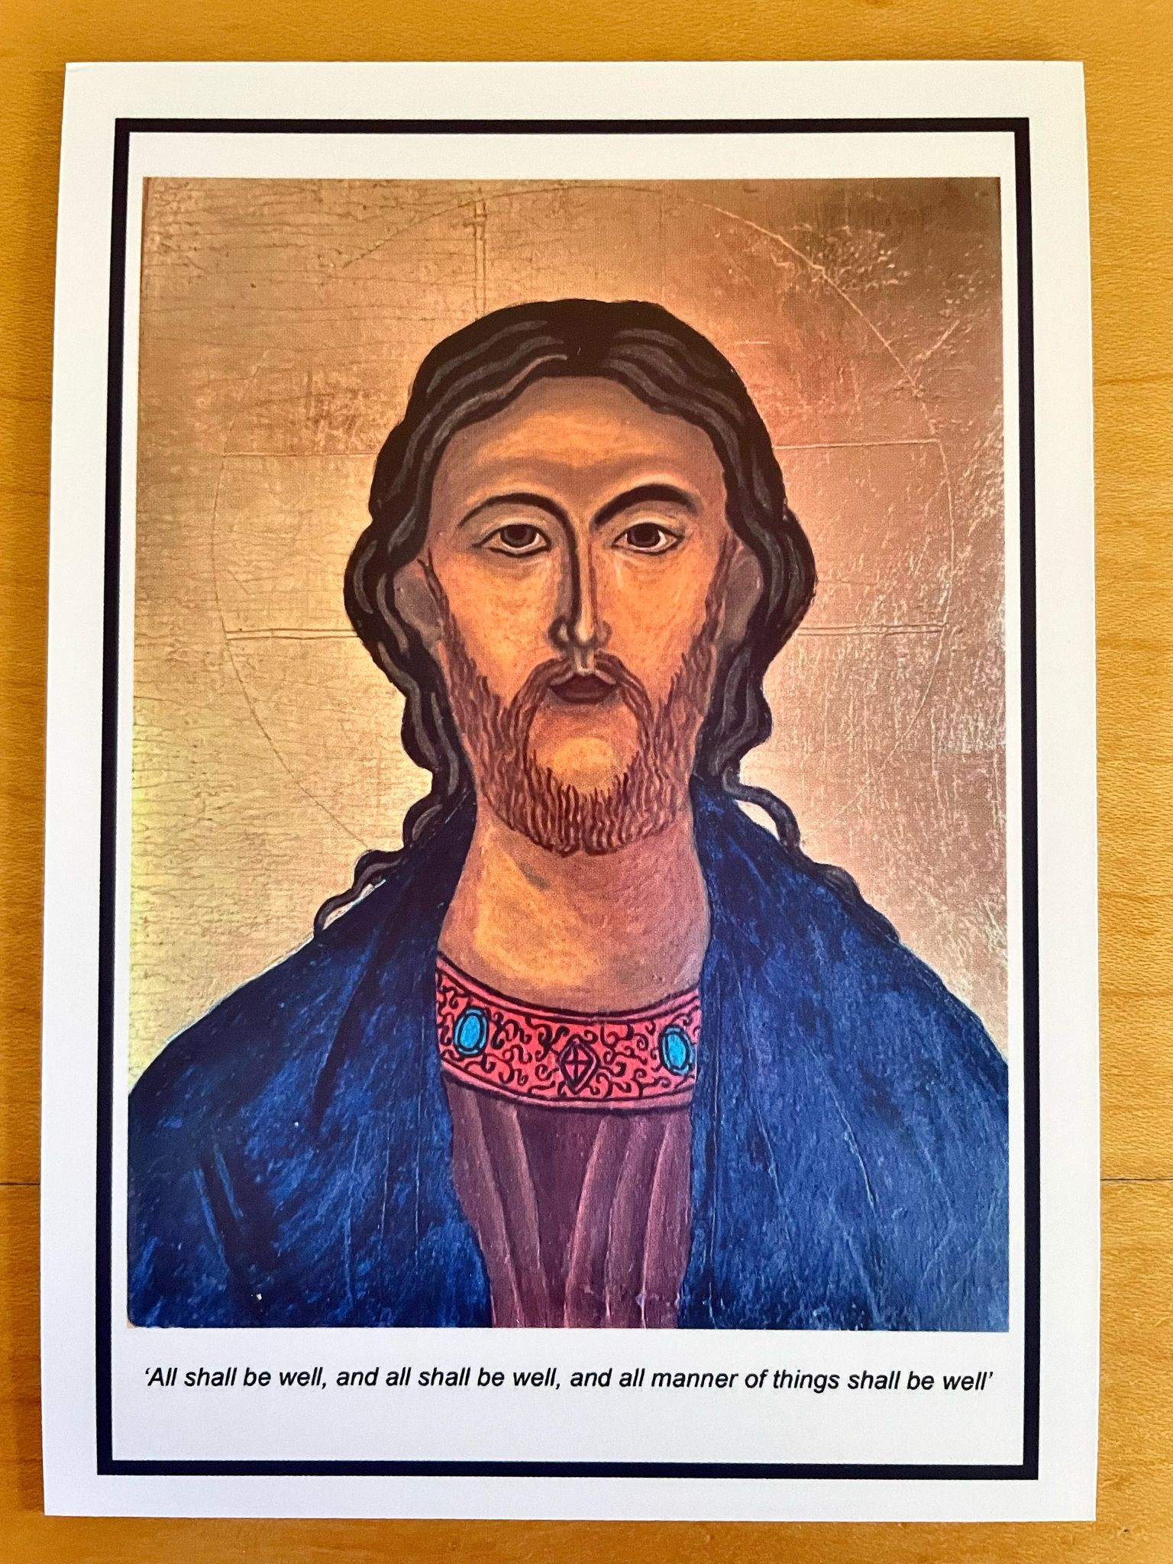
ST MARY’S WORSTEAD
As the ‘busy’ summer season draws to a close, we’ve time to reflect on our successes – porch window panes replaced, our new electronic door, complete with timer, and, of course, the Festival.

We were blessed with good weather and an enormous number of visitors who came to the many craft stalls and beautiful floral displays. Our hard-working catering team worked wonders with all the delicacies they produced, to say nothing of endless teas and coffees. Over £3000 was raised, on refreshments alone, thanks to their hard work and our ever-generous customers.

Our Patronal service, in August, was well supported, with a congregation of some thirty six people, all of whom were made welcome. Coffee & biscuits rounded off an enjoyable morning.

Autumn approaches, and with it, our thoughts turn towards the Festive Season.
Events and Services already planned include:

23rd October - Worstead School Service - 2.15 pm
9th November - Remembrance Sunday service - 10.45 am
22nd November - “Made in Worstead” Craft Fair - 10am – 2pm
18th December - School Christingle Service - 2.15 pm
21st December - Carol Service - 3.00 pm
24th December - Crib Service - 4.00 pm
24th December - Midnight Mass (midnight in Bethlehem) - 9.00 pm

We look forward to seeing you all as we head towards the end of another rewarding year.

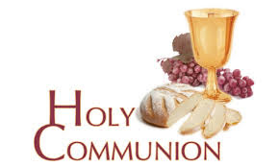
You may have read items in the press relating to the use of 'gluten free' wafers at Holy Communion - for those who require them, we use wafers which are approved and recommended for use by Coeliac UK - more information here. If you need a gluten free wafer, please advise the churchwardens/welcomers when you arrive for the service, and please indicate to the clergy distributing Holy Communion.
The Church teaches that receiving Holy Communion in both kinds (wafer and wine), or in one kind (the wafer or the wine) are acceptable and contain the fulness of the Sacrament. There are many reasons why this will be the case at different times in our lives, and there will be times when we cannot physically receive but join in an Act of Spiritual Communion (as those who watch online do - see below).

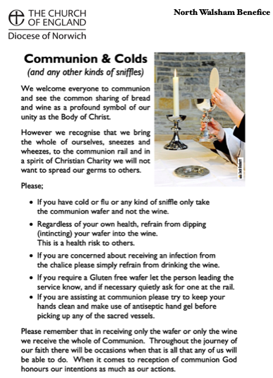
​Intinction (that is, dipping your wafer into the wine) is not permitted, both for hygiene reasons and because it might introduce gluten to the wine, which could be consumed by someone who is allergic to it.
If you wish to discuss any of this, please speak to David.

An Act of Spiritual Communion
In union, O Lord, with the faithful at every altar of your Church, where the Holy Eucharist is celebrated, I desire to offer you praise and thanksgiving. I present to you my soul and body with the earnest wish that I may always be united to you. And since I cannot now receive you sacramentally, I ask you to come spiritually into my heart.
I unite myself to you and embrace you with all the affections of my soul. Let nothing ever separate you from me. May I live and die in your love. Amen.



Why not come along to Sunday Kids and find out how to learn about what we do? We meet on the 1st and 3rd Sunday of the month at St Nicholas Church during the 10.30am service. You are most welcome.

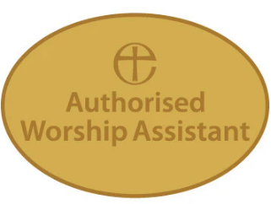

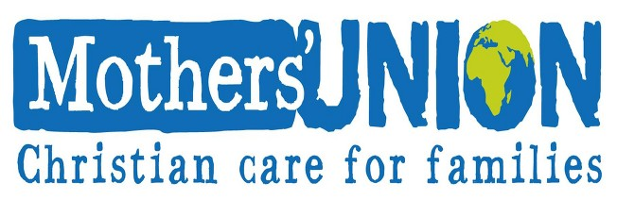

North Walsham Mothers’ Union. We meet in St Nicholas Room on the second Tuesday of the month at 2.00 p.m. Following a short act of worship and a few notices our speaker then takes the floor, after which, over tea and biscuits, there is an opportunity to ask questions and socialise. We usually finish about 3.30 pm.

Services for October

Wednesday 1st October
9am Morning Prayer at North Walsham
10am Worstead Wednesday coffee morning at the Village Hall
Thursday 2nd October
9am Morning Prayer at North Walsham
9.30am Market Day coffee morning in the St Nicholas Room
10.30am Holy Communion at North Walsham
Friday 3rd October
9am Morning Prayer at North Walsham
9.30am Quiet Prayer at North Walsham
Sunday 5th October 16th Sunday after Trinity
8am Holy Communion (1662) at North Walsham
9.15am Morning Prayer at Worstead
10.30am Holy Communion at North Walsham
5pm Choral Evensong at North Walsham
Monday 6th October
9am Morning Prayer at North Walsham
Tuesday 7th October
9am Morning Prayer at North Walsham
Wednesday 8th October
9am Morning Prayer at North Walsham
10am Worstead Wednesday coffee morning at the Village Hall
Thursday 9th October
9am Morning Prayer at North Walsham
9.30am Market Day coffee morning in the St Nicholas Room
10.30am Holy Communion at North Walsham
Friday 10th October
9am Morning Prayer at North Walsham
9.30am Quiet Prayer at North Walsham
Sunday 12th October - 17th Sunday after Trinity
8am Holy Communion (1662) at North Walsham
9.15am Holy Communion at Edingthorpe
10.30am Holy Communion at North Walsham
5pm Choral Evensong at North Walsham
Monday 13th October
9am Morning Prayer at North Walsham
Tuesday 14th October
9am Morning Prayer at North Walsham
2pm Mothers' Union meet in St Nicholas Room
Wednesday 15th October
9am Morning Prayer at North Walsham
10am Worstead Wednesday coffee morning at the Village Hall
6.45pm Baby Loss awareness week service at North Walsham
Thursday 16th October
9am Morning Prayer at North Walsham
9.30am Market Day coffee morning in the St Nicholas Room
10.30am Holy Communion at North Walsham
Friday 17th October
9am Morning Prayer at North Walsham
9.30am Quiet Prayer at North Walsham
Saturday 18th October
4pm Wedding at North Walsham
Sunday 19th October - 18th Sunday after Trinity
8am Holy Communion (1662) at North Walsham
9.15am Holy Communion at Worstead
10.30am Holy Communion at North Walsham
5pm Evening Prayer at North Walsham
Monday 20th October
9am Morning Prayer at North Walsham
Tuesday 21st October
9am Morning Prayer at North Walsham
9.30am Children's Society coffee morning in the St Nicholas Room
Wednesday 22nd October
9am Morning Prayer at North Walsham
10am Worstead Wednesday coffee morning at the Village Hall
Thursday 23rd October
9am Morning Prayer at North Walsham
9.30am Market Day coffee morning in the St Nicholas Room
10.30am Holy Communion at North Walsham
Friday 24th October
9am Morning Prayer at North Walsham
9.30am Quiet Prayer at North Walsham
Sunday 26th October - Last Sunday after Trinity
8am Holy Communion (1662) at North Walsham
9.15am Morning Prayer at Edingthorpe
10.30am Holy Communion at North Walsham
4pm Bereavement Service at North Walsham
Monday 27th October
9am Morning Prayer at North Walsham
Tuesday 28th October - Simon and Jude
9am Holy Communion at North Walsham
Wednesday 29th October
9am Morning Prayer at North Walsham
10am Worstead Wednesday coffee morning at the Village Hall
Thursday 30th October
9am Morning Prayer at North Walsham
9.30am Market Day coffee morning in the St Nicholas Room
10.30am Holy Communion at North Walsham
Friday 31st October
9am Morning Prayer at North Walsham
9.30am Quiet Prayer at North Walsham
Sunday 2nd November - All Saints
8am Holy Communion (1662) at North Walsham
9.15am Morning Prayer at Worstead
10.30am Holy Communion at North Walsham welcoming as our preacher Fr Ben Eadon CMP, Priest Administrator of the Shrine of Our Lady of Walsingham
4pm Patronal Choral Evensong at Edingthorpe followed by refreshments
Monday 3rd November
9am Morning Prayer at North Walsham
Tuesday 4th November
9am Morning Prayer at North Walsham
Wednesday 5th November
9am Morning Prayer at North Walsham
10am Worstead Wednesday coffee morning at the Village Hall
3.15pm Worstead PCC
7pm Edingthorpe PCC
Thursday 6th November
9am Morning Prayer at North Walsham
9.30am Market Day coffee morning in the St Nicholas Room
10.30am Holy Communion at North Walsham
Friday 7th November
9am Morning Prayer at North Walsham
9.30am Quiet Prayer at North Walsham
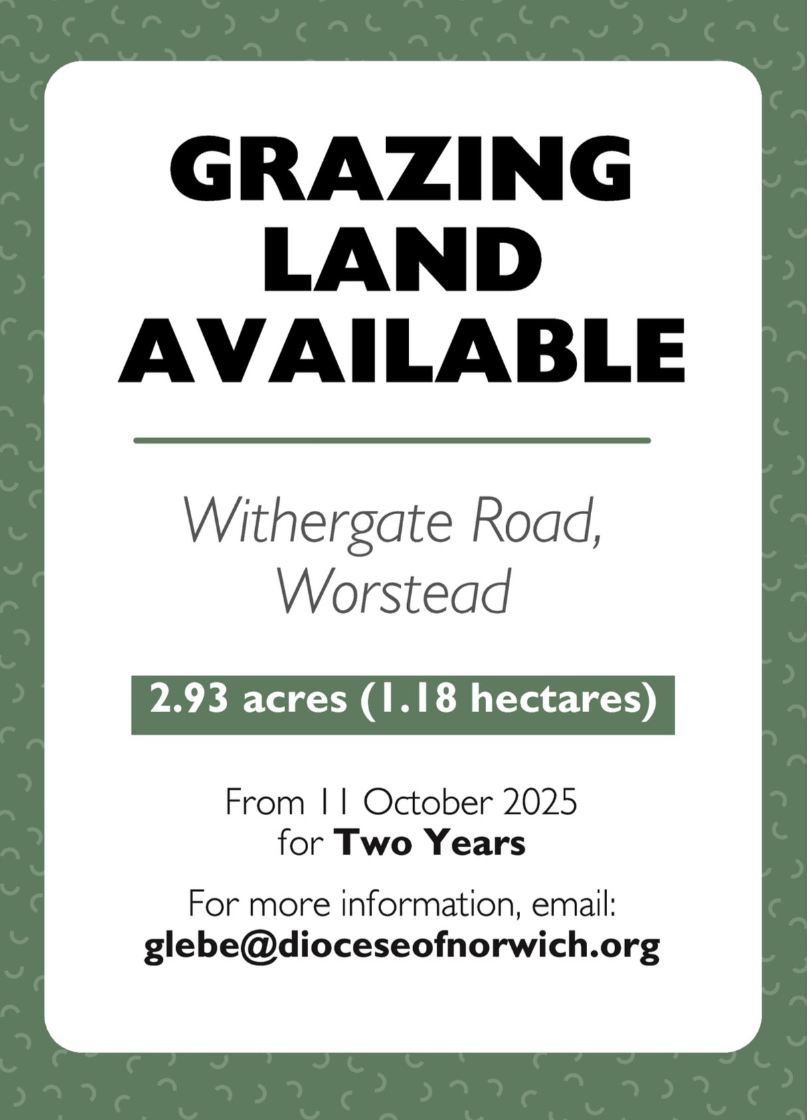

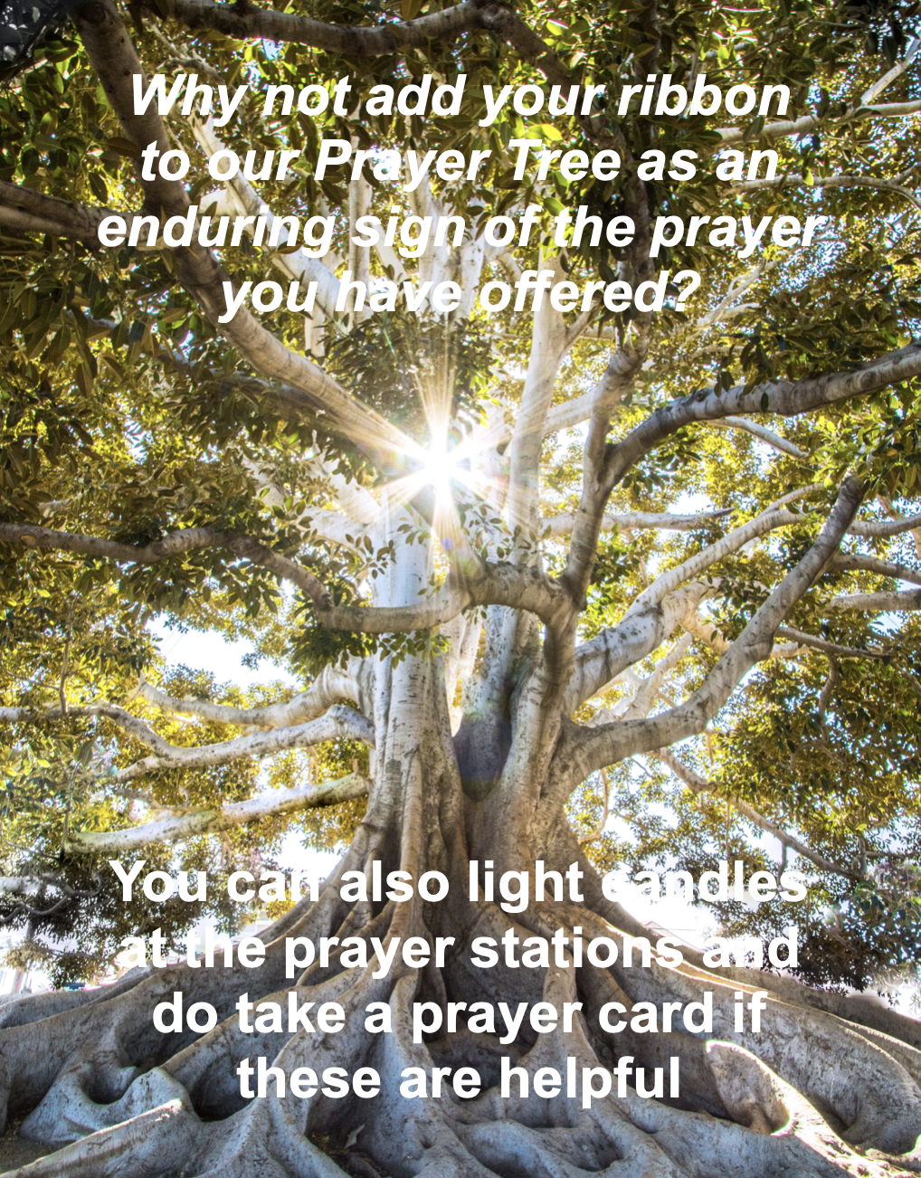

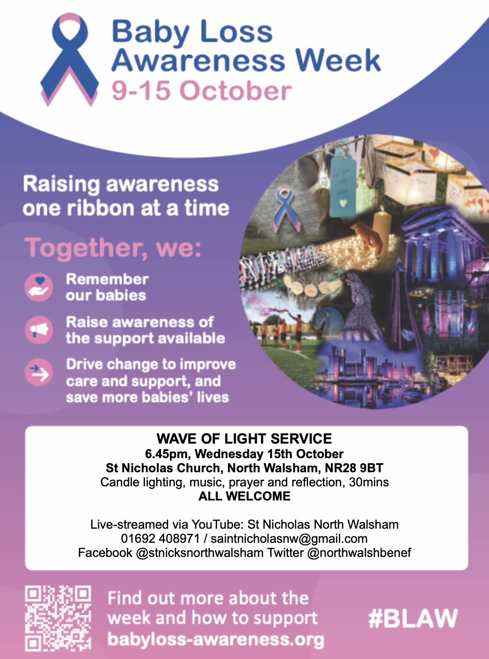

We are privileged to hold special
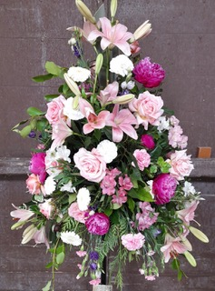
services at any of our churches
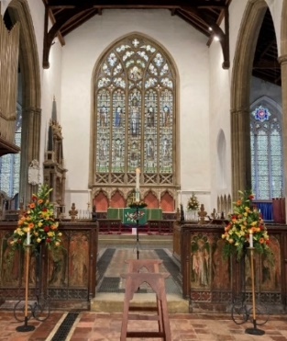
All who live in the benefice are entitled to a baptism, wedding or funeral service in church, and our clergy can officiate at the crematorium and cemeteries too. The church is here for you, through every moment of life.

************************************************************************************


Dates from the Diary

Baptisms
There were no Baptisms in September

Funerals
10th Stella May Howlett - St Nicholas
15th Lynn Marie Honeysett - St Nicholas

Weddings
13th Ellis Kathleen Lake and Samuel James Patrick - St Mary's

Please hold those above and their families in your prayers.

*************************************************************************************

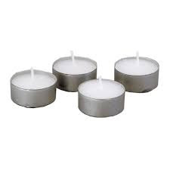
Thanks to all who’ve provided tealights for prayer stations at St Nicholas!
All donations of white, unscented tealights gratefully received!





We're pleased that our weekly coffee mornings at North Walsham and Worstead are now registered with Warm Welcome Spaces
North Walsham Market Day Coffee Morning
Thursdays 9.30 – 12.00noon
The space is open to all (and their well-behaved dogs on leads), every Thursday! A warm welcome and refreshments available

Thank you to everyone for raising donations for St. Nicholas Church, North Walsham with #easyfundraising! If you have not signed up yet, it is easy and completely FREE. 8,100 brands will donate to us when you use easy fundraising to do your everyday online shopping - at no extra cost to you! Every donation you raise makes a difference to us so please sign up & share today. https://join.easyfundraising.org.uk/stnicholaschurchnw/XT7MPH/at/TSX8RX7z/RTND2/facebook/
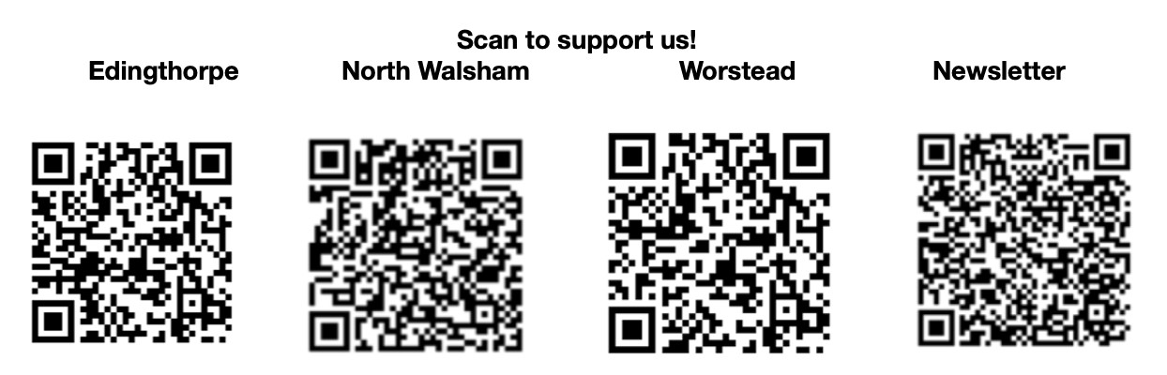


Please support the work of our Churches, by using the contactless giving point at St Nicholas or St Mary’s, leaving your gift on the offering plates or in the wall safes, or through these QR codes. Thank you.

Do you have a Business you would like to advertise in this magazine?
Whole, half or quarter page space is available.
Full Page £ 150.00
Half Page £ 75.00
Quarter Page £ 50.00
Please contact the Benefice office on 01692 408971
or email saintnicholasnw@gmail.com
for details and prices

Church Postcodes
Edingthorpe NR28 9TN, North Walsham NR28 9BT, Worstead NR28 9AL, Westwick NR10 5BW

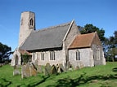
Benefice dates

All Saints’ Edingthorpe
12th October 9:15 Holy Communion
26th October 9:15 Morning Prayer
2nd November 4 p.m. Choral Evensong for the Patronal Festival

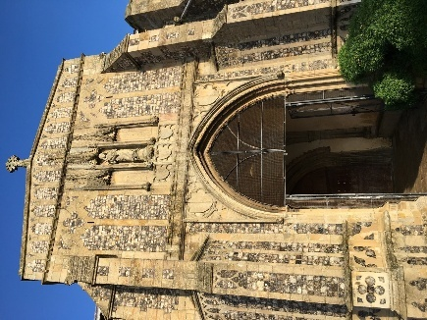
St. Mary’s, Worstead
5th October 9:15 Morning Prayer

19th October 9:15 Holy Communion

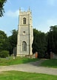
St Botolph’s Westwick

No service in October

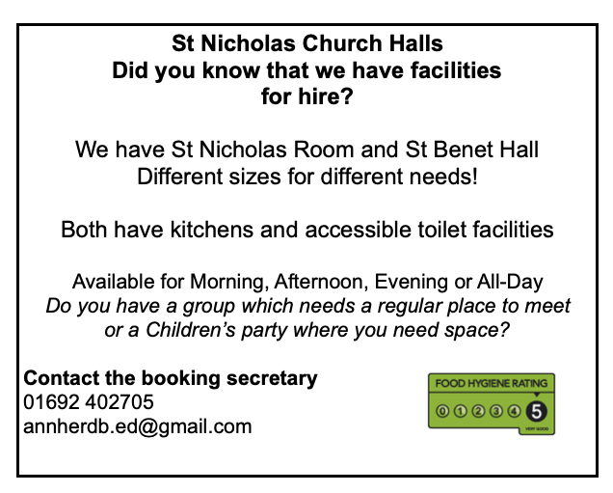

Ready to tick off your list – Will Made?
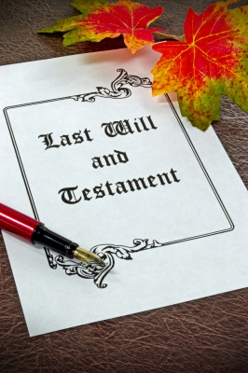
"The Church of England have teamed up with Farewills to provide a free will writing service: Online Will Writing Service | Legal Will In 15 Minutes . Anyone can use this service and it is not compulsory to leave something to your church, but it would be nice if you did. It is important for each one of us to leave our earthly matters in good order so why not take advantage of this opportunity now? It is good to remember a gift in your will to a charity is tax free. If you already have a will, you could consider leaving a legacy to the church by adding a codicil. https://farewill.com/norwich-diocese

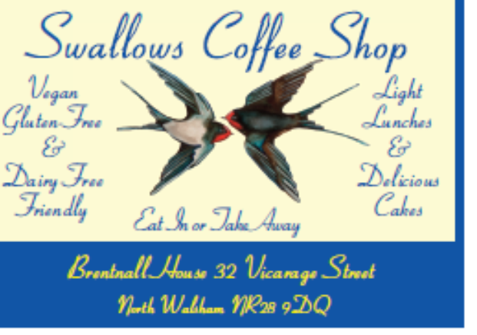

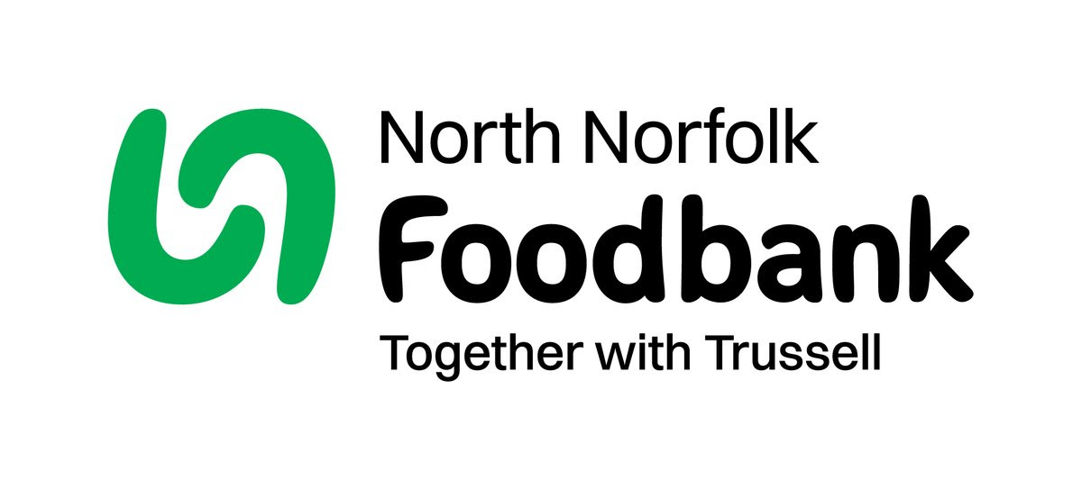
Dear Foodbank supporter,
Thank you for your donations from St Nicholas of 36.70 kg in August.
As a small charity we rely on donations, both food and financial, to operate and we are extremely grateful when people choose to support us.
During 2024 we fulfilled 2085 food vouchers, providing food for 4695 people, 2925 adults and 1770 children.
Whilst Trussell campaigns to end the need for foodbanks, we will be here helping those who need us right now. But that can only be done with kind donations from our supporters.
To see what we need most right now, our wish list is published on our website and social media, and the list gets updated throughout the month on our donation page
https://northnorfolk.foodbank.org.uk/give-help/donate-food/
Thank you for thinking of us and enabling us to serve the people facing hardship across our district.
Kind regards
Jules, Rebecca and the Foodbank team
North Norfolk Foodbank
Cromer Methodist Church Hall, West Street, Cromer, NR27 9DT
07826 376343

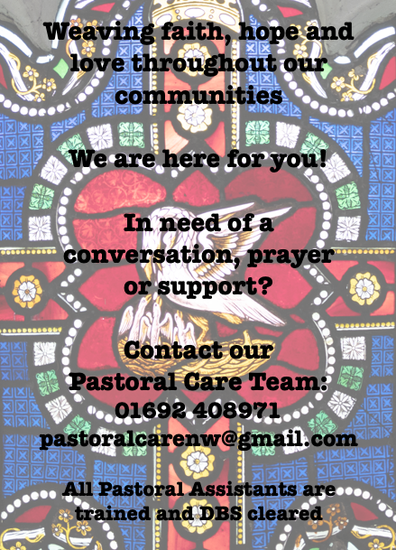

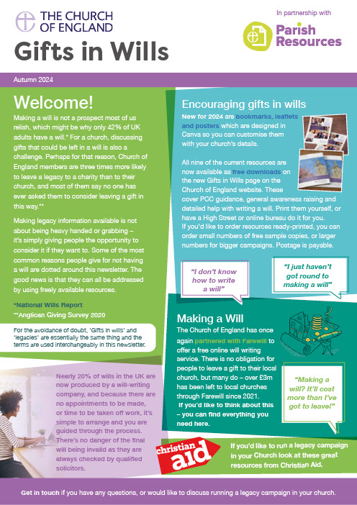
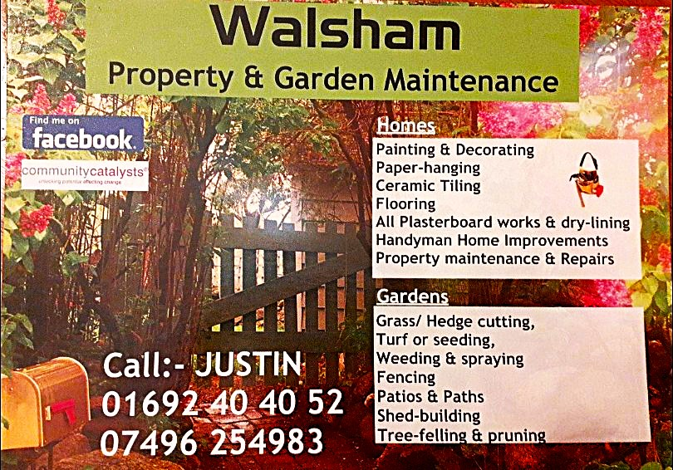

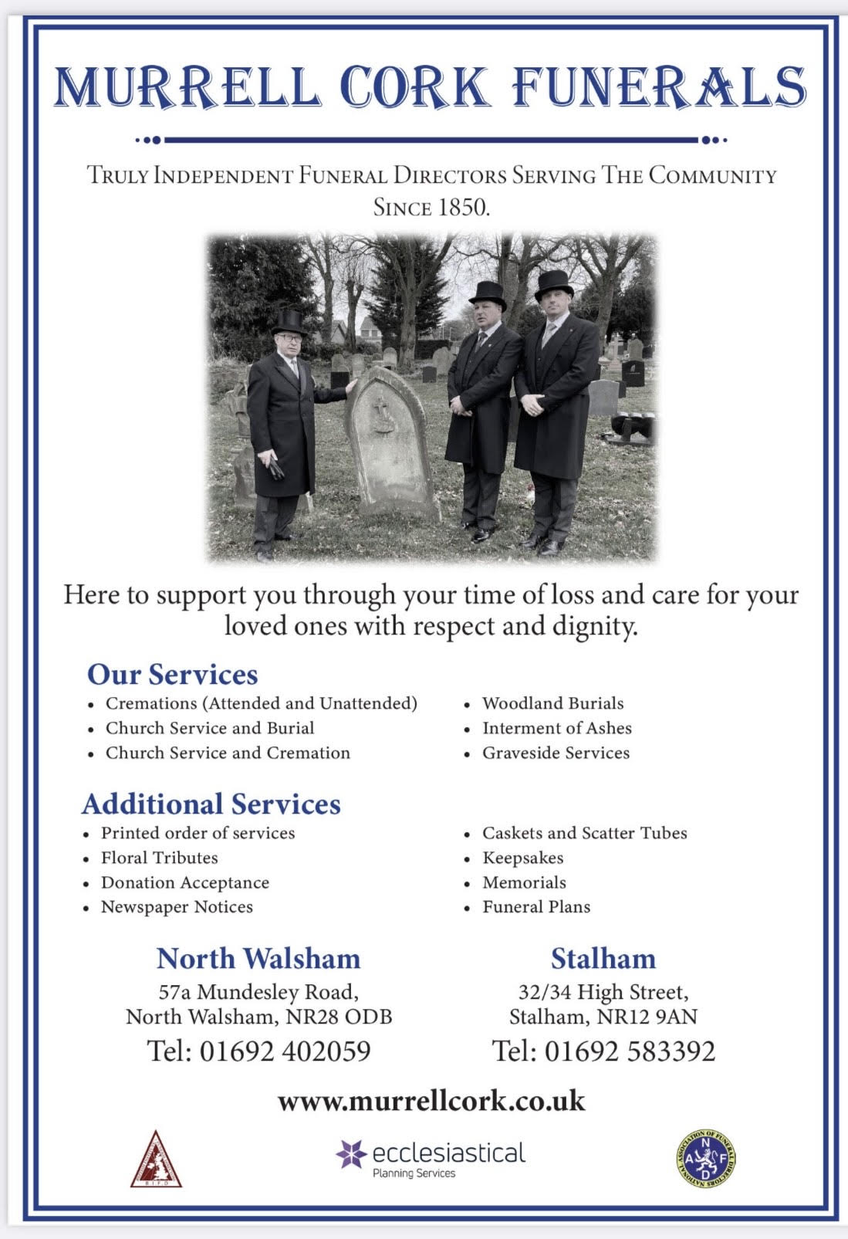
r Sale and Wants Page

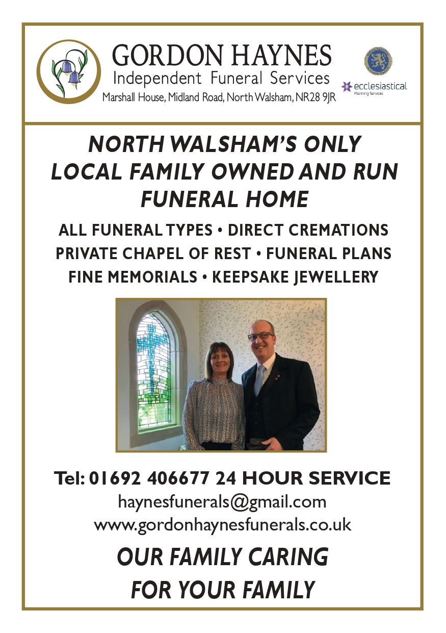


Money Matters …
A regular report for our readers written by James Reginald Drake at ClearView Financial Consultants
Burgh Road, Aylsham - 01263 734859, Station Road, Hoveton - 01603 273590 and North Walsham 07773 626662

Lasting Powers of Attorney – Why are they so Important?
Lasting Powers of Attorney (LPA’s) are documents that give an individual you trust (your attorney) the legal authority to make decisions on your behalf should you either lose the mental capacity to make them, or you no longer wish to make these decisions yourself. Lasting Powers of Attorney come in 2 forms, these coming under the heading of ‘Property & Financial Affairs’ and ‘Health & Welfare’
So, how can they help?
The Property & Financial Affairs LPA covers things such as running your bank and savings accounts, making or selling investments, paying bills, buying or selling property and applying for benefits.
The Health & Welfare LPA covers things such as the type of health care and medical treatment you receive (including decisions on life sustaining treatment), where you live, as well as the type of care that you receive in areas such as diet and daily routine.
Given the wide range of areas that these documents cover, it becomes quite obvious as to why they are so important. However, according to ‘The Office of the Public Guardian’ via an article produced in 2022, less than 1% of the UK population have a Lasting Powers of Attorney in place.
So, why do so few people have them in place? One of the most commonly mentioned reasons is that people assume that their spouse will automatically have the right to make decisions for them should they ever reach the stage where they are unable to. This however is a common misconception and it is very often discovered far too late that they actually have no legal authority at all. Cost is another reason people put it off, I can assure you are costs for this type of work are minimal, in the hope this is not a reason to delay.
What should you do?
Well, the answer to this one is quite simple……. get on and set up both types of LPA as soon as you can. It is never too soon to set one up, but it certainly can be too late. By law, once your mental capacity has gone, so has your opportunity to appoint attorneys to act on your behalf. At this point your loved ones will be required to go down a different route and apply to the Court of Protection for a Deputyship order. This requires more forms, more cost and more time, which can all be easily avoided with a bit of forward planning.
So, if setting up Lasting Powers of Attorney(s) is something that you think would benefit you and your loved ones, please feel free to contact me and we can discuss how they can be put in place in a way that is best suited to your own personal requirements.
This short article in no way should be taken by readers as advice.
James can be contacted on either of the above landline numbers or via email at support@smithifa.co.uk
ClearView Financial Consultants is a trading name of Martin Smith Independent Financial Adviser Ltd, a company registered in England
under number 11439150 and authorised and regulated by the Financial Conduct Authority under number 944677.


