12Then Jesus said to his host, ‘When you give a luncheon or dinner, do not invite your friends, your brothers or sisters, your relatives, or your rich neighbours; if you do, they may invite you back and so you will be repaid. 13But when you give a banquet, invite the poor, the crippled, the lame, the blind, 14and you will be blessed. Although they cannot repay you, you will be repaid at the resurrection of the righteous.’

Next collection will be **September 17th** please leave donations in narthex.

Small Pilgrim Places are: Small places, simple, quiet & unpretentious, with the

presence of the Divine. St Laurence’s Church. [www.smallpilgrimplaces.org](http://www.smallpilgrimplaces.org) Thur 10 - 11 am and Saturdays 2-4pm.

**Carrville Methodist Church**: Autumn concert with light vocal and instrumental music from local musicians and refreshments. Sept 13th at 3.00pm. Free admission & retiring collection for St Cuthberts hospice/Church organ fund.

There is **NO** Mothers Union Summer Meal in August. The next meeting will be 15th September when Kevin Dunne will talk about his visit to Norway.

**For our prayers this week:** Pray for those who are unwell or asked for our prayers: Jean Dennison, Anne Dobson, Andrew Dover, Sylvia Dawson, Anna Harvey, Mike Jackson, Anne Johnson (P’ton), George Kitching, Trevor Uren, Alfie Walton, Geoffrey Winter. Those who have been bereaved:- the family of Thomas Hardy

**From our Parish weekly prayer cycle:**

The Mothers' Union; local shops, bars, cafes and restaurants; victims of crime; Pittington Primary School, staff and pupils; residents of Plantation Avenue, Littletown; Derbyshire Drive, Oakham Drive, Lingdale, Nottinghamshire Road, Carrsway, Belmont

**The Benefice of**

**St Mary Magdalene, Belmont &**

**St Laurence, Pittington**

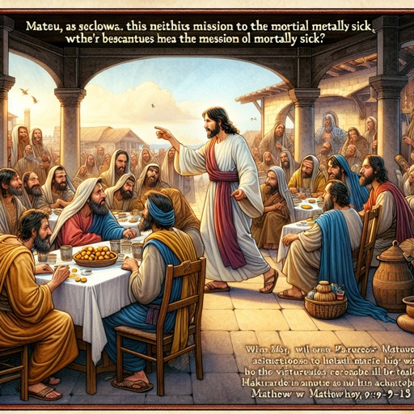

**Trinity 11**

**August 31**st **2025**

**Collect**

God of glory, the end of our searching, help us to lay aside all that prevents us from seeking your kingdom, and to give all that we have to gain the pearl beyond all price, through our Saviour Jesus Christ. Amen

**SMM Hymns: 19** All my hope; **543** Praise and thanksgiving; **289** I come with joy**; 54** Beauty for brokenness**; 445** Meekness and majesty; **368** Just as I am**; 612** Tell out my soul.

**Bible Readings**

**Readings:** Jeremiah 2:4-13

Hebrews 13:1-8; 15-16

**Gospel Reading:** Luke 14:1; 7-14

**Upcoming services**

**w/b Sunday 31st August**

9.00 am Holy Communion BCP SMM

9.30 am Holy Communion SL

10.30 am Holy Communion SMM

Wed 10.00am Holy Communion SMM

Thur 10 -11am Church open for prayer SL

**w/b Sunday 7th September**

10.30 am Joint Holy Communion SMM

Wed 10.00am Holy Communion SMM

Thur 10 -11am Church open for prayer SL

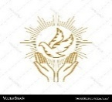

Spirit-led prayer group: Dates: 12th & 26th September at SMM

**Jeremiah 2:4-13**

Hear the word of the Lord, you descendants of Jacob, all you clans of Israel.

5This is what the Lord says:

‘What fault did your ancestors find in me,  
    that they strayed so far from me?  
They followed worthless idols  
    and became worthless themselves.  
6They did not ask, “Where is the Lord,  
    who brought us up out of Egypt  
and led us through the barren wilderness,  
    through a land of deserts and ravines,  
a land of drought and utter darkness,  
    a land where no one travels and no one lives?”  
7I brought you into a fertile land  
    to eat its fruit and rich produce.  
But you came and defiled my land  
    and made my inheritance detestable.  
8The priests did not ask, “Where is the Lord?” Those who deal with the law did not know me; the leaders rebelled against me. The prophets prophesied by Baal, following worthless idols.

9‘Therefore I bring charges against you again,’ declares the Lord. ‘And I will bring charges against your children’s children.  
10Cross over to the coasts of Cyprus and look, send to Kedar and observe closely;  
see if there has ever been anything like this:  
11has a nation ever changed its gods?  
    (Yet they are not gods at all.)  
But my people have exchanged their glorious God for worthless idols.  
12Be appalled at this, you heavens, and shudder with great horror,’ declares the Lord.  
13‘My people have committed two sins:  
They have forsaken me, the spring of living water, and have dug their own cisterns, broken cisterns that cannot hold water.

**Hebrews 13:1-8; 15-16**

Keep on loving one another as brothers and sisters. 2Do not forget to show hospitality to strangers, for by so doing some people have shown hospitality to angels without knowing it. 3Continue to remember those in prison as if you were together with them in prison, and those who are ill-treated as if you yourselves were suffering.

4Marriage should be honoured by all, and the marriage bed kept pure, for God will judge the adulterer and all the sexually immoral. 5Keep your lives free from the love of money and be content with what you have, because God has said,

‘Never will I leave you; never will I forsake you.’ 6So we say with confidence,

‘The Lord is my helper; I will not be afraid.  
    What can mere mortals do to me?’

7Remember your leaders, who spoke the word of God to you. Consider the outcome of their way of life and imitate their faith.

8Jesus Christ is the same yesterday and today and for ever. 15Through Jesus, therefore, let us continually offer to God a sacrifice of praise – the fruit of lips that openly profess his name. 16And do not forget to do good and to share with others, for with such sacrifices God is pleased.

**Luke 14:1;7-14**

One Sabbath, when Jesus went to eat in the house of a prominent Pharisee, he was being carefully watched. When he noticed how the guests picked the places of honour at the table, he told them this parable: 8‘When someone invites you to a wedding feast, do not take the place of honour, for a person more distinguished than you may have been invited. 9If so, the host who invited both of you will come and say to you, “Give this person your seat.” Then, humiliated, you will have to take the least important place. 10But when you are invited, take the lowest place, so that when your host comes, he will say to you, “Friend, move up to a better place.” Then you will be honoured in the presence of all the other guests. 11For all those who exalt themselves will be humbled, and those who humble themselves will be exalted.’