WORSHIP
SERVICES IN CHURCH
Christ Church is open for Sunday worship at 10.00 am
ONLINE SERVICES
twitch.tv/revdgill
LIVE from Christ Church Healey
and to view on twitch.tv/revdgill after the broadcast.
Downloads are available on request.
PASTORAL
If anyone needs help or support, please contact:
the Vicar on 01706 458506
or the Pastoral team on 07813 297313.
WEBSITE INFORMATION
Our websites are regularly updated and contain lots of useful information including service sheets, readings and news.
https://www.achurchnearyou.com/church/15941/
and
www.christchurchhealey.org.uk
BENEFICE MOTTO FOR 2025
I am certain that God, who began the good work within you, will continue his work until it is finally finished on the day when Christ Jesus returns.
Philippians chapter 1 verse 6, NLT.
Our Mission Statement – “To glorify God and serve our community in the name of Jesus Christ.”
PRAYERS
For the sick:
Sue Agnew, Ruth Graham, John and Julie, Stella Mills, Grace, Chris Makinson, Maureen Toolan, Kim McFarlane, Rev Graham Marshall, Rev Nick Andrewes, Andrew McElroy.
Home members:
Michelle Travillion, Tina Turner, Sophie Broome, Gary Watson, Chris Tapper, Linda Percival, Abigail Holt, John Archibald, Jane Steciuk, Jean France.
R.I.P.
Maureen Clegg
In Memoriam: Winifred Shaw, Gerald Beadling, Fred Nuttall, James Hirst, Benjamin Booth, Samuel Driver, Alan Tomkinson, William Gould, Evelyn Hartley.
Prayer for the week
Thank you, Father, for disturbing our complacency and challenging us to move forward with you, always assured of your company and your sustaining love as we journey. Amen.
BIBLE READING
1 Timothy chapter 1 verses 15b and 16
Christ Jesus came into the world to save sinners – of whom I am the worst. But for that very reason I was shown mercy so that in me, the worst of sinners, Christ Jesus might display his unlimited patience as an example for those who would believe on him and receive eternal life.
NOTICES
August 2025 finances
Total Income £3333.98
Planned giving £1422
Collection £190
Digi giving £175
Total Expenditure £4,150
Parish Share £12,840 paid to date - £4,159 remaining

Harvest 2025
We will be supporting the Farming Community Network at our harvest festivals this year.
Schools
Pray for our schools and colleges as we work to offer the Christian message to staff and pupils together.
DATES FOR YOUR DIARY
Help needed

Help is very much needed on Friday 12 September to set up for the Jumble Sale and also on Saturday 13 September to help run the Sale.
If you can offer any help, even for just a short time, please speak with Lynsey. Thank you.
175th Anniversary of the Dedication of Christ Church, Healey - 16th October 2025
A week of celebration and church and community events is planned – do you have memories to share? See the posters for further information. There are sign up sheets at the back of Church to help staff the open days.
ALM Authorisation Service
At Manchester Cathedral on Saturday 20th September at 2.30 pm. All welcome to see Julie Doherty licenced to the benefice.
MacMillan Afternoon Tea
On 27 September in the Hall. It’s more than just tea and cake. Come along to enjoy good company, delicious cakes and a brew whilst raising vital funds for MacMillan Cancer Support. Bring a friend and your appetite and together let’s make a difference.
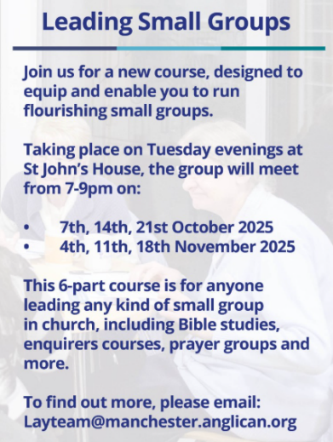
Leading Small Groups
Training for lay people – pilot course of 6 weeks at St John’s House in Bury. Limited numbers. See separate email. Looks very interesting.

Is this your calling?

FUTURE DATES
Neil Diamond Tribute
On Saturday 4th October starting at 7pm at St Clements Church, Spotland. Tickets £10. Contact Estelle on 07459 849274.
Art Exhibition and Craft Fayre
At St Ann’s Hall on Saturday 15th November.

