

**WELCOME**

**ST.STEPHEN’S CHURCH**

**is open 10am-3pm daily**

**for Private Prayer and Reflection**

**DOUBLE BULLETIN**

**7th & 14th September**

**THE 12th and 13th SUNDAYS AFTER TRINITY**

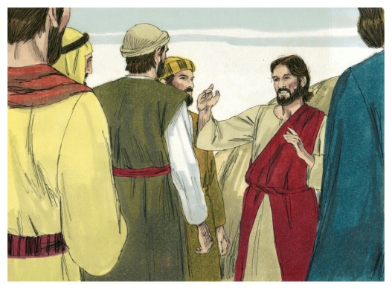

**7th – 9am Holy Communion 10.30am All Age Worship**

14th – **No Morning Service**

**3pm Battle of Britain Commemorative Service**

Notices for inclusion in the bulletin please email to me by Tuesday of each week

***officeststephenfradley@gmail.com***

**Please take Bulletin away with you**

 **Diary Dates**

**Sunday 14th September**

**(No morning Service)**

**3pm Battle of Britain Commemorative Service**

with Alrewas Royal British Legion

followed by Afternoon Tea

**Monday 15th September**

**7.30pm Deanery Synod** at St Mary’s, Weeford

**Next event**

**Saturday 4th October 7pm**

**Harvest Supper and Auction**

in Fradley Youth & Community Hall Tickets £15 including a hot meal and dessert Licensed Bar

D. Giles 07767 434776

**Tickets on sale from 7th September**



Welcome to our Worship today

If you are visiting for the first time, please introduce yourself so that we may welcome you personally.

Refreshments are served after every service – do join us!

**7th September 2025**

**Collect**

God of constant mercy,

who sent your Son to save us:

remind us of your goodness,

increase your grace within us,

that our thankfulness may grow,

through Jesus Christ our Lord.

**Readings**

Deuteronomy 30.15-end Philemon 1-21

Luke 14. 25-33

**Post Communion**

God of all mercy,

in this Eucharist you have set aside our sins

and given us your healing:

grant that we who are made whole in Christ

may bring that healing to this broken world,

in the name of Jesus Christ our Lord.

**St Stephen’s Fradley**

**Sunday 14th September**

**Alrewas and District Royal British Legion and**

**St Stephen’s Church**

**Invite you to**



**BATTLE OF BRITAIN**

**COMMEMORATIVE SERVICE**

**3pm at The War Graves**

**Followed by Afternoon Tea**

**(*in Church)***

**YOU ARE INVITED**

**LICHFIELD FAIRTRADE**

We are now happy to announce that Lichfield City is now once more officially a Fairtrade Community.

To mark this, we are hosting a Fairtrade tea and

coffee event at the start of Fairtrade Fortnight.

**Date: Tuesday 23 September**

**Time: 2:30pm – 4pm**

**Place: Jungle Street Kitchen, Bore Street, Lichfield**

**Price: Free Fairtrade tea and coffee**

**(donations accepted)**

We would like a rough idea of how many people we can expect, so please let us know via the form on our website https://www.lichfieldfairtrade.org.uk/invitation/

We will have some information and literature to share with you, as well as a short video from the

Fairtrade Foundation.

Information should flow both ways -

we will be interested in

hearing from you about new ways in which we can implement and promote Fairtrade .and if you are interested in working with us to help promote the

Fairtrade principles, we would love to hear from you when you join us for your Fairtrade drinks.

**See you on the 23rd!**

**Rosie, Hugh, and Ian**

*In our thoughts and prayers*

*New month, new beginnings, new opportunities…..*

Eternal God,   
as we enter into new ventures,   
calm and quieten our souls;   
keep us humble and full of wonder   
and trusting as we live in your love;   
through Jesus Christ our Lord. Amen.

In the quietness,

aware that we are only part of a great multitude,

on earth and in heaven, who share in the Church’s offering of worship, let us join ourselves with them

and bring to God in prayer our own hopes and needs, together with those of all his children.

Through silence, spoken word and music,

let us be open to the God who both listens and speaks to us.

Bless to us all, O God, the doors we open,

the thresholds we cross,

the roads that lie before us.

Go with us as we journey on……………………

…………………….and at our journeys ending,

open your arms and welcome us home.

**Auction of Talents, Gifts & Promises**

**We know that this is a very talented community with many gifts to offer. Could you offer even a small thing to raise some money for St Stephens’ and harvest your talents to help others (and have some fun in the process!!)**

**We plan to have an Action of talents, gifts and promises at our Harvest Supper**

**Saturday 4th October.**

**Ideas from our past auction can be very simple –**

**Can you offer a bit of gardening?**

**A trip out to a coffee shop? A Flower arrangement?**

**A lift for shopping at a supermarket?**

**Bake a cake? Host a meal or Afternoon Tea?**

**A half day or day out?**

**Unused or surplus Gifts?**

**See the offers which have already come in!**

**Perhaps you might like to bid for something at Harvest also? Do come along and enjoy the evening!**



**Can you help to support St Stephens Church?**

St Stephen’s Church is heavily dependent on voluntary donations and income from events in order to fulfil its ministry to the local and wider communities.

If you would like to support us at this time,

donations can be made via our Just Giving page.

We are grateful for any donation, large or small.

[**https://www.justgiving.com/fundraising/ststephensfradley**](https://www.justgiving.com/fundraising/ststephensfradley)



## Contact us

## Revd Elizabeth Wall

## 01543 254891

## Email: [ayton265@gmail.com](mailto:ayton265@gmail.com)

## Churchwarden

## Marian Derry 01283 791573

## 

## St Stephen’s Administrator: Di Cooper  07930162991

## Email: officeststephenfradley@gmail.com

## Find us on

## ACNY https://www.achurchnearyou.com/church/4123/

**Face book:** [**www.facebook.com/ststephensfradley**](http://www.facebook.com/ststephensfradley)

DC03/09/25