Next collection will be **October 29th** please leave donations in narthex.

St Laurence Autumn afternoon tea: Saturday **11th October** 2.00-4.00pm

Parish Hall: **October 4th** at 7pm. £3 pp and 6 in team. BYO refreshments.

**Wed 8 to Sun 12 October 2025**

Luxmuralis returns to Durham Cathedral for the fourth time with a different show *The Storytellers.*

**Magna Carta and the North is now open at Durham Cathedral until 2 November:**

This special exhibition features three rarely displayed Magna Cartas and three Forest Charters, & specially curated artworks. 800 years since the 1225 Magna Carta, this is a rare opportunity. Book: [https://durhamcathedral.co.uk/magnacarta](https://durhamdiocese.us14.list-manage.com/track/click?u=c469f35cd78778a0642cf65be&id=08baae2560&e=64990532a5)

**The Wildlife of Pittington**

Sat 18th Oct 10.00 – 3.00

Sun 19th Oct 12.00 – 3.00

Photographic exhibition at StL. £1.00 entry in aid of Church building fund.

****Sun **5th Oct** at 3-5pm in Belmont Parish Hall –craft activities, story, songs & food! For info Tel. 3863588

**Harvest festival is Oct 12th.** Please bring non perishable items suitable for Durham Christian Partnership foodbank. They can then create 3-day nutritionally balanced parcels for people who need them.

**For our prayers this week:**  Pray for those who are unwell or asked for our prayers: Jean Dennison, Andrew Dover, Sylvia Dawson, Mike Jackson, Anne Johnson (P’ton), George Kitching, Trevor Uren, Alfie Walton, Geoffrey Winter. Those who have been bereaved:- the family of Alan Smithson; the family of Marina O’Malley, the family of Margaret Robson.

**From our Parish weekly prayer cycle:**

The Girls' Friendly Society; children and youth groups in the parish; local police; the church architect; residents of Moor View, Littletown; residents of Limecragg Avenue, Lancashire Drive, Whitwell Court, Kepier Crescent, Ullerdale Close, Taylor Court, Belmont.

**The Benefice of**

**St Mary Magdalene, Belmont &**

**St Laurence, Pittington**

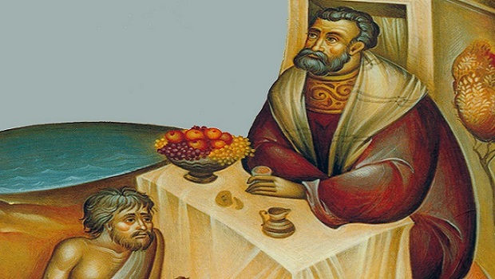

**Trinity 15**

**September 28th 2025**

**Collect:**

Lord God, defend your church from all false teaching and give to your people knowledge of your truth, that we may enjoy eternal life in Jesus Christ our Lord. Amen

**SMM Hymns:** He who would valiant be; **306** Immortal, invisible; **341** Jesus good above all other; **56** Before the throne**; 575** Seek ye first; **300** I heard the voice of Jesus say; **555** Praise to the Lord.

**Bible Readings**

**Readings:** Amos 6:1a,4-7 (also for BCP)

1 Timothy 6:6-19

**Gospel Reading:** Luke16:19-end

**Upcoming services**

**w/b Sunday 28th September**

9.00 am Holy Communion BCP SMM

9.30 am Holy Communion SL

10.30 am Holy Communion SMM

Wed 10.00am Holy Communion SMM

Thur 10 -11am Open Church SL

**w/b Sunday 5th October**

9.30 am Joint Benefice service with Rev John

McManners SL

3 – 5pm Messy Church SMM

Wed 10.00am Holy Communion SMM

Thur 10 -11am Open Church SL

Fri 10.00 am Spirit-led prayer group SMM

Funeral of Margaret Robson on Oct 2nd

at 10am at SMM

**Amos 6:1a,4-7**

Woe to you who are complacent in Zion,

and to you who feel secure on Mount Samaria, you notables of the foremost nation, to whom the people of Israel come!

You lie on beds adorned with ivory and lounge on your couches. You dine on choice lambs and fattened calves.

You strum away on your harps like David

and improvise on musical instruments.

You drink wine by the bowlful and use the finest lotions, but you do not grieve over the ruin of Joseph. Therefore you will be among the first to go into exile; your feasting and lounging will end.

**1 Timothy 6:6-19**

Godliness with contentment is great gain. For we brought nothing into the world, and we can take nothing out of it.

But if we have food and clothing, we will be content with that. Those who want to get rich fall into temptation and a trap and into many foolish and harmful desires that plunge people into ruin and destruction.

 For the love of money is a root of all kinds of evil. Some people, eager for money, have wandered from the faith and pierced themselves with many griefs.

But you, man of God, flee from all this, and pursue righteousness, godliness, faith, love, endurance and gentleness. Fight the good fight of the faith. Take hold of the eternal life to which you were called when you made your good confession in the presence of many witnesses. In the sight of God, who gives life to everything, and of Christ Jesus, who while testifying before Pontius Pilate made the good confession, I charge you to keep this command without spot or blame until the appearing of our Lord Jesus Christ, which God will bring about in his own time—God, the blessed and only Ruler, the King of kings and Lord of lords, who alone is immortal and who lives in unapproachable light, whom no one has seen or can see. To him be honour and might forever. Amen.

Command those who are rich in this present world not to be arrogant nor to put their hope in wealth, which is so uncertain, but to put their hope in God, who richly provides us with everything for our enjoyment. Command them to do good, to be rich in good deeds, and to be generous and willing to share. In this way they will lay up treasure for themselves as a firm foundation for the coming age, so that they may take hold of the life that is truly life.

**Luke 16:19-end**

“There was a rich man who was dressed in purple and fine linen and lived in luxury every day. At his gate was laid a beggar named Lazarus, covered with sores and longing to eat what fell from the rich man’s table. Even the dogs came and licked his sores.

“The time came when the beggar died and the angels carried him to Abraham’s side. The rich man also died and was buried. In Hades, where he was in torment, he looked up and saw Abraham far away, with Lazarus by his side. So he called to him, ‘Father Abraham, have pity on me and send Lazarus to dip the tip of his finger in water and cool my tongue, because I am in agony in this fire.’

“But Abraham replied, ‘Son, remember that in your lifetime you received your good things, while Lazarus received bad things, but now he is comforted here and you are in agony. And besides all this, between us and you a great chasm has been set in place, so that those who want to go from here to you cannot, nor can anyone cross over from there to us.’ “He answered, ‘Then I beg you, father, send Lazarus to my family, for I have five brothers. Let him warn them, so that they will not also come to this place of torment.’ “Abraham replied, ‘They have Moses and the Prophets; let them listen to them.’ “‘No, father Abraham,’

he said, ‘but if someone from the dead goes to them, they will repent.’ “He said to him, ‘If they do not listen to Moses and the Prophets, they will not be convinced even if someone rises from the dead.’”