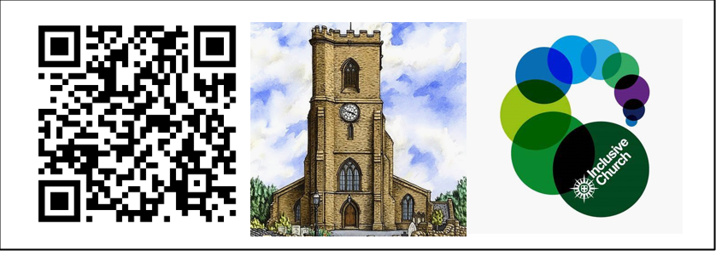

**St Mary’s Mirror**

**Vicar:** Fr Andrew Fisher AOJN 0115 975 5358 [a.j.fisher@outlook.com](mailto:a.j.fisher@outlook.com)

**Editor:** Ray Hotson Tel 0752 650 5426 [rhotson@tiscali.co.uk](mailto:rhotson@tiscali.co.uk)

**Sundays 37th - 14th September**

***St Mary’s is a down to earth Christian community seeking, serving and worshipping God by sharing the love of Jesus with all.*** https://[www.achurchnearyou.com/bulwell-st-mary-the-](http://www.achurchnearyou.com/bulwell-st-mary-the-) virgin-all-souls

# Sunday 7th September 12th Sunday after Trinity

**9.30am** Bellringing

**10.00am Family Mass** Reading: Luke 14: 25-33 There is a well-stocked Children’s Corner in church for pre-schoolers. Refreshments are available in the Upper Hall after the service

## If you are unable to attend church in person, the service can be watched online via our YouTube Channel: https:// [www.youtube.com/](http://www.youtube.com/) @bulwellchurch

To help us keep live streaming our Services, if you are able, please leave a donation. https:// givealittle.co/ campaigns/

ec595deb-2497-91d67f3dc088

**4pm.** Holy Communion Service at Highbury Hospital

(FR A, JB, CJ, NC, TH, DN)

**7.15pm.- 9.25pm** Farnaby & Co. practice (Church)

## Monday 8th September Birth of the Blessed Virgin Mary

**11am.** Growing Discipies Plan Meeting Jubilee House

(Fr A)

**6.– 7.30pm** 48th Nottingham Beavers (Upper Hall)

## Tuesday 9th September

*Rev Bob day off - emergencies only, please*

**6. – 7.30pm** 87th Nottingham Brownies (Upper Hall)

## Wednesday 10th September

**9am.** Collective Worship Bulwell St Mary’s CofE Primary

School (Fr A)

**9.30-11am** Little Acorns Toddler Group (West Room) Contact Zoe: [zoejackson000@gmail.com](mailto:zoejackson000@gmail.com)

**1pm - 3pm** Bestwood and Bulwell Food Bank 07527 048226

**3pm.** Welcome Back Assembly Cantrell Primary School

(Fr A)

**3.30pm** Staff Meditation/Reflection Bulwell St Mary’s

Primary School (Fr A)

**6.15pm** ‘Spokoj’ Al-Anon Group (West Room) For

more information visit:

<https://al-anonuk.org.uk/about-us/>

**7pm-9pm.** Bell Ringing Practice.

## Thursday 11th September

**9.30am** Midweek Mass Reading Luke 14: 25-33.

**2pm** Faith Study Group (Upper Hall) – NEW

SIX SESSION DVD COURSE “AWAKENING TO GOD

IN EVERYDAY LIFE” looking at the Book of Acts.

*All welcome!*

**2pm** Chaplaincy at St Andrews Winslow (JB)

**6pm – 7.30pm** 88th Nottingham Brownies (West Rm) **7pm – 9pm** 87th Nottingham Guides (Upper Hall) **7pm – 9pm** Rangers (14+ yrs) (West Room)

## Friday 12th September

*Fr A day off, emergencies only, please.*

**5.15pm – 6.15 pm** Rainbows

**6pm** Choir Practice

**Saturday 13th September**

**10am – 12pm** Church Open for Prayer with Terce,

Exposition of the Blessed Sacrament, the Rosary and the Angelus.

**Sunday 14th September Holy Cross Day**

**9.30am** Bellringing

**10.00am Parish Mass (Sung)** Our fantastic Sunday School, ‘Whiz Kids’ will be taking place during the Service (for ages 5-11). There is a well-stocked

Children’s Corner in church for pre-schoolers.

Readings: Numbers 21: 4-9.Phillipians 2: 6-11, John 3: 13-17. Refreshments are available in the Upper Hall after the service.

**If you are unable to attend church in person, the service can be watched online via our YouTube Channel:** [**https://www.youtube.com/@bulwellchurch**](https://www.youtube.com/%40bulwellchurch)

To help us keep live streaming our Services, if you are able, please leave a donation. https://givealittle.co/campaigns/

ec595deb-2497-91d67f3dc088

**The Aumbry Lamp** is the 7-day candle that burns before the aumbry in the Lady Chapel, announcing the Sacramental Presence of Our Lord in the aumbry. Sponsoring the Aumbry Lamp is a wonderful way to show gratitude for answered prayer, or as a tangible way to extend our petitions before God. Lamp sponsorships cover the cost of the candle for one month and can be sponsored for just £10 for a month.

## We are delighted to announce that this has been kindly sponsored for August to December in memory of Norah and for anyone who has lost someone dear to them at this time.

Please speak with Fr Andrew if you would like to sponsor St Mary’s Aumbry Lamp.

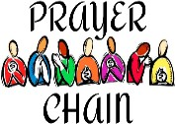If you would like yourself or a loved one to be prayed for, please speak with/contact

[jackiebramford@hotmail.co.uk](mailto:jackiebramford@hotmail.co.uk)

or Daniel Newton

[newtondaniel826@gmail.com](mailto:newtondaniel826@gmail.com)

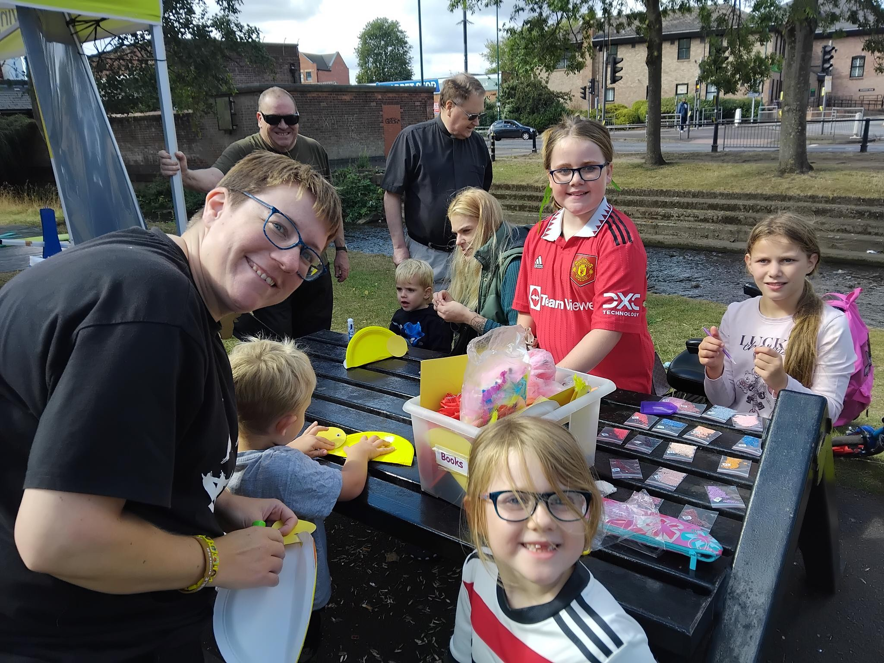Re safeguarding, If you are requesting prayer for somebody other than yourself, please obtain the person’s permission in the first instance. Failing that, give their first name only. Any details about health matters should only be given with the person’s permission. Where an individual is extremely ill, or not an adult, this permission may be given by the person’s caregiver, guardian or family member.

# Howard Lee

Having spent two lovely years as the organist at St. Mary's, Howard is set to move away from Nottingham in early September. Howard wishes to express his gratitude to the clergy and the congregation for their unwavering support during his musical journey and his time studying Architecture at the University of Nottingham.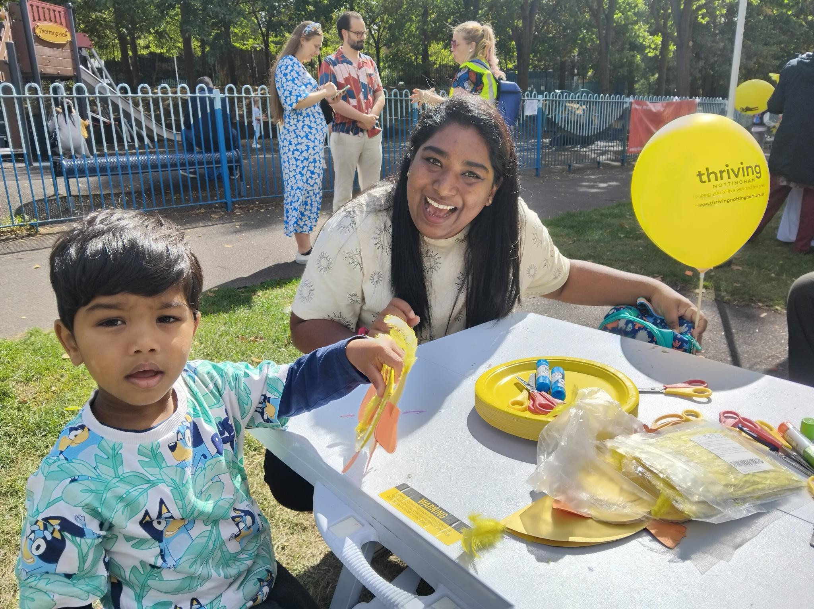 St. Mary's remains committed to its liturgical music traditions and is excited to foster the talents of the next generation of organists and musicians.

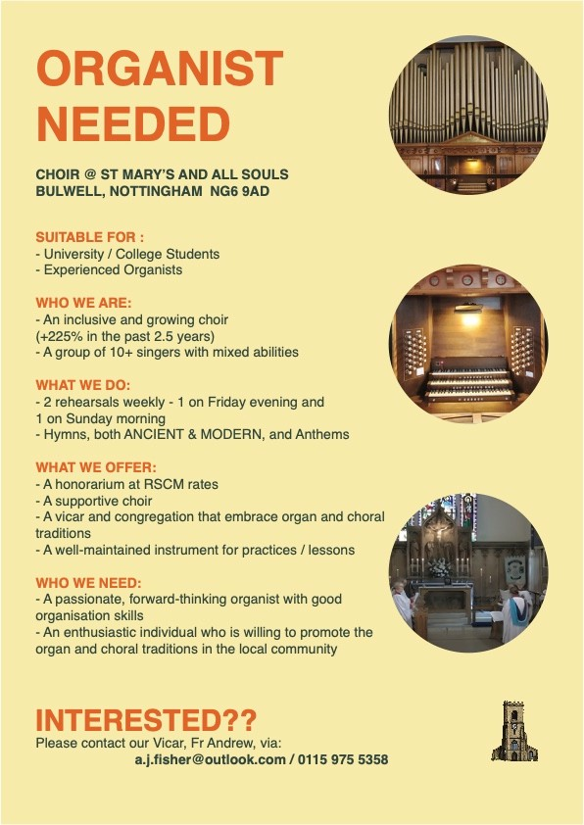 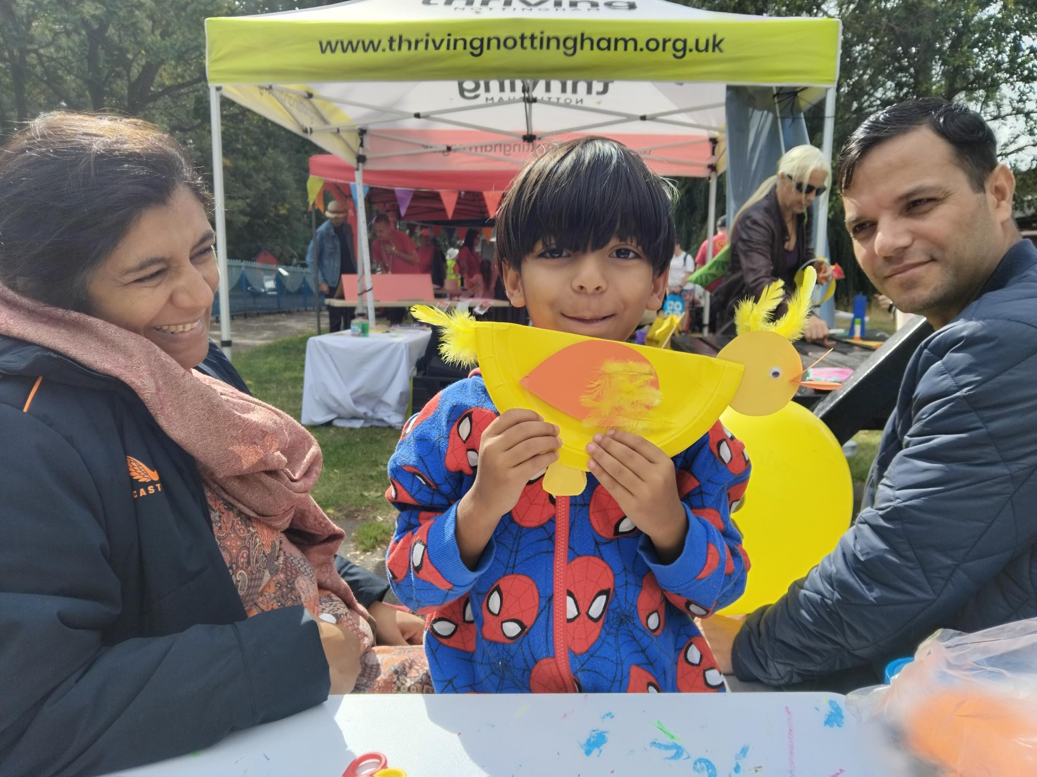

## Bulwell Summer Story “Ey Up Me Duck!”

St Mary’s Church, Bulwell, joined with other

community stakeholders (including Bulwell Academy,

Thriving Nottingham and the Hucknall Ukelele Band) to support the annual Bulwell Bog’s Duck Race on Saturday 30th August. The event was organised by the local One Vision Partnership (which St Mary’s is a part of) and the Friends of Bulwell Bogs. St Mary’s church ran a craft stall saying, “Ey Up Me Duck” to families, and inviting them to join in with the fun, making - appropriately enough - ducks!