

**WELCOME!**

**ST STEPHEN’S CHURCH IS OPEN**

**10am-3pm daily**

**for Private Prayer and Reflection**

**28th September 2025**

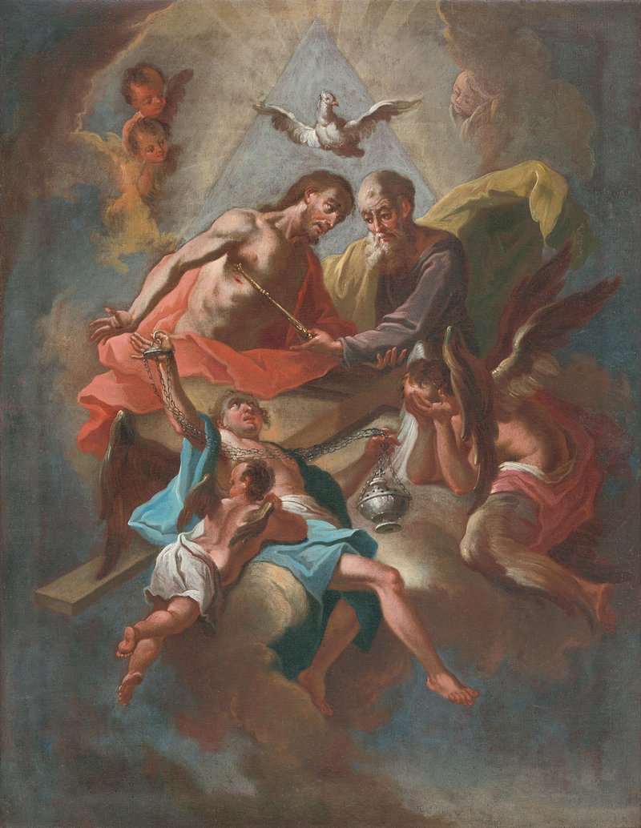

**Trinity 15**

**10.30am Family Communion**

***We extend a warm welcome to***

***The Rt Revd Dr Michael Ipgrave***

***Bishop of Lichfield***

***who will preside and preach at our service today***

Notices for inclusion in the bulletin please email to me

by Tuesday of each week

***officeststephenfradley@gmail.com***

**Please take Bulletin away with you**



**Diary Dates**

**September 2025**

**Tuesday 30th** 7-9pm Community Choir rehearsal

**October 2025**

**Wednesday 1st** 2-4pm Wednesday Welcome

**Thursday 2nd** 9.30-11am Events Committee

**Saturday 4th Harvest Supper & Auction**

in Fradley Youth & Community Hall

Tickets £15 including a hot meal and dessert Licensed Bar

**Tickets on sale from D. Giles 07767 434776**

**Sunday 5th**

**9am Holy Communion** (Book of Common Prayer)

**10.30am Harvest Praise and**

**Thanksgiving for the Gift of a child**

*The Music Group will be leading music at this service.*

**Sunday 12th**

**10.30am Family Communion**

Welcome to our Worship today

If you are visiting for the first time, please introduce yourself so that we may welcome you personally.

Refreshments are served after every service – do join us!

**28th September 2025**

**Collect**

Lord God,

defend your Church from all false teaching

and give to your people knowledge of your truth,

that we may enjoy eternal life

in Jesus Christ our Lord.

**Readings**

**Amos 6 1a, 4-7 1 Timothy 6.6-19**

**Luke 16. 19-end**

**Post Communion Prayer**

Keep, O Lord, your Church, with your perpetual mercy;

and, because without you our human frailty cannot but fall,

keep us ever by your help from all things hurtful,

and lead us to all things profitable to our salvation;

through Jesus Christ our Lord.

**Auction of Talents, Gifts & Promises**

**We know that this is a very talented community with many gifts to offer. Could you offer even a small thing to raise some money for St Stephens’ and harvest your talents to help others**

**(and have some fun in the process!!)**

**We plan to have an Action of talents, gifts and promises at our Harvest Supper**

**Saturday 4th October.**

**Ideas from our past auction can be very simple -**

**Can you offer a bit of gardening?**

**A trip out to a coffee shop? A Flower arrangement?**

**A lift for shopping at a supermarket?**

**Bake a cake? Host a meal or Afternoon Tea?**

**A half day or day out?**

**Unused or surplus Gifts?**

**See the offers which have already come in!**

**Perhaps you might like to bid for something at Harvest also?**

**Do come along and enjoy the evening!**



**FAIRTRADE**

**Fairtrade Fortnight**

**from**

**22nd September to 05 October**

**In Fairtrade Fortnight** there are many simple actions you can take to make the trade system fairer leading to a fairer world for all you rely on it.

**Fairtrade Fortnight** will take place from **22nd September to 05 October 2025.**

Over these fourteen days we will be asking each of you to **Do it Fair**. We will be celebrating the difference we can all make when we choose Fairtrade and campaign as part of a UK-wide movement calling for a fairer system behind the things we consume every day.

With the world in a tailspin, fairness isn’t given. But the power to get there is in our hands. Together, our actions can have a positive impact on real people’s lives. Fairer pay. Fairer treatment. Fairer futures. That’s Fairtrade. It’s not just a label – it’s a movement.

So, whatever you do, and however you do it.

**Do it Fair**

**\*\*\*\***



**Coffee Morning**

Saturday

25th October

10am-12 noon

a fund raiser for

**St Stephen’s Church Fradley**

**Bacon Baps Coffee & Cakes**

**Raffle Homemade produce**

**In our thoughts and prayers…..**

We thank God for the world he has made,

and for all his love and care:

For the warmth of the sun, and the rain

which makes things grow:

For the woods and the fields,

for the seas and the skies,

for the flowers and the animals:

For all that he has given

to nourish our bodies and to share with others.

Lord of the Harvest,

the harvest is plentiful but the workers are few,

yet you make your Church fruitful with many ministries.

We pray for our parish, that we may grasp

the opportunities of the present time.

You have blessed us in making us stewards

of your good earth.

We pray for your world,

that we may share and conserve its resources,

and live in reverence for the creation

and in harmony with one another.

We pray for the community

in which you have set us, for one another and for ourselves, that we may bear the harvest of the Spirit

in love and joy and peace.



**Can you help to support St Stephens Church?**

St Stephen’s Church is heavily dependent on voluntary donations and income from events in order to fulfil its ministry to the local and wider communities.

If you would like to support us at this time,

donations can be made via our Just Giving page.

We are grateful for any donation, large or small.

[https://www.justgiving.com/](https://www.justgiving.com/fundraising/ststephensfradley)

[fundraising/ststephensfradley](https://www.justgiving.com/fundraising/ststephensfradley)

**Contact us**

Revd. Elizabeth Wall

01543 254891

Email: ayton265@gmail.com

**Churchwarden**

Marian Derry

01283 791573

**St Stephen’s Administrator:** Di Cooper

07930162991

officeststephenfradley@gmail.com

Find us on

**ACNY** https://www.achurchnearyou.com/church/4123/

**Face book**[**www.facebook.comststephensfradley**](http://www.facebook.com/ststephensfradley)

DC 24/09/25