St Peter and the Holy Apostles, Plymouth- Sunday 14th September 2025

**The Exultation of the Holy Cross/  
The Twentieth-Fourth Week in Ordinary Time *(Year C)***

*Welcome to the Parish Mass*

Welcome to St Peters Church. This sheet provides all that you will need for today’s Mass. If you need any assistance before, during or after the service or need a large print copy of this order of service please speak to one of our welcome team. (identifiable by a lanyard)  
Please respond to the words in non-italic **Bold,** The **Hymns** are sung by all. Please inform the people on the door when you enter if you require a **Gluten Free** Host

…………………………………………………………………………………

*We Stand for* ***The Entrance Hymn***

*Lift high the cross, the love of Christ proclaim  
till all the world adore his sacred name.*

**1.** Come, Christians, follow where the Master trod,  
our King victorious, Christ, the Son of God: *Lift high the cross…*

**2.** This is the sign which Satan’s armies fear  
and angels veil their faces to revere: *Lift high the cross…*

**3.** Saved by the cross on which their Lord was slain  
see Adam’s children their lost home regain: *Lift high the cross…*

**4.** From north and south, from east and west they raise  
in growing unison their song of praise: *Lift high the cross…*

**5.** O Lord once lifted on the tree of pain,  
draw all the world to seek you once again: *Lift high the cross…*

**6.** So shall our song of triumph ever be:  
praise to the Crucified for victory! *Lift high the cross…*

***The*** ***Introductory Rite***

In the name of the Father and of the Son and of the Holy Spirit. **Amen.**

*Following the greeting we respond*. **And with your spirit.**

*The Priest introduces the Mass*

***The Penitential Rite***

Brothers and sisters, let us acknowledge our sins,

and so prepare ourselves to celebrate the sacred mysteries.

**I confess to almighty God and to you, my brothers and sisters, that I have greatly sinned, in my thoughts and in my words, in what I have done and in what I have failed to do, through my fault, through my fault, through my most grievous fault; therefore I ask blessed Mary ever-Virgin, all the Angels and Saints, and you, my brothers and sisters, to pray for me to the Lord our God.**

May almighty God have mercy on us, forgive us our sins, and bring us to everlasting life. **Amen.**

*Either:*

Lord, have mercy. **Lord, have mercy.**

Christ, have mercy. **Christ, have mercy.**

Lord, have mercy. **Lord, have mercy.**

*Or:*

Kyrie, eleison. **Kyrie, eleison.**

Christe, eleison. **Christe, eleison.**Kyrie, eleison. **Kyrie, eleison.**

***The Gloria***

**Glory to God in the highest,** **and on earth peace to people of good will.**   
**We praise you,** **we bless you,** **we adore you,** **we glorify you,** **we give you thanks for your great glory,** **Lord God, heavenly King,** **O God, almighty Father.**  
**Lord Jesus Christ, Only Begotten Son,** **Lord God, Lamb of God, Son of the Father,** **you take away the sins of the world,** **have mercy on us;** **you take away the sins of the world,** **receive our prayer;** **you are seated at the right hand of the Father,** **have mercy on us.**  
**For you alone are the Holy One,** **you alone are the Lord,** **you alone are the Most High,** **Jesus Christ,** **with the Holy Spirit,** **in the glory of God the Father.** **Amen.**

***The Collect***

Let us pray.

O God, who willed that your Only Begotten Son should undergo the Cross to save the human race, grant, we pray, that we, who have known his mystery on earth, may merit the grace of his redemption in heaven. Through our Lord Jesus Christ, your Son, who lives and reigns with you in the unity of the Holy Spirit, God, for ever and ever. **Amen.**

*We sit for* ***The First Reading***- **Numbers 21:4b-9**

In those days: The people became impatient on the way. And the people spoke against God and against Moses, ‘Why have you brought us up out of Egypt to die in the wilderness? For there is no food and no water, and we loathe this worthless food.’ Then the Lord sent fiery serpents among the people, and they bit the people, so that many people of Israel died. And the people came to Moses and said, ‘We have sinned, for we have spoken against the Lord and against you. Pray to the Lord, that he take away the serpents from us.’ So Moses prayed for the people. And the Lord said to Moses, ‘Make a fiery serpent and set it on a pole, and everyone who is bitten, when he sees it, shall live.’ So Moses made a bronze serpent and set it on a pole. And if a serpent bit anyone, he would look at the bronze serpent and live.

The word of the Lord. **Thanks be to God.**

***The Responsorial Psalm****-* ***Ps 78(77):1-2. 34-35. 36-37. 38. ℟ cf. 7b***

***Response-*** *Never forget the deeds of the Lord!*

Give ear, my people, to my teaching; incline your ear to the words of my mouth.

I will open my mouth in a parable and utter hidden lessons of the past. ***R***

When he slew them, then they sought him, repented and earnestly sought God.

They would remember that God was their rock, God the Most High their redeemer. ***R***

Yet they deceived him with their mouths; they lied to him with their tongues.

For their hearts were not steadfast towards him; they were not faithful to his covenant. ***R***

Yet he who is full of compassion forgave them their sin and spared them.

So often he held back his anger, and did not stir up all his rage. ***R***

***The Second reading- Philippians 2:6-11***

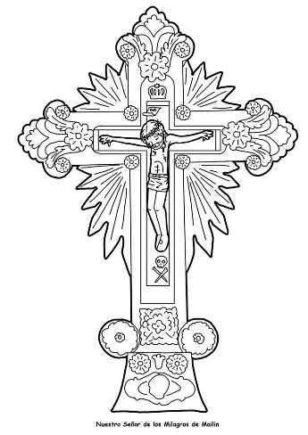Christ Jesus, though he was in the form of God, did not count equality with God a thing to be grasped, but emptied himself, by taking the form of a servant, being born in the likeness of men. And being found in human form, he humbled himself by becoming obedient to the point of death, even death on a cross. Therefore God has highly exalted him and bestowed on him the name that is above every name, so that at the name of Jesus every knee should bow, in heaven and on earth and under the earth, and every tongue confess that Jesus Christ is Lord, to the glory of God the Father.

The word of the Lord. **Thanks be to God**

*We stand for-* ***The Gospel Procession and Acclamation***

Alleluia, alleluia!

*We adore you, O Christ, and we bless you,*

*because by your Cross you have redeemed the world.*

Alleluia!

***The Gospel- John 3:13-17***

The Lord be with you. **And with your spirit.**

A reading from the holy Gospel according to *N*. **Glory to you, O Lord.**

At that time: Jesus said to Nicodemus, ‘No one has ascended into heaven except he who descended from heaven, the Son of Man. And as Moses lifted up the serpent in the wilderness, so must the Son of Man be lifted up, that whoever believes in him may have eternal life. For God so loved the world, that he gave his only begotten Son, that whoever believes in him should not perish but have eternal life. For God did not send his Son into the world to condemn the world, but in order that the world might be saved through him.’

The Gospel of the Lord. **Praise to you, Lord Jesus Christ.**

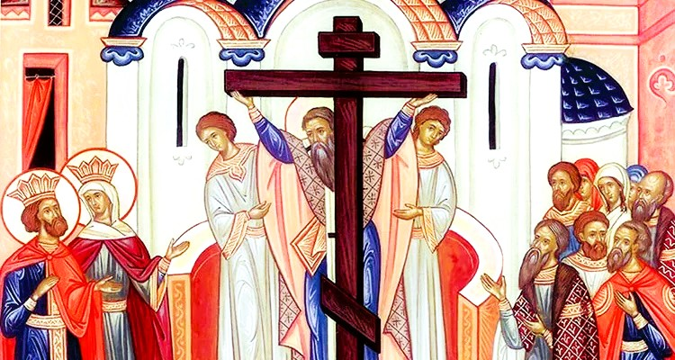

*We sit for* ***The Homily***

*We stand* ***The Creed***

**I believe in one God,** **the Father almighty,** **maker of heaven and earth,**

**of all things visible and invisible.**

**I believe in one Lord Jesus Christ,** **the Only Begotten Son of God,** **born of the Father before all ages.** **God from God,** **Light from Light,** **true God from true God,** **begotten, not made, consubstantial with the Father;** **through him all things were made.** **For us men and for our salvation he came down from heaven,**

*At the words that follow, up to and including ‘and became man’, all bow.*

**and by the Holy Spirit was incarnate of the Virgin Mary,** **and became man.**

**For our sake he was crucified under Pontius Pilate,** **he suffered death and was buried,** **and rose again on the third day** **in accordance with the Scriptures.**

**He ascended into heaven** **and is seated at the right hand of the Father.** **He will come again in glory** **to judge the living and the dead** **and his kingdom will have no end.**  
**I believe in the Holy Spirit, the Lord, the giver of life,** **who proceeds from the Father and the Son,** **who with the Father and the Son is adored and glorified,** **who has spoken through the prophets.  
I believe in one, holy, catholic and apostolic Church.** **I confess one Baptism for the forgiveness of sins** **and I look forward to the resurrection of the dead** **and the life of the world to come. Amen.**

*……………………………………………………………………………..*

*We remain standing for* ***The Prayers of the Faithful***

*Each biding concludes with the following said or sung-*

We pray to the Lord. **Lord in your Mercy hear our prayer.**

*The Priest Concludes the Prayers of the Faithful*

*……………………………………………………………………………..*

*No collection is taken during the Mass, but there is a collection box at the back of church for you to give your financial contribution. All money collected helps towards the mission and ministry of our churches. If you would prefer, a card reading machine is available at the back of the church for your contribution.*

***The Offertory Hymn***

**1.** Sing, my tongue, the song of triumph,  
Tell the story far and wide;  
Tell of dread and final battle,  
Sing of Savior crucified;  
How upon the cross a victim  
Vanquishing in death he died.

**2.** Thirty years among us dwelling,  
His appointed Time fulfilled,  
Born for this, He meets His Passion,  
For that this He freely willed:  
On the Cross the Lamb is lifted,  
Where His life-blood shall be spilled.

**3.** Faithful Cross! above all other,  
One and only noble Tree!  
None in foliage, none in blossom,  
None in fruit thy peers may be!  
Sweetest wood and sweetest iron,  
Sweetest weight is hung on thee!

**4.** Bend your boughs, O Tree of glory!  
All your rigid branches, bend!  
For a while the ancient temper  
That your birth bestowed, suspend;  
And the King of earth and heaven  
Gently on your bosom tend.

**5.** Praise and honour to the Father,  
praise and honour to the Son,  
praise and honour to the Spirit,  
ever Three and ever One:  
one in triumph, one in glory  
while eternal ages run!

***The Liturgy of the Eucharist***

Pray, brethren **(**brothers and sisters**)**, that my sacrifice and yours may be acceptable to God, the almighty Father.  
  
**May the Lord accept the sacrifice at your hands** **for the praise and glory of his  
name,** **for our good** **and the good of all his holy Church.**

The Lord be with you. **And with your spirit.**

Lift up your hearts. **We lift them up to the Lord.**  
Let us give thanks to the Lord our God. **It is right and just.**

*The Priest continues with the Preface. The Sanctus is the said or sung:*

**Holy, Holy, Holy Lord God of hosts.**

**Heaven and earth are full of your glory.** **Hosanna in the highest.**

**Blessed is he who comes in the name of the Lord.** **Hosanna in the highest.**

*The Priest continues the Eucharistic prayer. The following is said or sung*

The mystery of faith….  
**We proclaim your Death, O Lord,** **and profess your Resurrection** **until you come again.**

*The Priest concludes the Eucharistic prayer.*

Through him, and with him, and in him, O God, almighty Father, in the unity of the Holy Spirit, all glory and honour is yours, for ever and ever. **Amen.**

***The Lord’s Prayer***

At the Saviour’s command and formed by divine teaching, we dare to say:

**Our Father, who art in heaven,** **hallowed be thy name;** **thy kingdom come,** **thy will be done** **on earth as it is in heaven.** **Give us this day our daily bread,** **and forgive us our trespasses,** **as we forgive those who trespass against us;** **and lead us not into temptation,** **but deliver us from evil.**

Deliver us, Lord, we pray… and the coming of our Saviour, Jesus Christ.  
**For the kingdom,** **the power and the glory are yours** **now and for ever.**

***The Peace***

Lord Jesus Christ, who said to your Apostles: Peace I leave you, my peace I give you,

look not on our sins, but on the faith of your Church, and graciously grant her peace and unity in accordance with your will. Who live and reign for ever and ever. **Amen.**

The peace of the Lord be with you always: **And with your spirit.**

Let us offer each other the sign of peace.

*All are invited to make an acknowledgement to each other to mark the sign of the peace.*

***The Agnus Dei***

*All say or sing:***Lamb of God, you take away the sins of the world,** **have mercy on us.**

**Lamb of God, you take away the sins of the world,** **have mercy on us.**

**Lamb of God, you take away the sins of the world,** **grant us peace.**

***The Invitation to Communion***

Behold the Lamb of God, behold him who takes away the sins of the world. Blessed are those called to the supper of the Lamb. **Lord, I am not worthy** **that you should enter under my roof,** **but only say the word and my soul shall be healed.**

*All who are regular communicants in their own tradition are welcome to receive the*  *sacrament if you are not a communicant you are welcome to come forward at this point in the service to receive a blessing To indicate that it is just a blessing you require, please take this service sheet up with you. We have returned to offering the chalice at the time of communion but please do not feel any pressure to receive from the common cup as the church teaches that the sacrament is received fully in one kind. We request that you do not* ***intinct (dip) your host in the Chalice*** *but either take a sip from the cup or return directly to your seat. This is for reasons of good hygiene.*

***The Communion Hymn***

**1.** O my Saviour, lifted  
from the earth for me,  
draw me, in thy mercy,  
nearer unto thee.  
  
**2.** Lift my earth-bound longings,  
fix them, Lord, above;  
draw me with the magnet  
of thy mighty love.  
**3.** Lord, thine arms are stretching  
ever far and wide,  
to enfold thy children  
to thy loving side.  
  
**4.** And I come, O Jesus:  
dare I turn away?  
No, thy love hath conquered,  
and I come today.

**5.**  Bringing all my burdens,   
sorrow, sin and care;  
at thy feet I lay them,  
and I leave them there.

*We stand for* ***The Prayer After Communion***

Having been nourished by your holy banquet, we beseech you, Lord Jesus Christ, to bring those you have redeemed by the wood of your life-giving Cross to the glory of the resurrection. Who live and reign for ever and ever. **Amen**

*We remain standing for* **Our Mission Prayer for 2025**Lord Jesus, you call us to be your missionary disciples.

Guide and strengthen us to share your love with all we meet.

Give us courage to reach out to help others.

Give us wisdom to know how best to care,

And give us hope to believe we can make a difference.

Bless us all who bring your compassion and mercy to the poor and marginalised.

Together, may we make known your love on earth.

We make our prayer through Christ Our Lord. **Amen.**

*The priest may give some brief notices*

***The Concluding Rites***

The Lord be with you. **And with your spirit.**

May almighty God bless you, the Father, and the Son, ✠ and the Holy Spirit. **Amen.**

***The Dismissal***

Go forth, the Mass is ended. **Thanks be to God**

***The Final Hymn***

**1.** The head that once was crowned with thorns  
is crowned with glory now:  
a royal diadem adorns  
the mighty Victor's brow.

**2.** The highest place that heaven affords  
is his, is his by right,  
the King of kings, and Lord of lords,  
and heaven's eternal Light;  
  
**3.** The joy of all who dwell above,  
the joy of all below,  
to whom he manifests his love,  
and grants his name to know.  
  
**4.** To them the cross, with all its shame,  
with all its grace, is given:  
their name, an everlasting name,  
their joy, the joy of heaven.  
  
**5.** They suffer with their Lord below,  
they reign with him above;  
their profit and their joy to know  
the mystery of his love.

**6.**  The cross he bore is life and health,  
though shame and death to him;  
his people's hope, his people's wealth,  
their everlasting theme.

***The Angelus***

The Angel of the Lord declared unto Mary. **And she conceived of the Holy Spirit.**

Hail Mary, full of grace, The Lord is with Thee; Blessed art thou among women,  
And blessed is the fruit of thy womb, Jesus.   
**Holy Mary, Mother of God, Pray for us sinners, Now and at the hour of our death.**

Behold the handmaid of the Lord.  
**Be it done to me according to thy word.** *Hail Mary. . .*

And the Word was made flesh.  
**And dwelt among us.** *Hail Mary…*

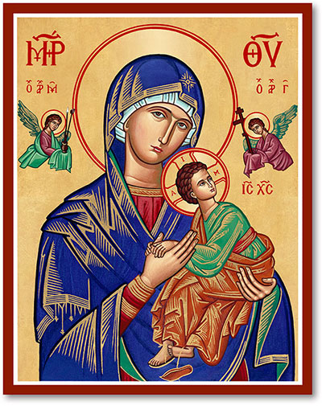Pray for us, O holy Mother of God.  
**That we may be made worthy of the promises of Christ.**

Let us pray:

Pour forth, we beseech Thee, O Lord, Thy grace into our hearts, that we to whom the Incarnation of Christ Thy Son was made known by the message of an angel, may by His Passion and Cross be brought to the glory of His Resurrection. Through the same Christ Our Lord. **Amen.**

***For Prayer***

**Those who have asked for our prayers….** Denise, Janice Allin, Leslie Porch, Sheila Tucker, Tina Smart, Kathy Haydon, Bobby Lilicrap, June Brock, Emma Addison, Georgie Maher, Ian Craggs, Brenda Alderson, Lois Tobin, Michael O’Leary, Brenda Steed, Anne Lewis, Jenny Harvey, Jackie Morrison, Fr Roger Beck, Anna, Gwen Lamb, Anna Lynch, Jackie Fisher, Helen Lewis, Val Bradden, Cynthia Way, Pauleen Stewart, Amelia Coughlan, Roger Lewis, Sarah Cavey, Shaun Carrie

**Recently Departed**- Audrey Dewey, David Steer, Diana Stephens, Pam Otley, Katherine (Duchess of Kent), Gordon Walters, Charles Curvengen-Pitt

**Anniversaries of Death**

***The Notices***

**Coffee, Cleaning and Cake**, or as we like to call it “Shiney Church” returns next Saturday between 11.00 and Noon

**The Bishop Of Oswestry’s Pastoral Visitation** to Plymouth is taking place on September 25th and 26th . There will be an opportunity for lay people to meet with the Bishop Friday 26th at 11.00am and there will be a festival Mass to bring the visitation to a close at 7.00pm on the Friday.

Advance notice- St Peters will be holding a Quiz on Saturday 18th October and an **Autumn Fair on Saturday 25th October-** Please keep this date available, help will be needed at the event and for preparation.

**St Gabriels- Peverell Feast of Title**- There will be evening prayer followed by refreshments at St Gabriels on **Sunday 28th September 5pm**- All welcome.

**Walsingham Cell- Sunday 21st September 6pm-** Our Walsingham Cell will take place at St Peters beginning with the Rosary- we will then move into cloisters for a time of fellowship enjoying memories of our recent pilgrimage.

The Mission Community of St Peter and the Holy Apostles

*St Peter, Wyndham Square + St Thomas, Royal Navy Avenue + St James-the-Less, Ham Drive*

**A Church of England Parish in the care of the Bishop of Oswestry**

**Parish Priest Fr. David Way SSC: 01752 240119** fr.davidway@gmail.com

.com

**Mission Development Minister/ LLM: Ben Otley 07939800544** benotley.mission.plym@gmail.com

**Parish Website**: **plymouthstpeter.co.uk ~ *FOR MUCH MORE INFORMATION ON EVENTS, ETC.***

***This week’s services***

|  |  |  |
| --- | --- | --- |
| **Sunday 14th-**  **The Exaltation of the Holy Cross** | **8.30am St Thomas Fr DCW**  **10.00am St Peter Fr DCW** | **Mass with Hymns**  **Sung Mass** |
| Monday 15th- Our Lady of Sorrows | St Peter 10.00am Fr PL | Mass |
| Tuesday 16th-  St Cornelius and St Cyprian | St Peter 10.00am Fr DCW | Mass |
| Wednesday 17th- Weekday in OT | St Peter 10.00am Fr DCW | Mass |
| Thursday 18th- Weekday in OT | St Peter 10.00am Fr DCW | Mass |
| Friday 19th- Weekday in OT | St Peter 10.00am Fr DCW | Mass |
| Saturday 20th-  Saints Andrew Kim Tae-gon and Paul Chong Ha-sang and Companions | St Peter 10.00am Fr DCW | Mass |
| **Sunday 21st**  **The Twenty-Fifth Sunday in Ordinary Time** | **8.30am St Thomas Fr DCW**  **10.00am St Peter Fr DCW**  **6.00pm St Peter** | **Mass with Hymns**  **Sung Mass**  **Rosary and Walsingham Cell** |

**St Peters is open daily 8.30am- 12noon- Place of Welcome, Place of Prayer, food larder etc.**

**Safeguarding:** If you have any concerns regarding the safety of children and others who are vulnerable, regardless of age, you must tell the Duty Priest or our parish Lay Safeguarding Representative- Jackie Morrison- email randj49@gmail.com Tel 07848859124.

***For online donations please scan the QR code***