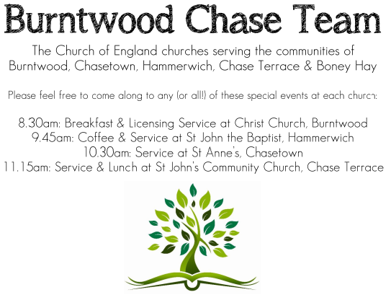 **CHRIST CHURCH**

SUNDAY 28th September 2025 at 10am

**SERVICES:**

**Sunday 28th September 2025**

**Morning Worship**

**15th Sunday after Trinity**

**Readings:**

**1 Timothy 6: 6-19**

6Of course, there is great gain in godliness combined with contentment; [7](https://www.biblesociety.org.uk/explore-the-bible/read/eng/NRSV/1Tim/6/#1TI.6.7!f.1)for we brought nothing into the world, so that we can take nothing out of it; 8but if we have food and clothing, we will be content with these. 9But those who want to be rich fall into temptation and are trapped by many senseless and harmful desires that plunge people into ruin and destruction. 10For the love of money is a root of all kinds of evil, and in their eagerness to be rich some have wandered away from the faith and pierced themselves with many pains.

11But as for you, man of God, shun all this; pursue righteousness, godliness, faith, love, endurance, gentleness. [12](https://www.biblesociety.org.uk/explore-the-bible/read/eng/NRSV/1Tim/6/#1TI.6.12!f.1)Fight the good fight of the faith; take hold of the eternal life, to which you were called and for which you made the good confession in the presence of many witnesses. 13In the presence of God, who gives life to all things, and of Christ Jesus, who in his testimony before Pontius Pilate made the good confession, I charge you 14to keep the commandment without spot or blame until the manifestation of our Lord Jesus Christ, 15which he will bring about at the right time—he who is the blessed and only Sovereign, the King of kings and Lord of lords. 16It is he alone who has immortality and dwells in unapproachable light, whom no one has ever seen or can see; to him be honour and eternal dominion. Amen.

17As for those who in the present age are rich, command them not to be haughty, or to set their hopes on the uncertainty of riches, but rather on God who richly provides us with everything for our enjoyment. 18They are to do good, to be rich in good works, generous, and ready to share, 19thus storing up for themselves the treasure of a good foundation for the future, so that they may take hold of the life that really is life.

**Luke 16: 19-31**

**19**‘There was a rich man who was dressed in purple and fine linen and who feasted sumptuously every day. **20**And at his gate lay a poor man named Lazarus, covered with sores, **21**who longed to satisfy his hunger with what fell from the rich man’s table; even the dogs would come and lick his sores. **22**The poor man died and was carried away by the angels to be with Abraham.The rich man also died and was buried. **23**In Hades, where he was being tormented, he looked up and saw Abraham far away with Lazarus by his side. **24**He called out, “Father Abraham, have mercy on me, and send Lazarus to dip the tip of his finger in water and cool my tongue; for I am in agony in these flames.” **25**But Abraham said, “Child, remember that during your lifetime you received your good things, and Lazarus in like manner evil things; but now he is comforted here, and you are in agony. **26**Besides all this, between you and us a great chasm has been fixed, so that those who might want to pass from here to you cannot do so, and no one can cross from there to us.” **27**He said, “Then, father, I beg you to send him to my father’s house— **28**for I have five brothers—that he may warn them, so that they will not also come into this place of torment.” **29**Abraham replied, “They have Moses and the prophets; they should listen to them.” **30**He said, “No, father Abraham; but if someone goes to them from the dead, they will repent.” **31**He said to him, “If they do not listen to Moses and the prophets, neither will they be convinced even if someone rises from the dead.”’

**COLLECT FOR TODAY**

God, who in generous mercy sent the Holy Spirit

upon your Church in the burning fire of your love:

grant that your people may be fervent

in the fellowship of the gospel

that, always abiding in you,

they may be found steadfast in faith and active

in service;

through Jesus Christ your Son our Lord,

who is alive and reigns with you,

in the unity of the Holy Spirit,

one God, now and for ever.

***WHAT’S GOING ON***

**Upcoming Services**

**Wednesday 1st October Morning Prayer 9.30am**

**Saturday 4th October Art Cafe 3-5pm**

**Sunday 5th October Harvest Communion 10am**

**Monday 6th October Cameo Cafe 10-12 noon**

**Wednesday 8th October Morning Prayer 9.30am**

**Sunday 12th October Morning Worship 10am**

**Congratulations**

Congratulations to Steve, he has been re -appointed for a further 3 years and it is a real blessing for us all.

**Harvest**

Harvest Service is 10am on 5th October  
Church will be open on Saturday 4th at 10am for decorating.  
Items for the Food Bank welcome.

**FLOODLIGHTING**If you think about commemorating a special occasion by floodlighting our Church.  Please contact Chris Brown on 01543 683862 for details.

PRAYER CHAIN

Christ Church is blessed with a very active prayer chain. If you, or anyone you know, feel that they would like others to pray for them, please speak to Chris Brown on 01543 683862.

HOME COMMUNION

For anyone who is unable to attend church and would like Home Communion,

Steve Morgan is able to carry this out.

VICAR CONTACT DETAILS

Stephen Morgan Tele: 07305 852152

**CHURCH WARDENS CONTACT DETAILS**

**Judith Rogers Tele: 01543 324718**

**Mike Holmes Tele: 01543 672970**

**Church Office Tele: 01543 642187** *[leave a message and we will respond]*

Church Web Site:www.christchurchburntwood.org.uk

Church Email: [christchurchburntwood15@gmail.com](mailto:christchurchburntwood15@gmail.com)

Facebook: [www.facebook.com/group/christchurchburntwood/](http://www.facebook.com/group/christchurchburntwood/)

**Other Contacts**

**Matt Wallace St. John’s, Chase Terrace— Tele: 01543 670078**

**Richard Westwood St. Anne’s, Chasetown—Tele: 01543 686111**

**NEXT SUNDAY SERVICE**

**Sunday 5th October at 10am**

**Harvest Communion**

**Deuteronomy 26: 1-11**

**John 6: 25-35**

**16th Sunday after Trinity**