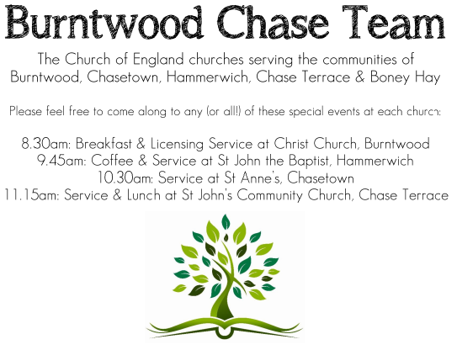 **CHRIST CHURCH**

SUNDAY 21st September 2025 at 10am

**SERVICES:**

**Sunday 21st September 2025**

**Holy Communion**

**14th Sunday after Trinity**

**Readings:**

**1 Timothy 2: 1-7**

[1](http://biblehub.com/1_timothy/2-1.htm)I urge, then, first of all, that petitions, prayers, intercession and thanksgiving be made for all people— [2](http://biblehub.com/1_timothy/2-2.htm)for kings and all those in authority, that we may live peaceful and quiet lives in all godliness and holiness. [3](http://biblehub.com/1_timothy/2-3.htm)This is good, and pleases God our Savior, [4](http://biblehub.com/1_timothy/2-4.htm)who wants all people to be saved and to come to a knowledge of the truth. [5](http://biblehub.com/1_timothy/2-5.htm)For there is one God and one mediator between God and mankind, the man Christ Jesus, [6](http://biblehub.com/1_timothy/2-6.htm)who gave himself as a ransom for all people. This has now been witnessed to at the proper time. [7](http://biblehub.com/1_timothy/2-7.htm)And for this purpose I was appointed a herald and an apostle—I am telling the truth, I am not lying—and a true and faithful teacher of the Gentiles.

**Luke 16: 1-13**

[1](http://biblehub.com/luke/16-1.htm)Jesus told his disciples: “There was a rich man whose manager was accused of wasting his possessions. [2](http://biblehub.com/luke/16-2.htm)So he called him in and asked him, ‘What is this I hear about you? Give an account of your management, because you cannot be manager any longer.’

[3](http://biblehub.com/luke/16-3.htm)“The manager said to himself, ‘What shall I do now? My master is taking away my job. I’m not strong enough to dig, and I’m ashamed to beg— [4](http://biblehub.com/luke/16-4.htm)I know what I’ll do so that, when I lose my job here, people will welcome me into their houses.’ [5](http://biblehub.com/luke/16-5.htm)“So he called in each one of his master’s debtors. He asked the first, ‘How much do you owe my master?’ [6](http://biblehub.com/luke/16-6.htm)“ ‘Nine hundred gallons [***a***](https://biblehub.com/niv/luke/16.htm#footnotes) of olive oil,’ he replied.

“The manager told him, ‘Take your bill, sit down quickly, and make it four hundred and fifty.’

[7](http://biblehub.com/luke/16-7.htm)“Then he asked the second, ‘And how much do you owe?’

“ ‘A thousand bushels [***b***](https://biblehub.com/niv/luke/16.htm#footnotes) of wheat,’ he replied.

“He told him, ‘Take your bill and make it eight hundred.’

[8](http://biblehub.com/luke/16-8.htm)“The master commended the dishonest manager because he had acted shrewdly. For the people of this world are more shrewd in dealing with their own kind than are the people of the light. [9](http://biblehub.com/luke/16-9.htm)I tell you, use worldly wealth to gain friends for yourselves, so that when it is gone, you will be welcomed into eternal dwellings.

[10](http://biblehub.com/luke/16-10.htm)“Whoever can be trusted with very little can also be trusted with much, and whoever is dishonest with very little will also be dishonest with much.[11](http://biblehub.com/luke/16-11.htm)So if you have not been trustworthy in handling worldly wealth, who will trust you with true riches? [12](http://biblehub.com/luke/16-12.htm)And if you have not been trustworthy with someone else’s property, who will give you property of your own? [13](http://biblehub.com/luke/16-13.htm)“No one can serve two masters. Either you will hate the one and love the other, or you will be devoted to the one and despise the other. You cannot serve both God and money.”

**COLLECT FOR TODAY**

Almighty God,

whose only Son has opened for us

a new and living way into your presence:

give us pure hearts and steadfast wills

to worship you in spirit and in truth;

through Jesus Christ your Son our Lord,

who is alive and reigns with you,

in the unity of the Holy Spirit,

one God, now and for ever.

***WHAT’S GOING ON***

**Upcoming Services**

**Wednesday 24th September Morning Prayer 9.30am**

**Sunday 28th September Morning Worship 10am**

**Wednesday 1st October Morning Prayer 9.30am**

**Saturday 4th October Art Cafe 3-5pm**

**Sunday 5th October Harvest Communion 10am**

**Burntwood Chase Mothers Union**  
Tea, Coffee and Cake  
Harvest Fundraiser  
Friday 26th September  
2pm - 4pm  
£5  
at St. John’s Church Chase Terrace  
Tickets from Chris Brown

**Congratulations**

Congratulations to Steve, he has been re -appointed for a further 3 years and it is a real blessing for us all.

**Harvest**

Harvest Service is 10am on 5th October  
Church will be open on Saturday 4th at 10am for decorating.  
Items for the Food Bank welcome.

**FLOODLIGHTING**If you think about commemorating a special occasion by floodlighting our Church.  Please contact Chris Brown on 01543 683862 for details.

PRAYER CHAIN

Christ Church is blessed with a very active prayer chain. If you, or anyone you know, feel that they would like others to pray for them, please speak to Chris Brown on 01543 683862.

HOME COMMUNION

For anyone who is unable to attend church and would like Home Communion,

Steve Morgan is able to carry this out.

VICAR CONTACT DETAILS

Stephen Morgan Tele: 07305 852152

**CHURCH WARDENS CONTACT DETAILS**

**Judith Rogers Tele: 01543 324718**

**Mike Holmes Tele: 01543 672970**

**Church Office Tele: 01543 642187** *[leave a message and we will respond]*

Church Web Site:www.christchurchburntwood.org.uk

Church Email: [christchurchburntwood15@gmail.com](mailto:christchurchburntwood15@gmail.com)

Facebook: [www.facebook.com/group/christchurchburntwood/](http://www.facebook.com/group/christchurchburntwood/)

**Other Contacts**

**Matt Wallace St. John’s, Chase Terrace— Tele: 01543 670078**

**Richard Westwood St. Anne’s, Chasetown—Tele: 01543 686111**

**NEXT SUNDAY SERVICE**

**Sunday 28th September at 10am**

**Morning Worship**

**1Timothy 6: 6-19**

**Luke 16: 19-31**

**15th Sunday after Trinity**