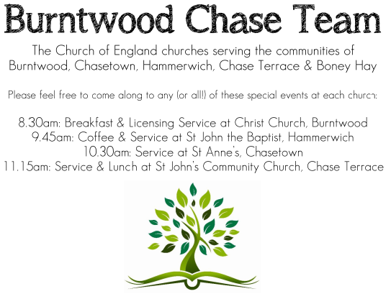 **CHRIST CHURCH**

SUNDAY 14th September 2025 at 10am

**SERVICES:**

**Sunday 14th September 2025**

**Morning Worship**

**13th Sunday after Trinity**

**Readings:**

**1 Timothy 1: 12-17**

**12**I am grateful to Christ Jesus our Lord, who has strengthened me, because he judged me faithful and appointed me to his service, **13**even though I was formerly a blasphemer, a persecutor, and a man of violence. But I received mercy because I had acted ignorantly in unbelief, **14**and the grace of our Lord overflowed for me with the faith and love that are in Christ Jesus. **15**The saying is sure and worthy of full acceptance, that Christ Jesus came into the world to save sinners—of whom I am the foremost. **16**But for that very reason I received mercy, so that in me, as the foremost, Jesus Christ might display the utmost patience, making me an example to those who would come to believe in him for eternal life. **17**To the King of the ages, immortal, invisible, the only God, be honour and glory for ever and ever.Amen.

**Luke 15: 1-10**

Now all the tax-collectors and sinners were coming near to listen to him. **2**And the Pharisees and the scribes were grumbling and saying, ‘This fellow welcomes sinners and eats with them.’

**3**So he told them this parable: **4**‘Which one of you, having a hundred sheep and losing one of them, does not leave the ninety-nine in the wilderness and go after the one that is lost until he finds it? **5**When he has found it, he lays it on his shoulders and rejoices. **6**And when he comes home, he calls together his friends and neighbours, saying to them, “Rejoice with me, for I have found my sheep that was lost.” **7**Just so, I tell you, there will be more joy in heaven over one sinner who repents than over ninety-nine righteous people who need no repentance.

**8**‘Or what woman having ten silver coins,if she loses one of them, does not light a lamp, sweep the house, and search carefully until she finds it? **9**When she has found it, she calls together her friends and neighbours, saying, “Rejoice with me, for I have found the coin that I had lost.” **10**Just so, I tell you, there is joy in the presence of the angels of God over one sinner who repents.’

**COLLECT FOR TODAY**

Almighty God,

who in the passion of your blessed Son

made an instrument of painful death

to be for us the means of life and peace:

grant us so to be glory in the cross of Christ

that we may gladly suffer for his sake;

who is alive and reigns with you,

in the unity of the Holy Spirit,

one God, now and for ever.

***WHAT’S GOING ON***

**Upcoming Services**

**Wednesday 17th September Morning Prayer 9.30am**

**Sunday 21st September Holy Communion 10am**

**Wednesday 24th September Morning Prayer 9.30am**

**Sunday 28th September Morning Worship 10am**

**Burntwood Chase Mothers Union**  
Tea, Coffee and Cake  
Harvest Fundraiser  
Friday 26th September  
2pm - 4pm  
£5  
at St. John’s Church Chase Terrace  
Tickets from Chris Brown

**FLOODLIGHTING**If you think about commemorating a special occasion by floodlighting our Church.  Please contact Chris Brown on 01543 683862 for details.

PRAYER CHAIN

Christ Church is blessed with a very active prayer chain. If you, or anyone you know, feel that they would like others to pray for them, please speak to Chris Brown on 01543 683862.

HOME COMMUNION

For anyone who is unable to attend church and would like Home Communion,

Steve Morgan is able to carry this out.

VICAR CONTACT DETAILS

Stephen Morgan Tele: 07305 852152

**CHURCH WARDENS CONTACT DETAILS**

**Judith Rogers Tele: 01543 324718**

**Mike Holmes Tele: 01543 672970**

**Church Office Tele: 01543 642187** *[leave a message and we will respond]*

Church Web Site:www.christchurchburntwood.org.uk

Church Email: [christchurchburntwood15@gmail.com](mailto:christchurchburntwood15@gmail.com)

Facebook: [www.facebook.com/group/christchurchburntwood/](http://www.facebook.com/group/christchurchburntwood/)

**Other Contacts**

**Matt Wallace St. John’s, Chase Terrace— Tele: 01543 670078**

**Richard Westwood St. Anne’s, Chasetown—Tele: 01543 686111**

**NEXT SUNDAY SERVICE**

**Sunday 21st September at 10am**

**Holy Communion**

**1Timothy 2: 1-7**

**Luke 16: 1-13**

**14th Sunday after Trinity**