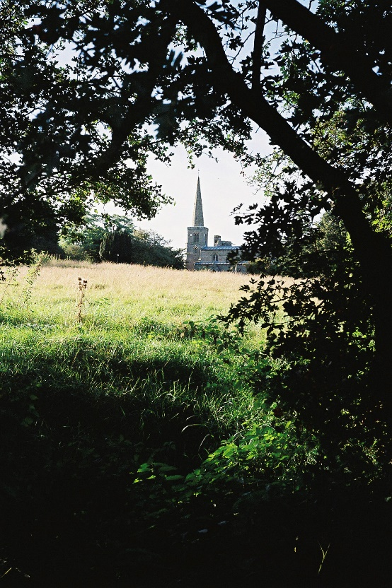
ST MICHAEL AND ALL ANGELS,
HAMSTALL RIDWARE

In the United Benefice of King’s Bromley, the Ridwares
and Yoxall

September 14th 2025
Trinity 13

PARISH NOTICES

UNITED BENEFICE SERVICE ROTA
 | Hamstall Ridware  St Michael and All Angels | Yoxall  St Peter | King’s Bromley  All Saints | Mavesyn Ridware  St Nicholas
September 14th  Trinity 13 | 5.00 pm  Holy Communion | 10.30 am  Parish Communion | 10.30 am  Parish Communion
September 21st  Trinity 14 | 10.30 am  Harvest Festival | 5.00 pm  Parish picnic at Goose Green | 9.00 am  Holy Communion | 10.30 am  Parish Communion
September 28th  St Michael and All Angels | 10.30 am  United Benefice service and Patronal Festival  St Michael and All Angels, Hamstall Ridware
October 5th  Trinity 16 | 9.00 am  Holy Communion | 10.30 am  Parish Communion | 10.30 am  Harvest Festival | 4.00 pm  Harvest Praise
October 12th  Trinity 17 | 4.00 pm  Holy Communion | 10.30 am  Harvest Festival | 10.30 am  Something different – come and see!
Please note that services of Holy Communion at 9 am follow the Book of Common Prayer and are said. Services at 10.30 will include hymns and other singing.
*******************
Rugeley Food Bank. Please do remember those who depend on Food Banks. They are needed now just as ever. If you wish to donate directly to Rugeley Foodbank at Rugeley Community Centre the Centre is open everyday to receive contributions. Alternatively, the Rugeley Food Bank welcomes financial contributions – see https://rugeley.foodbank.org.uk. Gifts can also be brought to St Michael’s and left in the box at the back of church near the font. If that is not convenient please contact Liz Carter on 07751 068181.
****************
Contact details: If you wish to contact the Rector, Jeremy Brading you can do so on revd@kbhmy.co.uk and Glenis Turner, the PCC Secretary and Benefice Administrator is on admin@kbhmy.co.uk. The churchwardens are Michael Elsom michael.elsom@btopenworld.com and John Ferguson clan.member1954@gmail.com Information about events at church can be found at our webpages at https://www.achurchnearyou.com/church/4451/ and https://kbhmy.co.uk/hamstall/
St Michael’s will continue to be open everyday (weather permitting) between 10.00 am until 6.00 pm. We will revert to shutting the church at 4.00 pm on October 26th
Safeguarding of children and vulnerable adults. If you have any concerns please speak in complete confidence to the Parish Safeguarding Officer, Dr Paul Carter 01889 504347 or the Diocesan Safeguarding Officer Mr Neil Spiring 01543 306 030.
PLEASE REMEMBER IN YOUR PRAYERS:
Those who are sick: Mary Mycock, Brenda, Angela Perkin, Doug, David and Barbara Rudge, May Windley, Pam Payne, Rev’d Frank Finch, Chris Poole, Les Woods, Pat Lomax, Alison Scott and any known personally to you.
Those who live and work in the Nursing, Care and Retirement homes in the villages both in and near the parishes of the United Benefice.
At a time when public life is in turmoil let us pray for those engaged in tasks or applying for posts which carry real responsibility for the welfare of others wherever they may be, that such people may observe proper standards of behaviour consistent with what they expect of those whom they claim to represent.
Using the Archbishops’ prayer for Ukraine at this time let us remember the people of that war-torn land:
God of peace and justice, we pray for the people of Ukraine today. We pray for peace and the laying down of weapons. We pray for all those who fear for tomorrow, that your Spirit of comfort would draw near to them. We pray for those with power over war or peace, for wisdom, discernment and compassion to guide their decisions. Above all, we pray for all your precious children, at risk and in fear, that you would hold and protect them. We pray in the name of Jesus, the Prince of Peace. Amen
Let us also pray that the right of the people of Ukraine and neighbouring countries to exist without threat of dominance from any other country and the greed of those with eyes on its resources may be honoured.
The situation in the Middle East where hopes for a peaceful resolution sometimes appear irretrievably bleak:
O God of all justice and peace, we cry out to you in the midst of the pain and trauma of violence and fear which prevails in the Holy Land. Be with those who need you in these days of suffering; we pray for people of all faiths - Jews, Muslims and Christians and for all people of the land. While we pray to you, O Lord, for an end to violence and the establishment of peace, we also call to you to bring justice and equity to the peoples. Guide us into your kingdom where all people are treated with dignity and honour as your children - for to all of us you are our Heavenly Father. In Jesus' name we pray. Amen.
From the Diocesan Prayer Diary:
Sunday 14th September: (Holy Cross Day)
Lord, on Holy Cross Day we lift before you today the four churches in the diocese named Holy Cross; in the villages of Bilbrook and Bobbington in South Staffordshire, Ilam in the Staffordshire Moorlands, and Tividale in the heart of the Black Country. We pray for your hand of blessing to rest on all of these churches and each of the communities they serve.
Wednesday 17th: (Hildegard, Abbess of Bingen, Visionary, 1179)
We bring before you the Soul Food course as it starts today. Thank you for the many wonderful ways we have of talking to you in prayer and that we know you always answer our prayers. Thank you for those taking the course this time and their eagerness to explore ways of strengthening their relationship with you, may you exceed their expectations in ways that they can't imagine. And thank you for Charles, Sue, and Ursula as they lead the course, please continue to bless them with vision and inspiration.
Saturday 20th: (John Coleridge Patteson, First Bishop of Melanesia, and his Companions, Martyrs, 1871)
Lord, we bring before you the Diocesan Safeguarding Conference taking place today at Telford Minster. Thank you for all those that take on the important role of Safeguarding Officer across our parishes. Thank you for all those in our diocesan team who support them. Please help each one of us to be ever more vigilant so that all our churches may be places where anyone coming will be welcome and safe.
HARVEST FESTIVAL
We will celebrate Harvest at St Michael’s on Sunday September 21st at 10.30. This is our opportunity to thank the Lord for the good things that we enjoy as a result of the cultivation of the land and the husbandry of farm animals. We also pray that He will guide and guard those who produce the food on which we all depend – whether it comes from near or far. Liz Carter has placed a list in church where you can sign to indicate what you would like to contribute to the Bring and Share lunch in church after the service.
The Churchyard
is a very important part of the heritage of the village and St Michael’s in particular. Keeping it in good order and a fitting place for the repose of those buried there and a space of solace and prayer for visitors is hard work but much appreciated by all. The next working party is on Tuesday September 16th at 5.00 pm.

