
SJN Newsletter 15 - September 2025
Try Praying
The banner is now in place outside church and there is an invitation to the official launch on Thursday 11th September from 6-7pm at Hull Minster (refreshments served from 5.45pm) to join in a time of prayer. Watch out for the 'Try Praying booklet' on Sunday 14th September for you to 'use it then lose it' (i.e. give it away to someone who might be interested). Please continue to pray that this campaign would have an amazing impact in Hull and that we might see new people becoming Christians because of it. For more info - https://www.trypraying.org/

Fresher week at Hull Uni
Hull Uni Fresher's week starts on the 15th September. Jake and Hannah will be around on campus especially on 16th for the Fresher's fair, both as chaplains of the Uni and as vicars of SJN. Once again, we will be hosting a Big Plant Giveaway at St. John's and inviting students to come along for a chat and receive a plant. Please bring donations of house plants to church by Sunday 21st September. See separate flyer.

The Prayer course
The Prayer course starts on Wednesday 17th Sept at 7.30pm in church. It will run for 8 weeks with a break over half term. Do let us know if you want to come so we have an idea of numbers. It would be great to deepen our pray life together and this course is a really helpful way of encouraging us to pray together. For more info - https://prayercourse.org/home/

Youth Work at SJN
We are hoping to run Youth Alpha for secondary school kids from October half term. The current plan is to meet after the morning service and share lunch and do Alpha. If you know any young people who might be interested, do let them know and put us in touch. Please pray for our young people at SJN - that God would meet with them, that friendships would continue to grow and that their gifts would be released in our church. For more info - https://alpha.org.uk/youth

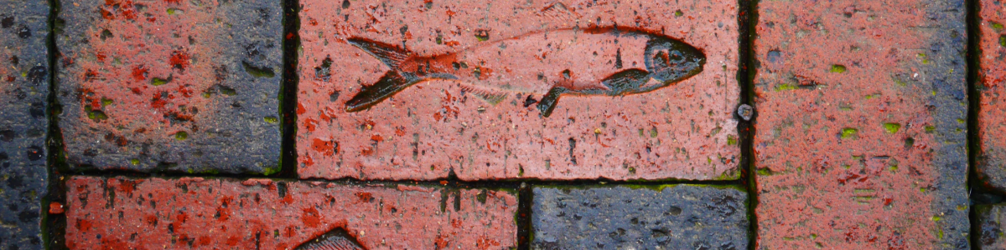
Heart 4 Hull


Upcoming events from Heart 4 Hull:
Loving, Losing, Remembering.
Service 10th Sept:
Wednesday 10th September is Suicide Prevention Day. In partnership with Hull Survivors of Bereavement by Suicide St Mary’s Cottingham will be holding a service for anyone bereaved or affected by suicide.
There will be stories of those affected by suicide, time to reflect and remember, and to find consolation in the support we can give one another.
The service is at 7pm on Wednesday 10th September at St Mary’s Cottingham.

The feast of St Michael and All Angels,
28th Sept:
You are invited to celebrate the life and ministry of St Michael's Church Orchard Park with a service of Holy Communion.
Bishop Eleanor will be present to share in the joy of the day.
Sunday 28th September at 11am at St Michael's Church Orchard Park: Orchard Park Road, North Hull, HU6 9BX

If you would like to receive the email version of the newsletter, please send your email address to SJNHull@outlook.com.

