** SPIRE & LIGHT United Churches**

United Benefice of St Keverne, St Ruan with St Grade & St.Wynwallow (The Lizard)

**\*If you do not wish to receive these notices, please let your Churchwarden know\***

**31st August 2025**

***Trinity 11***

**Readings**

**Ecclesiasticus 10:12-18**

**Psalm 112**

**Hebrews 13:1-8,15,16**

**Luke 14:1,7-14**

***UNITED BENEFICE SERVICE ST.KEVERNE CHURCH***

***11AM HOLY COMMUNION***

Next week – Sunday September 7th

9.30am –– Holy Communion - St.Peter’s, Coverack

9.30am – Holy Communion (BCP) - St.Wynwallow, The Lizard

11am – Morning Prayer (BCP) - St.Keverne Church

11.15am – Morning Prayer – St.Ruan, Ruan Minor

***BISHOP DAVID VISIT TO KERRIER – Mawgan Church***

***3.30pm Deanery Tea– (please take a plate of finger food to share)***

***5pm – Deanery Celtic Evening Service***

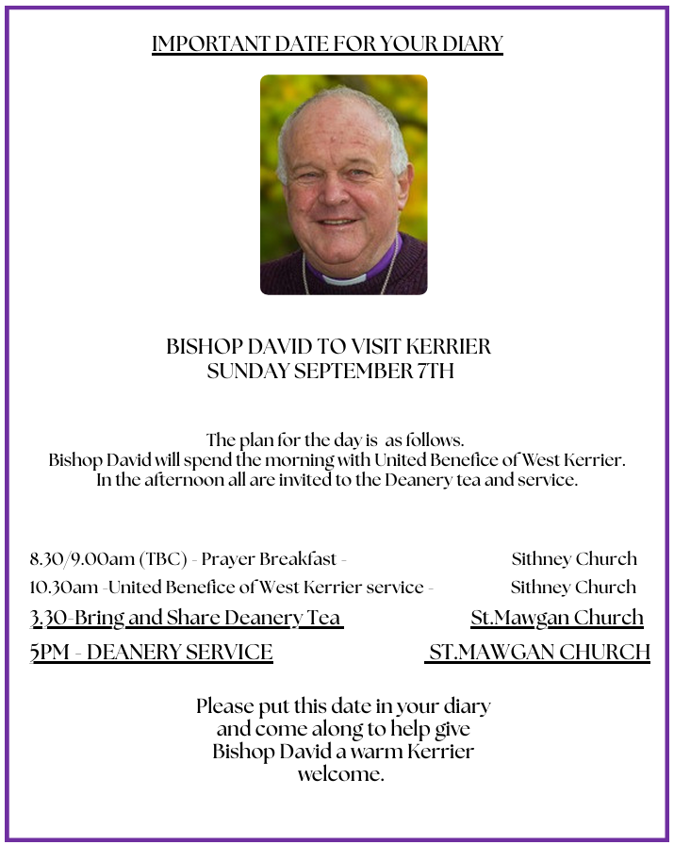

**The Prayer Spot**

We belong to a Benefice of six churches of The Lizard, Ruan, Grade, Cadgwith, Coverack, St Keverne. We have a duty of care to all those in our churches to be together in all we do in the name of Jesus Christ our saviour. God has given us this great gift of prayer - to pray for God's help and guidance in our lives and the lives of others and to ask God to be with us all in all we do in God's name.

Please pray for –

* those in our community who need God's help in their lives which can sometimes can be difficult.
* the people of the Ukraine who need God's help in these difficult times - we pray they will have God's presence in their lives.
* for all those who need hospital treatment, that God will be present with them and their family and will meet their needs.
* the churches in our Benefice - that God will be with us all, giving us the gifts of love to share with all our church members.
* for our Clergy, that God will guide them in all they do for us. Give them the gifts they need. We thank you heavenly Father for those gifts given to us of forgiveness, kindness, justice, generosity and peace - all gifts to share with others.

Remember God is ever present in your life and will answer your prayers in Jesus Christs wonderful name. Be blessed in all you do.

*Faithful Father, we begin today by giving you thanks. Your love endures for ever, it never fails. Though there are many ways in which we have failed we have not exceeded the supply of your mercy and grace. We thank you for revealing yourself to us through your word. As we open the Bible today, we pray we would hear your voice. We ask that your Holy Spirit would be at work, in opening our ears to hear and our hearts to receive your word. May we be transformed into your likeness. Through Jesus Christ our Lord, Amen*

Sam Buchanan

***The Diocese of Truro’s Prayer Diary for this week***

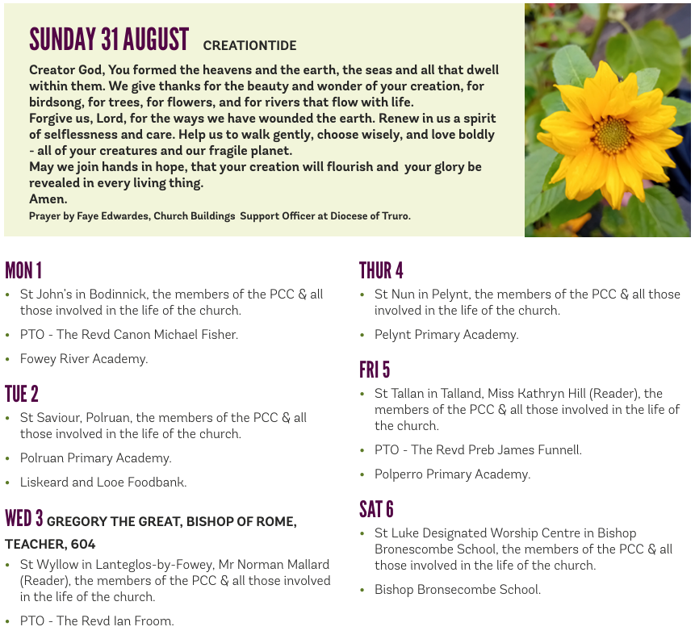

**On the Way Prayers**

Back soon!