 ST MICHAEL’S, HOLBROOK

PARISH NEWSLETTER September/October 2025

The Benefices of Christ Church Belper & All Saints’ Turnditch, St John the Evangelist Hazelwood & St Michael’s Holbrook, Heage & Ambergate.

At St Michael’s, as followers of Jesus Christ, we wish to share friendship and the love of God with all whom we meet and support one another.’

CONTACT DETAILS:

PRIEST-IN-CHARGE: Revd. Rachel Burdett CJN Tel: 07340 990483, revrachelcjn@gmail.com (Day off Monday)
WARDEN: John Maxwell-Jones 01332 679632/07890 241 673 johnmaxj@icloud.com
For any concerns re safeguarding please contact John Maxwell-Jones.

From our Priest in Charge

Rachel writes . . .
As you may know, I recently had a fortnight of leave to move house, and so I am writing this in the new vicarage in Belper, surrounded by boxes! The cats and I made it smoothly to our new home and are gradually getting used to our new surroundings. As I look out of the window I can see some large trees, and can hear the wind moving through the leaves, and so it seems a good place to start to think about the season of Creationtide, which the Church of England observes from September 1st to October 4th, when we move into Harvest Festival. We are especially blessed to live in Derbyshire, so close to the Peak District and the rest of the county - I am sure I am not the only one to give thanks daily for the beauty that surrounds us.

I started this article and wrote the first paragraph, but then came home the next day to find that my neighbours had arranged for someone to come and cut back at least 2 of the large trees at the end of their garden, filling the close with a lot of noise, and quite a large branch had fallen off one of the trees on the plot where I live. I made a mental note to call the property department at the diocese and ask if the two large trees need to be cut back before they drop more large branches in the road.

We read in Genesis chapter 1 that God creates the world, then living creatures, then human beings, and he entrusts the created world to them. As I thought about the two views of this little corner of Belper I had had over the last two days, it reminded me of what we think about during Creationtide: gratitude to God for his gift of creation, and a renewal of our commitment to take care of our planet home.

Each province in the Anglican Communion has its own service book, often called a Book of Common Prayer (which is not the same as the BCP the Church of England uses). Each one has grown from the original prayer book missionaries took with them, but that was the seed, or at least one of them. The soil is unique to each province and so each Book of Common Prayer or Prayer Book has its own distinctive flavour.

The New Zealand Prayer Book gives thanks for kauri and pine, rata and kowhai, mosses and ferns; dolphins and kahawai, sealion and crab, coral, anemone, pipi and shrimp.

And the American Episcopal Church’s Book of Common Prayer has a Eucharistic Prayer nicknamed the ‘Star Wars liturgy’:
God of all power, Ruler of the Universe, you are worthy of glory and praise.
At your command all things came to be: the vast expanse of
interstellar space, galaxies, suns, the planets in their courses,
and this fragile earth, our island home.
As we enter Creationtide in our own beautiful part of ‘our island home’, I wonder what specifically English or Derbyshire things you would give thank for? I’ll start: bluebell woods, goldfinches, Mam Tor and Blue John, purple heather in August, National Parks . .

Blessings,

Rachel CJN

ROTA OF SERVICES FOR SEPTEMBER/OCTOBER 2025

Date | Church | Time | Service | Read/  Welcome
7 September | Philemon 1-21; Luke 14:25-33
Trinity 12 | Holbrook  Hazelwood  Heage  Christ Church, Belper  Turnditch | 10.45  11.00  09.30  18.30  11.00 09.30 | Morning service at Belper Central  Parish Eucharist  Morning service  BCP Evensong  Sung Parish Mass  Parish Eucharist
14 Sept | 1 Timothy 1:12-17; Luke 15:1-10
Trinity 13 | Holbrook  Ambergate  Hazelwood  Heage  Christ Church, Belper  Turnditch | 11.00  09.30  09.30  10.30  18.30  11.00 | Parish Eucharist  Holy Communion  Morning Worship  Heage Methodist Central  BCP Evensong  Sung Parish Mass  No service | Sue Staton
21 Sept | 2 Corinthians 4:1-6; Matt 9:9-13
Trinity 14  St Matthew | Holbrook  Ambergate  Christ Church, Belper  Heage  Hazelwood  Turnditch | 10.45  11.00  09.30  18.30  11.00  09.30 | HMMC Harvest Festival  No service  Sung Parish Mass  Communion  BCP Evensong  Parish Communion  Parish Communion
28 Sept | Hebrews 1:5-end; John 1:47-end
Trinity 15  St Michael & All Angels | Holbrook  Ambergate  Hazelwood  Heage  Christ Church, Belper  Turnditch | 11.00  10.30  09.30  09.30  15.00  18.30  11.00 | Parish Eucharist  Morning Service (Meths)  Parish Eucharist  Family Service  Pet Service  BCP Evensong  Sung Parish Mass  No service | Pauline White
5 October | Ephesians 2:19-22; John 2:13-22
Trinity 16 | Holbrook  Hazelwood  Heage  Christ Church, Belper  Turnditch  Shottle | 10.45  11.00  09.30  18.30  11.00  09.30  15.00 | Morning service at HMMC  Parish Eucharist  Morning service  BCP Evensong  Sung Parish Mass  Parish Eucharist  Harvest Festival
12 October | Philippians 4:4-9; John 6:25-35
Trinity 17 | Holbrook  Ambergate  Hazelwood  Heage  Christ Church, Belper  Turnditch | 11.00  09.30  09.30  10.30  18.30  11.00 | Harvest Eucharist  Holy Communion  Morning Worship  Heage Methodist Central  BCP Evensong  Sung Parish Mass  No service | Jonathan Styles
19 October | 2 Timothy 3:14-4:5; Luke 18:1-8
Trinity 18 | Holbrook  Ambergate  Christ Church, Belper  Heage  Hazelwood  Turnditch | 11.00  11.00  09.30  18.30  09.30 | Morning Prayer  No service  Sung Parish Mass  Communion  BCP Evensong  Parish Communion | Penny & Richard Biggin
26 October | 2 Timothy 4:6-8,16-18; Luke 18:9-14
Trinity 19 | Holbrook  Ambergate  Hazelwood  Heage  Christ Church, Belper  Turnditch | 11.00  09.30  09.30  16.00  11.00 | Parish Eucharist  Holy Communion  Parish Eucharist  Light & Hope Service  Sung Parish Mass  No service | Chris & Jean Lamb

HOLBROOK WI
Wed 3 September @ 7.30 in the Arkwright Hall Janet and Paul Barass -The Swinging Sixties
Wed 1 October Pies and Peas @ 7.30 in the Arkwright Hall
Wed 5 November @ 7.30 in the Arkwright Hall Chrissie Booth: Vice-Chair of NFWI
and former Chair of DFWI

AFTERNOON FELLOWSHIP HOLBROOK CHURCHES TOGETHER
@ 2.00 p.m. in Holbrook Moor Methodist Chapel School Room
Wed 24 September – John Maxwell-Jones
Wed 22 October – Revd. Chris Scotchbrook

THE VILLAGE FÊTE

Many thanks to Pauline & John White, Kathryn White and Marilyn Rice who ran the Church stall and raised £160.00 for church funds. The winning number in “Find the Whiskey” was 13, so congratulations to Mr Frank McCabe, the lucky winner.

HOLBROOK HARVEST LUNCH – Saturday 11 October

See the poster on the back page for full details. Booking is essential.

EVENTS ACROSS THE BENEFICE

Every Wednesday @ 09.30 Mass at Christ Church
Every Friday from 10.00 till 12 noon Coffee at The Lion, Belper.
Christ Church marked 175 years since its consecration on 27th July. To celebrate this on
Saturday September 6th there is a 175th anniversary Exhibition & Gift Day. Afternoon Teas will be served.

LIFE EVENTS

We would love to help you mark key moments in the life of your family. Contact Rachel for more information on christenings, weddings, funerals, house blessings or ways to mark anniversaries.

FOOD BANK
The Statons continue to collect at 18 Pond Road each week, taking our contributions down on Tuesday and Friday mornings. You can target your donations by downloading the “BankTheFood” app on your phone and choosing Hope For Belper. It will give you a list of items that are urgently needed.

REST IN PEACE
Regulars at our online services during Covid will have seen Robert Walker and June Bowley, as well as at other services and events in the Benefice. We extend our sympathies to both families on their passing.

CHRISTMAS GIFT FROM CHURCHES TOGETHER IN BELPER

This year’s gift, for giving out at the Christmas Lights switch-on is to be hearts. They can be knitted, crocheted, sewn, felted or whatever works best for you. The request is that they be between 10 and 15cm long and have a hanging loop at the top please. Collection details nearer the time.

REGISTERS

Nothing to report this month.

Holbrook St Michael’s Church
Harvest Fish and Chip Lunch

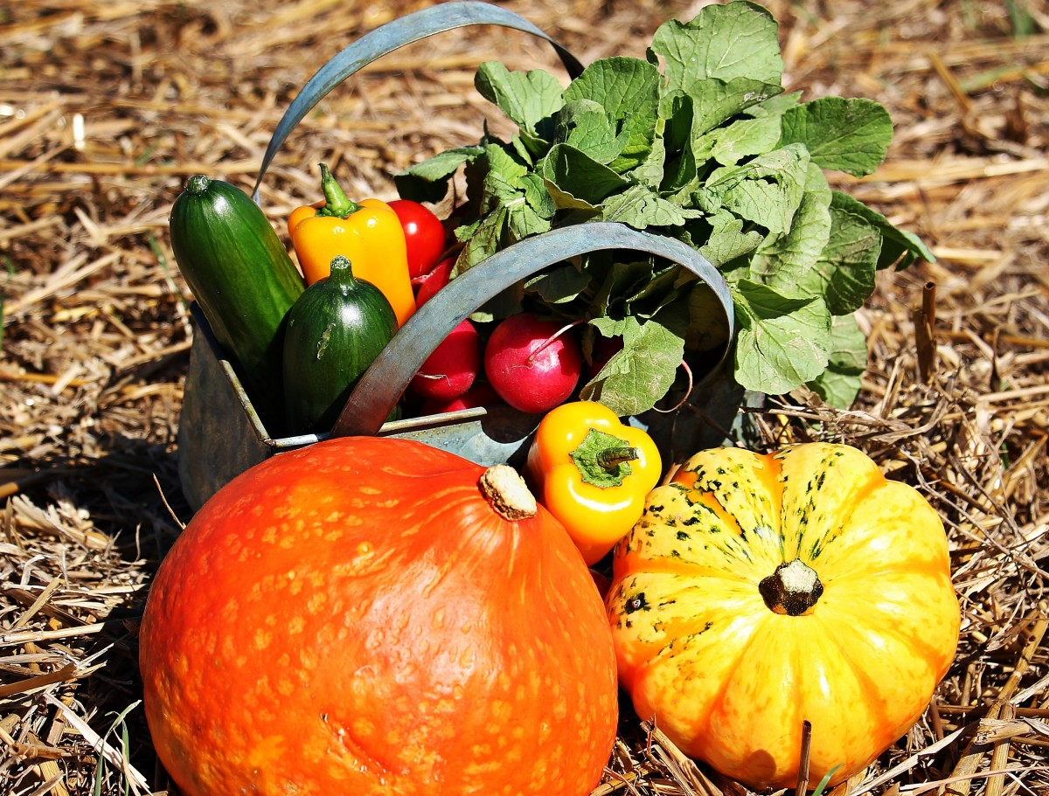

Saturday 11th October 2025

From 12 noon till 2.00 p.m. in the Arkwright Hall.

Adults £12.00, Children £6.00

Booking before Monday 6th October is essential.

Please get your ticket from Lily (01332 883063), Sue (07718679976) or John (07890 241673).

Printed by Moss Office Services, 65 King Street, Belper DE56 1QA 01773 822048

