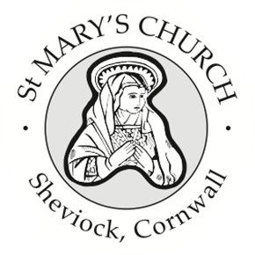

St Mary’s Church, Sheviock
Notices for Sunday 17 August 2025

- This afternoon we will be holding our second Sunday Tea to the accompaniment of the Torpoint Ukulele Band. Please do encourage family, friends and neighbours to call in.
- A reminder that it will be Revd Jo’s final service at Torpoint on Sunday 31st August, followed by a Bring and Share lunch which is being organised through each church (so you don’t need to bring your own). The Downderry minibus is being offered to pick up people in Crafthole and Sheviock – if you would like a space on the bus please email David Watters.
- Some of us will be making a hasty retreat from that lunch at Torpoint to set up for our final Sunday Tea with Reflections Choir – 3- 5pm on Sunday 31st August.
- Looking towards September, Jenny has copies of the next read for the Book Club “Coming back to God when you feel empty” Whispers of Restoration from the Book of Ruth – so please see Jenny and the books are available to anyone who would like to read them – whether you can attend the book club or not.

Weekly Services
A full list of weekly services and events for Rame & Rivers churches is published in the weekly Benefice Newsletter – there is a hardcopy on the lectern at the back

There is no service at St Mary’s next Sunday 24 August – Revd Jo will be leading the “Tunes in the Park” service at St Germans Priory at 10 am; or HC at Torpoint or Morning Worship at Maker.

Sunday 31st August will be a Joint Benefice Service at St James Torpoint which will be Revd Jo’s last service in the Benefice.

Next Service at St Mary’s
Holy Communion at 10 am on Sunday 7th September

