

**WELCOME**

**ST.STEPHEN’S CHURCH**

**is open 10am-3pm daily**

**for Private Prayer and Reflection**

**TODAY**

**10th August 2025**

**THE EIGHTH SUNDAY AFTER TRINITY**

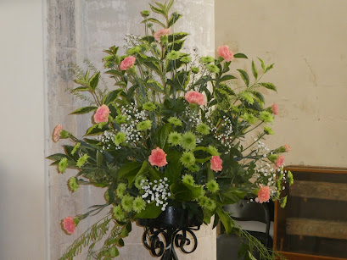

**10.30am Family Communion**

Notices for inclusion in the bulletin please email to me by Tuesday of each week

***officeststephenfradley@gmail.com***

**Please take Bulletin away with you**



**Diary Dates**

Please note – in the Benefice there is a said Communion Service (Common Worship) at

**10am every Wednesday - All Saints Church, Alrewas.**

**Sunday 10th August 10.30am Family Communion**

**Tuesday 12th August 3.30pm Bowbrook Service**

at Bowbrook Care Home

**Wednesday 13th August 9.30-11.30am Churchyard Gang**

in the churchyard

**Friday 15th August 11.55am VJ Day Commemorative Service**

**Sunday 17th August 10.30am Family Communion**

**Thursday 21st August 9.30am Events Committee** (in church)

**Next events**

**16th August 2025 – Please note the Coffee and Music**

**Morning is at Thomas Spencer Hall**

**Whittington WS14 9LE**

**Saturday 13th September Ride & Stride**

Church is open to offer hospitality to riders, striders and drivers!

**Saturday 4th October 7pm Harvest Supper**

in Fradley Youth & Community Hall

Welcome to our Worship today

If you are visiting for the first time, please introduce yourself so that we may welcome you personally.

Refreshments are served after every service – do join us!

**10th August 2025**

**Collect**

Lord God,

your Son left the riches of heaven

and became poor for our sake:

when we prosper save us from pride,

when we are needy save us from despair,

that we may trust in you alone;

through Jesus Christ our Lord.

**Readings**

Genesis 15. 1-6 Hebrews 11. 1-3, 8-16 Luke 12. 32-40

**Post Communion**

Strengthen for service, Lord,

the hands that have taken holy things;

may the ears which have heard your word

be deaf to clamour and dispute;

may the tongues which have sung your praise be free from deceit;

may the eyes which have seen the tokens of your love

shine with the light of hope;

and may the bodies which have been fed withyour body

be refreshed with the fullness of your life;

glory to you for ever.

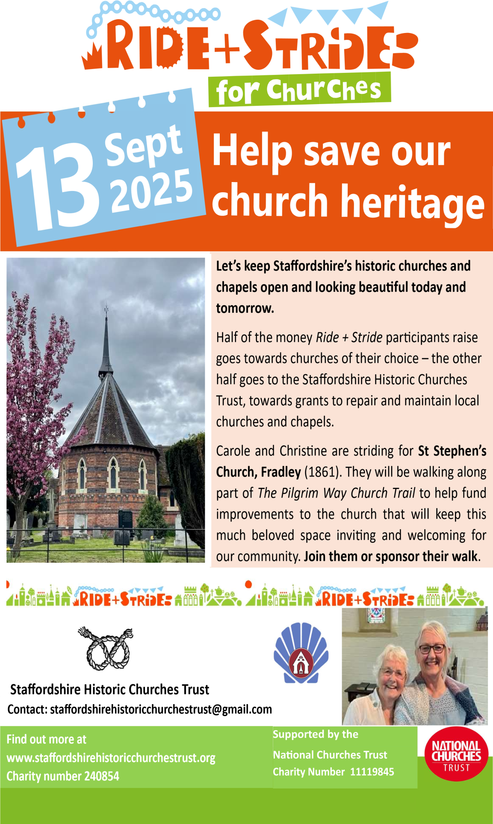

**St Stephen’s Church**

**A Commemorative Service**

**for the 80th Anniversary**

**of**

**VJ Day**

(Victory over Japan Day)

**Friday 15th August**

Do join us as we take the opportunity to honour and pay tribute to those of the WW2 generation who paid such a great sacrifice for the freedom we enjoy today.

A short service will begin at **11.55am** as we acknowledge the Two-minute National Silence at 12 noon.

There will be readings, music and prayers followed by light refreshments.

**Parish News**



**COFFEE AND MUSIC**

***Alzeimers Research UK – FOR A CURE***

A fantastic morning with coffee and music

By none other than

**TONY CHRISTIE**

**Date: 16th August 2025**

**Time: 10.00am to 2.00pm**

**ENTRANCE FEE: £10.00**

**All Funds raised for ARUK**

**VENUE: Thomas Spencer Hall**

**WS14 9LE**

**Prayers for the 80th Anniversary of VJ Day**

O Lord our God,

as we remember, teach us the ways of peace.

As we treasure memories, teach us to hope.

As we give thanks for the sacrifices of the past, help us to make your future in this world, until your kingdom come.

**Collect for Peace**

Almighty God, from whom all thoughts of truth and peace proceed: kindle in the hearts of all people the true love of peace; and guide with your pure and peaceable wisdom those who take counsel for the nations of the earth;

that in tranquillity your kingdom may go forward,

till the earth is filled with the knowledge of thy love;

through Jesus Christ our Lord.

**For those who served and died in World War II**

O God of truth and justice, we hold before you those men and women who have died in active service,

particularly in the Second World War.

As we honour their courage and cherish their memory, may we put our faith in your future;

for you are the source of life and hope,

now and for ever.

**St Stephen’s Church Fradley**

**A Commemorative Service**

**for the 80th Anniversary**

**of**

**VJ Day**

(Victory over Japan Day)

**Friday 15th August**

Do join us as we take the opportunity to honour and pay tribute to those of the WW2 generation who paid such a great sacrifice for the freedom we enjoy today.

A short service will begin at **11.55am** as we acknowledge the Two-minute National Silence at 12 noon. There will be readings, music and prayers followed by light refreshments.



 Can you help to support St Stephens Church?

St Stephen’s Church is heavily dependent on voluntary donations and income from events in order to fulfil its ministry to the local and wider communities.

If you would like to support us at this time,

donations can be made via our **Just Giving** page.

*We are grateful for any donation, large or small.*

[**https://www.justgiving.com/fundraising/ststephensfradley**](https://www.justgiving.com/fundraising/ststephensfradley)



## Contact us

## Revd Elizabeth Wall

## 01543 254891

## Email: [ayton265@gmail.com](mailto:ayton265@gmail.com)

## Churchwarden

## Marian Derry 01283 791573

## 

## St Stephen’s Administrator: Di Cooper  07930162991

## Email: officeststephenfradley@gmail.com

## Find us on

## ACNY https://www.achurchnearyou.com/church/4123/

**Face book:** [**www.facebook.com/ststephensfradley**](http://www.facebook.com/ststephensfradley)

DC 06/08/25