**St Aidan and St Columba**

**Hartlepool**



**August and September 2025** £1.00

**Directory**

**St Aidan and St Columba**

**Priest in Charge - Mother Becky Reeve 01429 671358**

**Email:** [**revbeckystaidanandstcolumba@gmail.com**](mailto:revbeckystaidanandstcolumba@gmail.com)

**Reader with Permission to Officiate – Ray Turner 07845042357**

**Parish Administrator and Church Office, please telephone or email Kathrine Batty Tel 01429 871814 Mobile 07836796374**

**Email:** [**staidans.hartlepool@btconnect.com**](mailto:staidans.hartlepool@btconnect.com)

***Please contact Kathrine Batty to make an appointment to book weddings and baptisms or to book St Columba’s for an event or party.***

**All Saints Stranton and St Luke’s**

**Priest in Charge - Revd John Bell Tel: 01429 756309 Mob 07512 481115**

**Email:** [**revdjohnbell@gmail.com**](mailto:revdjohnbell@gmail.com)

**Curate - Revd Claire Mead 07598 070481**

**curate@stlukeshartlepool.org.uk**

**Churchwardens** Miss Jane Spears 277773

Mrs Helen Rochester 293727

**Deputy Wardens** Miss Clair Barker 07494038230

Miss Liz Halford 267575

**Safeguarding Officer** Mrs Kathrine Batty 07836796374

**Children’s Worship Lead** Lesley Small 07572860345

**P.C.C. Secretary**  Miss Jane Spears 277773

**P.C.C. Treasurer** Mr Tony Batty 871814

**Gift Aid Secretary** Mrs Helen Rochester 293727

**Magazine Editor** Mrs Kathrine Batty 07836796374

**Food Store Manager** Miss Clair Barker 07494038230

**School Head teacher** Miss Gillian Hood 273695

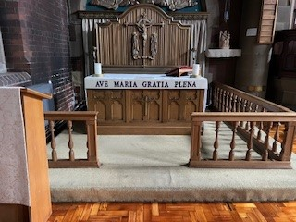**Parish and Group Information**

**St Aidan’s and St Columba’s**

**Sunday - 10.45 am Sung Mass in St Aidan’s; with Children’s Worship starting in church at 10.30 am**

**Tuesday - 9.15 am Mass in St Columba’s**

**- 10.30 am Daytime Cell Group in St Columba’s**

**- 6:00pm Prayer Zoom Group**

[zoomprayergroup@gmail.com](mailto:zoomprayergroup@gmail.com)  title PrayerGroupStA&StC

The meeting number is 871 9675 8134 Passcode: r2Mxw8

**Wednesday - 6.00 pm Midweek service in St Aidan’s – at the moment this service is on every fortnight but from 10th September will be on each week.**

**Thursday - 9.30 am Kitchen in St Aidan’s**

**7.00 pm Cell Group, The Vicarage, 5 Tunstall Avenue**

**………………………………………………………………………………….**

**All Saints Stranton**

**Sunday at 9.00am Holy Communion**

**Sunday at 11.00 am Morning Service**

**Wednesday at 10.00 am Holy Communion in St Matthew’s Hall, Elwick Road**

**………………………………………………………………………………………….**

**St Luke’s**

**Sunday at 9.15 am Holy Communion**

**Wednesday at 9.30 am Holy Communion (from 3rd September this service will be at 10.00 am)**

**…………………………………………………………………………………………..**

*We aim to try and live stream as many services as possible.*

**Group Facebook Addresses:**

<https://www.facebook.com/aidancolumba/>

<https://www.facebook.com/allsaintsstranton/>

<https://www.facebook.com/stlukeshartlepool/>

**Mother Becky writes ……………**I have just got back from the Durham Clergy Conference where, for two and a half days, clergy from all over the diocese gathered together, prayed together, ate together and studied together. It was great to be united as a group, and to share how things were going with each of us: what we were struggling with and what we were celebrating. And the most inspiring thing about it was, although some of us liked to wave our hands during songs while others of us preferred to bow during psalms, we were all able to share good natured fellowship and find a blessing in each other’s company.

This unity is something, sadly, which we can’t always find in the wider Christian world at the moment, but as I get to know the Hartlepool Group of churches, I think it is fair to say that we have an affection and respect for each other which crosses individual church boundaries. This is a precious thing, and has the power to witness to Hartlepool that churches are able to work together despite different traditions. It has really encouraged me that as we launch more missional activities in the group, such as our cell groups, meditation groups, Lent course and pub theology meet ups, all of these have been attended by people from all the parishes. This seems to be the way forwards for us to connect as a group, and I look forwards to the group barbeque on the 9th August as a way for us to get to know each other better and to enjoy each other’s company.

There has been more good news- Ray Turner has been given PTO as a lay reader to work, initially in St Aidan’s. As Ray and I met last Monday morning to say morning prayer, a line from our New Testament reading jumped out at me:

Let us therefore no longer pass judgement on one another…Do not let what you eat cause the ruin of one for whom Christ died.

‘One for whom Christ died’. We are all one for whom Christ died- the ones of us who bow and the ones who wave. The ones who like thees and thous when they worship and the ones who would be happy with everything unscripted. Imagine if, every time we saw someone from one of the four churches in the group we thought to ourselves ‘there goes someone for whom Christ died’. How would that change what we did, or thought or said next? Something special happens when what binds us together overpowers all the little things which act as stumbling blocks between us and it is called the kingdom. Long may it reign!

X ***Mother Becky***

**Transfiguration**

‘There Must Be More to Life Than This’. These words from Freddie Mercury of Queen will resonate with many of us, when we are looking to get more out of life, even as Christians. At a deeper level, we want to see and hear more clearly what God is doing in our circumstances.

The Transfiguration of Jesus helps us to consider this issue (Luke 9:28-36).

Jesus was transfigured alongside Moses and Elijah, ‘As He was praying, the appearance of His face changed, and His clothes became as bright as a flash of lightning.’ To understand our circumstances, firstly we need to see Jesus as God wants us to see Him. The disciples’ eyes were opened to see Jesus’ divinity. The presence of Moses and Elijah confirmed Him as God’s promised Messiah. By helping us the grasp who Jesus really is, this event powerfully calls us to entrust our lives into Jesus’ hands to experience His presence and power.

Secondly, if we are to make sense of our circumstances, we need to hear what God says about His Son. A cloud covered them and ‘a voice came from the cloud, saying, ‘This is my Son, whom I have chosen; listen to Him.”

God affirmed His love and call on Jesus as His beloved and chosen Son. Do we hear God speaking these same words to us? When we know that we too are loved and accepted by God, this transforms our understanding of our lives.

Whatever our circumstances, they can be transformed by what we see and hear. Open your eyes to see a transfigured world. Open your ears to hear a transfiguring voice. Open your heart to become a transfigured life.

Philip Yancey an American author who has explored the most basic questions and deepest mysteries of the Christian faith once wrote ‘No one who meets Jesus ever stays the same.’

***Taken from Parish Pump***

**Lord’s Prayer top in public recognition poll**

People in the UK are more likely to identify correctly a short extract from the Lord’s Prayer – also known as the Our Father – than one from the National Anthem and other sources chosen for their deep cultural resonance, a new poll has found.

The polling, carried out for the Church of England, also found the reference in the prayer to being forgiven and forgiving others was the element people found most meaningful to them.

Pollsters Savanta surveyed more than 2,000 people across the UK. They asked them to match seven famous lines – spanning areas ranging from literature and history to popular culture – with their source, from a list of correct answers.

Overall, the phrase from the Lord’s Prayer was recognised correctly by the largest number of people (80.3 per cent), just ahead of Star Wars (79.9 per cent).

They were followed by Hamlet’s “To be or not to be” (73 per cent) the extract from the National Anthem (63 per cent); the line from Churchill’s ‘The Few’ speech (61 per cent); and You’ll Never Walk Alone (58 per cent).

Overall, 89 per cent of those surveyed said that they had previously heard of the Lord’s Prayer or the Our Father. This was highest among those who described themselves as Christian (95 per cent), but also by 88 per cent of those who said they had no religion.

The Archbishop of York, Stephen Cottrell, is currently leading a ‘Lord’s Prayer Tour’ of events at churches and cathedrals across the north of England attended by thousands of people, as part of his Faith In The North initiative.

He said: “In a world of shifting cultures and changing circumstances, the Lord’s Prayer remains a steady guide – perhaps never more so than now.

“Lines like ‘Give us this day our daily bread’ speak powerfully to today’s challenges, reminding us to seek sufficiency, not excess, and to consider what ‘enough’ truly means.”

**When I say, I am a Christian**

**When I say, “I am a Christian,” I’m not shouting, “I am saved!”  
I’m whispering, “I get lost; that is why I chose this way.”**

**When I say, “I am a Christian,” I don’t speak of this with pride.  
I’m confessing that I stumble and need Someone to be my Guide.**

**When I say, “I am a Christian,” I’m not bragging I am strong.  
I’m professing that I’m weak, and I pray for strength to carry on.**

**When I say, “I am a Christian,” I’m not bragging of success.  
I’m admitting I have failed and cannot ever pay the debt.**

**When I say, “I am a Christian,” I’m not claiming to be perfect.  
My flaws are all too visible, but God believes I’m worth it.**

**When I say, “I am a Christian,” I still feel the sting of pain.  
I have my share of heartaches, which is why I cry His name.**

**When I say, “I am a Christian,” I do not wish to judge.  
I have no authority; I only know I’m loved.**

**(Author unknown)**

**What’s the Big Idea? - the Books of the New Testament**

**Romans**

*‘Paul’s letter to Rome is the high peak of Scripture…all roads in the Bible led to Romans, and all views afforded by the Bible are seen most clearly from Romans’*

Paul probably wrote his letter to the Christians in Rome around AD 57 at Corinth, on his third missionary journey. The original recipients of the letter were predominantly Gentile, although Jews would have constituted a substantial minority of the congregation.

Paul set out to explain the relationship between Jew and Gentile in God’s plan of salvation, as the Jewish Christians were being rejected by the larger Gentile group in the church. Paul begins by showing that both Jews and Gentiles are sinners in need of salvation. He shows how the life, death and resurrection of Jesus eternally affects both world history and every person.

This salvation, secured by Jesus, must be received by faith, as the example of Abraham shows. As salvation is not just about starting the Christian journey, Paul goes on to show how believers are freed from sin, law and death. This is made possible both through their union with Christ in His death and resurrection and by the indwelling presence and power of the Holy Spirit.

The theme of the book centres on the Gospel of Christ, which brings us into a right standing with God though faith: ‘I am not ashamed of the gospel, because it is the power of God for the salvation of everyone who believes: first for the Jew, then for the Gentile. For in the gospel a righteousness from God is revealed, a righteousness that is by faith from first to last, just as it is written: "The righteous will live by faith."’([Rom. 1:16,17](javascript:%7b%7d)).

**1 Corinthians**

*‘When people become Christians, they don’t at the same moment become nice. This always comes as something of a surprise’*

After founding the church in Corinth Paul spent a year and a half with them, showing them how to live out this new life as a community of believers. Corinth was a major commercial centre in Greece and a crossroads for travellers and traders across the Empire. Its people placed a high premium on wisdom, but Corinth was also known for its immorality. Little wonder that the church was plagued with so many problems! However, after Paul left the church factions developed, immorality was rife, and worship had become a selfish grabbing for the supernatural. Paul’s letter, written around AD 55 in Ephesus, is a response to these problems.

It is clear that, although the church was gifted (1:4–7), it was immature and unspiritual (3:1–4). Paul’s purpose for writing was to: instruct and restore the church in its areas of weakness, correcting erroneous practices such as divisions (1:10—4:21), immorality (ch. 5; 6:12–20), litigation in pagan courts (6:1–8) and the abuse of the Lord’s Supper (11:17–34). Correct false teaching concerning the resurrection (ch. 15).

This letter is very relevant for us today, as we are also powerfully influenced by our cultural environment. Many of the questions and problems that confronted the church at Corinth are still with us. Yet despite the problems, Paul’s focus remained on knowing Christ in His life and trusting in the power of the cross: ‘For I resolved to know nothing while I was with you except Jesus Christ and Him crucified.’ (2:2).



**When – Saturday 9th August from 2.00 pm**

**Where – The Vicarage Garden at 5 Tunstall Avenue**

**What should I bring – Yourself, your friends, your drink and a side dish or dessert.**

**What now – please sign the list in church to let us know you are coming, just so we can plan catering and chairs.**

**The Nicene Creed** – part two

Here is the second part of our look at the Nicene Creed and how it affirms about the person of Jesus

We believe in one Lord, Jesus Christ, the only Son of God, eternally begotten of the Father, God from God, Light from Light, true God from true God, begotten, not made, of one Being with the Father; through him all things were made.

‘**We believe in one Lord, Jesus Christ, the only Son of God’**: Jesus is presented as the unique Son of God. This reflects the big debate at the time, which was to counter the teachings of Arius, who taught that Jesus was the first and greatest of God’s creatures, but not the same as God the Father. Today we can be more concerned about Jesus’ authority as a moral teacher, neglecting that Jesus the man is also truly God. ‘We have seen His glory, the glory of the one and only Son, who came from the Father’ (John 1:14).

**‘eternally begotten of the Father, God from God, Light from Light, true God from true God, begotten, not made, of one Being with the Father’**: These words affirm the divinity of Jesus. The phrase ‘begotten not made’ is crucial in understanding Jesus as the unique Son of the Father, who existed eternally of the same divine nature as the Father. ‘In the beginning was the Word, and the Word was with God, and the Word was God. He was with God in the beginning’(John 1:1,2). It is a powerful reminder that our belief revolves around trusting a person, not simply in a set of beliefs and moral teaching.

**‘through Him all things were made’**: The Creed affirms that Jesus the Son cannot be made, because through Him all things were made and only God can create from nothing. ‘Through Him all things were made; without Him nothing was made that has been made.’ (John 1:3). This implies that our world was made good, with a purpose in which we can share.

Also, Jesus has the last word in promising to bring everything in heaven and on earth together at the end of time under His Lordship (Ephesians 1:10). This makes a real difference to how we see and treat God’s Creation and those created in God’s image.

In response to this, can we say that Jesus is Lord of every area of our life?

**Taken from Parish Pump**

**Nicene Creed** – part three

In this study we are looking at what the Nicene Creed says about the ministry of Jesus on earth.

For us men and for our salvation He came down from heaven; by the power of the Holy Spirit He became incarnate of the Virgin Mary, and was made man. For our sake He was crucified under Pontius Pilate; He suffered death and was buried.

**‘For us men and for our salvation He came down from heaven’**: Jesus came down to earth to save us all. Salvation involves healing and rescuing us from the wrong things in our lives, which result in death itself. The Creed demonstrates the importance of having a proper understanding of Christ that safeguards the gospel of salvation. ‘For the Son of Man came to seek and to save the lost.’ (Luke 19:10).

**‘by the power of the Holy Spirit He became incarnate of the Virgin Mary, and was made man’**: Although the word ‘incarnate’ doesn’t appear in the New Testament, it expresses the meaning of Jesus’ birth. Heresies of the time included Adoptionism (i.e. Jesus became God’s Son only at His baptism) and Docetism (i.e. Jesus appeared to be human, as a fully divine being). The incarnation affirms that the divine son, was conceived in Mary’s womb by the power of the Spirit and born in time as a human being: ‘The Holy Spirit will come on you, and the power of the Most High will overshadow you. So the holy One to be born will be called the Son of God.’ (Luke 1:35). If Jesus was not conceived both fully divine and human, the Christian understanding of salvation is lost.

**‘For our sake He was crucified under Pontius Pilate; He suffered death and was buried’:** In the Creed we move straight from Jesus’ birth to His death, which is the climax of His ministry. Jesus dying for our sins on the cross lies at the heart of God’s plan of salvation. The mention of Pontius Pilate roots our faith in history and reminds us of the important part people played in God’s plan. ‘He himself bore our sins in His body on the cross, so that we might die to sins and live for righteousness; by His wounds you have been healed.’ (1 Peter 2:24).

What is the place of the incarnation in your understanding of the Christian Faith?

**Taken from Parish Pump**

**The Vicar who won Wimbledon**

Ninety years ago, on 21st August 1935, John Hartley, the British tennis player, died. He was the only clergyman ever to win Wimbledon and was World Number One in both 1879 and 1880 – winning Wimbledon both years.

The Revd John Thorneycroft Hartley was born in 1849 in Wolverhampton and was well connected: his parents were both from Staffordshire industrial business families, and he married Alice Lascelles Murray, daughter of the 4th Earl of Mansfield and a granddaughter of Henry Lascelles, 3rd Earl of Harewood. They had no children.

He won the 1879 Gentlemen’s Singles title against Irish champion Vere St Leger Goold in three sets on 15th July, retaining his title the following year. But in attempting the hat-trick in 1881 he lost the shortest ever men’s final, 0-6, 1-6, 1-6, in 37 minutes. He was said to have been ill at the time.

Hartley had become a priest in 1873. He was firstly curate of Christ Church, Southwark, and then became vicar of Burneston, a village in North Yorkshire, from 1874 to 1919. In 1891 he became Rural Dean of East Catterick, and later he was Honorary Canon of Ripon Cathedral.

As an amateur, he received no cash for his Wimbledon wins, and in the course of his first finals win he caught a train to Yorkshire so that he could do his duty and take his services at Burneston on the Sunday. Not only that, but he stayed with a dying parishioner until he passed away on the Monday – the day of the semi-finals. A rain delay helped him to get back to London in time.

At the Golden Jubilee Championships in 1926 he received a silver medal from Queen Mary as one of 34 surviving champions.

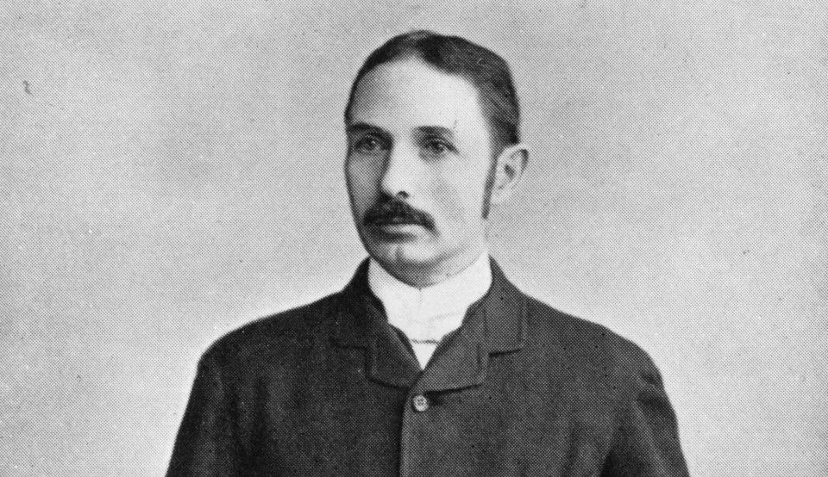

**Consecration (Cert. 15),**

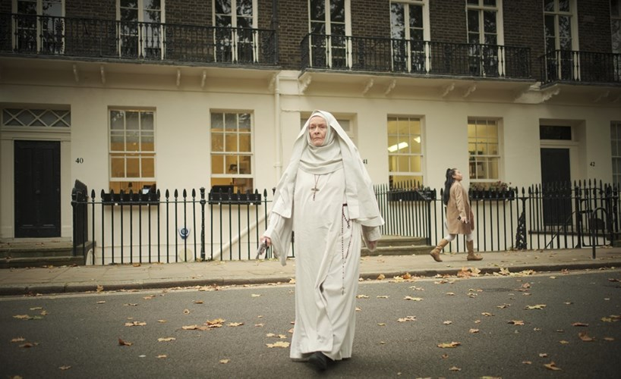

*Janet Suzman as the Mother Superior*

Consecration now available on streaming services, including YouTube, was released in 2023, dramatically dividing opinion. A serious examination of alternatives to religious fanaticism or just the kind of schlock-fest beloved of horror movies? Well, to coin a phrase, let us see; for it is sight that’s key to the film’s basic premises. Grace (Jena Malone) is an ophthalmologist.

An elderly patient asks if it takes a miracle to avoid going blind. Grace’s scientific approach gives little credence to that line of healing, nor to how one’s inner being may subjectively fashion the way in which we perceive our surroundings. Several weeks later, Grace, strolling through London, muses about her brother Michael who had always believed that she had a guardian angel. “I used to believe in nothing,” she says. “Now I’m not so sure.”

We subsequently learn that DCI Harris (Thoren Ferguson) had earlier phoned Grace from Scotland, saying that Michael was alleged to have murdered a fellow priest at a convent before killing himself. It all occurred on a remote island. Grace, on visiting, disputes this version of events. So does the spooky Mother Superior (Janet Suzman), who claims that it was a demon. Evil will continue, she asserts, unless her nuns can locate and contain an ancient relic whose powers are creating such havoc. This is the narrative’s first point of departure from a conventional understanding of relics as objects to inspire sanctity: a gift, one might say, of grace, not wickedness.

As the film proceeds, flashbacks and visions capture the heroine’s imagination. Sight becomes insight into a deeply upsetting personal history, which she has so far suppressed. While various Sisters present us with an extreme range of religious fervour, we are shown, in contrast, a kindly face of Catholicism in the form of Father Romero (Danny Huston). Dispatched from the Vatican to discover the truth, he acts as Grace’s guide, explaining to her (and to us) what is going on. At times, Consecration has the feel of Ken Russell’s The Devils: mania in abundance, but without that particular film’s sense of its underlying causes.

Elsewhere, there are attempts to identify in Grace an admixture of good and bad. How is she to cope with former sins, especially if there is some question of what exactly went wrong? Is she someone now aware of misspent moments past and in need of forgiveness? or more sinned against than sinning? And, when it comes to the supernatural elements, where one stands on the incredulity spectrum will determine whether the whole enterprise begins quelling, like Grace, any doubts about faith.

The title of the film may well be an invitation to look deeper than the blood-spattered orgy that dominates its scenario. All that gore obscures serious questions that are being asked about consecrating our lives to God or the devil. Possibly any of us could be guardian angels, benign or otherwise, enabling others to assess the state of their immortal souls. What would it take to see things differently from the beliefs that we cling to? A miracle, perhaps.

Written by Stephen Brown





Bread

for the

Soul

**Wednesday 6.00 pm**

St Aidan’s

Midweek

Communion

Informal, relaxing, peaceful, friendly – Come and join us

**Sit and relax with these pages of puzzles**

**Crossword**



Across

1 ‘The people were — at his teaching’ (Mark 1:22) (6)

4 ‘He saved —; let him save himself’ (Luke 23:35) (6)

8 He addressed the crowd in Jerusalem on the day of Pentecost (Acts 2:14) (5)

9 Father of James and John (Matthew 4:21) (7)

10 One who charges another with an offence (Job 31:35) (7)

11 ‘ — thy ministers with righteousness’ (Book of Common Prayer) (5)

12 and 15 Down ‘All — is God-breathed and is — for teaching, rebuking, correcting and training in righteousness’ (2 Timothy 3:16) (9,6)

17 ‘No — of the field had yet appeared on the earth and no plant of the field had yet sprung up’ (Genesis 2:5) (5)

19 Made to feel embarrassed (Isaiah 24:23) (7)

21 This man built his house on sand (Matthew 7:26) (7)

22 David’s hypocritical message to Joab on the death in battle of Uriah: ‘Don’t let this — you’ (2 Samuel 11:25) (5)

23 Detest (Job 10:1) (6)

24 ‘God made two great lights, the greater light to govern the day and the — light to govern the night’ (Genesis 1:16) (6)

Down

1 To make a serious request (1 Corinthians 1:10) (6)

2 Launches an assault against (Genesis 32:8) (7)

3 ‘The wicked man — deceptive wages’ (Proverbs 11:18) (5)

5 Tuba ale (anag.) (7)

6 ‘The day thou gavest, Lord, is — ’ (5)

7 Old Testament measure of weight, equivalent to about 12 grammes

(Exodus 30:13) (6)

9 Where Elijah restored life to the son of a widow with whom he lodged

(1 Kings 17:10) (9)

13 Paul said of whatever was to his profit, ‘I consider them — , that I may gain Christ and be found in him’ (Philippians 3:8) (7)

14 City visited by Paul, described by the city clerk as ‘the guardian of the temple of the great Artemis’ (Acts 19:35) (7)

15 See 12 Across

16 Rioted (anag.) (6)

18 She had a surprise when she answered the door and found 8 Across outside (Acts 12:13) (5)

20 Maltreat (1 Chronicles 10:4) (5)



**Wordsearch**

If you ever struggle with doubt, take heart: so did one of the apostles. St Thomas just could not believe that the Jesus he had seen crucified and dead on the cross could ever come back to life. But Thomas was an honest sceptic, because he really wanted to know the truth. Jesus could help such a man. And so He appeared to him and the other disciples. Instead of scolding him, Jesus simply showed him the wounds. Thomas’s response was immediate: “My Lord and my God”. Ancient legends tell how Thomas went on to India as a missionary. There are rumours that Thomas even built a palace for a king’s daughter in India, and thus he is the patron saint of architects. It is believed that he was martyred by a spear on 3rd July, 72 AD in Mylapore, near Madras. 46 ancient churches in England are dedicated to him.

Thomas, Doubt, Apostle, Cross, Dead, Truth, Sceptic, Wounds, Lord, God, Appeared, India, Patron, Martyred, Spear, Mylapore, Missionary, Showed, Saint, Madras.

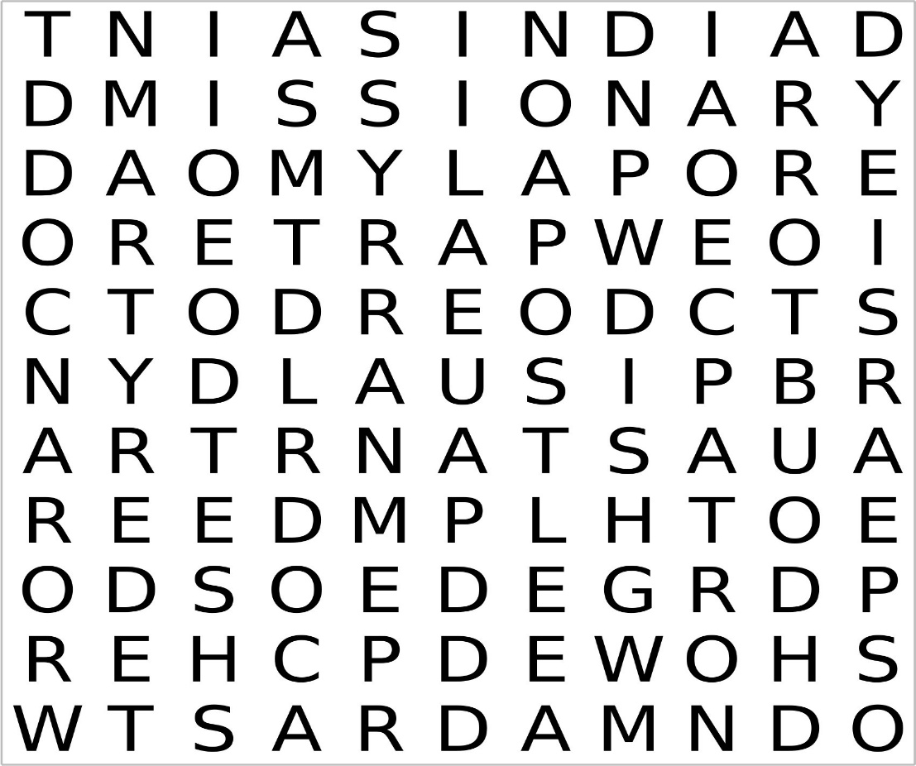

**General Knowledge quiz**

1 What is the most mentioned animal in the Bible?

2 What was the nickname of the German Field Marshall Erwin Rommel?

3 If an egg floats in water is it stale or fresh?

4 What number do we associate with James Bond?

5 If you don't have a napkin, is it OK to use the tablecloth? Yes or No

6 A cricket umpire holds both arms straight up to indicate what?

7 The Monument in London commemorates what?

8 What country is sometimes known as 'Blighty'?

9 What product was originally marketed as 'liquid beef'?

10 What is the 19th hole of a golf course?

11 'Allegro' is a musical direction to play how?

12 How many men did the Grand Old Duke of York have?

13 Who wrote 'All I need to make a comedy is a park, a policeman and a pretty girl’?

14 What is Uri Geller famous for?

15 Who or what is the Old Lady of Threadneedle Street?

16 What does three squared equal?

17 Which Olympic event begins with the words 'en garde'?

18 What do the initials KFC stand for?

19 Who is known as the Lady with the Lamp?

20 An Australian wind instrument?

The answers to all the puzzles are further in the magazine

**Attendance rises for fourth year**

Attendance at Church of England churches grew for the fourth year in a row last year. The overall number of regular worshippers across the Church of England’s congregations grew to 1.02 million in 2024, a rise of 1.2 per cent, according to an early snapshot of the annual Statistics for Mission findings.

It was the second year in a row in which the Church of England’s ‘worshipping community’ – the combined number of regular members of local congregations – has stood above a million since the Covid-19 pandemic.

The numbers in the pews on a typical Sunday was up by a further 1.5 per cent to 582,000 in 2024, extending rises over recent years. And overall, the in-person attendance across the week edged upwards by 1.2 per cent in a year, and stood at just over 701,000 last year, according to the early figures.

The increase was driven by a recovery in attendance by adults (over 16), among whom average Sunday attendance was up by 1.8 per cent, and weekly attendance rose by 1.5 per cent.

While the overall figures show that in-person attendance has not fully reached pre-pandemic levels, the figures suggest it is moving closer to the pre-pandemic trend.

The preliminary snapshot of Statistics for Mission returns follows separate figures which show there has also been a sharp increase in traffic on the Church of England’s church-finder website, AChurchNearYou.com.

The number of page visits to AChurchNearYou.com jumped by 55 per cent last year to almost 200 million as people searched for their local congregation.

The Archbishop of York, Stephen Cottrell, said: “The Church of England exists to share the good news of Jesus Christ. So, it is encouraging to see further signs that more people are coming to faith in Jesus Christ and having their lives changed”. Although this is just a snapshot and we don’t know the ages of those who have started attending church in the past year, other evidence suggests that many of these are young adults.

Debbie Clinton, the Church of England’s Director for Vision and Strategy, said: “Our statistics are much more than numbers, each represents an individual. In 2024 we have heard and seen exciting stories of growth in parishes, in our estates and in post-industrial and coastal towns.

“Nationally we aim to ensure that each young person has a flourishing children, youth and families’ ministry within reach of them, we are seeing growth in the number of churches with more than 25 young people attending.”

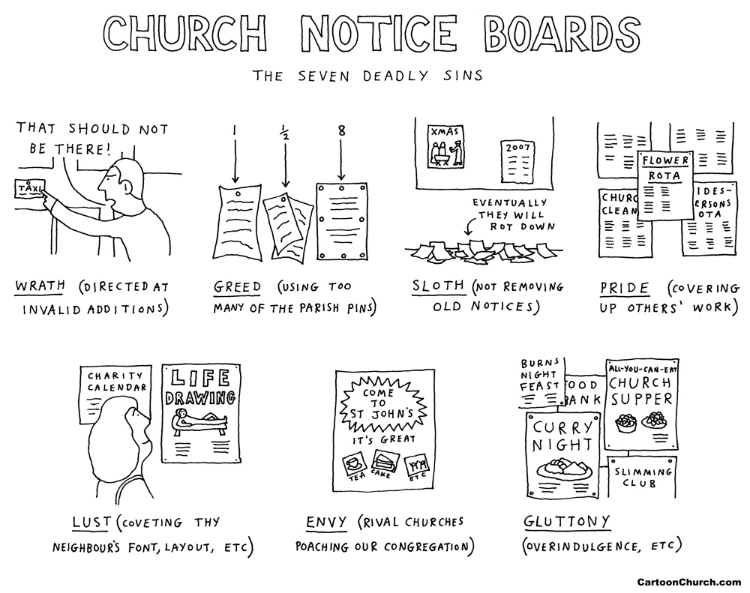



**‘Don’t forget the seafarers,’**

A Christian mission agency has called for the welfare of nearly two million seafarers to be taken into consideration, as the global shipping fleet cuts costs by adopting new technologies.

The Mission to Seafarers runs 121 welfare centres in ports around the world, and its people visit more than 40,000 ships each year. Seafarers face dangerous oceans and seas to transport more than 90 per cent of the world’s goods and fuels – making them essential key workers who often go unrecognised by the general population.

Mission to Seafarers Secretary General Peter Rouch has expressed concern that often ships’ crews are overlooked when investment is being made in new technology. He said: “Conditions aboard ships should not focus solely on minimising costs but also on ensuring the health and well-being of the crew. Humanly, as well as operationally sustainable crew sizes, shift rotations, and shore leave are essential for maintaining the mental and physical health of seafarers. “Overworked crew members are more likely to make costly mistakes, which can harm the shipping industry of course, but the more important aspect is to understand seafarers as much more than a simple resource.”

Mr Rouch explained that while the shipping industry was embracing digital technology and low-carbon fuels, the needs of seafarers often remained secondary. He had heard a politician from a leading maritime nation name the major issues facing the industry over the next five to ten years – but failing to address the human aspects of seafarers’ working lives. Peter Rouch added: “At its core, any human activity such as a commercial activity like shipping should serve the flourishing of humanity, and this includes the well-being of seafarers.

“The Mission to Seafarers, grounded in faith and a vision that values human dignity and human community in and of itself, continues to advocate for seafarers’ well-being and we are glad to partner with others in the shipping industry who share these values.”

Collectively, there are more than 1.89 million seafarers across the world, made up of many nationalities. They often spend up to nine months at a time far away from their family, friends and loved ones. This can lead to loneliness and mental health issues.

**Why do we give**

Generosity is at the heart of our faith. We believe in a generous God, and our own generosity is a testament and hallmark of our faith in action. The ministry and mission of The Church of England is largely funded through the incredible generosity of those who give to it.

Our giving, in its broadest sense, enables our churches to flourish and grow. Our financial giving is the main way we resource our ministry and mission and enables us to grow as communities of faith not just in our parish, but across the diocese. Giving our time to volunteer helps us create places of welcome and hospitality, places that make it possible for every member of our community to seek an encounter with God through prayer, worship, and fellowship.

But we don’t just give to resource our churches, by giving generously we grow as disciples. How? Well, how we use our money enables us to reflect upon our priorities in life and shows a challenge of discipleship; what should we as Christians spend our money on? Our challenge as Christians is to place God at the top of the list, rather than working out what is left over at the end of the day. We are called to move from asking “how much of what is mine do I give away,” to “how much of what is God’s do I keep”?

Giving is therefore a central component of our discipleship, our following of Jesus, and our desire and calling to be Christ-like. When the Apostle Paul wanted to talk about giving and generosity to the church in Corinth, he wrote this… “For you know the generous act of our Lord Jesus Christ, that though he was rich, yet for your sakes he became poor, so that by his poverty you might become rich.” 2 Corinthians 8:9

Throughout scripture, throughout our church services, we are reminded of God’s abundant generosity. This means the starting point for any discussion on Christian Giving is not our generosity but God's - God's generosity to us. The good news of the gospel is that God is generous; extraordinarily, extravagantly and sacrificially generous. And perhaps the most amazing thing of all is that we are on the receiving end of the total generosity of God’s love and goodness. All that we have comes from God.

There are a lot of needs in the church. General expenses such as utility bills, maintenance, and parish share all need to be dealt with in God-honouring fashion. The physical needs of the people can also present a great need. We are not a rich Diocese: “a third of our parishes are in the 10% most deprived communities nationally and face significant inequality of income, employment, health, wellbeing and opportunity.”

However, when we talk about need and giving, we need to remember that Christians don’t just give to a need - we need to give. Why? Because our giving is the overflow of God’s gift to us in Jesus. And that is the heart of giving for Christians.

So, here’s the thing. If we see ‘stewardship’ as simply getting in the money, maybe stockpiling it ‘just in case,’ then it simply becomes part of the PCCs job to work out ways of parting reluctant givers from their hard-earned cash. But rather, we are to be mindful that this is God’s church – we are the body of Christ in this beautiful part of his creation. Our giving is not a tip we offer to God for spiritual services rendered. It’s not a tax on church life: pay as you pray. To give generously is to be caught up in the overflow of God’s grace because, when we give, we reflect the nature of God himself.

So, if we believe generosity is at the heart of our faith; if we believe in a generous God; then our own generosity is a testament and hallmark of our faith in action. This means the question for us as Christians is not why give, but how do I give. How do I respond to God’s generosity. How should we be using our time, energy, skills, money and possessions? God has given us everything – and once we accept that, then it’s only logical that everything we have should be offered back to God to be used in his service - devoted to the work of his kingdom, and to living and sharing the gospel. And ‘everything’ includes our money.

God has given us, his disciples, his church, all that we need to live a life befitting a follower of Christ. Maybe not all that we want – there is a difference – but he responds to us as we call for him to “give us this day our daily bread.”

That’s why this is a discipleship issue. Because possibly the hardest discipleship challenge we face as we try to live generous lives is the move from asking ourselves “how much of what is mine do I choose to give away?” to “how much of what God has given me do I choose to keep?”

**Taken from the Durham Diocese Website**

To make a donation for the work and mission of our parish

Send a cheque made payable to St Aidan’s PCC to

Mr Tony Batty

St Aidans and St Columba’s Treasurer

C/O 36 Newark Road

Hartlepool

TS25 2JX

Send your donation by bank transfer to account 15415262 sort code 050974

Put your donation in the collection plate in church

Use your bank card and make a donation at the Collection

………………………………………………………………………

It seems it is easier to choose a new Pope than to choose a new Archbishop of Canterbury! Here is an update on the process thus far…

More than 11,000 people have so far participated in the consultations for the next Archbishop of Canterbury. It was carried out online, by post and in person between February and March this year.

The public consultation was a unique opportunity to influence the future of leadership within the Church, helping to discern the gifts, skills and qualities that will be required in the 106th Archbishop of Canterbury, to meet the needs of the Church today and in the years to come.

The themes that emerge through this consultation will sit alongside the ‘Statement of Needs’ produced by the Diocese of Canterbury, as well as other information provided by the National Church and Anglican Communion. This information will inform the Canterbury Crown Nominations Commission of the needs of the mission of the Church of England and the wider Anglican Communion.

**Central Group Mission Projects**

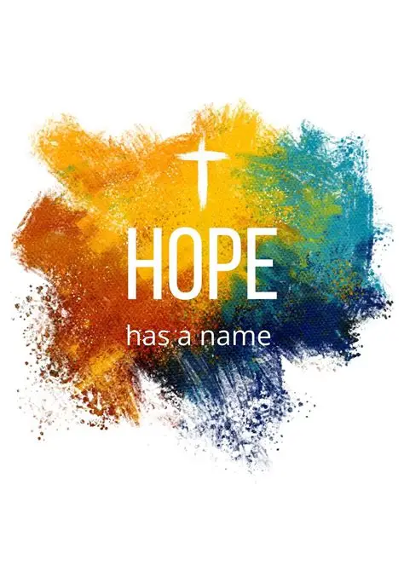

Monday - Meditation – 6.00 pm to 7.00 pm, St Columba’s

Wednesday – Spiritual Oasis – from 8.30 am to 2.00 pm, St Columba’s

Wednesday – Heart of the Week Intentional prayers – 1.00 pm, St Columba’s

Wednesday - Pub Theology - from 7.00 pm to 9.00 pm, Causeway Pub

Friday - Community Drop-In Café – from 10:00am to 12:00pm, St Aidan’s

Friday - Meditation - 2:00pm to 3:00pm, St Columba’s

Our Mission Enabler is Partick Reeve, please contact him for more information about the Group mission or any of the projects.

Tel: 07712150190

Email; [patrick@hartlepoolcoh.co.uk](mailto:patrick@hartlepoolcoh.co.uk)

This is your invitation to pray day by day through August, then write some of your own for September.

1st Children with special needs and their families

2nd Peace between peoples of different faiths

3rd The ability to speak up for those who cannot speak for themselves

4th The NHS and its tireless work in looking after the sick and infirm

5th The prison service and the hardships it is facing.

6th Those who work in the legal profession, and the work they do for everyone 7th Local organisations for children and young people

8th Those known to us who are unwell and need our prayers

9th Families hoping to spend part of the summer on holiday abroad or in the

UK

10th The Central Hartlepool Group, the Parishes and the Group Mission Project

Team

11th Those who give of their time to help those who are less fortunate than

themselves.

12th The environment, and how we can ensure that it is not polluted by our

waste

13th The kindness of those who keep in touch with the vulnerable and the

lonely

14th Fair trade and sustainable development in the third world

15th For Foodbanks, our own Kitchen and those who visit them

16th The situation in the Middle East and those trying to find a peaceful

outcome.

17th The homeless

18th The Diocese of Durham

19th The work of retreat houses and places of pilgrimage

20th Food and clothing for those afflicted by war and famine

21st Single parents, teenagers living alone and families on low incomes

22nd Chaplains in the armed forces, hospitals and prisons

23rd All pets and the pleasure they give to so many both young and old

24th Farmers and the problems they face.

25th The people of Ukraine who have lost everything and seem to have no hope 26th Those who have been bereaved recently or remembering the death of

oved ones.

27th Family life throughout the world

28th Those who have died for their faith in Jesus Christ

29th Those who work in the holiday industry and the difficulties they are

experiencing

30th Victims of abuse, cruelty, and violence

31st Children and students enjoying their break from school or college

**Answers to the puzzles**

**Crossword**

**ACROSS:** 1, Amazed. 4, Others. 8, Peter. 9, Zebedee. 10, Accuser. 11, Endue. 12, Scripture. 17, Shrub. 19, Abashed. 21, Foolish. 22, Upset. 23, Loathe. 24, Lesser.

**DOWN:** 1, Appeal. 2, Attacks. 3, Earns. 5, Tableau. 6, Ended. 7, Shekel. 9, Zarephath. 13, Rubbish. 14, Ephesus. 15, Useful. 16, Editor. 18, Rhoda. 20, Abuse.

**Wordsearch**

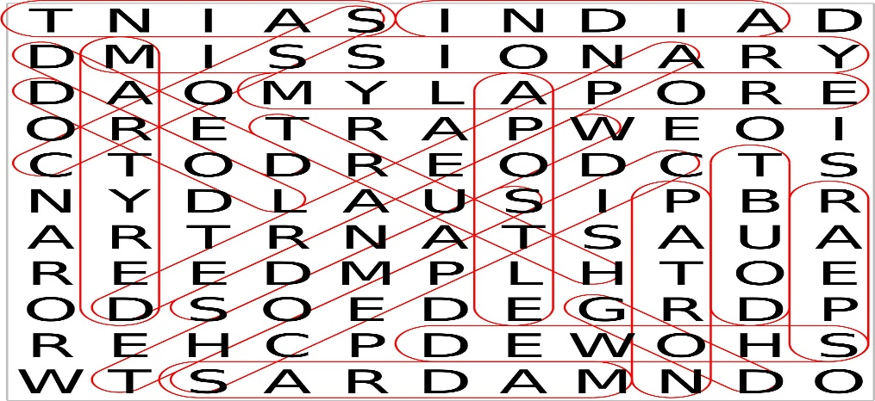

**General knowledge quiz**

1. Sheep 2. The Desert Fox 3. Stale 4. 007 5. No

6. Six runs 7. The start of the Great Fire of London 8. England 9. Bovril

10. The Club House 11. Faster 12. 10,000 13. Charlie Chaplin

14. Bending spoons 15. The Bank of England 16. 9 17. Fencing

18. Kentucky Fried Chicken 19.Florence Nightingale 20. Didgeridoo



**Church Legacy - a Lasting Gift to your Church**

At St Aidan’s and St Columba’s we welcome all gifts in wills, however large or small, and we promise to use your gift to make a difference in our parish.



You can be confident that your gift will be used to make a real difference to our future mission and ministry.

St Aidan’s Church

**Weddings** [](https://uk.images.search.yahoo.com/images/view;_ylt=Az_6xdmcUT1V7ToALrJNBQx.;_ylu=X3oDMTIzbzQ0aGdrBHNlYwNzcgRzbGsDaW1nBG9pZAM1NGM3NDRiZmUzZjc4MWVkOWFjODM4ZjEzNzUzM2Q5YwRncG9zAzgzBGl0A2Jpbmc-?.origin=&back=https://uk.images.search.yahoo.com/search/images?p=cross&fr=yfp-t-203&fr2=piv-web&nost=1&tab=organic&ri=83&w=937&h=937&imgurl=www.londonbaystationery.com/Images/celtic_cross.jpg&rurl=http://www.londonbaystationery.com/?page_id=5&size=14.6KB&name=the+celtic+%3cb%3ecross%3c/b%3e+the+circle+connecting+the+arms+of+this+%3cb%3ecross%3c/b%3e+from+the+...&p=cross&oid=54c744bfe3f781ed9ac838f137533d9c&fr2=piv-web&fr=yfp-t-203&tt=the+celtic+%3cb%3ecross%3c/b%3e+the+circle+connecting+the+arms+of+this+%3cb%3ecross%3c/b%3e+from+the+...&b=61&ni=21&no=83&ts=&tab=organic&sigr=11droe6tt&sigb=13am82nr5&sigi=11j2nsv50&sigt=12o0ikr4g&sign=12o0ikr4g&.crumb=SEFBRa4rjdP&fr=yfp-t-203&fr2=piv-web) **Funerals**

**£741 £429**

includes statutory fees, organist, vergers, service sheets,

light & heating.

Bells may be rung for an additional charge of £160.

For more information, please contact Kathrine Batty on

01429 871814 or 07836796374

**Gas and Heating Engineer**

*Boiler installation, repairs and servicing*

*Plumbing work also undertaken*

**Bill Fletcher**

01429 409206 ***Gas***

07740 958239 ***Safe*** ***Registered*** [willfletch@ntlworld.com](mailto:willfletch@ntlworld.com)

Alice House Hospice

Provides free palliative care for patients.

Offers of voluntary help are always welcome, as are donations. Please contact us at:

*Alice House, Wells Avenue *

*Hartlepool, TS24 9DA*

*Tel: 01429 855555*

*www.alicehousehospice.co.uk*



**Fetching Feet Chiropody**

**Sophie Odgers BSc (Hons)Pod. M. Ch.s**

**Telephone 01429 232536 or 07828540793**

Treatments include:

Hard, long and ingrowing nails, Hard skin/callus, Plantar fasciitis,

Corns and verrucas, Athletes foot, fungal nail infections,

K-laser for pain management

*Clinic and home visit appointments available*

