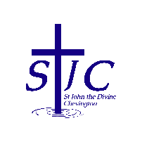
St John the Divine Welcome to our service today
Chevington 10th August 2025
Eighth Sunday after Trinity

Dates for your diary  Sunday August 10th  10am Eucharist with Carollyn  11:30am Baptism of Elsie Stevens  Wednesday August 13th  9:30am Eucharist at St Cuthbert’s  Friday August 15th  80th anniversary of VJ Day  2pm Short commemoration at Amble War Memorial  Saturday August 16th  10am Coffee morning at St Cuthbert’s  Sunday August 17th  10am Eucharist with Rachael  Thursday August 21st  2pm Third Thursday  = . = . = . = . = . = . = . = . = . = . = . = . = . = . = . = . = . = . = . = . = . = . = . = . = . =  Baptism  We have a baptism this morning so please pray for Elsie and her family.  Coffee will be in the kitchen!  = . = . = . = . = . = . = . = . = . = . = . = . = . = . = . = . = . = . = . = . = . = . = . = . = . =  This week, please pray for  We pray this week for all those who live in live in Carnaby Drive, Lake View and Togston Court and for the staff and families of Hadston Family Hub  From the memorial book  Brian Garnham 2008  Henry Hardy 1941  Norman Richardson 1917  May Robinson 1980  Florence Mary Shanks 2012  Florrie Smith 1971  Edna Stewart 2010  Hannah Wilkinson 1992  = . = . = . = . = . = . = . = . = . = . = . = . = . = . = . = . = . = . = . = . = . = . = . = . = . =  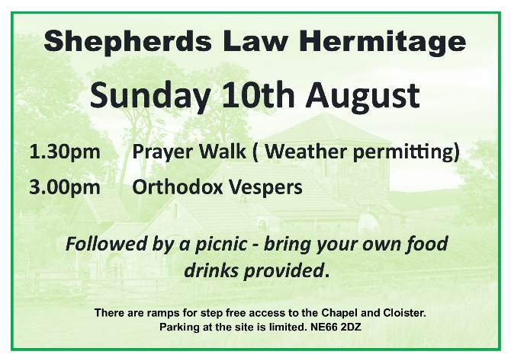 |  | Recycling – thank you!  Just a quick note to say “thank you” for all you do in recycling to support our environment.  To help make our lives easier and save people having to sort the bin contents, here is a reminder of what can go in the 3 bins in the kitchen.  Council Recycling – only paper, cans and plastic bottles, please  Soft plastic recycling – everything the Co-op accepts, generally bread bags, crisp packets, anything which when scrunched up unfolds when released.  Everything else – destined for the black bin    = . = . = . = . = . = . = . = . = . = . = . = . = . = . = . = . = . = . = . = . = . = . = . = . = . =  Craft Club  We are relaunching our craft club under a new name “Making Space”.  Our first meeting will be in the church kitchen at 7pm on Thursday September 4th and we will then meet on the first Thursday of every following month.  This club is not just for church people so if you know anyone who enjoys knitting, sewing, card making, etc, etc and who would like to spend a couple of hours with a friendly group, then please let them know about this.  = . = . = . = . = . = . = . = . = . = . = . = . = . = . = . = . = . = . = . = . = . = . = . = . = . =  Church contacts  Priest in charge Revd Rachael Dines  revd.rachael.dines@gmail.com  01665 497631 / 07763 211901  Please note - Rachael’s rest day is Tuesday  Churchwardens  Anthony Reay – 07429 929537  Sheila Orgill (also Parish Safeguarding Officer) – 07484 825203  Reader Cynthia Bishop – 07498 182350  Website https://www.achurchnearyou.com/church/16282/  Facebook St John the Divine Chevington  Churchwardens St Cuthbert’s Amble  Richard Colson – 07724 687107  Linda Williams – 07720 716794

