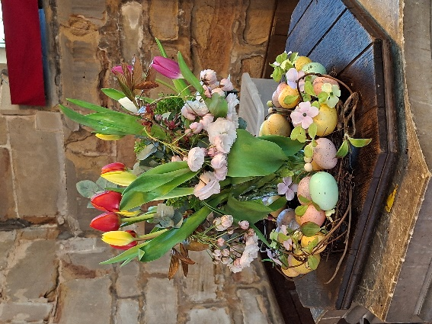
ST MICHAEL AND ALL ANGELS,
HAMSTALL RIDWARE

In the United Benefice of King’s Bromley, the Ridwares
and Yoxall

August 3rd 2025
Trinity 7
PARISH NOTICES

UNITED BENEFICE SERVICE ROTA
 | Hamstall Ridware  St Michael and All Angels | Yoxall  St Peter | King’s Bromley  All Saints | Mavesyn Ridware  St Nicholas
August 3rd  Trinity 7 | 9.00 am  Holy Communion | 10.30 am  Parish Communion | 5.00 pm  Holy Communion | 10.30 am  Morning Prayer
August 10th  Trinity 8 | 10.30 am  United Benefice service of Holy Communion at All Saints, King’s Bromley
August 17th  Trinity 9 | 10.30 am  United Benefice service of Holy Communion at St Peter’s, Yoxall
August 24th  Trinity 10 | 10.30 am  United Benefice service of Holy Communion at St Michael and All Angels,  Hamstall Ridware
August 31st  Trinity 11 | 10.30 am  United Benefice service of Holy Communion at All Saints, King’s Bromley

Please note that services of Holy Communion at 9 am follow the Book of Common Prayer and are said. Services at 10.30 will include hymns and other singing.
*******************
Rugeley Food Bank. Please do remember those who depend on Food Banks. They are needed now just as ever. If you wish to donate directly to Rugeley Foodbank at Rugeley Community Centre the Centre is open everyday to receive contributions. Alternatively, the Rugeley Food Bank welcomes financial contributions – see https://rugeley.foodbank.org.uk. Gifts can also be brought to St Michael’s and left in the box at the back of church near the font. If that is not convenient please contact Liz Carter on 07751 068181.
****************
Contact details: If you wish to contact the Rector, Jeremy Brading you can do so on revd@kbhmy.co.uk and Glenis Turner, the PCC Secretary and Benefice Administrator is on admin@kbhmy.co.uk. The churchwardens are Michael Elsom michael.elsom@btopenworld.com and John Ferguson clan.member1954@gmail.com Information about events at church can be found at our webpages at https://www.achurchnearyou.com/church/4451/ and https://kbhmy.co.uk/hamstall/
St Michael’s will continue to be open everyday (weather permitting) between 10.00 am until 6.00 pm. We will revert to shutting the church at 4.00 pm on October 26th
Safeguarding of children and vulnerable adults. If you have any concerns please speak in complete confidence to the Parish Safeguarding Officer, Dr Paul Carter 01889 504347 or the Diocesan Safeguarding Officer Mr Neil Spiring 01543 306 030.
PLEASE REMEMBER IN YOUR PRAYERS:
Those who are sick: Mary Mycock, Brenda, Angela Perkin, Doug, David and Barbara Rudge, May Windley, Pam Payne, Rev’d Frank Finch, Chris Poole, Les Woods, Pat Lomax, Alison Scott and any known personally to you.
Those who live and work in the Nursing, Care and Retirement homes in the villages both in and near the parishes of the United Benefice.
In a week which sees the 80th anniversary of the dropping of two Atomic bombs the need to pray for peace appears just as pressing and urgent as ever. In particular let us hope and pray that grim though the various conflicts currently affecting diverse parts of the world, none of them ever lead to a situation where such a devastating weapon of war is deployed again.
On Saturday August 9th we remember the murder of the Catholic nun and philosopher Edith Stein in 1942 after outspoken criticism of the Nazi regime and the Catholic church for its failure to condemn that regime’s persecution of the Jews. Such fervent devotion to faith remains a cogent example to us all.
Using the Archbishops’ prayer for Ukraine at this time let us remember the people of that war-torn land:
God of peace and justice, we pray for the people of Ukraine today. We pray for peace and the laying down of weapons. We pray for all those who fear for tomorrow, that your Spirit of comfort would draw near to them. We pray for those with power over war or peace, for wisdom, discernment and compassion to guide their decisions. Above all, we pray for all your precious children, at risk and in fear, that you would hold and protect them. We pray in the name of Jesus, the Prince of Peace. Amen
Let us also pray that the right of the people of Ukraine and neighbouring countries to exist without threat of dominance from any other country and the greed of those with eyes on its resources may be honoured.
The situation in the Middle East where hopes for a peaceful resolution sometimes appear irretrievably bleak:
O God of all justice and peace, we cry out to you in the midst of the pain and trauma of violence and fear which prevails in the Holy Land. Be with those who need you in these days of suffering; we pray for people of all faiths - Jews, Muslims and Christians and for all people of the land. While we pray to you, O Lord, for an end to violence and the establishment of peace, we also call to you to bring justice and equity to the peoples. Guide us into your kingdom where all people are treated with dignity and honour as your children - for to all of us you are our Heavenly Father. In Jesus' name we pray. Amen.
From the Diocesan Prayer Diary:
Tuesday 5th: (Oswald, King of Northumbria, Martyr, 642)
On St Oswald's day, we pray for the two churches in the diocese dedicated to him, both in Shropshire, one in central Oswestry, and one in Hinstock between Market Drayton and Newport. We pray for your hand of blessing to rest on both of these churches and the communities they serve.
Wednesday 6th: (The Transfiguration of Our Lord)
A Collect from Common Worship:
Father in heaven, whose Son Jesus Christ was wonderfully transfigured before chosen witnesses upon the holy mountain, and spoke of the exodus he would accomplish at Jerusalem:
give us strength so to hear his voice and bear our cross that in the world to come we may see him as he is;
who is alive and reigns with you, in the unity of the Holy Spirit, one God, now and for ever. Amen
Saturday 9th: (Mary Sumner, Founder of the Mothers’ Union, 1921)
The Mother's Union Prayer;
Loving Lord, We thank you for your love so freely given to us all. We pray for families around the world. Bless the work of the Mothers' Union as we seek to share your love through the encouragement, strengthening and support of marriage and family life. Empowered by your Spirit, may we be united in prayer and worship, and in love and service reach out as your hands across the world. In Jesus' name. Amen.
The Churchyard
is a very important part of the heritage of the village and St Michael’s in particular. Keeping it in good order and a fitting place for the repose of those who lie buried there and a space of solace and prayer for those who visit is hard work but much appreciated by all. The next working party is on Tuesday August 5th at 5.00 pm. Please help!

