** SPIRE & LIGHT United Churches**

United Benefice of St Keverne, St Ruan with St Grade & St.Wynwallow (The Lizard)

**\*If you do not wish to receive these notices, please let your Churchwarden know\***

**17th August 2025**

***Trinity 9***

**Readings**

**Jeremiah 23:23-29**

**Psalm 82**

**Hebrews 11:29-12:2**

**Luke 12:49 -56**

9.30am –– Holy Communion- St.Peter’s, Coverack

9.30am –– Holy Communion - St.Wynwallow, The Lizard

11am –- Morning Prayer - St.Keverne Church

11.15am – Family Service – St.Ruan, Ruan Minor

Next week – Sunday August 24th

9.30am –– Morning Prayer - St.Peter’s, Coverack

9.30am – Holy Communion– St.Ruan, Ruan Minor

11am – Holy Communion - St.Keverne Church

11.15am – Café Church – St.Wynwallow, The Lizard

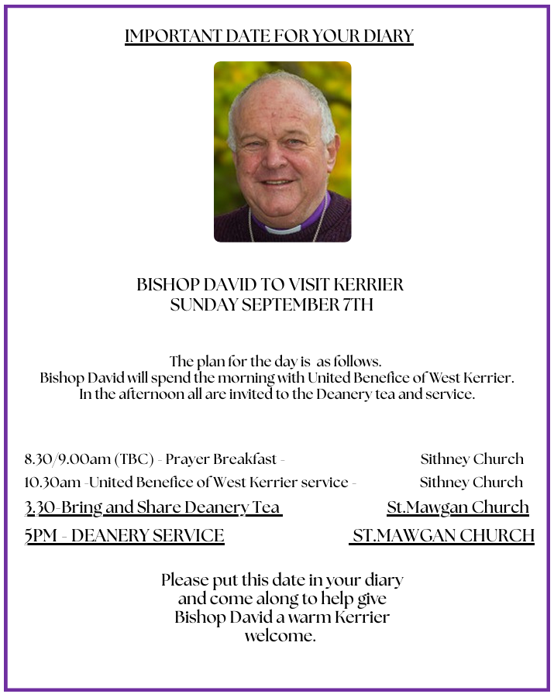****

**The Prayer Spot**

Dear Heavenly Father, as we come to pray to you today, remind us of the love we must share with others, that love given to us by you. Help us to remember those in need within our churches and community and how we can be there for them - it may just need an act of kindness just to show we really care for them.

It says in 1 PETER 1 “Therefore prepare your minds for action, be self-controlled, set your hope fully on the grace to be given to you when Jesus Christ was revealed to you. As obedient children of God do not conform to self-desires you had when you lived in ignorance but as he who has called you is Holy so be holy in all you do for it is written to be holy because I am Holy.”

Remember God has given you gifts to use for the needs of others. Use them well because everyone needs your help in times of troubles. Be generous and full of God’s love, pray for all those who are in need of hospital treatment and that God will be present with them and for those who have the job of taking them. Pray for all our benefice that God will guide us in our care for everyone and to remember them all in our prayers.

*We praise you for your kindness and all the love you give us, for your endless willingness to forgive us when we fail you. We thank you for the love shown to us as members of your flock, for being the shepherd who guides us through each day. Thank you for those wonderful gifts given to us of forgiveness, justice, generosity, and peace and of course that great joy of knowing your presence in our lives.*

As always, I tell you God will be ever present in your prayer time and will answer all your prayers in the name of His Son Jesus Christ. Be blessed by all you do in His name.

*O God our Father, grant that whatever happens to us today we may take it to thee. If we shall have decisions to make help us to ask for your guidance and grant us humility and obedience to take it when you give it to us. If we shall have problems to solve, help us ask for thy light upon them so we may see a clear way through them. Help us through today to decide everything by thy will and to test everything by thy presence so that we may come to the days ending without mistakes and without regrets through Jesus Christ our Lord. Amen*

***The Diocese of Truro’s Prayer Diary for this week***

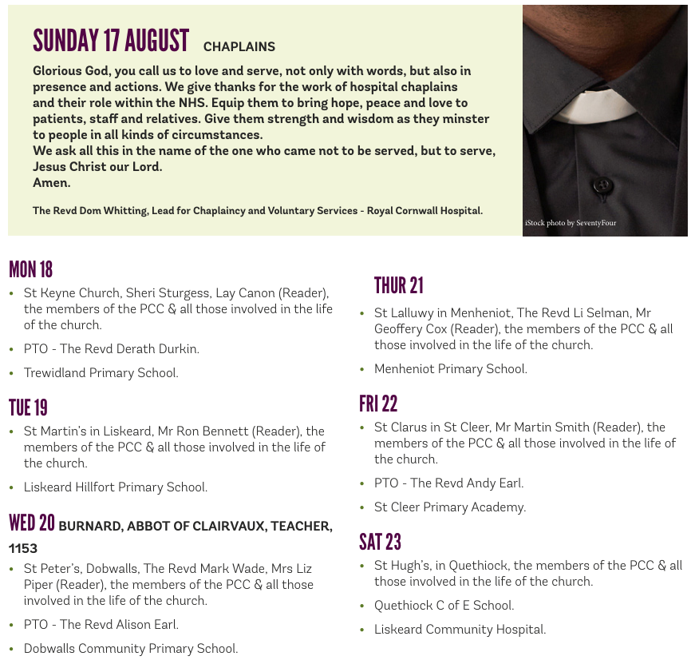

**On the Way Prayers**

Summer suns are glowing over land and sea, happy light is flowing bountiful and free. Everything rejoices in the mellow rays; all earth’s thousand voices swell the psalm of praise. Let’s just be still for a moment and thank God for warm summer weather which maybe makes us slow down.

We give thanks for the continuing holiday season, for all the visitors who flock to this part of your glorious world at this time of year and for the much-needed boost they give to our local economy. Lord, we ask for your blessing on all who are working in hospitality at this time, particularly as costs are rising and we see so many businesses folding. We give thanks too for all the visitors who help to swell our congregations during the summer months. May we give them a warm welcome, learn from them as they tell us about their churches and help us to realise that the problems we are experiencing are being felt everywhere.

Help us to remember that holidays were originally Holy Days. We know that we all need a break sometime, that we all need to recharge our batteries and to broaden our minds in pastures new. Help us Lord to put our trust in you as we travel, as we entertain family and friends, and as we try to relax and refresh ourselves. “Come unto me, all ye that labour and are heavy laden, and I will give you rest. “

We pray for our clergy and for all who minister in our churches and in our communities. Today we particularly give thanks for Robert Evans, and for all that he has done, taking services while Heidi has been away and for his contribution to the DIT. We give thanks that he is to hold further sessions for us on 1 Corinthians in Degibna Chapel beginning in September. Help us always to keep learning.

As our young people receive their examination results we pray for them; for those who will be celebrating their successes and those who must come to terms with disappointment and having to make new plans. Dear Lord be with each of them as they reach a new crossroad in their life and help them prepare for the next stage of their life’s journey.

And now we take a moment to pray for anyone who needs the comfort of our collective prayers right now or for anything that is uppermost in our minds and in need of God’s help.

We will never doubt thee, though thou veil thy light; life is dark without thee; death with thee is bright. Light of Light! shine o’er us on our pilgrim way, go thou still before us to the endless day. As our prayer time comes to an end we pray, Lord, for each one of us, for the things we have to do and for peace and calm in our lives.