Welcome to your Church Newsletter for August 2025

For more information or to contact us please visit:[www.achurchnearyou.com/church/9954](http://www.achurchnearyou.com/church/9954)**

**Look out for our New Monthly services**

***Family Friendly Café style Church***

***Less sitting, more doing!***

***Starting 7th September***

***Pizza & Praise less formal worship aimed at families and young people.***

***All age, inclusive worship.***

***Starting 28th September***

***Everyone welcome.***

**MORNING PRAYER**

**Led by Rev Mandy**

**TUESDAYS 10am Holy Trinity, Larkfield**

**WEDNESDAYS 9.30am St. James, East Malling**

*Both churches are then open till midday*

*so why not join us for a chat, a hot drink or to explore the beautiful church. Enjoy the Peace and quiet to light a candle,to say a prayer or just rest awhile.*

*Whatever your reason, a warm welcome awaits.*





**Home Communion & Home visits**

If you are unable to get to church and would like communion brought to you at home, please phone me 01474 852265 to arrange a convenient date and time. If you would like a home visit, again, please phone me to arrange a time. I can only apologise for not having seen so many of your for so long.

**AFTERNOON** **TEAS AT St. JAMES**

**Continue Sundays in August 3-5pm**

**Different hosts each week.**

**EVERYONE WELCOME**

**Everyone welcome**

CONFIRMATION CLASSES

Will run every Thursday evening through OCTOBER in preparation for a Deanery service on 17TH November 2025

If you are interested in being confirmed, come and have a chat with Rev Mandy.

D

**SERVICES AT St. JAMES THE GREAT & HOLY TRINITY IN AUGUST**

**(All services begin at 10am unless otherwise stated)**

**3rd - Holy Communion at St. James and Family Service at Holy Trinity**

**10th – Holy Communion at Holy Trinity and Morning Prayer at St. James**

**17th – Benefice Holy Communion at Holy Trinity (No service at St. James).**

**24th – Holy Communion at St James and Morning Prayer at Holy Trinity**

**31st – Ecumenical Holy Communion at St James joined by our friends from Larkfield Methodist Church.**

**All communions are led by Rev. Mandy & Services of the word by Alan Bramley**

**We are a fully inclusive church where everyone is welcome.**

D

**The Bradbourne Benefice**

**St James the Great Church, East Malling**

**& Holy Trinity, Larkfield  
*‘ Walking together to share the love of Christ****”*

*BABY AND TODDLERS 1.30 – 2.30 weekly on a Wednesday at St James Church. Small friendly group.*

*Music fun for pre- school children and their Adults*

UPCOMING DATES FOR YOUR DIARY:

27TH Sept Jumble Sale in Scout Hall, Larkfield

25th Oct Quiz Night in Scout Hall, Larkfield.

All to raise funds for Holy Trinity, Larkfield.

Any Donations of bric a brac, books, clothes, etc in good usable condition would be greatly appreciated.

**Not able to attend regularly but would like to stay in touch?**

**You could receive this pew sheet electronically by**

**emailing Sue Payne on**

[**paynes48@hotmail.com**](mailto:paynes48@hotmail.com)

**VICARAGE OPEN DAYS IN AUGUST**

**You are warmly invited for tea and cake on THURS 14th August**

**&**

**SAT 23rd August**

**Between 1- 4pm 4, Tassell Close, ME19 6QB**

**Everyone welcome.**

LGBTQIA+

PICNIC AT St. BENEDICTS CENTRE

West Malling Abbey

Saturday 16th August 2025

At 14.30

O*pen to Everyone*

**Priest-in-Charge The Rev’d Mandy Clampin** Mob: 01732 823948 Email: [rev.mandy24@gmail.com](mailto:rev.mandy24@gmail.com)

You may also contact us via our website, or facebook page for any enquiries regarding weddi

ngs, baptisms and Funerals

God of peace and justice,   
We pray for the people of Ukraine today.  
We pray for peace and the laying down of weapons.  
We pray for all those that fear for tomorrow,   
that your Spirit of comfort would draw near to them.  
We pray for those with power over war or peace,   
for wisdom, discernment and compassion   
to guide their decisions.  
Above all, we pray for all your precious children, at risk and in fear,   
that you would hold and protect them.  
We pray in the name of Jesus, the Prince of Peace.   
Amen

**If you have any news or events you would like included in next months pew sheet, please email by 15th August to** [rev.mandy24@gmail.com](mailto:rev.mandy24@gmail.com)

[rev.mandy24@gmail.com](mailto:rev.mandy24@gmail.com)

**Welcome Hub at the Sycamore Tree**

**Summer Opening Times**

**Coffee Mornings**

**Mon 21st July 10-12**

**Weds 30th July 10-12**

**Mon 4th Aug 10-12**

**Weds 13th Aug 10-12**

**Afternoon Teas**

**Mon 18th Aug 2-4**

**Weds 27th Aug 2-4**

**1st Sept back to normal Rota**

**Mon and Weds 10am – 4pm**

‘The Harvest is plentiful but the workers are few’ (Matthew 9:37)

What is Jesus calling you to join in with?

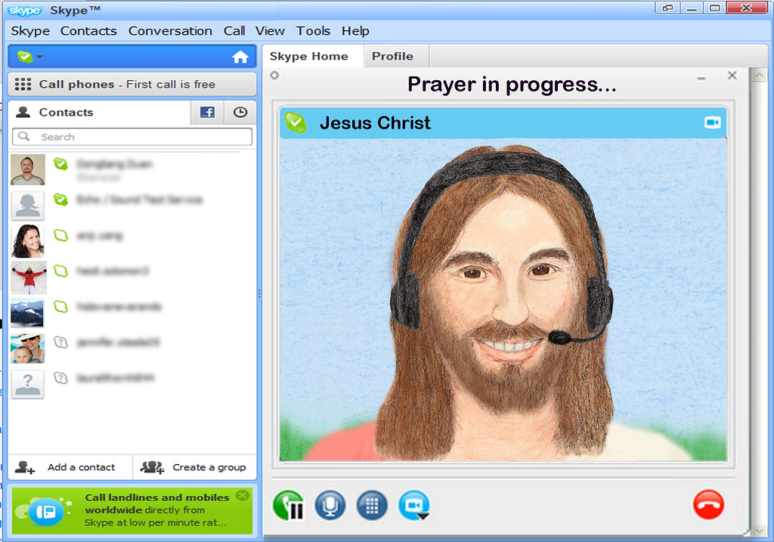

We need volunteers to increase the mission and outreach across our benefice. Please consider how you may be being called. Volunteers required for refreshments at services & EMCC, Cake baking, running stalls, Meet and Greet, hosting fundraisers and assisting with youth and family services. NO SKILL TOO SMALL!

Come & have a chat with Mandy

*For any enquiries please contact Rev Mandy Clampin, Priest in charge*

**Priest-in-Charge The Rev’d Mandy Clampin** Mob: 01732 823948 Email: [rev.mandy24@gmail.com](mailto:rev.mandy24@gmail.com)

You may also contact us via our website, or facebook page for any enquiries regarding weddi

ngs, baptisms and Funerals

God of peace and justice,   
We pray for the people of Ukraine today.  
We pray for peace and the laying down of weapons.  
We pray for all those that fear for tomorrow,   
that your Spirit of comfort would draw near to them.  
We pray for those with power over war or peace,   
for wisdom, discernment and compassion   
to guide their decisions.  
Above all, we pray for all your precious children, at risk and in fear,   
that you would hold and protect them.  
We pray in the name of Jesus, the Prince of Peace.   
Amen

***Tel :07864743309*** *or Email: rev.mandy24@gmail.com*