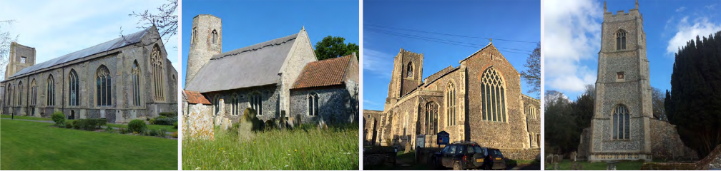

N.E.W.
North Walsham
Edingthorpe
Worstead and Westwick
NEWS
The Magazine for the North Walsham Benefice September 2025 40p
Transformed by Christ: Prayerful, Pastoral, Prophetic

Editor’s Bit

Contents in this issue:
- Vicar’s Page
- From the assistant curate
- Dates from the Diary
- September service Dates
- Upcoming Events
We hope to see you at our services, you are all welcome.

Please note the date for items to go in the October edition of NEWS needs to be at the Parish office by September 20th latest.

Financial Information

Please may we remind you, that if you are giving us a cheque for any of the Churches, they need to be made payable to the following:
St Nicholas’ Church – North Walsham PCC
All Saints’ – Edingthorpe PCC
St Mary’s – Worstead PCC
St Botolph’s – Diocesan Churches Trust

Please may we ask if you are sending any payments to us via an online service that you put a meaningful reference on the payment to ensure we know where the payment should go to.

Live-streamed services are available on YouTube - please search St Nicholas North Walsham. Do you participate in our live-streamed services - we would love to hear your feedback: contact David on 07506 723946 or davidnorthwalsham@gmail.com

If you are considering a change to your Committed Giving for St. Nicholas, please inform Chris Sherman (Committed Giving Officer)
Please support St. Nicholas Church, North Walsham on #easyfundraising, you can raise FREE donations when you shop online with over 5,000 retailers. It is simple and only takes 2 minutes to sign up! Plus, once you have raised your first £15, easy fundraising will match it!
Sign up now: https://www.easyfundraising.org.uk/causes/stnicholaschurchnw/

The Vicar’s page:
From David:
September already!
So much seems to have happened since our last edition - of course the major event in the Benefice is that we were finally able to welcome Dan amongst us as Assistant Curate - it is great to see him getting to work, and many of you will already have benefitted from his wisdom, insight and company - he has an infectious love for Christ which is a blessing to us all.
Worstead had a very successful Festival this year, the church packed with weavers, flowers, music and people receiving hospitality. It was also good to be on the field with our own stall - Dan and I had many hugely encouraging conversations, and it was a blessing to hear the music provided in church, as well as hourly on the church bells. Our celebrations were marred by the loss of our dear Sue Pomroy, and in August we came together to give thanks for her life and witness and pray for Michael and his family - we continue to hold them all in our prayers and Sue in our thanksgivings.
Edingthorpe held a very successful concert earlier in the summer, as well as a very moving service where we blessed the graves around the church building - we look forward to the Pet service on the 8th of this month. As I write, members of the PCC will be meeting with the architect and other experts to see what work the building needs to safeguard and improve it for the next generation.
North Walsham has hosted concerts and recitals, as well as regular worship and other events - it was good to be at the centre of the VJ 80th anniversary as well as the VE day anniversary celebrated earlier in the year. In September members of the PCC and others will be meeting with our Major Churches Network contacts to begin to test what kind of plan we want for the future God has for us here - as I recently said at PCC, we need to make the church building, which is a jewel, less of a burden to our faithful givers and supporters, and a more effective and flexible tool of worship, work and witness. The recent Committed Giving campaign yielded a rise in our regular income, with many respondents increasing their monthly giving and new givers joining the scheme. Thank you all.
Westwick has been able to carry out some minor repairs to safeguard the building as well as install new LED lighting to ensure the services we have there are safe and welcoming.
As we approach October, Penny and I will continue to prepare for the new arrival in our lives - I'm reliably informed this will be the first baby in the Vicarage here for more than 50 years. We are grateful for your prayers and support as we get ready.
With my prayers and good wishes,
David
The Curate’s Page
When writing this article, I have exactly 11 days left until the second month anniversary of my Curacy in our lovely Benefice.
And I must say it does not feel like two months, but much longer indeed.
The reason for that is not feeling like a newcomer no more, but rather like an integral part of life in North Walsham.
There are faces now which are familiar, as well as my face being recognisable to more and more people on the street.
There were life stories you told me, conversations I got engaged in, and jokes you told me that made me laugh like never before.
And finally (or rather most importantly), there are services which I had the pleasure of joining with you. Nothing makes me happier and more grounded in my ministry than sharing the joy of the Gospel with people I care about.
What can I say about these first two months?
I was not expecting to be left to ‘run the place’ in my second week of Curacy (which was a great responsibility but also a blessing), I enjoyed every single moment of meeting all of you, the Worstead Festival was a blast (and you never forget your first one), Blessing of Graves at Edingthorpe was something literally out of the Vicar of Dibley series (which will always remain my ultimate fantasy) and I did my first solo School Service and Sunday Service (I dare say both went really well, not my words!). But most importantly seeing all of you out and about, having to divide my attention at Lidl’s between the middle aisle and people I bump into, cheerful ‘good morning’ I hear whenever I pass you on my bike; these are and will always be the highlights of my time here.
As this is my first article as your official Curate I can say proudly that I keep you all in my prayers daily, as part of my ministry for and amongst you all here.
God bless!
Dan



Edingthorpe Village news for September

SERVICES
14th September: Holy Communion 9.15 am
28th September: Morning Prayer 9.15 am

Dates for your diary
7th September at 4pm. Do come along with your pet, whatever shape or size, and join us for a Pet Service.
28th September is our Harvest Thanksgiving Day followed by the Harvest Service at 4pm. There will be a display of old tractors etc. together with refreshments.
All events and information about the Church are available on the website: www.achurchnearyou.com/church/10076/
June Hannant 01592 402337
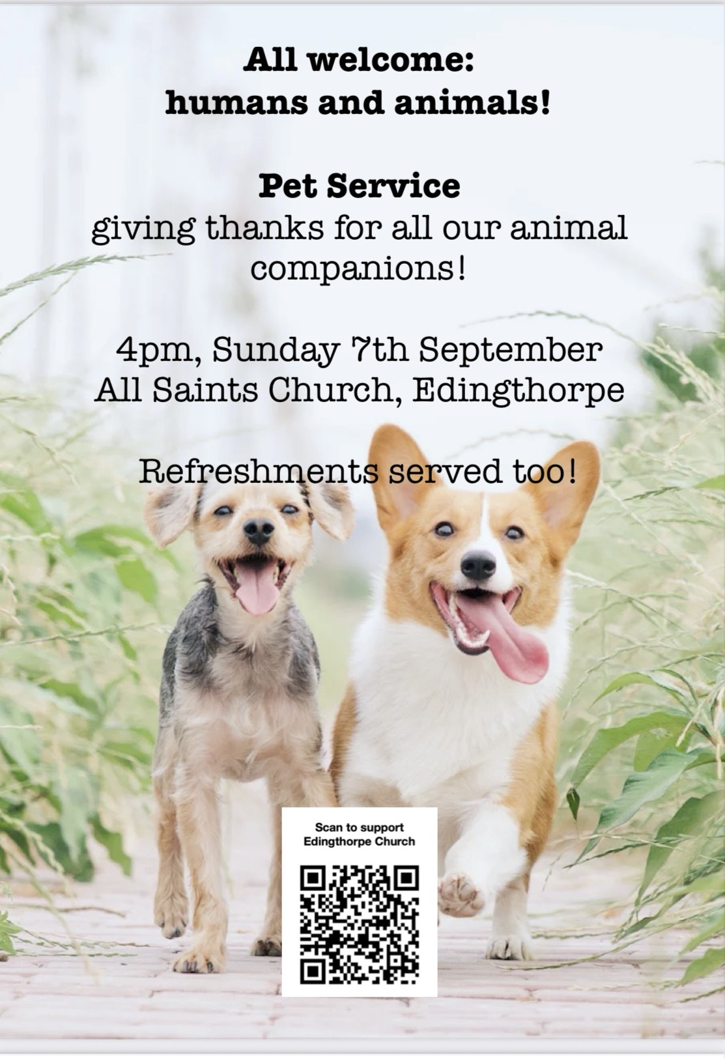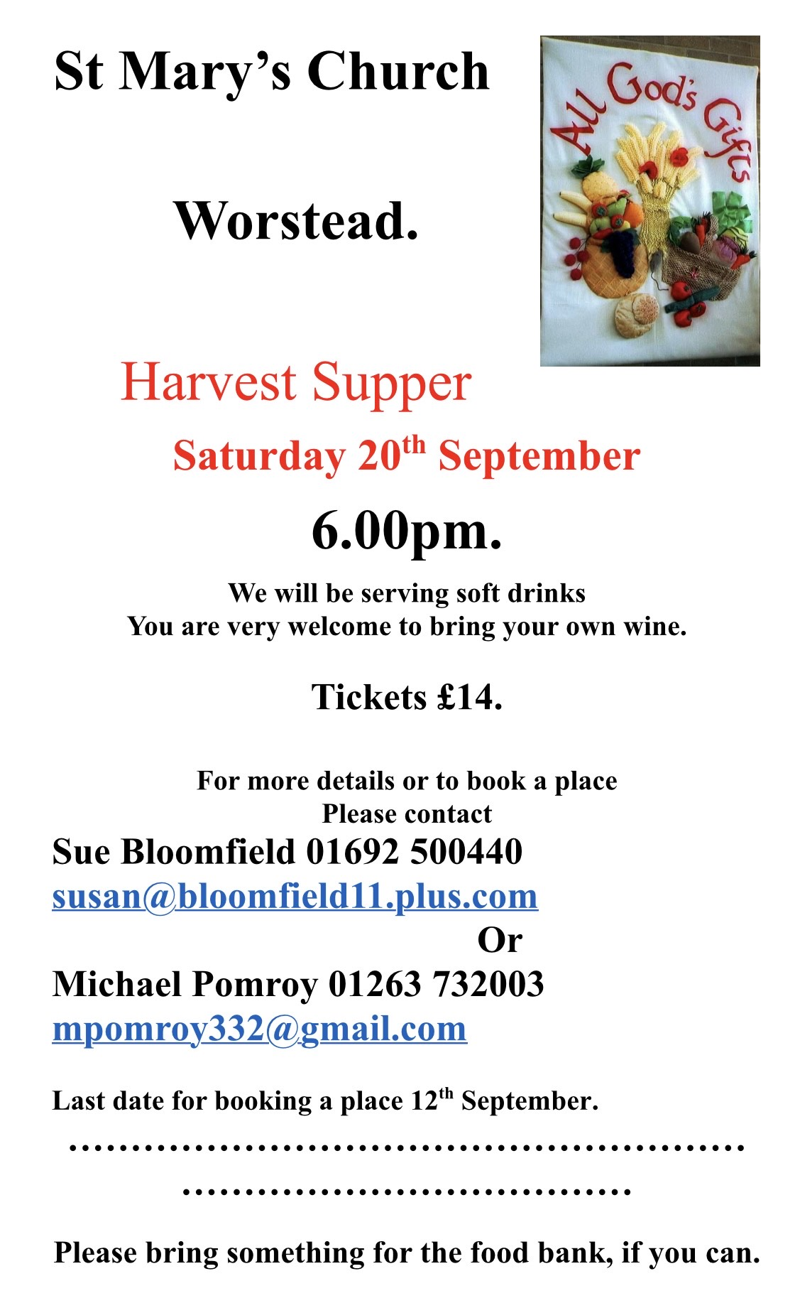
ST MARY’S WORSTEAD
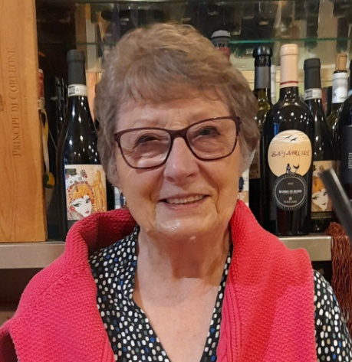
On 1st August family, friends and colleagues packed St Mary’s Worstead for the funeral of Sue Pomroy. It was a wonderful celebration of Sue’s life, led by David. Married to our churchwarden Michael, Sue was a much-loved part of our Worstead church team, and our organist for many years. In addition to her regular playing for all our services, she frequently accompanied local schools in their concerts and assemblies, and played for other churches in our area. A beautiful floral tribute to Sue, created by churchwarden and flower artist Sue Bloomfield, took pride of place in the church during the Worstead Festival. We miss her greatly, and extend warmest sympathies to Michael and all the family.

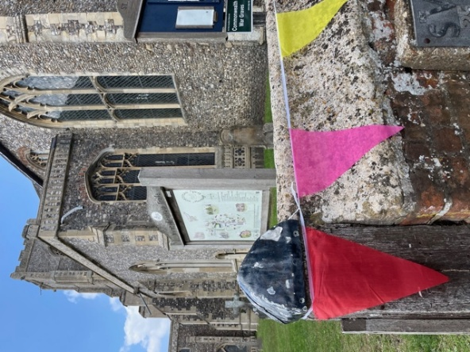
While we felt Sue’s absence at the Festival this year, on the last weekend of July, she would have been delighted with its successes. The weather was mostly warm and bright, and both the main events on the field and our church activities drew large crowds and raised record amounts of money for charities and St Mary’s. In a church festooned with bunting, visitors came in their hundreds to enjoy the Café, the fabulous flower displays (theme: A Special Occasion), watch the Worstead Weavers and Dyers in action, and listen to live music acts from a range of local singers, choirs, organists and bands. Other attractions included a photo display from North Walsham Archives, and we rounded off on the Sunday with a celebratory Songs of Praise service.

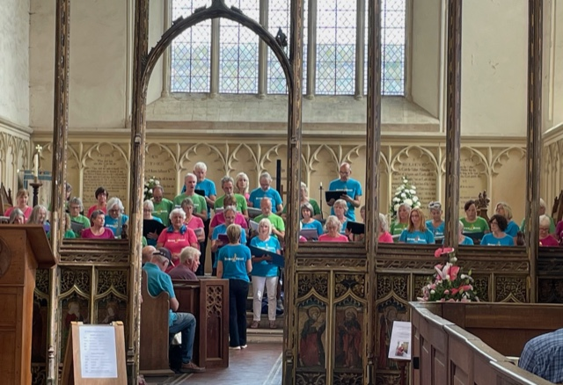
We’ve enjoyed hosting several summer weddings, with more to come, and our bells rang out to mark the 80th anniversary of the end of the Second World War (on both VE Day and VJ Day). On Saturday 20th September we’ll be holding our Harvest Supper in the church at 6pm, and all in the Benefice are warmly invited. Tickets at £14 (soft drinks included, but bring your own wine) can be obtained from Sue Bloomfield through susan@bloomfield11.plus.com.

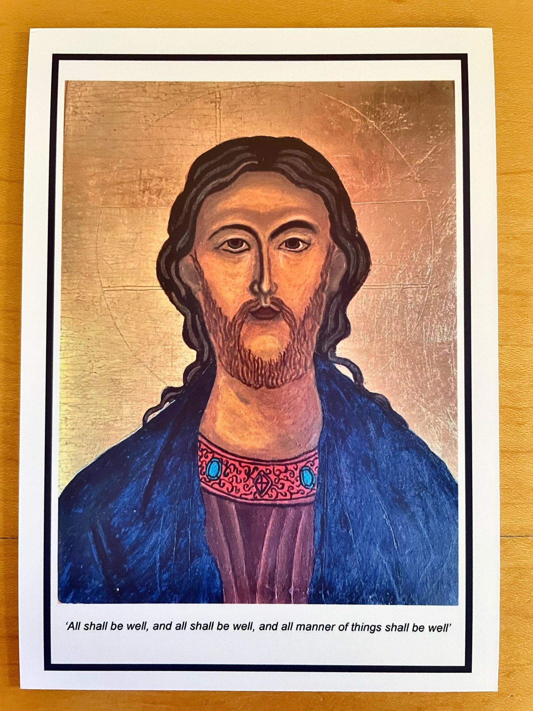
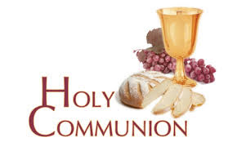
You may have read items in the press relating to the use of 'gluten free' wafers at Holy Communion - for those who require them, we use wafers which are approved and recommended for use by Coeliac UK - more information here. If you need a gluten free wafer, please advise the churchwardens/welcomers when you arrive for the service, and please indicate to the clergy distributing Holy Communion.
The Church teaches that receiving Holy Communion in both kinds (wafer and wine), or in one kind (the wafer or the wine) are acceptable and contain the fulness of the Sacrament. There are many reasons why this will be the case at different times in our lives, and there will be times when we cannot physically receive but join in an Act of Spiritual Communion (as those who watch online do - see below).

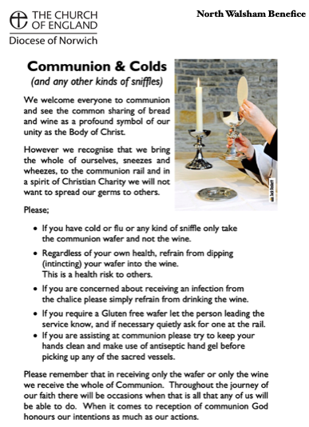
​Intinction (that is, dipping your wafer into the wine) is not permitted, both for hygiene reasons and because it might introduce gluten to the wine, which could be consumed by someone who is allergic to it.
If you wish to discuss any of this, please speak to David.

An Act of Spiritual Communion
In union, O Lord, with the faithful at every altar of your Church, where the Holy Eucharist is celebrated, I desire to offer you praise and thanksgiving. I present to you my soul and body with the earnest wish that I may always be united to you. And since I cannot now receive you sacramentally, I ask you to come spiritually into my heart.
I unite myself to you and embrace you with all the affections of my soul. Let nothing ever separate you from me. May I live and die in your love. Amen.



Why not come along to Sunday Kids and find out how to learn about what we do? We meet on the 1st and 3rd Sunday of the month at St Nicholas Church during the 10.30am service. You are most welcome.

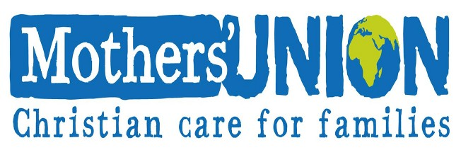

North Walsham Mothers’ Union. We meet in St Nicholas Room on the second Tuesday of the month at 2.00 p.m. Following a short act of worship and a few notices our speaker then takes the floor, after which, over tea and biscuits, there is an opportunity to ask questions and socialise. We usually finish about 3.30 pm.

Services for September

Monday 1st September
No service at North Walsham
Tuesday 2nd September
9am Morning Prayer at North Walsham
Wednesday 3rd September
9am Morning Prayer at North Walsham
10am Worstead Wednesday coffee morning at the Village Hall
Thursday 4th September
9am Morning Prayer at North Walsham
9.30am Market Day coffee morning in the St Nicholas Room
10.30am Holy Communion at North Walsham
Friday 5th September
9am Morning Prayer at North Walsham
9.30am Quiet Prayer at North Walsham
Sunday 7th September - 12th Sunday after Trinity
8am Holy Communion (1662) at North Walsham
9.15am Morning Prayer at Worstead
10.30am Holy Communion at North Walsham welcoming the Revd Lucy Dallas, Diocesan Director of Ordinands as our preacher
4pm Pet service at Edingthorpe
No 5pm service
Monday 8th September
9am Morning Prayer at North Walsham
Tuesday 9th September
9am Morning Prayer at North Walsham
2pm Mothers’ Union in St. Nicholas’ Rooms
Wednesday 10th September
9am Morning Prayer at North Walsham
10am Worstead Wednesday coffee morning at the Village Hall
10am Knitting Group in North Walsham Church
4pm Worstead PCC
7pm Edingthorpe PCC
Thursday 11th September
9am Morning Prayer at North Walsham
9.30am Market Day coffee morning in the St Nicholas Room
10.30am Holy Communion at North Walsham
Friday 12th September
9am Morning Prayer at North Walsham
9.30am Quiet Prayer at North Walsham
Saturday 13th September
1pm Wedding at Worstead
Sunday 14th September - Holy Cross Day
8am Holy Communion (1662) at North Walsham
9.15am Holy Communion at Edingthorpe
10.30am Holy Communion at North Walsham with act of remembrance for Battle of Britain Sunday
5pm Choral Evensong at North Walsham
Monday 15th September
9am Morning Prayer at North Walsham
Tuesday 16th September
9am Morning Prayer at North Walsham
Wednesday 17th September
9am Morning Prayer at North Walsham
10am Worstead Wednesday coffee morning at the Village Hall
7.30pm North Walsham PCC
Thursday 18th September
9am Morning Prayer at North Walsham
9.30am Market Day coffee morning in the St Nicholas Room
10.30am Holy Communion at North Walsham
Friday 19th September
9am Morning Prayer at North Walsham
9.30am Quiet Prayer at North Walsham
Saturday 20th September
Harvest Supper at Worstead
Sunday 21st September - Harvest
8am Holy Communion (1662) at North Walsham
9.15am Holy Communion at Worstead
10.30am Holy Communion at North Walsham
5pm Evening Prayer at North Walsham
Monday 22nd September
9am Morning Prayer at North Walsham
Tuesday 23rd September
No service - clergy conference
Wednesday 24th September
9am Morning Prayer at North Walsham
10am Worstead Wednesday coffee morning at the Village Hall
10am Knitting Group in North Walsham Church
Thursday 25th September
9am Morning Prayer at North Walsham
9.30am Market Day coffee morning in the St Nicholas Room
10.30am Holy Communion at North Walsham

Friday 26th September
9am Morning Prayer at North Walsham
9.30am Quiet Prayer at North Walsham
Sunday 28th September - 15th Sunday after Trinity
8am Holy Communion (1662) at North Walsham
9.15am Morning Prayer at Edingthorpe
10.30am Holy Communion at North Walsham
4pm Harvest Service at Edingthorpe
No 5pm service at North Walsham
Monday 29th September - Michael & all angels
9am Holy Communion at North Walsham
Tuesday 30th September
9am Morning Prayer at North Walsham
Wednesday 1st October
9am Morning Prayer at North Walsham
10am Worstead Wednesday coffee morning at the Village Hall
Thursday 2nd October
9am Morning Prayer at North Walsham
9.30am Market Day coffee morning in the St Nicholas Room
10.30am Holy Communion at North Walsham
Friday 3rd October
9am Morning Prayer at North Walsham
9.30am Quiet Prayer at North Walsham
Sunday 5th October 16th Sunday after Trinity
8am Holy Communion (1662) at North Walsham
9.15am Morning Prayer at Worstead
10.30am Holy Communion at North Walsham
5pm Choral Evensong at North Walsham
Monday 6th October
9am Morning Prayer at North Walsham


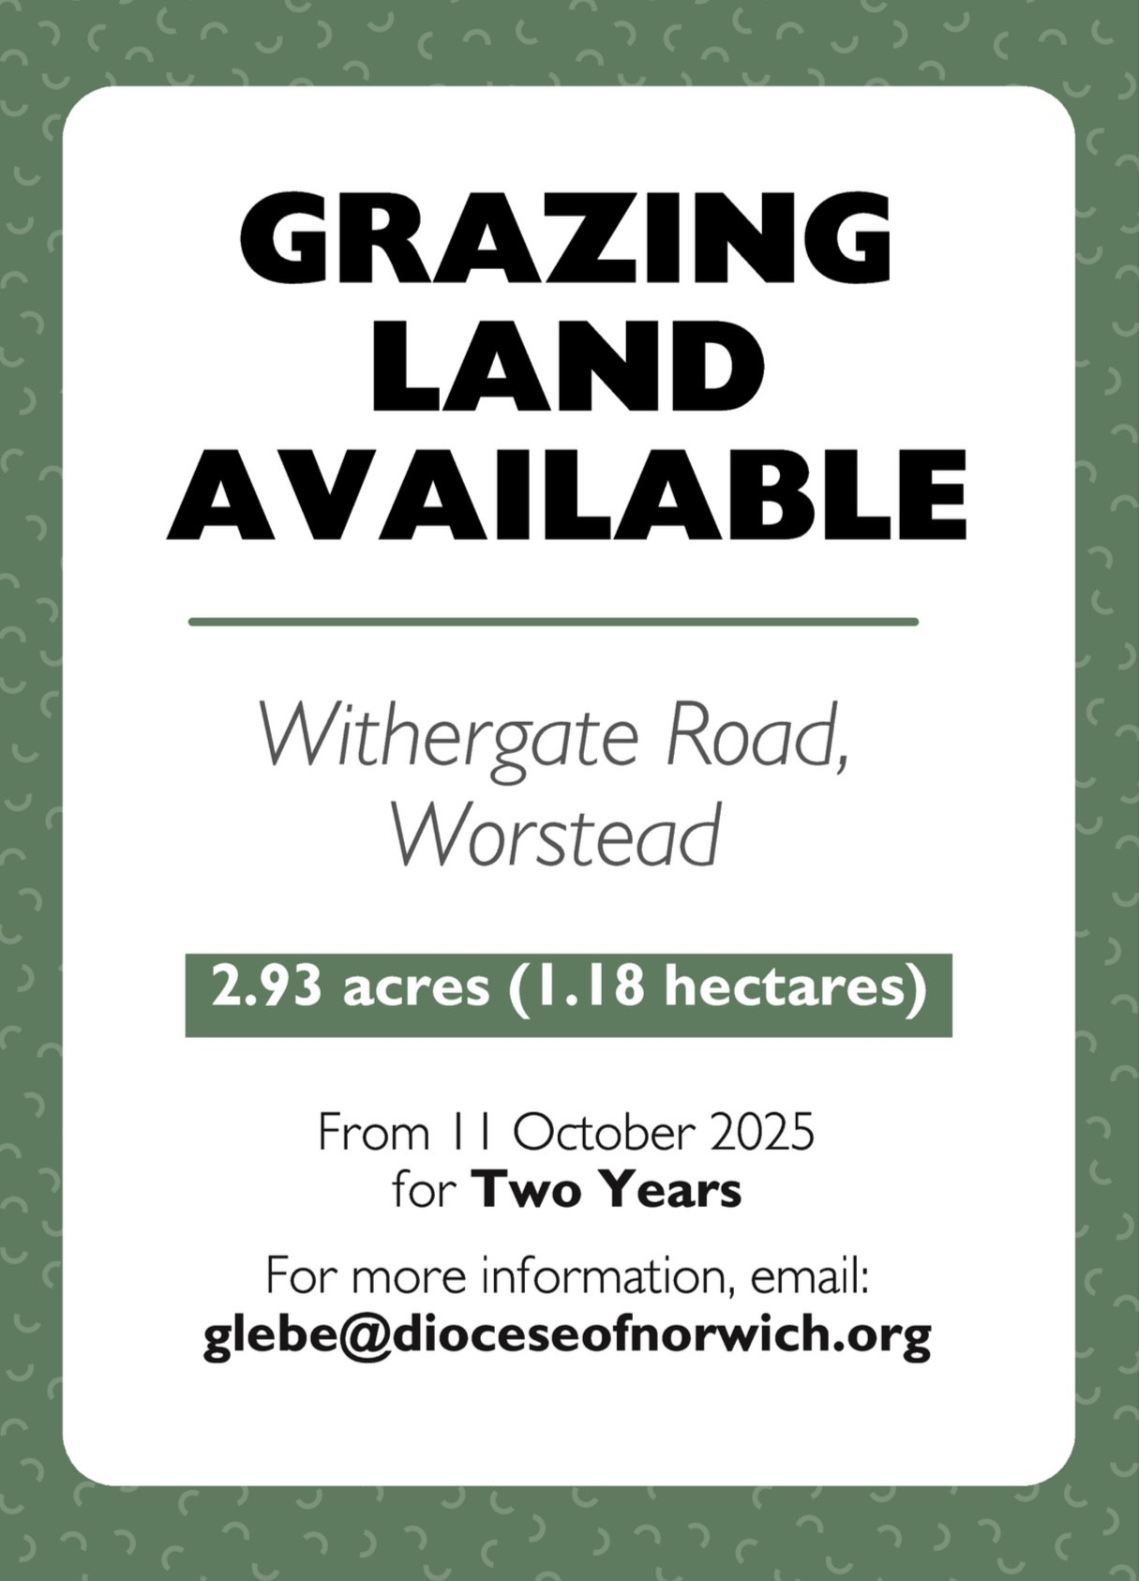

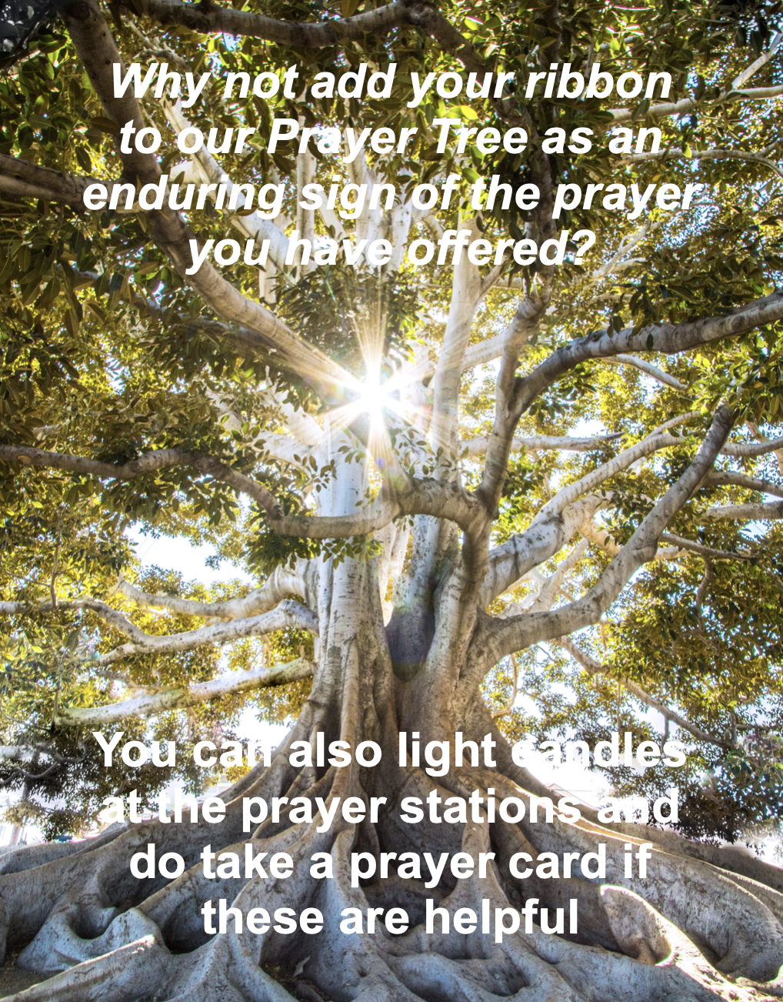

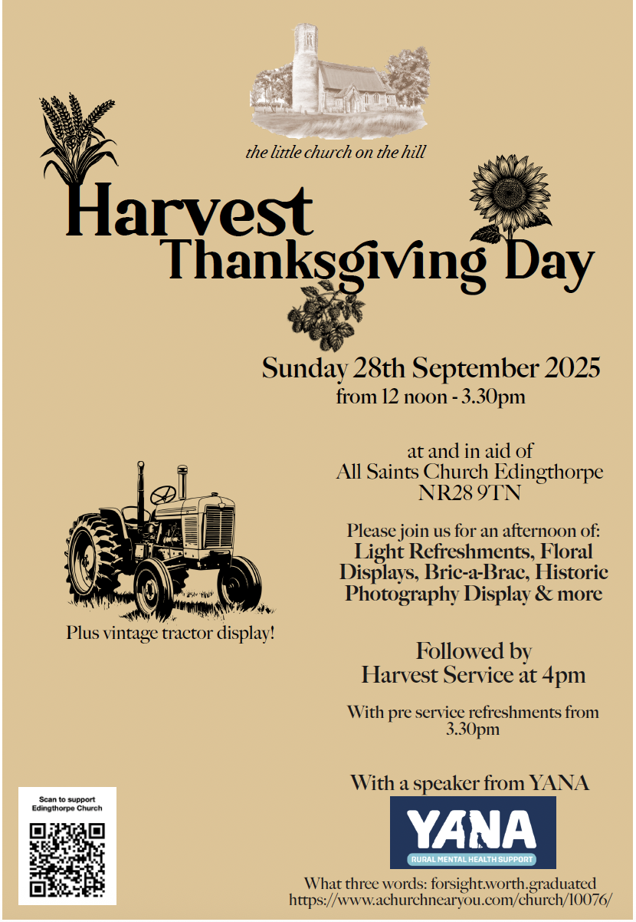

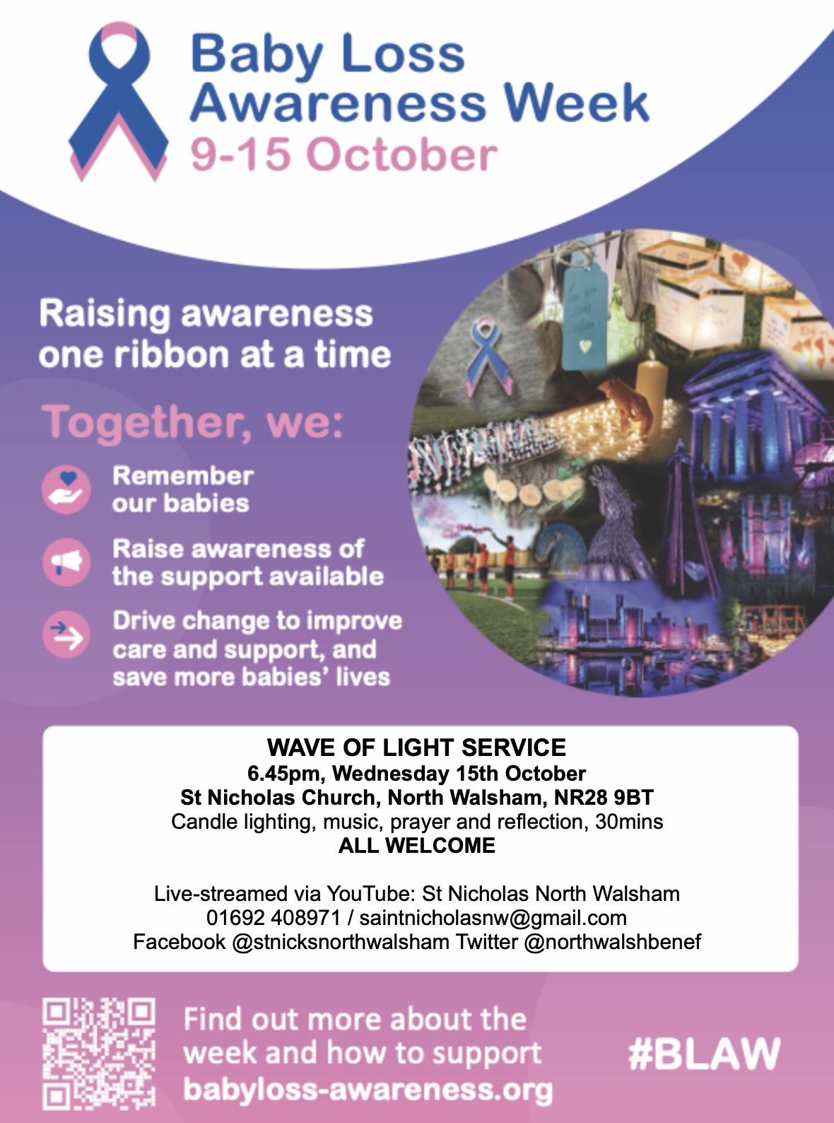

We are privileged to hold special
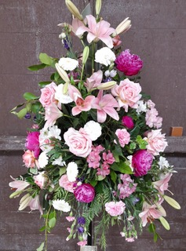
services at any of our churches
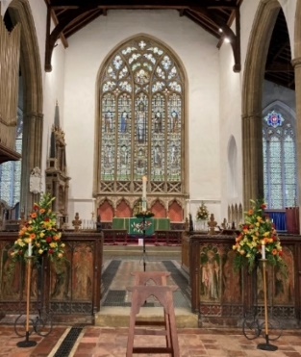
All who live in the benefice are entitled to a baptism, wedding or funeral service in church, and our clergy can officiate at the crematorium and cemeteries too. The church is here for you, through every moment of life.


Dates from the Diary

Baptisms
20th July Ellie-Anne Murphy - St Nicholas

Funerals
16th July Jean Ada Hutchins - Cromer Crematorium
21st July Jean Lillian Oakley - St Nicholas
25th July John Sydney Hook - St Nicholas
1st August Susan Pomroy - St Mary's
29th August Suzanne Jennifer Dyke - St Nicholas

Weddings
12th July, Sheridan Jane Ballard-Pines and Jonathan Charles Cork - St Nicholas
30th August, Gina Louise Mattioli & Loui Branch - St Mary's

Burial of Ashes
24th August, Sandra Elizabeth Hill-Williams - St Botolph

Please hold those above and their families in your prayers.

Thanks to all who’ve provided tealights for prayer stations at St Nicholas!
All donations of white, unscented tealights gratefully received!
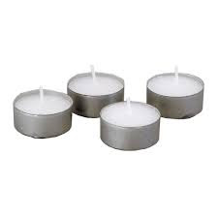




We're pleased that our weekly coffee mornings at North Walsham and Worstead are now registered with Warm Welcome Spaces
North Walsham Market Day Coffee Morning
Thursdays 9.30 – 12.00noon
The space is open to all (and their well-behaved dogs on leads), every Thursday! A warm welcome and refreshments available

Thank you to everyone for raising donations for St. Nicholas Church, North Walsham with #easyfundraising! If you have not signed up yet, it is easy and completely FREE. 8,100 brands will donate to us when you use easy fundraising to do your everyday online shopping - at no extra cost to you! Every donation you raise makes a difference to us so please sign up & share today. https://join.easyfundraising.org.uk/stnicholaschurchnw/XT7MPH/at/TSX8RX7z/RTND2/facebook/
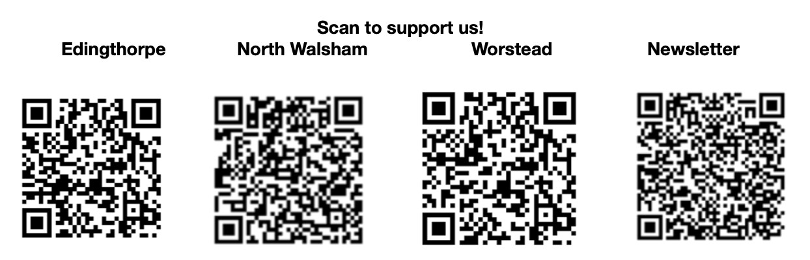


Please support the work of our Churches, by using the contactless giving point at St Nicholas or St Mary’s, leaving your gift on the offering plates or in the wall safes, or through these QR codes. Thank you.

Do you have a Business you would like to advertise in this magazine?
Whole, half or quarter page space is available.
Full Page £ 150.00
Half Page £ 75.00
Quarter Page £ 50.00
Please contact the Benefice office on 01692 408971
or email saintnicholasnw@gmail.com
for details and prices

Church Postcodes
Edingthorpe NR28 9TN, North Walsham NR28 9BT, Worstead NR28 9AL, Westwick NR10 5BW

Benefice dates

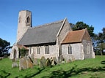
All Saints’ Edingthorpe
14th September 9:15 Holy Communion
28th September 9:15 Morning Prayer
4:00 Harvest Thanksgiving

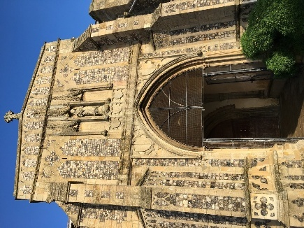
St. Mary’s, Worstead
7th September 9:15 Morning Prayer
21st September 9:15 Holy Communion

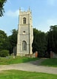
St Botolph’s Westwick

No services in September

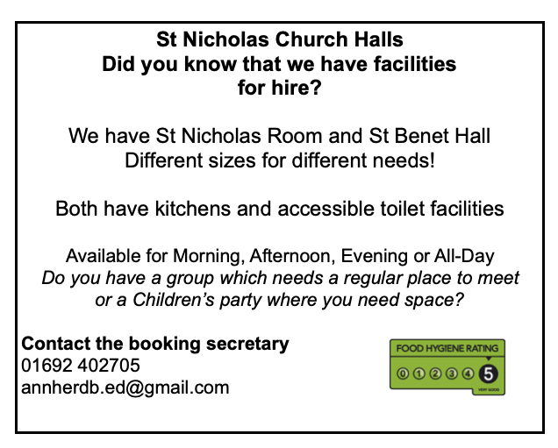

Ready to tick off your list – Will Made?
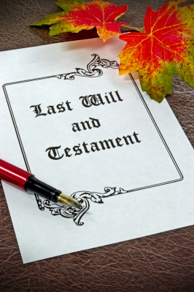
"The Church of England have teamed up with Farewills to provide a free will writing service: Online Will Writing Service | Legal Will In 15 Minutes . Anyone can use this service and it is not compulsory to leave something to your church, but it would be nice if you did. It is important for each one of us to leave our earthly matters in good order so why not take advantage of this opportunity now? It is good to remember a gift in your will to a charity is tax free. If you already have a will, you could consider leaving a legacy to the church by adding a codicil. https://farewill.com/norwich-diocese

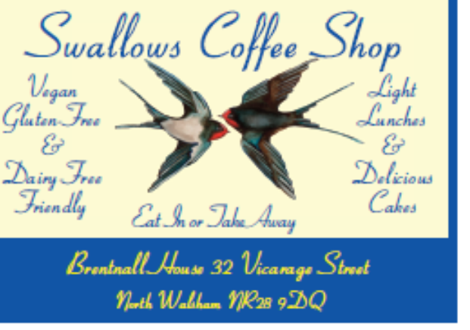

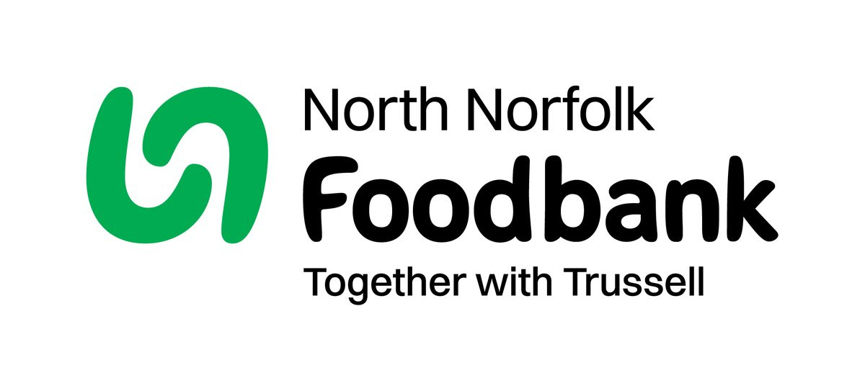
Dear Foodbank supporter,
Thank you for your donations from St Nicholas of 36.70 kg in July.
As a small charity we rely on donations, both food and financial, to operate and we are extremely grateful when people choose to support us.
During 2024 we fulfilled 2085 food vouchers, providing food for 4695 people, 2925 adults and 1770 children.
Whilst Trussell campaigns to end the need for foodbanks, we will be here helping those who need us right now. But that can only be done with kind donations from our supporters.
To see what we need most right now, our wish list is published on our website and social media, and the list gets updated throughout the month on our donation page
https://northnorfolk.foodbank.org.uk/give-help/donate-food/
Thank you for thinking of us and enabling us to serve the people facing hardship across our district.
Kind regards
Jules, Rebecca and the Foodbank team
North Norfolk Foodbank
Cromer Methodist Church Hall, West Street, Cromer, NR27 9DT
07826 376343

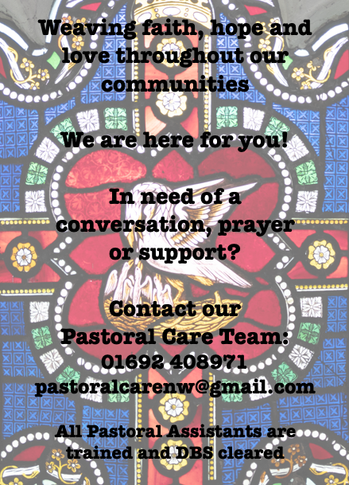

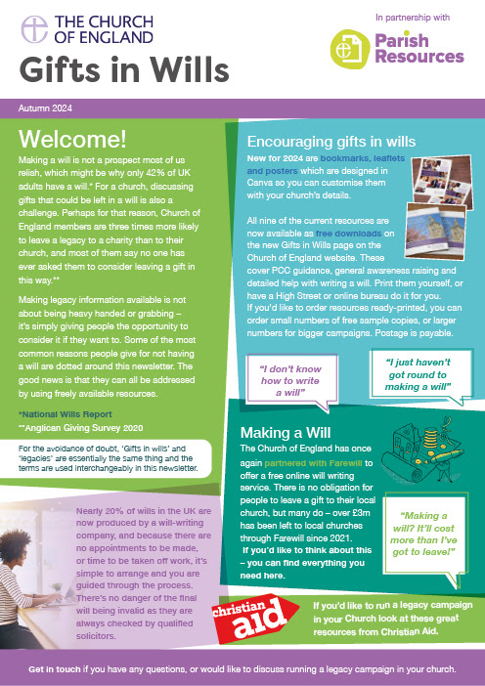
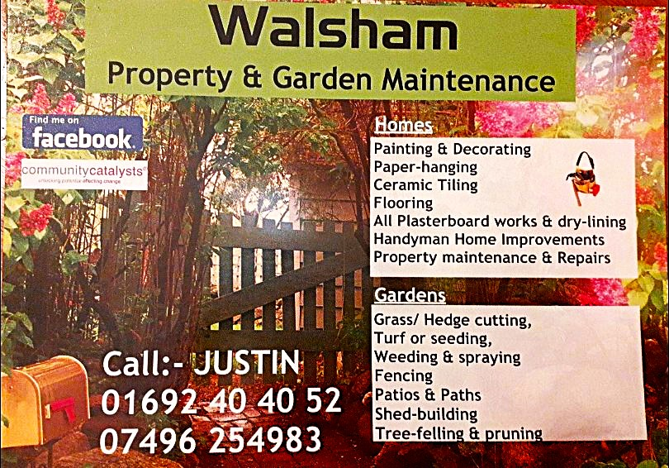

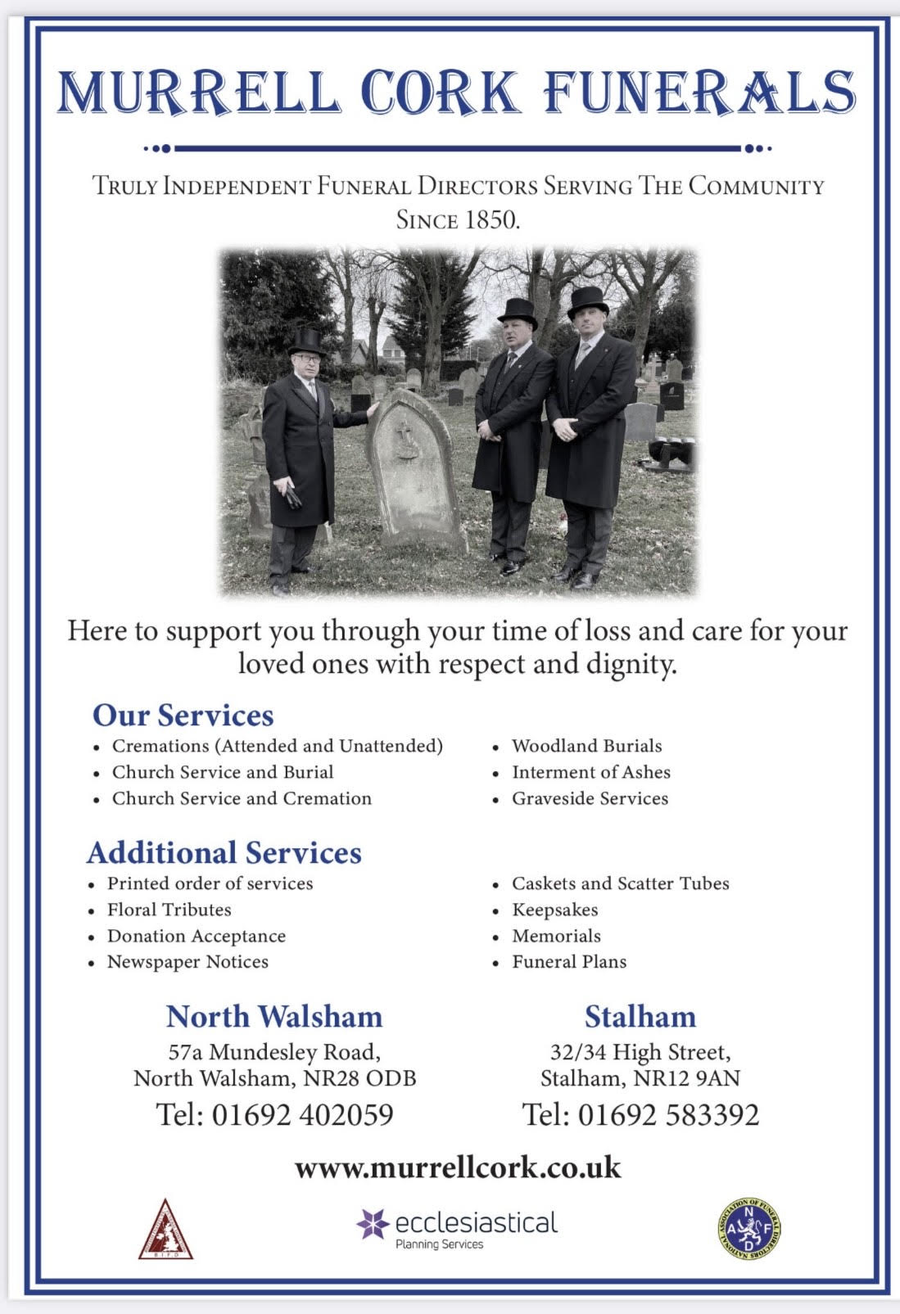
r Sale and Wants Page

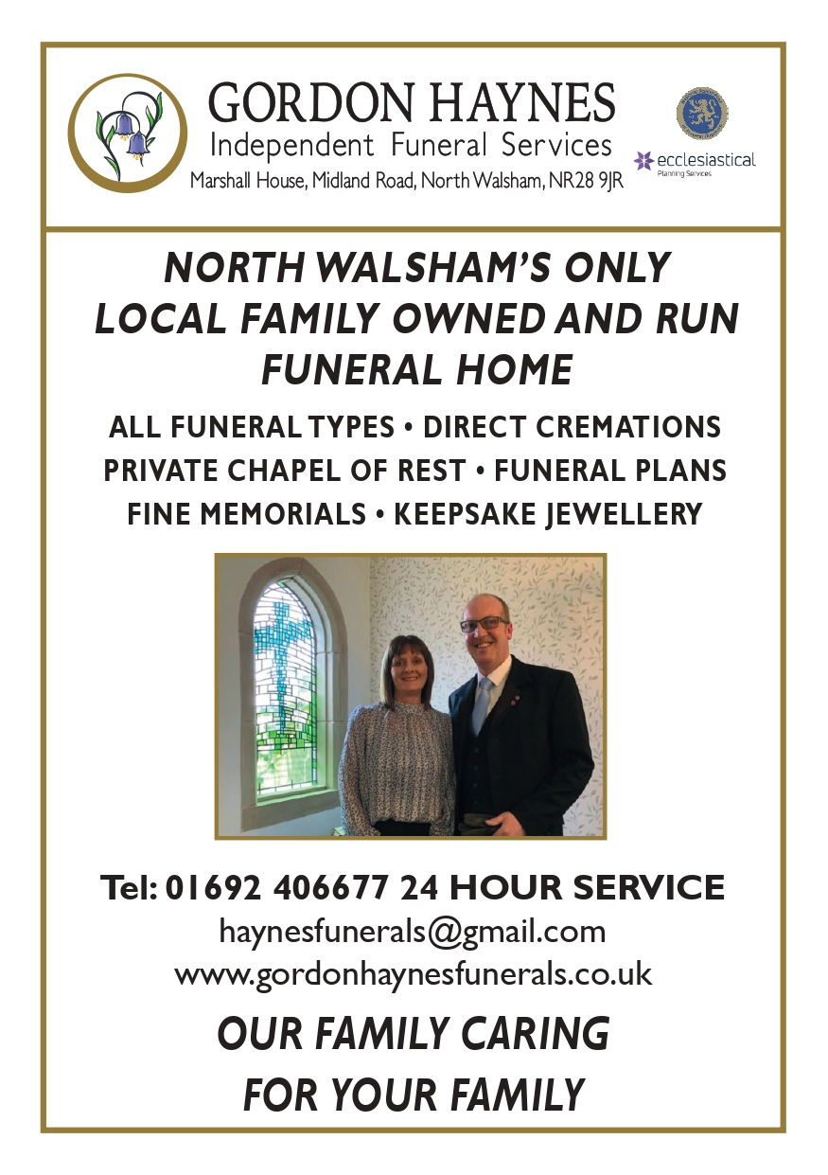


Money Matters …
A regular report for our readers written by James Reginald Drake at ClearView Financial Consultants
Burgh Road, Aylsham - 01263 734859, Station Road, Hoveton - 01603 273590 and North Walsham 07773 626662

Lasting Powers of Attorney – Why are they so Important?
Lasting Powers of Attorney (LPA’s) are documents that give an individual you trust (your attorney) the legal authority to make decisions on your behalf should you either lose the mental capacity to make them, or you no longer wish to make these decisions yourself. Lasting Powers of Attorney come in 2 forms, these coming under the heading of ‘Property & Financial Affairs’ and ‘Health & Welfare’
So, how can they help?
The Property & Financial Affairs LPA covers things such as running your bank and savings accounts, making or selling investments, paying bills, buying or selling property and applying for benefits.
The Health & Welfare LPA covers things such as the type of health care and medical treatment you receive (including decisions on life sustaining treatment), where you live, as well as the type of care that you receive in areas such as diet and daily routine.
Given the wide range of areas that these documents cover, it becomes quite obvious as to why they are so important. However, according to ‘The Office of the Public Guardian’ via an article produced in 2022, less than 1% of the UK population have a Lasting Powers of Attorney in place.
So, why do so few people have them in place? One of the most commonly mentioned reasons is that people assume that their spouse will automatically have the right to make decisions for them should they ever reach the stage where they are unable to. This however is a common misconception and it is very often discovered far too late that they actually have no legal authority at all. Cost is another reason people put it off, I can assure you are costs for this type of work are minimal, in the hope this is not a reason to delay.
What should you do?
Well, the answer to this one is quite simple……. get on and set up both types of LPA as soon as you can. It is never too soon to set one up, but it certainly can be too late. By law, once your mental capacity has gone, so has your opportunity to appoint attorneys to act on your behalf. At this point your loved ones will be required to go down a different route and apply to the Court of Protection for a Deputyship order. This requires more forms, more cost and more time, which can all be easily avoided with a bit of forward planning.
So, if setting up Lasting Powers of Attorney(s) is something that you think would benefit you and your loved ones, please feel free to contact me and we can discuss how they can be put in place in a way that is best suited to your own personal requirements.
This short article in no way should be taken by readers as advice.
James can be contacted on either of the above landline numbers or via email at support@smithifa.co.uk
ClearView Financial Consultants is a trading name of Martin Smith Independent Financial Adviser Ltd, a company registered in England
under number 11439150 and authorised and regulated by the Financial Conduct Authority under number 944677.


