Prayers
Please pray for the sick, particularly Rachel Inglis, Harry Wilson, George and Norma Hall, George Bone, Chloe French, Gail Calder, Andrew Watson, Christine Hammill, John Rutherford, Brenda Cossar. We pray too for the family and friends of those who have recently died, and we remember those whose anniversaries of death fall at this time of year.

This week and beyond
- Summer Mondays the last of this series will be on Monday 18th August , continuing to look at ‘The Bible & the Barricades: the Gospel according to Les Misérables’. Join Kevin & Tracey at 38A Main Street, Lowick from 7pm-8.30pm.
- VJ Day 80th Anniversary Commemoration in Ford Parish Church at 3pm on Friday 15th August, followed by tea in Lady Waterford Hall.
- Lowick Souper Saturday Meeting 2pm on Tuesday 12th August at East Lodge, 83A Main Street, Dee’s home. Everyone who is involved in Soup Saturdays invited as we plan for September and the new ‘soup season’.
- Save This Date: Flower Festival at Lowick Church, 12-14th September.
‘Flora -nature’s fleeting beauty’.’ Church open all weekend for viewing. See poster and flyers for details. Tickets from Lowick Village Shop.
- What is confirmation? Why does it matter? What does it do? On November 16th there will be a deanery confirmation service with +Mark at Tweedmouth. If you would like to discuss these questions and explore being confirmed, or even reception into the Church of England please contact Alex for a series of conversations in September and October.

Parish Contacts
Ancroft Leigh Yorke 07716116739
Etal Andrew Joicey 01890 820540
Ford Kathleen Holmes 07951099668
Lowick Niall Cartlidge 07850876246

Websites: www.achurchnearyou.com
Instagram: https://www.instagram.com/the_flake_churches/
Facebook: the_flake_churches

Clergy licensed to our parishes:
Revd Margaret Sentamu 077871 204745 m.sentamu@gmail.com
Canon Nick Sagovsky, Revd Marion Penfold 01289 305664

The Parishes of Ford & Etal, Ancroft, Lowick with Kyloe

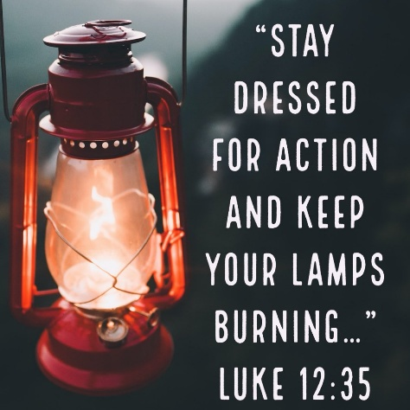
A very warm welcome to you, especially if you are visiting and do stay for refreshments after the service at Lowick if you are able.
NB no coffee at Ford
in July and August.
Please take this sheet home with you and use it as a basis for prayer.
Children are welcome in all our services.

Sunday 10th August 2025
Trinity 8
Lowick 9.15am Holy Communion
Revd Margaret Sentamu/Revd Charlotte Osborn
Ford 11am Holy Communion
Revd Charlotte Osborn
Ancroft No Service

Sunday 17th August 2025
Trinity 9
Lowick 9.15am Holy Communion
Canon Nick Sagovsky
Ford No Service
Ancroft No Service

Licensed Clergy
Revd Charlotte Osborn (Vicar) 01289 388591
ceosborn@mail.com 07957 367457
Revd Alex Firman (Assistant Curate) 07935 732811 alex_firman@hotmail.co.uk

