

**WELCOME**

**ST.STEPHEN’S CHURCH**

**is open 10am-3pm daily**

**for Private Prayer and Reflection**

**TODAY**

**17th August 2025**

**THE NINTH SUNDAY AFTER TRINITY**

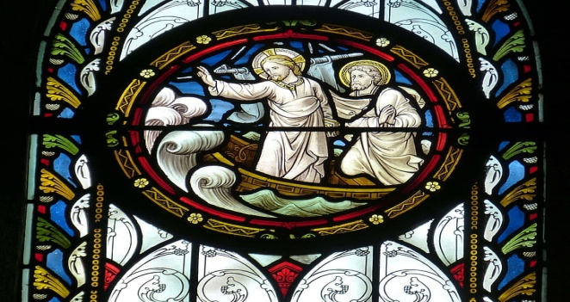

**10.30am Family Communion**

Notices for inclusion in the bulletin please email to me by Tuesday of each week

***officeststephenfradley@gmail.com***

**Please take Bulletin away with you**

**St Stephen’s Church Fradley**

**The**

**80th Anniversary of**

**VJ Day**

(Victory over Japan Day)

**Friday 15th August**



**“We will remember them”**



We honour and pay tribute to those

of the WW2 generation

who paid such a great sacrifice

for the freedom we enjoy today



Please note – in the Benefice there is a said Communion Service (Common Worship) at

**10am every Wednesday - All Saints Church, Alrewas.**

**Wednesday 20th August**

**2-4pm ‘Wednesday Welcome’**

Drop in for tea cakes and chat!

**Thursday 21st August**

**9.30am Events Committee** (in church)

**Saturday 23rd August**

**1pm Baptism of Kenny**

**Sunday 24th August**

**10.30am Songs of Praise**

Come and sing your favourite hymns!

**Next events**

**Saturday 13th September Ride & Stride**

Church is open to offer hospitality to riders, striders

and drivers!

**Saturday 4th October 7pm Harvest Supper**

in Fradley Youth & Community Hall



Welcome to our Worship today

If you are visiting for the first time, please introduce yourself so that we may welcome you personally.

Refreshments are served after every service – do join us!

**17h August 2025**

**Collect**

Gracious Father,

revive your Church in our day,

and make her holy, strong and faithful,

for your glory’s sake

in Jesus Christ our Lord

**Readings**

Jeremiah 23. 23-29 Hebrews 11. 29 – 12.2

Luke 12. 49-56

**Post Communion**

Holy Father,

who gathered us here around the table of your Son

to share this meal with the whole household of God:

in that new world where you reveal the fullness of your peace,

gather people of every race and language

to share in the eternal banquet of Jesus Christ our Lord.

**News from Lichfield Cathedral**

**Wildlife Photographer of the Year**



From Saturday 26 July to Sunday 31 August 2025, Lichfield Cathedral is hosting the Natural History Museum's Wildlife Photographer of the Year Exhibition.

This world-renowned exhibition, now in its 60th year, celebrates the wonder of the natural world through the best wildlife photography. Each year, the exhibition embarks on an international tour seen by millions of people all over the world. For the summer of 2025, its home will be Lichfield Cathedral, where visitors can explore over 80 breathtaking images alongside soundscapes and film footage. This multi-media exhibition offer insights into the diversity, fragility and beauty of life on Earth,

and what we can do to protect it.

The exhibition will be presented inside the Cathedral alongside our regular summer activities,

**including the extremely popular Beach on the Cathedral's West Front which will return for its fourth summer.**

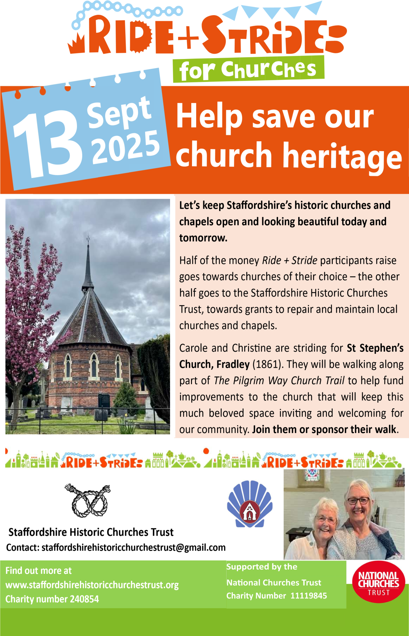

*In our thoughts and prayers…..*

**For those who served and died in World War II**

O God of truth and justice, we hold before you those men and women who have died in active service, particularly in the Second World War. As we honour their courage and cherish their memory, may we put our faith in your future; for you are the source of life and hope.

We give thanks for those whose lives are dedicated to healing the sick

* For our hospitals and medical care
* -we bring before God the needs of those whose lives are shadowed by suffering, those whose illness finds no cure, whose sadness finds no comfort and whose loneliness can never be filled.

Lord the people we pray for are suffering. Let them know that you are with them. Be their strength and support in this time of darkness and grant them that deep peace which comes form trusting you.



**Can you help to support St Stephens Church?**

St Stephen’s Church is heavily dependent on voluntary donations and income from events in order to fulfil its ministry to the local and wider communities.

If you would like to support us at this time,

donations can be made via our Just Giving page.

We are grateful for any donation, large or small.

[**https://www.justgiving.com/fundraising/ststephensfradley**](https://www.justgiving.com/fundraising/ststephensfradley)



## Contact us

## Revd Elizabeth Wall

## 01543 254891

## Email: [ayton265@gmail.com](mailto:ayton265@gmail.com)

## Churchwarden

## Marian Derry 01283 791573

## 

## St Stephen’s Administrator: Di Cooper  07930162991

## Email: officeststephenfradley@gmail.com

## Find us on

## ACNY https://www.achurchnearyou.com/church/4123/

**Face book:** [**www.facebook.com/ststephensfradley**](http://www.facebook.com/ststephensfradley)

DC 13/08/25