**Sunday 17th August 2025 Patronal Festival**

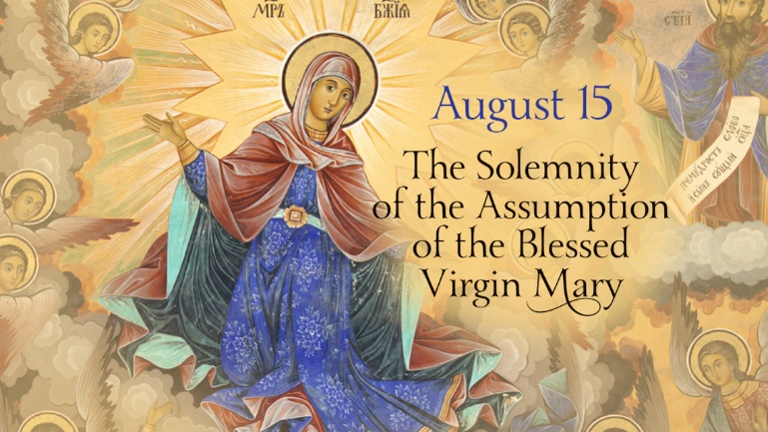

*Collect:* Almighty God, who looked upon the lowliness of the Blessed Virgin Mary and chose her to be the mother of your only Son: grant that we who are redeemed by his blood may share with her in the glory of your eternal kingdom; through Jesus Christ your Son our Lord, who is alive and reigns with you, in the unity of the Holy Spirit, one God, now and for ever.

**Isaiah 61.10–11**

10 I will greatly rejoice in the LORD, my whole being shall exult in my God; for he has clothed me with the garments of salvation, he has covered me with the robe of righteousness, as a bridegroom decks himself with a garland, and as a bride adorns herself with her jewels. 11 For as the earth brings forth its shoots, and as a garden causes what is sown in it to spring up, so the Lord GOD will cause righteousness and praise to spring up before all the nations.

**Psalm 45.11–18**

R **Sing praises to God, sing praises;**

11 ‘Hear, O daughter; consider and listen closely;

forget your people and your family’s house.

12 The king will have pleasure in your beauty;

he is your master; therefore do him honour. R

13 The people of Tyre are here with a gift;

the rich among the people seek your favour.’

14 All glorious is the princess as she enters;

her gown is cloth-of-gold. R

15 In embroidered apparel she is brought to the king; after her the bridesmaids follow in procession.

16 With joy and gladness they are brought,

and enter into the palace of the king. R

17 ‘In place of fathers, O king, you shall have sons; you shall make them princes over all the earth.

18 I will make your name to be remembered

from one generation to another;

therefore nations will praise you for ever and ever.’ R

**Galatians 4.4–7**

4 When the fullness of time had come, God sent his Son, born of a woman, born under the law, 5 in order to redeem those who were under the law, so that we might receive adoption as children. 6 And because you are children, God has sent the Spirit of his Son into our hearts, crying, ‘Abba! Father!’ 7 So you are no longer a slave but a child, and if a child then also an heir, through God.

**Luke 1.46–55**

46 Mary said, ‘My soul magnifies the Lord,

47 and my spirit rejoices in God my Saviour,

48 for he has looked with favour on the lowliness of his servant. Surely, from now on all generations will call me blessed;

49 for the Mighty One has done great things for me, and holy is his name.

50 His mercy is for those who fear him from generation to generation.

51 He has shown strength with his arm; he has scattered the proud in the thoughts of their hearts.

52 He has brought down the powerful from their thrones, and lifted up the lowly;

53 he has filled the hungry with good things, and sent the rich away empty.

54 He has helped his servant Israel, in remembrance of his mercy,

55 according to the promise he made to our ancestors, to Abraham and to his descendants for ever.’

*Post Communion Prayer:* God most high, whose handmaid bore the Word made flesh: we thank you that in this sacrament of our redemption you visit us with your Holy Spirit and overshadow us by your power; strengthen us to walk with Mary the joyful path of obedience and so to bring forth the fruits of holiness; through Jesus Christ our Lord.

**THE HAVEN BENEFICE OF SEAVIEW,** **ST HELEN’S,** **BRADING And YAVERLAND**

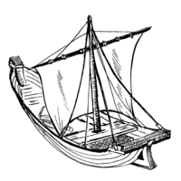Providing a Spiritual Harbour for ALL

**Sunday 17th August**

**NB NO** Said BCP Holy Communion Service, St John’s

09.30 Sung Eucharist, St Mary’s (Patronal Festival)

11.00 Sung Eucharist St Peter’s

17.30 Sung Evensong, St John’s

**Tuesday 19th August**

10.00 Morning Worship, St Catherine’s

**Wednesday 20th August**

10.00 Morning Worship, St Mary’s

11.00 Prayer Circle, St Peter’s

**Sunday 24th August**

09.30 Sung Eucharist, St Helen’s

09.30 Service of the Word, St Mary’s

10.00 Regatta Service St Peter’s

11.00 Sung Eucharist, St John’s

**Wednesday 27th August**

10.00 Morning Worship, St Mary’s

11.00 Prayer Circle, St Peter’s

**Sunday 31st August Creation Tide**

10.00 Benefice Service, St Helen’s

**Tuesday 2nd September**

10.00 Morning Worship, St Catherine’s

**Wednesday 3rd September**

10.00 Morning Worship, St Mary’s

11.00 Prayer Circle, St Peter’s

**Sunday 7th September**

08.00 Said BCP Holy Communion Service, St John’s

09.30 Sung Eucharist, St Mary’s

11.00 Sung Eucharist St Peter’s

18.00 Sung Eucharist, St Catherine’s

**Church contacts:**

**Haven Benefice -** **Priest-in-Charge**

Revd Karen Wilson on 07591240640

or email: [revdkarenwilson@outlook.com](mailto:revdkarenwilson@outlook.com)

**(Day off: Tuesday)**

**St Helen’s and St Catherine's, St Helens –**

Sue Whitewick on 01983 568761

**St Peter’s Seaview and Safeguarding –**

Revd Karen Wilson on 07591240640

**St Mary’s Brading –**

Nigel Elton Walterson 01983 406817

**Safeguarding** - Catherine Davis on 07940826034

**St John’s Yaverland –**

Kevin Norton on 07951407423

**Curate at Haven Benefice**

Revd Bevaly Rackett – 01983 407432

Email: [revbevrackett@gmail.com](mailto:revbevrackett@gmail.com)

To add items to this news sheet please contact Rev Bevaly

Website: [www.havenchurches.org.uk](http://www.havenchurches.org.uk)

Or find us on achurchnearyou.com

Or follow us on Facebook: Haven Churches IOW

**Scarecrow Building:** Brading is hosting its 10th annual scarecrow festival from 22nd – 31st August. If you would like to help St Mary’s build theirs, please come to the De Aula Chapel on Thursday 21st August at 2pm. If anyone has any cuddly lions that would be most helpful!

St Peter’s are holding a **Coffee Morning** on Saturday 6th September from 10am in the church hall. All are welcome for coffee, cakes and a chat.

The next **Jumble Sale** at St Mary’s is on Saturday 6th Sept from 2pm. Jumble can be left from 11am. There will also be refreshments, cakes and a raffle. Entry 20p.

**Confirmation preparation:** Rev Karen and Rev Bevaly are leading a day of preparation for confirmation on Sat 13th September in St Mary’s Church hall. If you are interested and would like to know more please contact either one for more information. The Confirmation service is set for 19th October here at St Mary’s Church, Brading at 4pm.

Revd. Karen is leading an **Intercessions Preparation Session** on Saturday 20th September at 10am at The Vicarage: This will equip intercession leaders with the tools and inspiration to write and deliver those prayers.

A **session for all who currently read, or are interested in reading, during services** will be held on September 20th at 2pm in St Helen’s Church. It will provide valuable guidance on vocal projection, pacing, understanding the text, and conveying its meaning with appropriate emotion, all to the glory of God and the enrichment of the worshipping community.

There will be a **Joint benefice PCC meeting** on Thurs. 18th September 2025 at 6pm in St Mary’s church hall

Also a **Ministry Team/CW meeting to finalize Advent and Christmas Worship Rota** onWednesday 24th September at 2pm in St Catherine’s Chapel

**Do you volunteer for any of our Haven Benefice Churches?** Rev Karen warmly invites you to a **‘Thank You’** for our church Volunteers, however you give your time, on Saturday 4th October at 10am in St Mary’s Church Hall, Brading. There will be tea, coffee and cake.