** SPIRE & LIGHT United Churches**

United Benefice of St Keverne, St Ruan with St Grade & St.Wynwallow (The Lizard)

**\*If you do not wish to receive these notices, please let your Churchwarden know\***

**10th August 2025**

***Trinity 8***

**Readings**

**Genesis 15:1-6**

**Psalm 33.12-22**

**Hebrews 11:1-3, 8-16**

**Luke 12:32 -40**

9.30am –– Morning Prayer - St.Peter’s, Coverack

9.30am – Holy Communion– St.Ruan, Ruan Minor

11am – Holy Communion - St.Keverne Church

11.15am – Café Church – St.Wynwallow, The Lizard

6pm – Evensong – St.Grade

Next week – Sunday August 17th

9.30am –– Holy Communion- St.Peter’s, Coverack

9.30am –– Holy Communion - St.Wynwallow, The Lizard

11am –- Morning Prayer - St.Keverne Church

11.15am – Family Service – St.Ruan, Ruan Minor

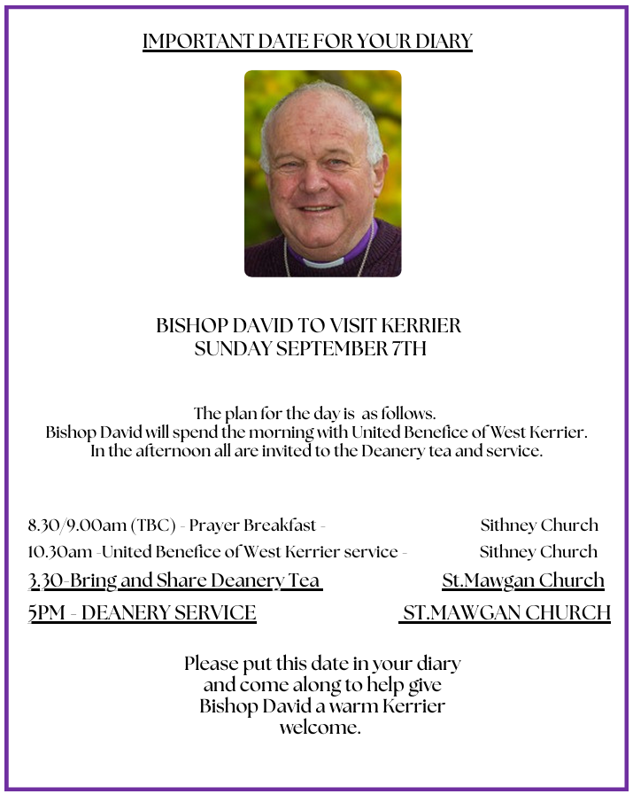****

**The Prayer Spot**

Dear Heavenly Father, as we come to pray to you today, remind us of the love we must share with others, that love given to us by you. Help us to remember those in need within our churches and community and how we can be there for them - it may just need an act of kindness just to show we really care for them.

It says in 1 PETER 1 “Therefore prepare your minds for action, be self-controlled, set your hope fully on the grace to be given to you when Jesus Christ was revealed to you. As obedient children of God do not conform to self-desires you had when you lived in ignorance but as he who has called you is Holy so be holy in all you do for it is written to be holy because I am Holy.”

Remember God has given you gifts to use for the needs of others. Use them well because everyone needs your help in times of troubles. Be generous and full of God’s love, pray for all those who are in need of hospital treatment and that God will be present with them and for those who have the job of taking them. Pray for all our benefice that God will guide us in our care for everyone and to remember them all in our prayers.

*We praise you for your kindness and all the love you give us, for your endless willingness to forgive us when we fail you. We thank you for the love shown to us as members of your flock, for being the shepherd who guides us through each day. Thank you for those wonderful gifts given to us of forgiveness, justice, generosity, and peace and of course that great joy of knowing your presence in our lives.*

As always, I tell you God will be ever present in your prayer time and will answer all your prayers in the name of His Son Jesus Christ. Be blessed by all you do in His name.

*O God our Father, grant that whatever happens to us today we may take it to thee. If we shall have decisions to make help us to ask for your guidance and grant us humility and obedience to take it when you give it to us. If we shall have problems to solve, help us ask for thy light upon them so we may see a clear way through them. Help us through today to decide everything by thy will and to test everything by thy presence so that we may come to the days ending without mistakes and without regrets through Jesus Christ our Lord. Amen*

***The Diocese of Truro’s Prayer Diary for this week***

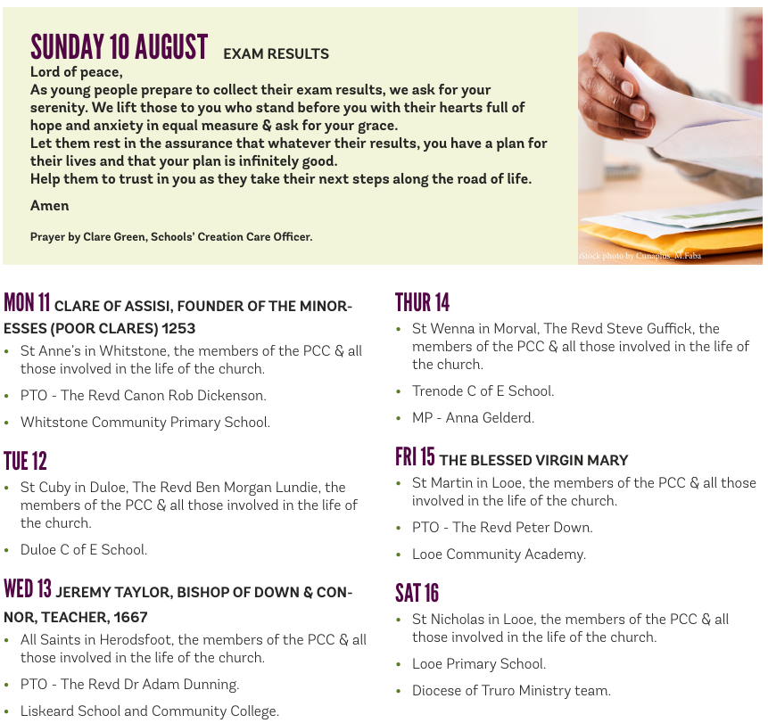

**On the Way Prayers**

“Do not be afraid, for I have redeemed you.” Let us just dwell, in silence, on those words for a moment. The phrase “Do not be afraid” is mentioned 365 times in the Bible in both the New and Old Testaments. Dear Lord we pray that we will trust you enough to not be afraid every single day of each year.

Help us to not be afraid for the future of your church but determined to be moved by your Holy Spirit to do something positive to ensure its future – not a future that harks back to the past, but a real future, for this ever-changing world. We pray for our Deanery – for Heidi who has started back at work, for all our clergy, for all our lay leaders and above all for all our communities. Let us always remember that we are here to serve your people – particularly the poor, the hungry, the lonely and the lost – all those in our communities, who don’t come to church Sunday by Sunday.

We give thanks for anything special that has happened in our church or in our community during this last week. Help us to not be afraid of trying different things, of sometimes getting things wrong, of offending some people whilst helping others, and of always remembering that Jesus spent his life taking risks, challenging authority and championing the underdog. Help us be brave!

We do fear for our world. It is hard not to, when we see so much devastation, war, and constant examples of Man’s inhumanity to Man. But let us keep praying, let us keep believing that your will, will, eventually, be done on earth as it is in heaven. We pray for the leaders of nations that they will be guided by you, strengthened by you and, in the end, do the right thing.

And now let us take a moment to pray for all those in our communities who are afraid – of the future, of their own health, or for a loved one. Lord comfort all who are anxious – give them hope and give them peace.

We pray now for ourselves. For anything that we are afraid of. For anyone who we fear for. For all those little things that worry us – be it money, relationships, or just difficult things we have to do or say. Lord, teach me not to worry.  Remind me to not be anxious. As it says in Philippians ‘Do not be anxious about anything, but in everything by prayer and supplication with thanksgiving let your requests be made known to God.’