

**WELCOME**

**ST.STEPHEN’S CHURCH**

**is open 10am-3pm daily**

**for Private Prayer and Reflection**

**TODAY**

**24th August 2025**

**THE TENTH SUNDAY AFTER TRINITY**

**BARTHOLOMEW THE APOSTLE**

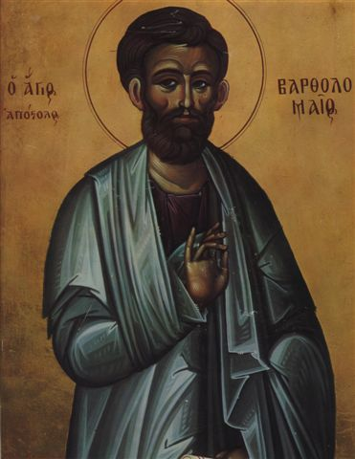

**10.30am Songs of Praise**

Come and sing your favourite hymns!

Notices for inclusion in the bulletin please email to me by Tuesday of each week

***officeststephenfradley@gmail.com***

**Please take Bulletin away with you**



**Diary Dates**

Please note – in the Benefice there is a said Communion Service (Common Worship) at

**10am every Wednesday - All Saints Church, Alrewas.**

**Sunday 24th August**

**10.30am Songs of Praise**

Come and sing your favourite hymns!

**Wednesday 27th August 2-4pm Wednesday Welcome**

**Sunday 31st August**

**10.30am Family Communion**

**Next events**

**Saturday 13th September Ride & Stride**

Church is open to offer hospitality to riders, striders

and drivers!

**Saturday 4th October 7pm Harvest Supper**

in Fradley Youth & Community Hall



Welcome to our Worship today

If you are visiting for the first time, please introduce yourself so that we may welcome you personally.

Refreshments are served after every service – do join us!

**24th August 2025**

**Collect**

Almighty God,

you search us and know us:

may we rely on you in strength

and rest on you in weakness,

now and in all our days;

through Jesus Christ our Lord.

**Readings**

Isaiah 58. 9b-end Hebrews 12. 18-end

Luke 13. 10-17

**Post Communion**

God our creator,

you feed your children with the true manna,

the living bread from heaven:

let this holy food sustain us through our earthly pilgrimage

until we come to that place

where hunger and thirst are no more;

through Jesus Christ our Lord.

**Diocesan Synod Report July 2025**

The Diocesan Synod Report is available to anyone who would like a copy. Please email Elizabeth or the Administrator, Di, for a copy. Some hard copies are available in Church.

**St Stephen’s Fradley**

**Sunday 14th September**

**Alrewas and District Royal British Legion and**

**St Stephen’s Church**

**invite you to**

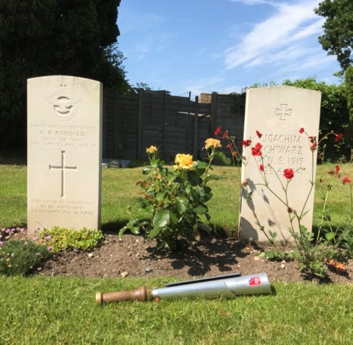

Photograph reproduced by courtesy of RAF100 Baton Team

**BATTLE OF BRITAIN**

**COMMEMORATIVE SERVICE**

**3pm at The War Graves**

**Followed by Afternoon Tea**

**(*in Church)***

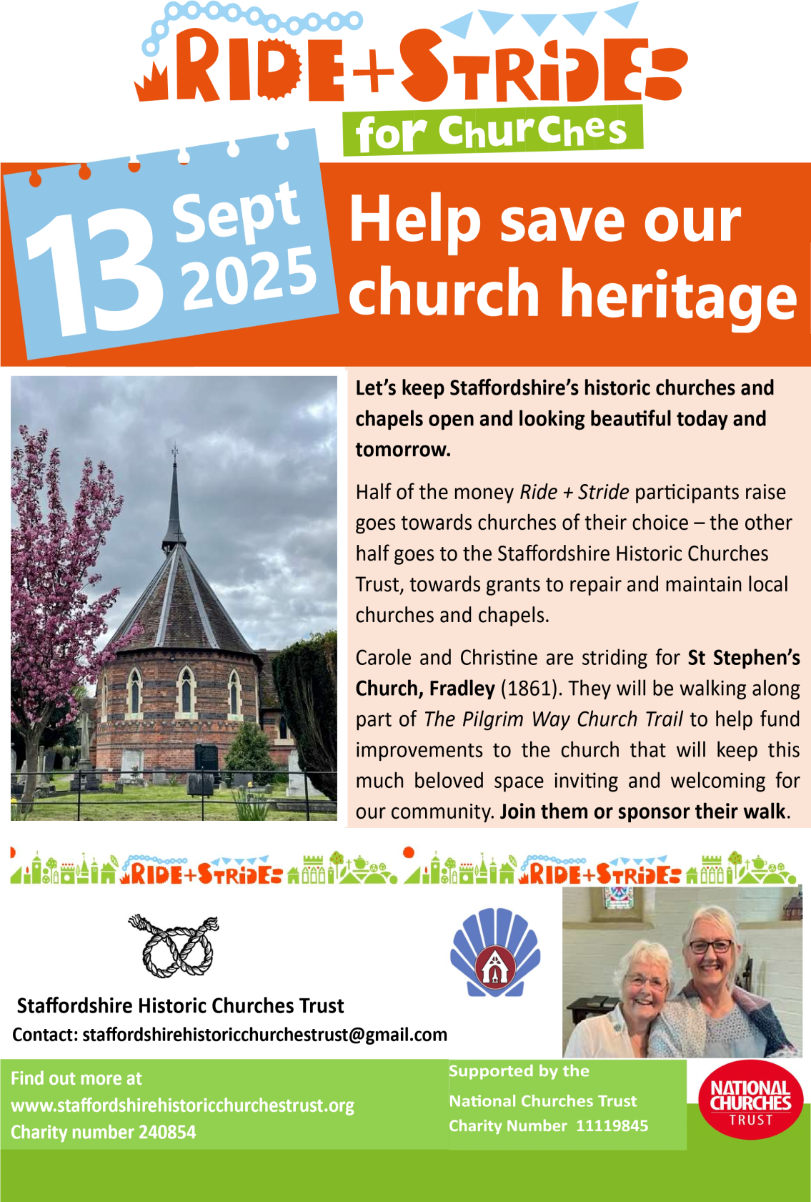

***In our thoughts and prayers***

We pray today for all who are called to serve; for all who serve in any way for the smooth running of this church. May they minister truth and compassion. May they hold your people in their hearts.

Hear our prayer for all in whom trust is placed, all through whom knowledge is sought and all through whom love is asked.

We pray for those seeking to deepen their faith….

*God go with us on our journey of faith-*

*Revive us when we grow weary,*

*Direct us when we go astray,*

*Inspire us when we lose heart,*

*Keep us ever travelling onwards;*

*A pilgrim people,*

*Looking to Jesus Christ*

*Who has run the race before us,*

*And who waits to welcome us home.*

**Confirmation**

A DeaneryConfirmation Service will take place on

Sunday 26th of October at 5.00pm

(local venue to be decided)

If you are interested in exploring Confirmation please have a word with Elizabeth

**News from Lichfield Cathedral**

**Wildlife Photographer of the Year**



Lichfield Cathedral is hosting the Natural History Museum’s Wildlife Photographer of Year Exhibition until Sunday 31st August.

The Exhibition is presented inside the Cathedral alongside their regular summer activities, including the extremely popular Beach on the Cathedral’s West Front which has returned for its fourth summer with a Noah’s Ark theme.

**J.L Petit: The Lost Treasures Exhibition**

The Friends of Lichfield Cathedral are delighted to be opening the J.L. Petit Exhibition in the Old Stables on the following dates: Monday 25th August 2-4pm, Saturday 13th September 2-4pm, and Saturday 8th November 10am-3pm. The Exhibition features images of Lichfield and the Cathedral, local beauty spots including Chartley and Tutbury Castles and industrial landscapes. There are still many people who have not seen it, so if you would like to take a look, do come along. Entry is just £2 in support of the Friends.

**Enlightenment Tickets now on sale – 26th-28thh September**

*Where thinking comes alive*

We are pleased to announce that speakers for this gala of ideas will include Professor Diarmaid MacCulloch, Sir Jeremy Hunt, Rupert Shortt and Professor Alec Ryrie. You can book your tickets for them all now at enlighten-lichfield.org

**Can you help to support St Stephens Church?**

St Stephen’s Church is heavily dependent on voluntary donations and income from events in order to fulfil its ministry to the local and wider communities.

If you would like to support us at this time,

donations can be made via our Just Giving page.

We are grateful for any donation, large or small.

[**https://www.justgiving.com/fundraising/ststephensfradley**](https://www.justgiving.com/fundraising/ststephensfradley)



## Contact us

## Revd Elizabeth Wall

## 01543 254891

## Email: [ayton265@gmail.com](mailto:ayton265@gmail.com)

## Churchwarden

## Marian Derry 01283 791573

## 

## St Stephen’s Administrator: Di Cooper  07930162991

## Email: officeststephenfradley@gmail.com

## Find us on

## ACNY https://www.achurchnearyou.com/church/4123/

**Face book:** [**www.facebook.com/ststephensfradley**](http://www.facebook.com/ststephensfradley)

DC 20/08/25