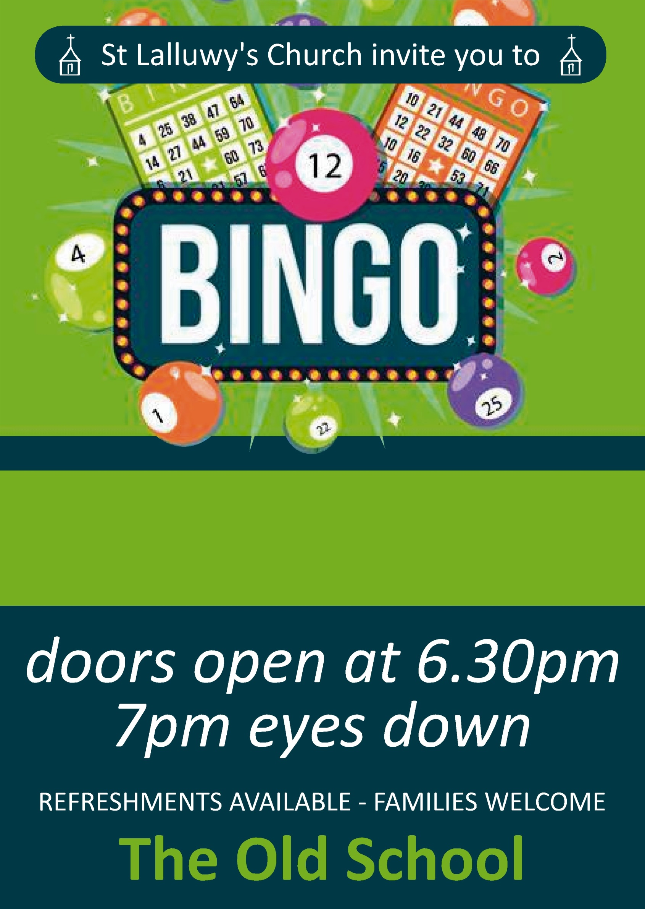

**Wednesday 27th August**

**Sponsored by Rob and Fiona Sneyd**